|  |
| --- |
| Threatened Species Assessment |
| *Pterostylis* X *aenigma*  Enigmatic Greenhood |

## Taxonomy

*Pterostylis* X *aenigma* D.L. Jones & M.A. Clem.

There is some debate as to the correct taxonomic status for *P. aenigma*. Some believe that it is a natural hybrid between Leafy Greenhood *(P. cucullata)* and Sickle Greenhood *(P. falcata)*, both of which occur with or nearby known Enigmatic Greenhood populations. Plant characters tend to lie in between the two putative parent taxa, however the taxonomic status requires clarification (Duncan 2008).

## Current conservation status

Listed as Endangered under the *Environment Protection and Biodiversity Conservation Act 1999*.

Listed as threatened under the *Flora and Fauna Guarantee Act 1988* as *Pterostylis aenigma* (SAC 2000).

Categorised as Endangered in the 2014 Advisory list of rare or threatened flora (DEPI 2014).

## Proposed conservation status

Critically Endangered in Australia

Criteria B1ab(i,ii,iii,iv,v)+2ab(i,ii,iii,iv,v); C2a(ii)

## Species Information

### Description and Life History

The taxon is a terrestrial, deciduous herb emerging annually from spherical subterranean tubers that are dormant during the drier summer months. It grows to 30 cm in height, with a loose rosette of 3 - 4 leaves and a large, leafy floral bract. The single, terminal flower is white with green and brown stripes and olive brown erect lateral sepals. The galea is erect for three quarters of its length before curving forward with an obliquely deflexed tip. When dormancy is broken in response to soaking rains in early autumn, the plants produce a loose rosette of 3-4 leaves that grows throughout the winter and early spring. It flowers in November and December (late spring). Plants reproduce from seed as well as from daughter tubers. Pollination is probably facilitated by small flying insects such as gnats, flies, or mosquitoes. Following pollination, fruits usually take 5-8 weeks to mature. Each mature capsule may contain tens of thousands of microscopic seeds, which are dispersed by the wind when the capsule dries out. The foliage and fruits of the Enigmatic Greenhood are likely to be highly palatable and frequently lost to predation. The role of fire in the ecology of greenhoods is variable and not well understood, but is likely to be an important factor. Light grazing of the site by native herbivores is likely to be beneficial for the taxon through reduction in competition from grasses (Duncan 2008).

Fire is an integral part of the physical environment of most vegetation types in southern Australia, and is required to maintain plant diversity. Fire removes the surrounding vegetation, thereby increasing light levels and temperature at ground level. Increased moisture levels are possibly a result of reduced plant competition for water. The soil ecology changes and mycorrhizal fungal symbionts become more prevalent, and allelopathic inhibition by the surrounding vegetation may be reduced or removed. Seedling establishment may be critically dependent on fire (Duncan 2008).

It is not known if the hybrid plants are fertile, and persistence of the hybrid possibly relies on regular cross-pollination of the two parent taxa. However, the taxon can reproduce vegetatively by tuber multiplication, giving rise to small clonal groups of plants, and therefore it is not certain how many plants actually represent separate genetic entities (Duncan 2008).

### Generation Length

The generation length of *Pterostylis* X *aenigma* is estimated to be 20 to 40 years (midpoint 30 years). Generation time for non-colonial terrestrial orchids is estimated to be a nominal 30 years based on the annual replacement of the mother tuber by daughter tubers. Whilst somatically immortal, each individual is susceptible to endogenous exhaustion or environmental causes of mortality at rates likely to result in replacement at intervals of several decades only. Such orchids are classed as obligate seed regenerators reliant on seed-based recruitment for population maintenance. It is not known if the hybrid plants are fertile, and persistence of the hybrid possibly relies on regular cross-pollination of the two parent taxa.

### Distribution

The taxon is endemic to eastern Victoria. It is known from one wild population in only a single location about 10 km north of Omeo at an altitude of 950 metres above sea level. It occurs in the Alpine National Park in the Australian Alps bioregion. The population size appears to fluctuate, with approximately 50 plants recorded in November 2003, no plants were observed in November 2004, and five plants located in 2005. It is likely to be naturally rare because, although suitable habitat is relatively widespread throughout the Victorian Alps, it has only been recorded from the one population. Little is known about the historical distribution of this taxon.

### Habitat

The taxon occurs on a seasonally waterlogged, alluvial flat within tall grassy open forest, on grey to brown clay moisture-retentive loam soil (Duncan 2008; VicFlora 2015). The overstorey is dominated by Mountain Swamp Gum *(Eucalyptus camphora* subsp. *humeana)* with an understorey of Blackwood *(Acacia melanoxylon)*. The ground layer is dominated by grasses, lilies, and sedges, and major taxa include Tall Mountain Tussock-grass *(Poa helmsii)*, Fen Sedge *(Carex gaudichaudiana)*, Tasman Flax-lily *(Dianella tasmanica)* and Mother Shield-fern *(Polystichum proliferum)*. Inter-tussock species include Forest Buttercup *(Ranunculus plebeius)*, Prickly Starwort *(Stellaria pungens)*, Alpine Cotula *(Cotula alpina)*, Kidney-weed (*Dichondra repens*), Self-heal *(Prunella vulgaris)*, Ivy-leaf Violet (*Viola hederacea*) and Rough Cranesbill (*Geranium* sp. 4). (Duncan 2008)*.*

### Threats

There is some indication of a current decline in plant numbers and habitat condition. The taxon could be expected to arise wherever the parent taxa are present, although there are few sites where both grow together so the hybrid is probably genuinely rare. It is likely to persist as long as both parent taxa persist, although 1 parent taxa grows in damp to wet conditions and may also be at risk from the increasingly dry conditions due to declining rainfall and consequent increase in the frequency and severity of bushfires. Very small subpopulations are highly susceptible to stochastic events causing major decline or local extinction within a very short time frame. Habitat condition appears to be deteriorating through increasingly dry conditions from declining rainfall and the impact of heavy grazing pressure, and plant numbers appear to be declining.

The restricted distribution of the taxon increases its vulnerability to grazing pressure from herbivores including kangaroos, wallabies, wombats, and invertebrate taxa. It is subject to weed invasion from weeds such as Sweet Briar *(Rosa rubiginos*), Blackberry (*Rubus fruticosus* spp. agg.), Thistle (*Cirsium* sp.), Yorkshire Fog Grass *(Holcus lanatus)*, White Clover (*Trifolium repens* var. *repens*), and in particular, regeneration of English Broom *(Cytisus scoparius*).

The taxon may also be at risk from long-term drying out of its habitat. The extensive eucalypt seedling germination following the 2003 bushfire may alter site hydrology for years to come through increased transpiration leading to greatly reduced run-off. The increased temperatures, increased evaporation rates, and decreased rainfall expected to affect south-eastern Australia due to climate change are also likely to lead to further loss of habitat, as the seasonally wet site favoured by the taxon gradually dries out (Duncan 2008).The dense cover of eucalypt seedling regeneration following the 2003 bushfire may also lead to site changes such as increased interspecific competition for light and moisture, which disfavour the persistence of *P. aenigma*.

The taxon is also subject to site disturbance, caused by the movement of large volumes of silt onto the site. A huge volume of silt (1 metre deep in places) was deposited onto the site following a freak rainstorm event a month after the bushfire. Tonnes of soil were washed off the surrounding hills onto the flat containing the taxon's population and the presence of this soil, just metres upstream from the taxon colony, represents a serious ongoing threat to the population (Duncan 2008).

The conditions for seedling recruitment and maintenance of the pollinator/mycorrhiza are unknown. It is also unknown whether Cinnamon Fungus *(Phytophthora cinnamomi)* is present at the site or in surrounding areas, however its current or future presence may pose a potential threat to the population. The collection of native orchids has also been recognised as a potentially threatening process (Duncan 2008), and there is also potential for trampling by cattle and orchid enthusiasts.

## IUCN Criteria

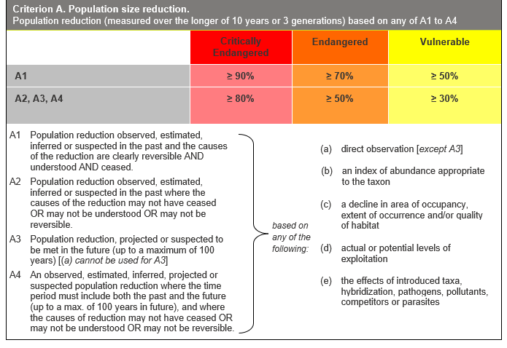

## Evidence:

**Eligible under Criterion A3 as Endangered**

The population reduction over the next 60 to 100 years is suspected to be 50 to 75%, based on (c) above.

Habitat condition appears to be deteriorating, through increasingly dry conditions from declining rainfall and impact of heavy grazing pressure, and plant numbers appear to be declining. However, the taxon is likely to persist as long as both parent species persist.

**Eligible under Criterion A4 as Endangered**

The population reduction over any 60 to 120 year period, including both past and future (up to 100 years in the future), is suspected to be 50 to 75%, based on (c) above.

There is little indication of any previous decline and nothing is known of the taxon's previous distribution or abundance in Victoria. Habitat condition appears to be deteriorating, through increasingly dry conditions from declining rainfall and impact of heavy grazing pressure, and plant numbers appear to be declining.

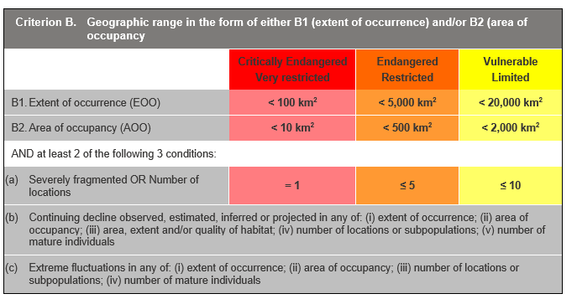

## Evidence:

**Eligible under Criterion B1 as Critically Endangered**

The Extent of Occurrence (EoO) across the taxon's range is estimated to be 4 km², based on accepted, post-1970 records from the Victorian Biodiversity Atlas (VBA). The EoO has been made equal to the Area of Occupancy (AoO to ensure consistency with the definition of the AoO as an area within EoO.

The taxon is estimated to have one location, as it is known from a single population, and the identified threats can rapidly affect all individuals of the taxon present.

It has a continuing decline in (i), (ii), (iii), (iv) and (v) above as a result of increasingly dry conditions from declining rainfall and the impact of heavy grazing pressure.

**Eligible under Criterion B2 as Critically Endangered**

The AoO across the taxon's range is estimated to be 4 km², based on 2 x 2 km grids derived from accepted, post-1970 records in the VBA. As above, the taxon has 1 location and has a continuing decline in (i), (ii), (iii), (iv) and (v) above.

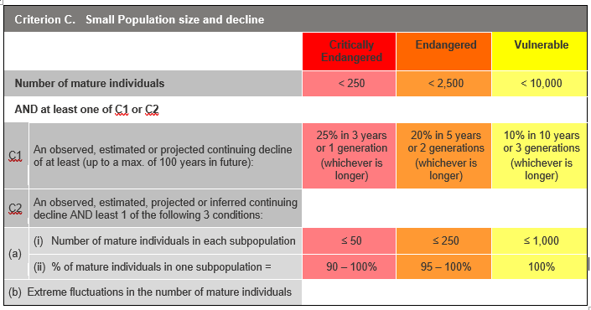

## Evidence:

**Eligible under Criterion C2 as Critically Endangered**

It is estimated that there are 80 to 100 mature individuals.

The number of mature individuals is inferred to continue to decline based on the current and projected impact of the identified threats, and the percentage of mature individuals in one subpopulation is 90-100%.

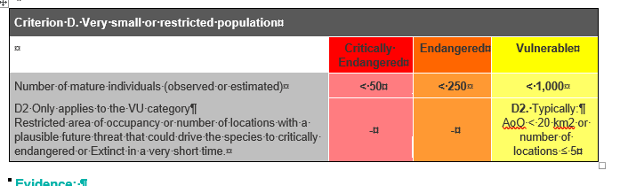

## Evidence:

**Eligible under Criterion D as Endangered**

It is estimated that there are 80 to 100 mature individuals.

### Criterion E (Quantitative Analysis) was not addressed as the taxon does not have a detailed Population Viability Analysis.

## References

DEPI (2014). *Advisory list of rare or threatened plants in Victoria - 2014.* Department of Environment and Primary Industries, Melbourne. Retrieved from: https://www.environment.vic.gov.au/__data/assets/pdf_file/0021/50448/Advisory-List-of-Rare-or-Threatened-Plants-in-Victoria-2014.pdf

DSE (2009). Action Statement - *Pterostylis aenigma* Enigmatic Greenhood(No. 246). Department of Sustainability and Environment, East Melbourne. Retrieved from: https://www.environment.vic.gov.au/__data/assets/pdf_file/0008/33002/Enigmatic_Greenhood_Pterostylis_aenigma.pdf

Duncan, M. (2008). *National Recovery Plan for Enigmatic Greenhood* *Pterostylis aenigma*. Melbourne: Department of Sustainability and Environment. Retrieved from: https://www.environment.gov.au/system/files/resources/cf12ca26-84d4-4703-8642-3ea4e5de13ee/files/pterostylis-aenigma.pdf

SAC (2000). Flora and Fauna Guarantee Scientific Advisory Committee: Final Recommendation on a Nomination for Listing. Nomination No. 475 *Pterostylis aenigma.*

VicFlora (2015). Flora of Victoria, Royal Botanic Gardens Victoria: *Pterostylis* X *aenigma*. Retrieved from: https://vicflora.rbg.vic.gov.au/flora/taxon/d025fc46-cad0-4542-b327-73d822f88a42