|  |
| --- |
| Threatened Species Assessment |
| *Galaxiella toourtkoourt*  Little Galaxias |

## Taxonomy

*Galaxiella toourtkoourt* Coleman & Raadik, 2015

A review of the Dwarf Galaxias (*Galaxiella pusilla*) in 2015 resulted in the description of two distinct species across what was previously considered one species. The revised distribution of *G.pusilla* s.s. has reduced its range by approximately 60% (Coleman et al. 2015). *G. pusilla* is now only known from the Mitchell River Basin near Bairnsdale, west to Dandenong Creek near Melbourne in Victoria, Flinders Island in Bass Strait and north-eastern and north-western Tasmania.

## Current conservation status

Listed as threatened under the *Flora and Fauna Guarantee Act 1988* as *G. pusilla* (SAC 1991).

Categorised as Vulnerable in the 2013 Advisory list of threatened vertebrate fauna in Victoria (DSE 2013).

## Proposed conservation status

Endangered in Victoria

Criteria A3bce+4bce; B2ab(i,iii,iv,v)

## Species Information

### Description and Life History

The taxon is a very small, scaleless and elongated native freshwater fish. Similar to other Galaxiids, the Dwarf Galaxias has a single dorsal fin situated well back commencing behind anal fin, distinguishing features include rounded caudal fin with fleshy flanges extending from the tail which almost join with the anal and dorsal fins. There are three black longitudinal stripes on each side of the body. In the spawning season males have a bright orange stripe between the middle and lower black stripes and females have a silvery-white stripe between the middle and lower dark stripes. Males range from 29-34mm whereas females range between 39-48mm.

The entire life cycle of the Little Galaxias is completed in freshwater. The spawning period is possibly during late autumn to spring, but may be variable (Beck 1985, Romanowski 2004) and where present, it can occur in high densities, although there may be substantial seasonal and inter-annual variability in population abundances (Romanowski 2004, Coleman et al. 2017). The female lays (singly) between 65-250 eggs. Spawning extends over several days with approximately 10 eggs laid per day. The female attaches the eggs usually to the underside of vegetation or hard surfaces like a leaf or stone. After the female has laid the eggs two or three males fertilise them and then search for more ripe females. The larvae take between two-three weeks to hatch and are approximately 2 -4 mm in length. Adults are thought to die after spawning.

Although many of the floodplain habitats and small streams where this taxon is present undergo large seasonal and inter-annual fluctuation in water levels (e.g. droughts and severe floods) that can dramatically alter available habitat (Coleman 2014), large fluctuations in population densities associated with dynamic wetting and drying regimes, along with dispersal in floods, short lifespan and semelparity suggest a continual process of local extinction and recolonisation and a metapopulation structure (Coleman et al. 2017).

It has developed adaptations to surviving extended seasonal periods of habitat drying, aided via a capacity for air-breathing and the use of moisture retaining habitat features such as vegetation cover and crayfish burrows (Beck 1985, Romanowski 2004, Coleman et al. 2017). It is likely to exist within a metapopulation structure or a 'population of subpopulations', where persistence of the population as a whole is facilitated by multiple interconnected subpopulations. Wetting and drying cycles are also likely to be important for enhancing food resources and reducing competition and predation pressures (Romanowski 2004, Coleman et al. 2017).

### Generation Length

The generation length of the Little Galaxias is inferred to be 1 year. This is based on the closely related *Galaxiella pusilla.*

### Distribution

This recently-described Australian endemic species is known from freshwater systems in coastal south-eastern mainland Australia, from the upper Barwon River system near Barwon Downs, Victoria, west to the Cortina Lakes, upper south-east South Australia (Coleman et al. 2015).

### Habitat

As detailed in Coleman et al. (2015), this is a freshwater taxon (occasionally found in inland slightly saline waters) that is generally found in swamps, wetlands, shallow lakes, billabongs, small creeks and artificial earthen drains at low elevation (mean 100 m asl, typically 22-176 m asl). Habitats are mostly shallow (mean maximum depth 1.1 m, typically 0.5-2.0 m), with still to low water velocities (or often backwaters in faster flowing conditions) and partial shading. The substrate tends to be dominated by fine clay and silt and occasionally coarser (particularly sand) with deposits of coarse particulate organic matter. Frequently captured where the vegetation cover is dense and consists primarily of emergent and submerged (mean 17 %, typically 0-23 % cover) aquatic species. Measurements of water quality at the time of collection suggest that the taxon can withstand a broad range of conditions, being recorded at water temperatures of 5.2-26.9 degrees C, dissolved oxygen levels of 20-263 % saturation, pH of 5.3-9.3, and turbidity of 1-96 NTU.

### Threats

The extent and quality of habitat for this taxon is expected to have been substantially reduced by widespread human activities across its range, such as wetland drainage, water extraction, construction of dams, levees, artificial channels, underground pipes, pollution, channel incision and widening (Saddlier et al. 2010, Coleman 2014, Coleman et al. 2017). Conversely, too much hydrologic connectivity that permanently inundates habitats (such as from altered water drainage paths) may increase the rate and extent of predator and competitor dispersal and reduce productivity of habitats (Coleman 2014, Coleman et al. 2017). It is also likely that a warmer and drier future climate predicted for south-eastern Australia over the next few decades (CSIRO 2007), will reduce the extent and quality of habitat.

Habitat loss and fragmentation, drought, climate change and negative interactions with invasive fishes (particularly the Eastern Gambusia, *Gambusia holbrooki*), are considered major threats to the long-term survival of this taxon (Koster 2003, Saddlier et al. 2010, Coleman et al. 2015, Coleman et al. 2017). The broad presence of Eastern Gambusia is also expected to have reduced the extent of occurrence and area of occupancy of the taxon.

The Little Galaxias is thought to be an annual taxon, where adults die after spawning. Therefore it is vital to have successful recruitment each year, or severe declines in populations will occur, potentially leading to the extinction in certain areas.

## IUCN Criteria

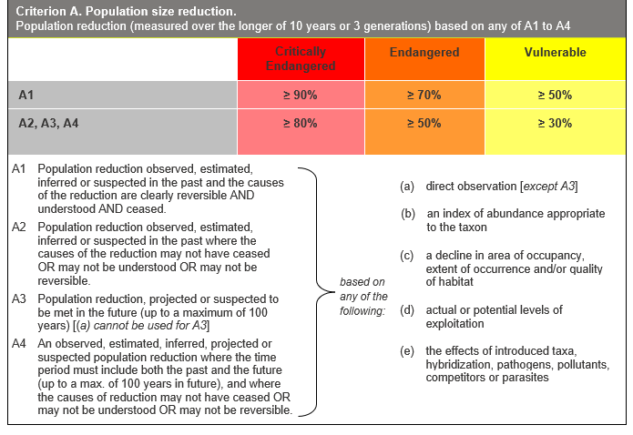

## Evidence:

**Eligible under Criterion A3 as Endangered**

The population reduction over the next 10 years is projected to be 30 to 50%, based on (b), (c) and (e) above.

This based on continuing impacts from climate change (drought, increased fire and sedimentation post-fire, and degradation and loss of habitat through agricultural development.

**Eligible under Criterion A4 as Endangered**

The population reduction over any 10 year period, including both past and future (up to 100 years in the future), is inferred to be 15 to 50%, based on (b), (c) and (e) above. The causes of reduction may not have ceased, be understood or be reversible.

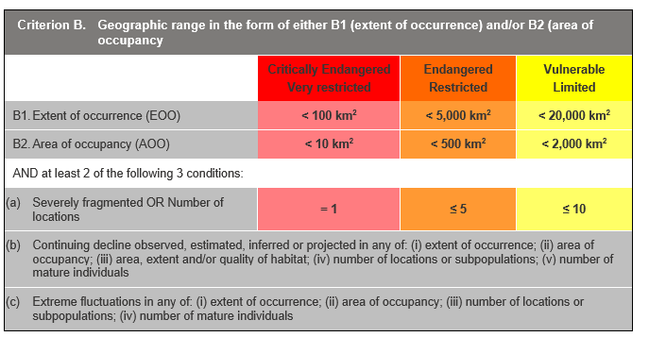

## Evidence:

**Eligible under Criterion B2 as Endangered**

The Area of Occupancy (AoO) across the taxon's range is estimated to be 436 km², based on 2 x 2 km grids derived from accepted, post-1970 records in the Victorian Biodiversity Atlas. Records are also based on historical survey records from 2008 onwards e.g. Coleman et al. (2013); Bachmann et al. (2014).

It is projected to have 2 locations. It has a continuing decline in (i), (iii), (iv) and (v) above.

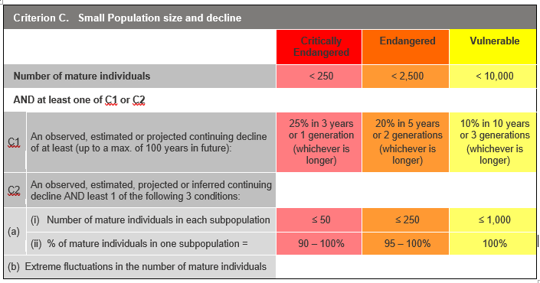

## Evidence:

**Ineligible under Criterion C as Data Deficient**

There is insufficient evidence to determine the number of mature individuals.

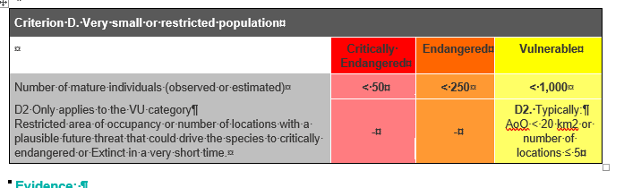

## Evidence:

**Ineligible under Criterion D**

There is insufficient evidence to determine the number of mature individuals.

### Criterion E (Quantitative Analysis) was not addressed as the taxon does not have a detailed Population Viability Analysis.

## References

Bachmann, M., Whiterod, N., Anderson, D and Veale, L. (2014). Regional status update of the dwarf galaxias (*Galaxiella pusilla*) in the South East of South Australia: Spring 2012-14. A report funded by the Nature Foundation SA Inc.Aquasave. Nature Glenelg Trust, Mount Gambier, South Australia.

Beck, R.G. (1985). Field Observations of the Dwarf Galaxias *Galaxiella pusilla* (Mack) (Pisces: Galaxiidae) in the south-east of South Australia, Australia. *South Australian Naturalist* 60: 12-22.

Coleman, R. (2014). Conservation of the dwarf galaxias, *Galaxiella pusilla* (Mack 1936) (Teleostei: Galaxiidae), a threatened freshwater fish from south-eastern Australia. Department of Zoology, The University of Melbourne

Coleman, R.A., Pettigrove, V., Raadik, T.A., Hoffmann, A.A., Miller, A.D., Carew, M.E. (2010). Microsatellite markers and mtDNA indicate two distinct groups in dwarf galaxias, *Galaxiella pusilla* (Mack) (Pisces: Galaxiidae), a threatened freshwater fish from south-eastern Australia. *Conservation Genetics* 11: 1911-1928.

Coleman, R.A., Weeks, A.R., Hoffmann, A.A. (2013). Balancing genetic uniqueness and genetic variation in determining conservation and translocation strategies: a comprehensive case study of threatened dwarf galaxias, *Galaxiella pusilla* (Mack) (Pisces: Galaxiidae). *Molecular Ecology* 22: 1820-1835.

Coleman, R.A., Hoffman, A.A. and Raadik, T.A. (2015). A review of *Galaxiella pusilla* (Mack) (Teleostei: Galaxiidae) in south-eastern Australia with a description of a new species . *Zootaxa* 4021(2): 243-281.

Coleman R.A., Raadik T.A., Pettigrove V., Hoffmann A.A. (2017). Taking advantage of adaptations when managing threatened species within variable environments: the case of the dwarf galaxias *Galaxiella pusilla* (Teleostei, Galaxiidae). *Marine and Freshwater Research* 68: 175-186.

CSIRO (2007) *Climate change in Australia.* Technical report by the Commonwealth Scientific and Industrial Research Organisation (CSIRO) and the Australian Bureau of Meteorology. CSIRO Atmospheric Research, Melbourne, Australia.

DSE (2013) *Advisory List of Threatened Vertebrate Fauna in Victoria*. Victorian Government Department of Sustainability and Environment Melbourne, Melbourne

Hammer, M. (2002). *The South East fish inventory: distribution and conservation of freshwater fishes of south east South Australia*. Native Fish Australia (SA) Inc., Adelaide.

Koster, W. (2003). Threatened species of the world: *Galaxiella pusilla (*Mack 1936) (Galaxiidae). *Environmental Biology of Fishes* 68: 268.

Romanowski N. (2004). Notes on dwarf galaxias *Galaxiella pusilla. Fishes of Sahul* 18: 80-86.

Saddlier, S., Jackson, J. and Hammer, M. (2010). *National Recovery Plan for the Dwarf Galaxias Galaxiella pusilla*. Department of Sustainability and Environment, Melbourne.

SAC (1991). Flora and Fauna Guarantee Scientific Advisory Committee: Final Recommendation on a Nomination for Listing. Nomination No. 141 *Galaxiella pusilla*

Unmack, P., Bagley, J.C., Adams, M., Hammer, M.P. and Johnson, J.B. (2012). Molecular phylogeny and phylogeography of the Australian freshwater fish genus Galaxiella, with an emphasis on Dwarf Galaxias (*G. pusilla*). *PLoS ONE* 7(6): e38433. doi:10.1371/journal.pone.0038433