|  |
| --- |
| Threatened Species Assessment |
| *Astelia australiana*  Tall Astelia |

## Taxonomy

*Astelia australiana* (J.H. Willis) L.B. Moore

## Current conservation status

Listed as Vulnerable under the *Environment Protection and Biodiversity Conservation Act 1999*.

Listed as threatened under the *Flora and Fauna Guarantee Act 1988*. (SAC 1991)

Categorised as Vulnerable in the 2014 Advisory list of rare or threatened flora (DEPI 2014).

## Proposed conservation status

Endangered in Australia

Criteria A2ace+3ce+4ace; B1ab(i,ii,iii,iv,v)+2ab (i,ii,iii,iv,v)

## Species Information

### Description and Life History

The taxon is a robust, tufted plants to c. 1.8 m high, with a long, stout, branching rhizome. Leaves linear, 60-230 cm long, 5-10 cm wide, with a close, silvery and silky indumentum on the lower surface. Inflorescence a racemose panicle to 1.2 m high, many-flowered; axis rather stout; each of the 5-10 racemes 10-20 cm long, each subtended by a leaf-like bract. Flowers 12-18 mm wide, green to deep maroon, at least the males with a strong foetid odour; segments fused basally, reflexed at tips. Male or bisexual flowers with stamens shorter than the perianth. Female flowers with rudimentary stamens, sometimes producing fruit without fertilization; perianth tube fleshy, ovary c. 4-6 mm long, 3-locular. Berry ovoid to globular, 6-10 mm long, orange. Seeds 4-12, c. 2.5 mm long. The taxon flowers from Nov.-Feb. (VicFlora 2018).

Most reproduction is by rhizomes, but isolated plants upslope of the larger colonies in the drainage lines suggest that the taxon is not obligately restricted to swampy drainage lines. Flowering is rare and seed set is very rare, and has not been recorded in the Otways population. The genetic distinctions between relatively geographically close populations in the Beenak-Upper Yarra area also suggest that sexual reproduction is rare but not unknown. Vegetative growth is perennial and long-lasting.

### Generation Length

The generation length of *Astelia australiana* is estimated to be 15 to 80 (midpoint 30) years. The taxon is strongly rhizomatous and sexual reproduction is rare, sporadic and unpredictable. Since European settlement, the Otways population has never been observed to set seed.

### Distribution

The taxon is a Victorian endemic, restricted to the Beenak-Upper Yarra region in south-central Victoria and a discrete single population in the Otways Ranges in south-western Victoria. It is known from 4 catchments: La Trobe, Bunyip and Yarra Rivers in the Central Highlands, and Aire River in the Otways.

### Habitat

Nearly all populations are within or surrounded by Cool Temperate Rainforest (*Nothofagus-Atherosperma-Acacia melanoxylon* dominant) and often in swampy drainage lines, but they occasionally occur as isolated plants on protected valley slopes. The sites are always cool, permanently moist and sheltered by tall trees from strong, desiccating winds and fires, in landscapes with high mean annual rainfall, which may fall at any time throughout the year. Soils are loamy, gradational, well-structured and relatively fertile, although they are swampy for much of the year.

### Threats

The taxon is threatened by inappropriate fire regimes, climate change, Sambar Deer (*Rusa unicolor*), disease (Myrtle Wilt, Pythium), weed establishment and mechanical disturbance during road management, bushfire suppression and forestry operations (Cutler & Murphy 2010, DSE (2003).. Bushfires have burnt stands in the past and are the cited explanation for local extinctions. The most recent catastrophic fires were the Black Saturday fires of 2009. Currently, fuel management operations are not usually applied in these wet forests, but isolated upslope plants are affected by occasional fuel management operations. However, in the future, fuel management operations may become more intensive. Regrowth forests in the catchments of affected drainage lines also desiccate these same drainage lines as they evaporate more water than do mature forests.

Sambar deer are common and numbers are increasing in these areas, causing visible damage. Many Tall Astelia sites are in swampy drainage lines - the preferred wallow sites for Sambar deer. In addition, Sambar deer browse the foliage and trample these boggy soils.

Altered hydrology is a substantial threat in catchments dominated by regrowth forests. Regrowing forests absorb and evaporate to the atmosphere at much higher quantities of soil water than mature forests, leaving less water to maintain the swampy conditions of the drainage lines that Tall Astelia favours (Vertessy et al. 2001).

Myrtle Wilt may threaten some Tall Astelia populations by killing the sheltering *Nothofagus* trees, thus opening the sites to fires and desiccation. There is a suspicion that Pythium may be the explanation for a lack of recruitment in many stands.

Spatial analysis of likely habitat for Tall Astelia on all land tenures indicates that 52% occurs within the CAR reserve system, including parks and reserves, special protection zones and areas excluded from harvesting by prescription under the Victorian Code of Practice for Timber Production 2014 (the Code). Species-specific protections for Tall Astelia are included in the Code. Other more general prescriptions such as protection and buffering of rainforest and waterways also provide protection from timber harvesting.

In recent years, modified harvesting and forest regeneration practices have been implemented in native forest to further mitigate the potential threat from forestry operations to threatened species and their habitats.

## IUCN Criteria

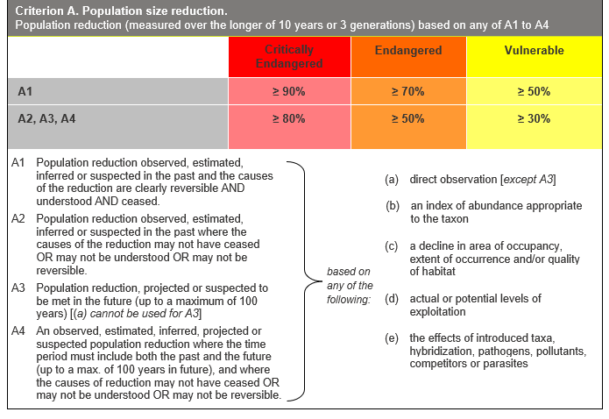

## Evidence:

**Eligible under Criterion A2 as Endangered**

The population reduction over the past 45 to 240 years is estimated to be in the range of 50 to 75%, based on (a), (c) and (e) above.

Past decline is based on former records and previous management practices.

The causes of the reduction may not have ceased, be understood or be reversible.

**Eligible under Criterion A3 as Endangered**

The population reduction over the next 45 to 100 years is projected to be in the range of 50 to 75%, based on (c) and (e) above.

Future decline is based on the likely impacts of climate change, particularly drought and bushfires. There may be additional impacts from forestry operations in some areas in the short-term.

**Eligible under Criterion A4 as Endangered**

The population reduction over any 45 to 240 year period, including both past and future (up to 100 years in the future), is inferred to be in the range of 50 to 75%, based on (a), (c) and (e) above. The causes of reduction may not have ceased, be understood or be reversible.

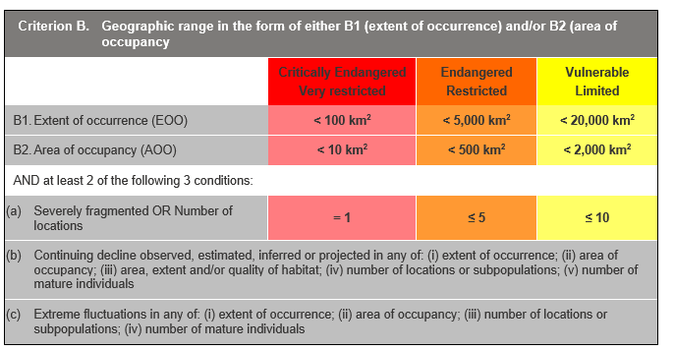

## Evidence:

**Eligible under Criterion B1 and B2 as Endangered**

The Extent of Occurrence (EoO) is estimated to be 1,587 km², based on accepted, post-1970 records in the Victorian Biodiversity Atlas (VBA).

The Area of Occupancy (AoO) is estimated to be 76 km², based on 2 x 2 km grids derived from accepted, post-1970 records in the VBA.

The taxon is estimated to be severely fragmented. There are multiple, small isolated subpopulations that are all at risk from the identified threats, such that there is increased extinction risk and little or no probability of recolonisation should subpopulations become extinct.

The taxon is considered to occur in one location as all key identified threats apply across its range and can rapidly affect all individuals of the taxon present.

It has a continuing decline in (i), (ii), (iii), (iv) and (v) above, based on hydrology changes and fires.

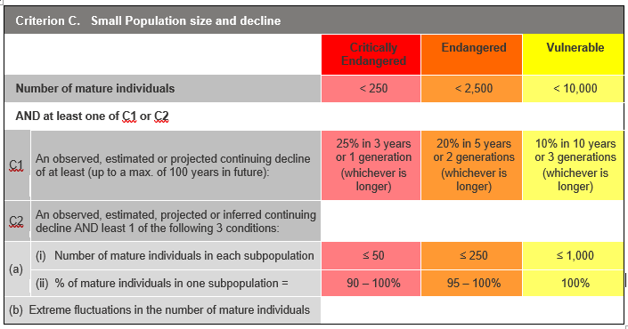

## Evidence:

**Ineligible under Criterion C**

It is suspected that there are 100 to 10,000 (midpoint 2,000) mature individuals, but this qualifier is too weak and other thresholds under this criterion have not been met.

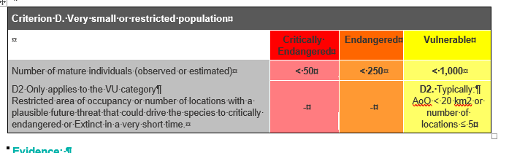

## Evidence:

**Eligible under criterion D2 as Vulnerable**

The taxon is estimated to be very restricted.

### Criterion E (Quantitative Analysis) was not addressed as the taxon does not have a detailed Population Viability Analysis.

## References

Cutler, S., & Murphy, A. H. (2010). *National Recovery Plan for the Tall Astelia* *Astelia australiana.* Department of Sustainability and Environment, Melbourne.

DEPI (2014). *Advisory list of rare or threatened plants in Victoria - 2014*. Department of Environment and Primary Industries, Melbourne. Retrieved from: https://www.environment.vic.gov.au/__data/assets/pdf_file/0021/50448/Advisory-List-of-Rare-or-Threatened-Plants-in-Victoria-2014.pdf

DSE (2003) Flora and Fauna Guarantee Action Statement no. 7 – Tall Astelia *Astelia australiana* Department of Sustainability and Environment. https://www.environment.vic.gov.au/__data/assets/pdf_file/0027/32688/Tall_Astelia_Astelia_australiana.pdf

SAC (1991). Flora and Fauna Guarantee Scientific Advisory Committee: Final Recommendation on a Nomination for Listing. Nomination No. 8 *Astelia australiana.*

Vertessy, R.A., Watson, F.R.G., and O’Sullivan, S.K. (2001) Factors determining relations between stand age and catchment water balance in mountain ash forests. *Forest Ecology and Management* **143** pp13-26

VicFlora (2018). Flora of Victoria, Royal Botanic Gardens Victoria: *Astelia australiana*. Retrieved from: https://vicflora.rbg.vic.gov.au/flora/taxon/11110b23-8273-4b14-88d5-b8da9f417ebd