|  |
| --- |
| Threatened Species Assessment |
| *Hydrilla verticillata*  Hydrilla |

## Taxonomy

*Hydrilla verticillata* (L. f.) Royle

## Current conservation status

Categorised as Rare in the 2014 Advisory list of rare or threatened flora (DEPI 2014).

## Proposed conservation status

Critically Endangered in Victoria

Criteria A2c+4c; B1b(i,ii,iii,iv,v)c(i,ii,iii,iv)+2b(i,ii,iii,iv,v)c(i,ii,iii,iv)

## Species Information

### Description and Life History

The taxon is a submerged freshwater, dioecious herb, attached to substrate. Leaves (3-)4-6(-8) per whorl, mostly well-spaced along the branch, sessile, 0.6-4 cm long, narrowly elliptic or narrowly ovate to linear, glabrous, green, often with red-brown markings, 1-veined; margin coarsely toothed with fine translucent teeth; apex obtuse to rounded with midvein extended into a fine tooth. Flowers basally subtended by united floral bracts, solitary or rarely in pairs; perianth of 2 whorls of 3 segments each, translucent. Male flower ± sessile, released as a globular, mature unopened bud and opening as a free-floating flower on the water surface; stamens 3. Female flower with long, slender hypanthium 1.5-10 cm long; staminodes absent; ovary enclosed in base of hypanthium, unilocular; style as long as hypanthium; stigmas 3, thread-like and entire. Seeds 2-3 mm long.

The flowers are air-pollinated. The hypanthium of the female flower elongates such that the flower reaches the water surface and the floating male flowers release the pollen explosively. Male flowers are recorded in May (VicFlora 2021).

The taxon is widespread in USA and Canada where it is represented only by female plants, and is inferred to not produce viable seed. Reproduction and dispersal in North America seems to be via stem tubers (turions) which can drop off the plant and successfully survive freezing and drought. Rhizome tubers may also be present and contribute to vegetative reproduction. Turions are condensed shoots 5-8 mm long whilst rhizome tubers are 5-10 mm long. Turions are spiny in appearance, increasing their ability to attach to biotic vectors. Such propagules increase the potential for dispersal by waterbirds since they are likely to be carried externally in mud or attached to plumage (www.wiki.bugwood.org\\Hydrilla_verticillata 2023).

### Generation Length

The generation length of *Hydrilla verticillata* is estimated to be 5 to 50 (likely 15) years. It is a perennial in deep permanent waters and is anchored to the substrate, although it may become detached and float downstream or in response to wind and wave pressure. Given that it is known to produce vegetative propagules (stem and rhizome tubers) (www.wiki.bugwood.org\\Hydrilla_verticillata 2023), it is inferred to be potentially very long-lived. However, like similar species such as the exotic *Elodea canadensis* and *Egeria densa*, it is likely to grow rapidly under suitable conditions such as high nutrient levels, and may be capable of more rapid generational turnover.

### Distribution

The taxon occurs in all mainland states. It is recorded from scattered localities along the Murray River between Yarrawonga and Mildura, and possibly occurring further downstream (VicFlora 2021).

The taxon was collected in 1890 at Swan Hill on the Murray River, and in 1896 at the junction of the Ovens and Murray Rivers. It is presumed extinct at these two sites. It was also collected in 1965 in Sunday Creek (the eastern inlet to Lake Moodemere); in 1968 in the Murray River upstream from the Red Cliffs pumps near Mildura; and in 1970 at the confluence of the Darling and Murray Rivers. Persistence of the taxon at these three sites in the absence of further records in the intervening 53-58 years is unlikely, since these sites have been well surveyed in recent decades. However, vegetative propagules are reported to persist in the soil-stored propagule bank and the survival of these occurrences cannot be ruled out.

In 1990 it was recorded in a quadrat taken at Dowdle Swamp 10 km south of Yarrawonga, and in 1992 was recorded on the Midland Highway 3 km south-east of Cooma and 28 km west of Shepparton in the Shepparton Irrigation District. Whilst the taxon is more likely to persist at Dowdle Swamp, which is a natural wetland in a Wildlife Reserve, its persistence on the Midland Highway near Cooma in an intensely managed irrigation district is less certain. The taxon is likely to behave as a transient species capable of colonising transient anthropogenic habitats through vegetative propagule dispersal by waterbirds from stable natural wetland habitats.

An undated collection by an unknown collector from Five Mile Beach, purportedly from Wilsons Promontory, is considered unreliable and may originate from an interstate coastal site of the same name.

### Habitat

The taxon occurs in still to slow-flowing freshwater of lakes and streams, to a depth of at least 3.5 metres (VicFlora 2021). It has a demonstrated capacity to colonise anthropogenic habitats, as illustrated by the record on the Midland Highway near Shepparton and its widespread naturalisation in North America (www.wiki.bugwood.org\\Hydrilla_verticillata 2023).

### Threats

The taxon may have suffered drastic historic decline, and in the absence of recent records, may now be locally extinct in Victoria at all five sites where it has been collected along the Murray River between 1890 and 1970 although a 2006 collection from the Murray River adjacent to Chowilla downstream of the Victorian border in South Australia indicates that the taxon persists in the Murray River system and may recolonise these or similar sites along the Murray River by dispersal of seed or vegetative propagules by waterbirds. Plausible current and future threats may include changes to water bodies, saline discharges from irrigation (especially lower down the Murray River), floodwater diversion for other purposes and disconnection to the river system leading to lower water depths. Perhaps the greatest threat to the taxon is the wide range of stochastic events resulting from climatic drying and warming and agricultural and other anthropogenic activities across the rural landscapes of the Murray Valley.

## IUCN Criteria

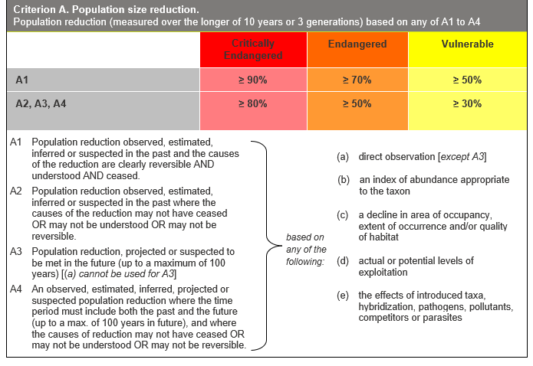

## Evidence:

**Eligible under Criterion A2 as Critically Endangered**

The population reduction over the past 15 to 150 years is inferred to be 50 to 100%, based on (c) above.

The taxon is likely to have suffered drastic historic decline in response to stochastic events and other plausible localised threats. The lower bound reflects the likelihood that the taxon has become locally extinct at the Midland Highway site west of Shepparton in the last 30 years, surviving in Victoria only at Dowdle Swamp. The upper bound reflects the possibility that the taxon has become locally extinct at all Victorian sites in the last 133 years since it was first collected in the state in 1890.

The causes of the reduction may not have ceased, be understood or be reversible.

**Eligible under Criterion A4 as Critically Endangered**

The population reduction over any 15 to 150 year period, including both past and future (up to 100 years in the future), is inferred to be 50 to 100%, based on (c) above.

The taxon is likely to have suffered drastic historic decline in response to stochastic events and other plausible localised threats. If it still persists in the state, the magnitude of future decline cannot be estimated with any confidence since the identified threats operate incrementally or stochastically and with unpredictable intensity.



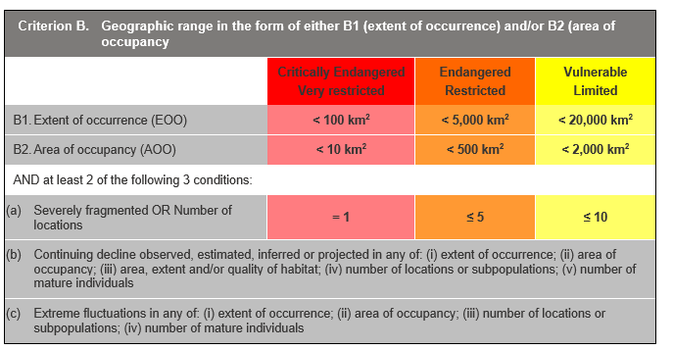

## Evidence:

**Eligible under Criterion B1 as Critically Endangered**

The Extent of Occurrence (EoO) across the taxon's range is estimated to be 4 or 8 km² (or up to 8,635 km² if historic records are still extant), based on accepted, post-1970 records from the Victorian Biodiversity Atlas (VBA). The two lower bound estimates of the EoO have been made equal to the Area of Occupancy (AoO) to ensure consistency with the definition of the AoO as an area within the EoO. The upper bound estimate encompasses all five Victorian sites where the taxon has been collected or recorded between 1965 and 1992, excluding territory within New South Wales.

The taxon is estimated to have one, two or three locations. A single location is identified if the plant survives only at Dowdle Swamp, which is a natural wetland unconnected to the Murray River and its tributaries and anabranches. A second location can be identified if it also survives at the Midland Highway site in the Cooma district in the Shepparton Irrigation District, which is subject to a wide range of anthropogenic disturbance regimes. A third location can be identified if it survives at any sites directly connected to the Murray River and its tributaries and anabranches which are likely to experience the most reliable flood regimes and hydrological stability.

It has a continuing decline in (i), (ii), (iii), (iv) and (v), based on the current and projected impact of the identified threats, and therefore the high risk of local extinction of one or more occurrences (if others survive).

It has extreme fluctuations in (i), (ii), (iii) and (iv) above. It appears to behave as a somewhat transient occupant of suitable wetland habitats, either persisting as a soil or mud-stored seedbank or vegetative propagule bank, or else becoming locally extinct as wetland conditions become unfavourable, and recolonising wetland sites as they become favourable through dispersal of seed or vegetative propagules by waterbirds or floodwaters. Population size at any one site or across the region is thus likely to fluctuate significantly in response to seasonal conditions. The scant collection and site record history provides circumstantial evidence that the taxon may have experienced a peak of site occupancy in the 1890s, in the 1960s and again in the 1990s.

**Eligible under Criterion B2 as Critically Endangered**

The AoO across the taxon's range is estimated to be 4 or 8 km² (or up to 20 km² if historic records are still extant) based on 2 x 2 km grids derived from accepted, post-1970 records in the VBA. As above, it has one to three locations, has a continuing decline in (i), (ii), (iii), (iv) and (v), and extreme fluctuations in (i), (ii), (iii) and (iv) above.

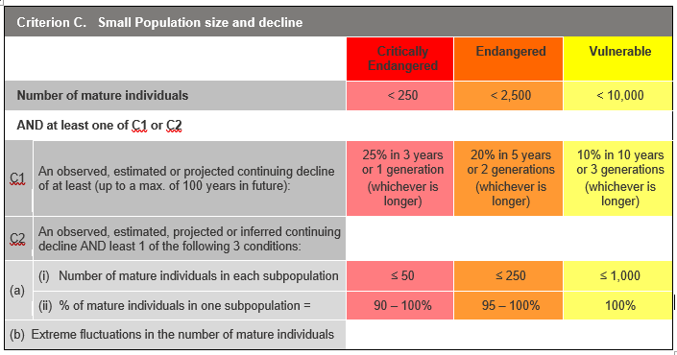

## Evidence:

**Ineligible under Criterion C**

There is insufficient evidence to determine the number of mature individuals.

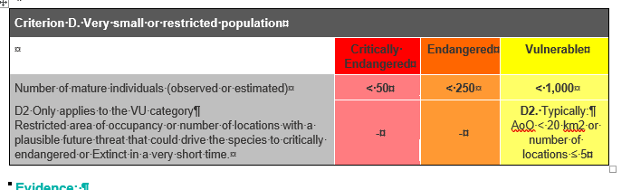

## Evidence:

**Eligible under criterion D2 as Vulnerable**

The taxon has a restricted distribution, with an estimated AoO of 4-20 km2 and an estimated 1-3 locations, such that this restriction makes the taxon capable of becoming extinct within the timespan of one or two generations, in response to the impact of the identified threats.

### Criterion E (Quantitative Analysis) was not addressed as the taxon does not have a detailed Population Viability Analysis.

## References

DEPI (2014). *Advisory list of rare or threatened plants in Victoria - 2014*. Department of Environment and Primary Industries, Melbourne.

VicFlora (2021). Flora of Victoria, Royal Botanic Gardens Victoria: *Hydrilla verticillata*. Retrieved from: https://vicflora.rbg.vic.gov.au/flora/taxon/dc7645a3-9ea0-4e19-896f-844bfd98f99b

www.wiki.bugwood.org\\Hydrilla_verticillata accessed 07/06/2023