|  |
| --- |
| Threatened Species Assessment |
| *Caladenia insularis*  French Island Spider-orchid |

## Taxonomy

*Caladenia insularis* G.W. Carr

The taxon is also referred to as *Arachnorchis insularis*. It is very similar to *C. reticulata* which occurs in Western Victoria. *C. insularis* is in need of further taxonomic research to determine its relationship to other taxa in the *C. reticulata* complex (Backhouse et al. 2016).

## Current conservation status

Listed as Vulnerable under the *Environment Protection and Biodiversity Conservation Act 1999*.

Listed as threatened under the *Flora and Fauna Guarantee Act 1988* (SAC 1999).

Categorised as Vulnerable in the 2014 Advisory list of rare or threatened flora (DEPI 2014).

## Proposed conservation status

Endangered in Australia

Criteria A2bce+4bce; D

## Species Information

### Description and Life History

The taxon is a flowering plant (20-)30-40 cm tall. Leaf 5-10 cm long, 7-10 mm wide. Flowers solitary (rarely 2); perianth segments 2.5-6 cm long, cream, pink or pale yellow, heavily streaked and suffused with red; sepals with slender reddish clubs 10-25 mm long; dorsal sepal 3-6 cm long, 3-4 mm wide, incurved; lateral sepals 3-6 mm long, 4-5 mm wide, divergent, deflexed; petals 2.5-4.5 cm long, 3-4 mm wide, spreading to deflexed, flattened at base, tapered to a long acuminate apex, sometimes with short thickened clubs. Labellum curved forward with apex recurved and lateral lobes erect, lamina ovate, obscurely 3-lobed, 10-13 mm long and 7-9 mm wide (when flattened), red at least distally, proximal half often paler red or yellowish-cream, with red veins; marginal calli on lateral lobes to 1 mm long, diminishing in size towards the entire or slightly irregular mid-lobe; lamina calli in 4 or 6 rows, glossy, well-spaced, not extending onto mid-lobe, stout and flat-topped, to 1 mm long at base of lamina, decreasing in size towards apex. The taxon flowers from September to October (VicFlora 2018).

The taxon is a small terrestrial, deciduous herb that emerges annually from a spherical subterranean tuber. Plants have a summer dormancy period, with growth occurring during late autumn, winter, and spring. Plants reproduce solely from seed. Pollination is almost certainly via pseudocopulation, with the dense, apical clubs on the sepals emitting pheromones that attract male thynnid wasps, although the pollinator of *C. insularis* is not known. The response to fire is not known, however, flowering appears to be enhanced by summer bushfires or slashing of the surrounding vegetation (SAC 1999).

After summer bushfires, the taxon is often relatively tall with large flowers and are frequently double flowered. However, in the absence of summer fire, a few plants still flower in most years in open areas such as along tracks. These plants are invariably smaller and usually have just a single flower. Only very low numbers of flowering plants are seen in most years, none in some years. Larger numbers flower in the year or 2 following infrequent summer bushfires. The taxon is rare and poorly known and, despite being described in 1991, it has never had a formal detailed botanical description prepared (Backhouse et al. 2016).

### Generation Length

The generation length of *Caladenia insularis* is estimated to be 20 to 40 years (midpoint 30 years). Generation time for non-colonial terrestrial orchids is estimated to be a nominal 30 years based on the annual replacement of the mother tuber by daughter tubers. Whilst somatically immortal, individuals are susceptible to endogenous exhaustion or environmental causes of mortality at rates likely to result in replacement at intervals of several decades only. Such orchids are classed as obligate seed regenerators reliant on seed-based recruitment for population maintenance.

### Distribution

The taxon is endemic to Victoria, where it occurs only on French Island in Western Port in southern Victoria, in the South East Coastal Plain IBRA bioregion. Small groups of plants occur right across the National Park, which occupies most of the island. Despite being described in 1991, little is known of the previous distribution and abundance (Backhouse et al. 2016).

Although it seems to be rare, the taxon possibly occurs elsewhere as its dense heath and heathy woodland habitat still covers much of the island. However, as flowering is probably stimulated by fire or by mechanical removal of competing vegetation such as through mowing, flowering plants are not often seen (Duncan et al. 2009).

### Habitat

The taxon occurs on dense heath and heathy woodland dominated by Manna Gum (*Eucalyptus viminalis*), with a diverse understorey of heathy shrubs, on soils varying from well-drained light grey loamy sand to gravely red clay loam. Some sites are seasonally waterlogged and the altitude ranges from 15-75 metres above sea level (Backhouse et al. 2016; Duncan et al. 2009). The taxon is generally only seen in flower on slashed fire breaks or after fires in its dense heathy habitat (SAC 1999).

### Threats

There may have been some historic decline in distribution and abundance due to loss of habitat, as perhaps one third of the island has been cleared.

While most sites occur within the French Island National Park, a variety of current and potential threats face the taxon. These include weed invasion by *Phalari*s sp. (canary grass) at the French Island National Park site, and weed invasion, through colonisation of bare ground, at the French Island Quarry site. The taxon is threatened by grazing and trampling by feral goats, deer, and rabbits, and accidental damage and trampling by visiting orchid enthusiasts. The two subpopulations that occur along vehicle tracks are at risk of accidental damage from vehicle and machinery movement. There is a high risk of extinction from stochastic events due to small population size and the taxon is particularly prone to inappropriate fire regimes and habitat (Duncan et al. 2009; SAC 1999).

## IUCN Criteria

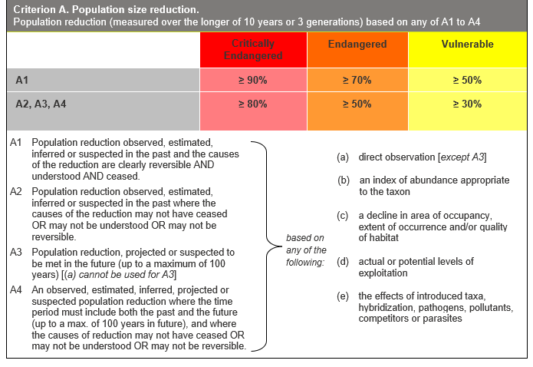

## Evidence:

**Eligible under Criterion A2 as Endangered**

The population reduction over the past 60 to 120 years is inferred to be 35 to 75%, based on (b), (c) and (e) above.

Past decline is based on a historic loss of habitat. Specifically, about 50% of French Island has been cleared of native vegetation which would have almost certainly resulted in the loss of plants.

The causes of the reduction may not have ceased, be understood or be reversible.

**Eligible under Criterion A4 as Endangered**

The population reduction over any 60 to 120 year period, including both past and future (up to 100 years in the future), is inferred to be 35 to 75%, based on (b), (c) and (e) above. The causes of reduction may not have ceased, be understood or be reversible.

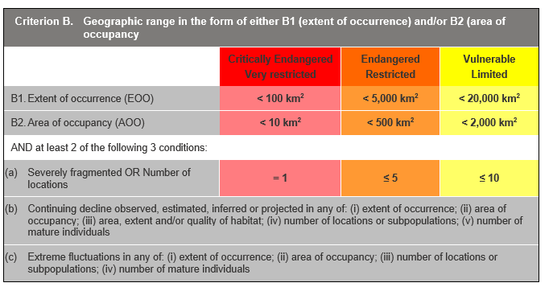

## Evidence:

**Ineligible under Criterion B**

The Extent of Occurrence (EoO) across the taxon's range is estimated to be 58 km² and the Area of Occupancy (AoO) is estimated to be 48 km², but other thresholds under this criterion have not been met.

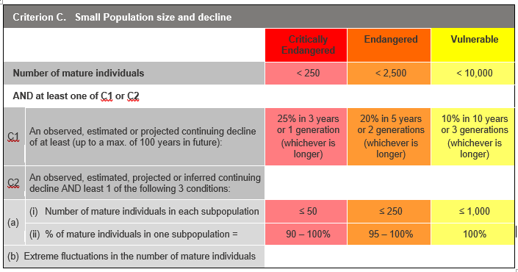

## Evidence:

**Ineligible under Criterion C**

It is estimated that there are 50 to 200 mature individuals, but other thresholds under this criterion have not been met.

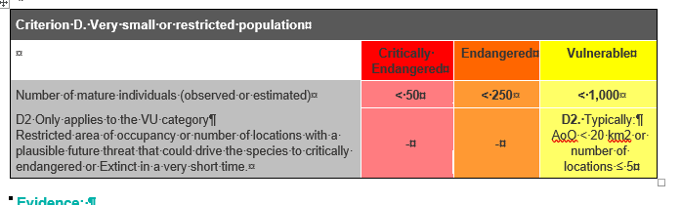

## Evidence:

**Eligible under Criterion D as Endangered**

The taxon is estimated to have 50 to 200 mature individuals. The taxon is known from one subpopulation, with fewer than 200 plants.

### Criterion E (Quantitative Analysis) was not addressed as the taxon does not have a detailed Population Viability Analysis.

## References

Backhouse, G., Kosky, B., Rouse, D., and Turner, J. (2016). *Bush Gems: A Guide to the Wild Orchids of Victoria, Australia.* Melbourne, Victoria: EBook.

DEPI (2014). *Advisory list of rare or threatened plants in Victoria - 2014.* Department of Environment and Primary Industries, Melbourne. Retrieved from: https://www.environment.vic.gov.au/__data/assets/pdf_file/0021/50448/Advisory-List-of-Rare-or-Threatened-Plants-in-Victoria-2014.pdf

Duncan, M., Pritchard, A., and Coates, F. (2009). *National Recovery Plan for Fifteen Threatened Orchids in South-eastern Australia.* Melbourne, Victoria: Department of Sustainability and Environment.

Entwisle, T.J. (1994). *Orchidaceae.* In N.G. Walsh and T.J. Entwisle (Eds.), *Flora of Victoria Vol. 2, Ferns and Allied Plants, Conifers and Monocotyledons.* Melbourne: Inkata Press.

SAC (1999). Flora and Fauna Guarantee Scientific Advisory Committee: Final Recommendation on a Nomination for Listing. Nomination No. 476 *Caladenia insularis.*

VicFlora (2018). Flora of Victoria, Royal Botanic Gardens Victoria: *Caladenia insularis*. Retrieved from: https://vicflora.rbg.vic.gov.au/flora/taxon/09af1149-6678-4f8a-bed0-5cfe8e0a1ee2