|  |
| --- |
| Threatened Species Assessment |
| *Euastacus crassus*  Alpine Spiny Crayfish |

## Taxonomy

*Euastacus crassus* Riek, 1951

The taxon is found on both sides of the Great Dividing Range in Victoria. The localities on the south side (in the headwaters of the Tambo and Snowy River catchments) may represent a different, as yet undescribed, taxon based on ongoing research (McCormack pers. comm).

## Current conservation status

Listed as threatened under the *Flora and Fauna Guarantee Act 1988* (SAC 2001).

Categorised as Endangered in the 2009 Advisory list of threatened invertebrate fauna in Victoria (DSE 2009).

## Proposed conservation status

Endangered in Victoria

Criterion B2ab(i,ii,iii,v)

## Species Information

### Description and Life History

The Alpine Spiny Crayfish is a moderate-sized species of spiny crayfish with a maximum recorded occipital carapace length of 61 mm (McCormack 2012). Typically, a nocturnal species, it wanders extensively during the night within the stream channel (McCormack 2012). Most species of *Euastacus* are moderate burrowers, seeking refuge under rock ledges and amongst submerged, in-stream tree roots (Zeidler 1982). The Alpine Spiny Crayfish is a significant burrower, building extensive burrow systems, usually from a stream at water level, but extending far back into the riparian zone and up to the forest floor. Whilst preferring permanent streams, some burrows are made in intermittent streams and crayfish persist in the burrows during dry spells by using the water in the base of the burrow (McCormack 2012).

The diet of spiny freshwater crayfish consists primarily of aquatic to semi-aquatic vegetation and benthic invertebrates (Goddard 1988). Fungi and bacteria found in rotting detrital matter is also consumed (DCE 1992): The Alpine Spiny Crayfish is a scavenger, eating vegetation/detritus, but occasionally meat (McCormack 2012). Sexual maturity is reached by females at 30-50 mm OCL and mating commences in July. Eggs are burgundy in colour and are carried under the tail of the female (McCormack, 2012). After hatching from eggs, the dependent juvenile crayfish are carried beneath the tail until their release during February to March (McCormack 2012). The yolk of the egg is retained by the young hatchlings as a yolk sac supplying food during early growth. Once the yolk sac has been completely absorbed, the juveniles disperse to fend for themselves.

### Generation Length

The generation length of the Alpine Spiny Crayfish is inferred to be 5 to 15 years. Several reproductive studies show *Euastacus* spp. mature late with females only becoming reproductive at >5-8 years in most species (Honan and Mitchell 1995, Turvey and Merrick 1997, Furse and Wild 2004). The minimum generation is therefore set at 5 years. Studies on large species of *Euastacus* show ages of up to 30 years and above (e.g. Turvey and Merrick 1997). As a small taxon, (maximum of 59 mm OCL) the generation length for *E. crassus* is nominally set at 15 years. There has been no research into age in this taxon.

### Distribution

The Alpine Spiny Crayfish has a small distribution in Victoria, extending from the NSW border across the Upper Murray River system to the headwaters of the Kiewa River system and just to the upper, south-eastern portion of the Ovens River system, including the Snowy River system and headwaters of the Tambo River in southern, coastal Victoria. It is predominantly a high elevation species, found in mountain streams over 600 m in elevation (Morgan 1997, McCormack 2012).

### Habitat

The crays are usually found in cool, clear and flowing large and small rivers and streams above 600 m in elevation, some of which are covered by snow during the winter. Found in areas dominated by dry sclerophyll and heath dominated vegetation (Morgan 1997), in state forest and conservation reserves (DSE 2003).

### Threats

The major threat to taxa of spiny crayfish in Victoria is the decline in quality and quantity of habitat, both underground and at the surface. This can be caused by a range of factors, many of which are predicted to be exacerbated by climate change. These include decline in quantity and quality of streamflows and/or groundwater; decline or loss of vegetation due to removal or disturbance; soil disturbance; sedimentation or smothering from overland debris flow during high rainfall events following soil disturbance; the impact of chemicals and loss of areas of suitable soil profile in which to construct burrows.

These threats may be driven by a range of land and water management activities, including urban and agriculture development, road construction and maintenance, bushfire prevention and suppression, water extraction and forestry operations. These threats may also be triggered or exacerbated by natural events such as droughts, floods and bushfires.

Bushfires have the potential to degrade water quality and alter the dynamics of stream ecosystems. Most critical effects occur if there is heavy rain soon after fire, as loss of vegetation and altered soil structure can make fire-affected soils more erodible. Runoff can carry sediments and pollutants that affect aquatic environments and consequently aquatic species.

Loss of food resources due to soil disturbance or loss of riparian vegetation can lead to various ecological changes, particularly sedimentation affecting instream processes, increased water temperature from greater incidence of light, and reduction in the type and amount of debris accumulation in streams, changes which generally reduce the suitability of streams as habitat for *Euastacus* species. The coarse woody debris provides important crayfish habitat and the finer debris would provide an important food source for the species.

The introduction of exotic biota could also be a threat due to predation, competition, or the spread of disease (Horwitz 1990b). Introduced fish, including Brown Trout *Salmo trutta*, occur throughout many of the river systems within the taxon's range, and predation may have a detrimental impact on populations of the crayfish.

The overall level of threat and the relative contribution of each of the land management activities and natural events varies according to the circumstances of each species. In relation to the Alpine Spiny Crayfish, there are very few populations on south side of Great Dividing Range, those are small and isolated, and are at very high risk of population inbreeding. The lack of genetical diversity is likely to reduce the taxon’s adaptability in a climate change scenario. The 2019-20 bushfires are believed to have impacted almost all southern populations' habitat. The majority of populations are south of Great Dividing Range, they are very few, small and isolated. At the time of publication of the Flora and Fauna Guarantee Action Statement for this taxon (DSE 2003), all known sites fell within national parks. Subsequent surveys have located this taxon within areas currently or previously available for timber production, based on data held within the Victorian Biodiversity Atlas.

## IUCN Criteria

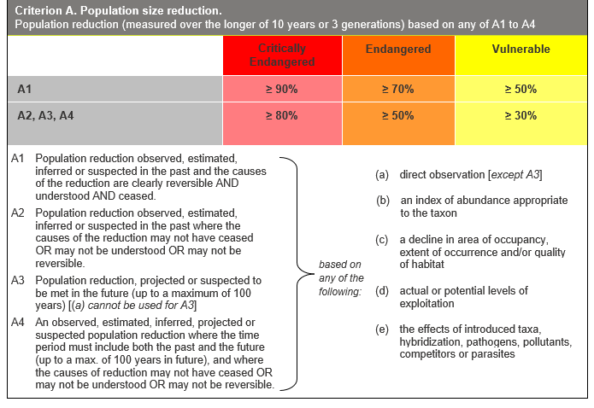

## Evidence:

**Ineligible under Criterion A**

The past and future population reductions do not meet the thresholds for eligibility under criterion A2, A3 or A4.

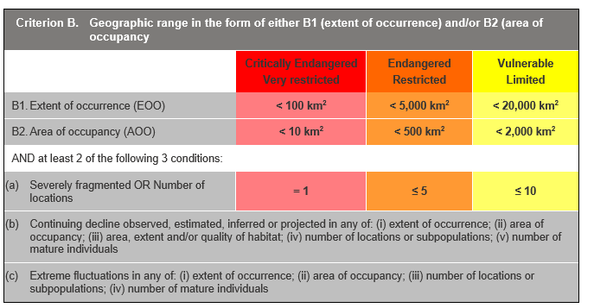

## Evidence:

**Eligible under Criterion B2 as Endangered**

The Area of Occupancy (AoO) across the taxon's range is estimated to be 102 km², based on 2 x 2 km grids derived from accepted, post-1970 records in the Victorian Biodiversity Atlas.

It is estimated to have two locations, based on the range of the taxon across a number of river basins and on both sides of the Great Dividing Range, and the main threats impacting all subpopulations at one time (e.g. climate change induced impacts such as drought, fire, etc). The locations are considered to be the southern localities including northern Victorian upper localities; the northern lower localities north of Dartmouth at lower elevation towards the Murray River.

It has a continuing decline in (i), (ii), (iii) and (v) above. This is based on the assumption that the known threats will continue to impact the taxon, predation by alien species, and reduction in quality and quantity of habitat due to climate change).

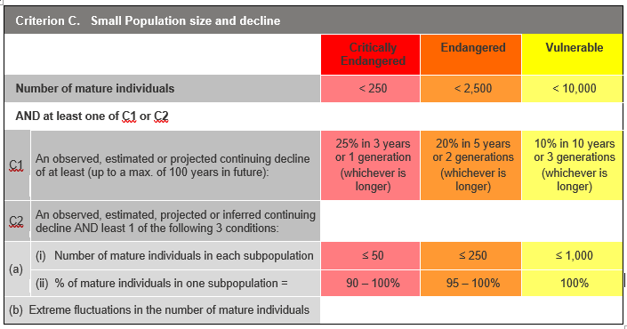

## Evidence:

**Ineligible under Criterion C as Data Deficient**

There is insufficient evidence to determine the number of mature individuals.

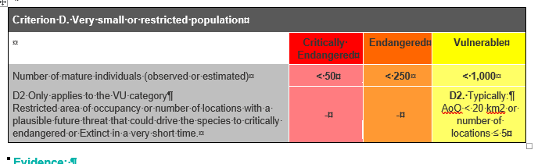

## Evidence:

**Ineligible under Criterion D**

There is insufficient evidence to determine the number of mature individuals.

### Criterion E (Quantitative Analysis) was not addressed as the taxon does not have a detailed Population Viability Analysis.

## References

DCE (1992). Spiny Freshwater Crayfish. Fisheries Management Information Sheet No. 78. Department of Conservation and Environment, Victoria, 6 pp.

DSE (2009) *Advisory list of threatened invertebrate fauna in Victoria - 2009.* Department of Sustainability and Environment, Melbourne. (Retrieved from https://www.environment.vic.gov.au/__data/assets/pdf_file/0016/50452/Advisory_List_of_Threatened_Invertebrate_Fauna_2009_FINAL_Sept_2009.pdf)

DSE (2003). Alpine Spiny Crayfish *Euastacus crassus* Flora and Fauna Guarantee Act 1988 Action Statement No. 136. Department of Sustainability and Environment, Melbourne. (Retrieved from https://www.environment.vic.gov.au/__data/assets/pdf_file/0018/32508/Alpine_Spiny_Crayfish_Euastacus_crassus.pdf)

Furse, J.M. and Wild, C.H. (2004). Laboratory moult increment, frequency, and growth in *Euastacus sulcatus*, the Lamington Spiny Crayfish. *Freshwater Crayfish*, 14: 205-211.

Goddard, J. S. (1988). Food and feeding. Chapter 6 in: Holditch, D. M. and Lowery, R. S. (eds.) *Freshwater Crayfish: Biology, Management and Exploitation.* Croon Helm, London pp: 145-66.

Honan, J. A. and Mitchell, B.D. (1995). Growth of the large freshwater crayfish *Euastacus bispinosus* Clark (Decapoda: Parastacidae). *Freshwater Crayfish*, 10: 118-131.

Horwitz, P. (1990) The conservation status of Australian freshwater crustacea. *Australian National Parks and Wildlife Service Report No* 14. ANP&WS, Canberra.

McCormack, R. B. (2012). *A guide to Australia's Spiny Freshwater Crayfish.* CSIRO publishing, Collingwood, Victoria pp 155-157.

Morgan, G. J. (1986). Freshwater crayfish of the genus *Euastacus* Clark (Decapoda: Parastacidae) from Victoria. *Memoirs of the Museum of Victoria* 47 (1): 1-57.

Morgan, G.J. (1997). Freshwater crayfish of the genus *Euastacus* Clark (Decapoda: Parastacidae) from New South Wales, with a key to all species of the genus. *Rec. Aust. Mus.*, (Supplement) 23: 110.

SAC (2001). Flora and Fauna Guarantee Scientific Advisory Committee: Final Recommendation on a Nomination for Listing. Nomination No. 537 *Euastacus crassus.*

Turvey, P. and Merrick, J.R. (1997). Growth with age in the freshwater crayfish, *Euastacus spinifer* (Decapoda: Parastacidae), from the Sydney region, Australia. *Proc. Linn. Soc. N.S.W*., 118: 205-215.

Zeidler, W. (1982). South Australian freshwater crayfish. *South Australian Naturalist* 56 (3): 37-43.