|  |
| --- |
| Threatened Species Assessment |
| *Hakea asperma*  Native Dog Hakea |

## Taxonomy

*Hakea asperma* Molyneux & Forrester

## Current conservation status

Categorised as Endangered in the 2014 Advisory list of rare or threatened flora (DEPI 2014).

## Proposed conservation status

Critically Endangered in Australia

Criteria B1ab(iii); D

## Species Information

### Description and Life History

The taxon is a suckering shrub to c. 1.3 m high; stems erect; branchlets glabrous. Leaves rigid, terete, (2-)3-9(-10) cm long, 0.8-1.3 mm wide, not grooved, white-pubescent when young; apex straight. Inflorescence 6-10-flowered; rachis 1-1.5 mm long, sericeous; pedicel c. 5 mm long, sericeous; perianth 4-4.5 mm long, white, glabrous, rarely with silky hairs at base; pistil 7-8 mm long; pollen presenter an oblique disc. The taxon flowers in November (1 record) (VicFlora 2018).

The taxon is known to only reproduce asexually via root-suckers (VicFlora 2019). The taxon extends by single ramet production along buried or occasionally exposed roots (its obligate method of population extension), has only terete leaves, a sericeous rachis, and sets no fruit. While pollen has been observed escaping from anthers of *H. asperma*, no testing has been undertaken by the authors to ascertain its viability, nor whether any fertilisation takes place. Future DNA studies may shed light on the inability of *H. asperma* to set fruit. The taxon persists by ramet production. The taxon flowers early November to mid-December (Molyneux & Forrester 2009).

### Generation Length

The generation length of *H. asperma* is inferred to be 1,000 years. Each known occurrence comprises one or very few vegetative clones which appear to have lost the capacity to produce fruit or seed perhaps as long ago as the end of the last ice age. The taxon is currently known by three clonal stands which, in the absence of seed recruitment, are inferred to be of inestimable age.

### Distribution

The taxon is endemic to Victoria and located at three sites in East Gippsland, above the north side of at Native Dog Flat on the Upper Buchan River (the type population), Native Cat Flat on the Nunniong Plateau, and the headwaters of Splitters Creek, south of Mt Wombargo (Molyneux and Forrester, 2009; VicFlora, 2018).

### Habitat

The taxon occurs on the lower slopes of a small steep hill of Devonian igneous origin, where sufficient soil depth and area exists to support the root systems between broken, often buried rock. An occasional root is exposed growing over shallow rock. Associated eucalypts include *Eucalyptus* sp. aff. *stellulata* (an undescribed mallee with several locally endemic populations), a dwarf form of *E. pauciflora* subsp. *pauciflora, E. rubida* and *E. viminalis* subsp. *viminalis*. Other associated taxa include *Bossiaea foliosa, Daviesia latifolia, D. ulicifolia, Goodenia hederacea, Lomatia myricoides, Persoonia confertiflora* and *Polyscias sambucifolius* (Molyneux and Forrester 2009; VicFlora 2018).

### Threats

The overriding threat to the taxon is climatic drying, leading to an increasing risk of repeat fire events which are projected to increase the risk of recruitment failure (death of vegetative resprouts), increase the exhaustion of root system resources and increase exposure of resprouts to browsing by Sambar Deer (*Rusa unicolor*) in particular. Clonal stands in flood-prone valleys or flats are also at risk of recurrent flood damage. Extreme and protracted drought stress may also result in recruitment failure. The taxon also has an exceedingly small population size, which may comprise no more than a single or very few genetic individuals or genets at each known site, which renders the taxon highly susceptible to extinction by repeat fire events or other stochastic events.

## IUCN Criteria

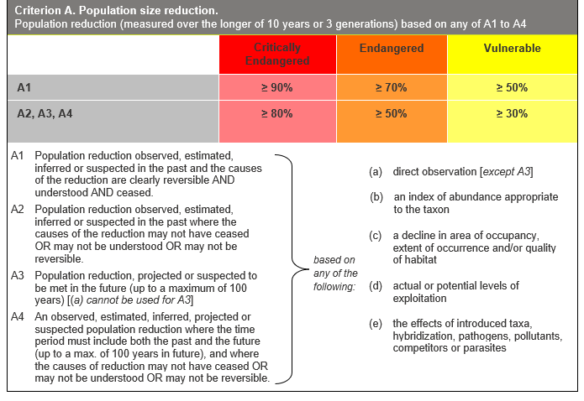

## Evidence:

**Ineligible under Criterion A**

There is insufficient evidence to determine whether there has been or will be a reduction in population sufficient to meet any threshold for Criterion A.

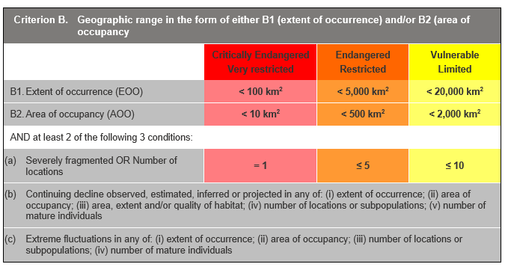

## Evidence:

**Eligible under Criterion B1 as Critically Endangered**

The Extent of Occurrence (EoO) across the taxon's range is estimated to be 60 km², based on three reliably documented subpopulations.

The taxon is severely fragmented naturally at the landscape scale since it is apparently inability of seed set and therefore has no capacity for recolonisation in the event of local extinction. Each occurrence is interpreted as relictual, having survived by vegetative resprouting for, potentially, thousands of years.

One to three locations are identified, since the key threat of climatic drying operates uniformly across the highly restricted geographic and ecological range of the taxon.

It has a continuing decline in (iii) above, based on increasing risk of fire and browsing by Sambar Deer.

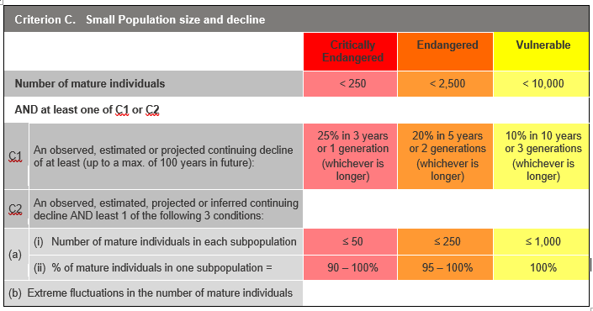

## Evidence:

**Ineligible under Criterion C**

The taxon is estimated to have 3 mature individuals, but other thresholds under this criterion have not been met.

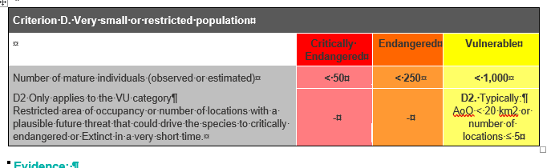

## Evidence:

**Eligible under Criterion D as Critically Endangered**

Each known occurrence may comprise no more than a single or very few genetic individuals (Molyneux & Forrester 2009).

### Criterion E (Quantitative Analysis) was not addressed as the taxon does not have a detailed Population Viability Analysis.

## References

DEPI (2014). *Advisory list of rare or threatened plants in Victoria - 2014.* Department of Environment and Primary Industries, Melbourne. Retrieved from: https://www.environment.vic.gov.au/__data/assets/pdf_file/0021/50448/Advisory-List-of-Rare-or-Threatened-Plants-in-Victoria-2014.pdf

Molyneux, W.M. and Forrester, S.G. (2009). A new *Hakea* species Proteaceae: Grevilleoideae from East Gippsland, Victoria. *Muelleria, 27*(2), 225-226.

VicFlora (2018). Flora of Victoria, Royal Botanic Gardens Victoria: *Hakea asperma*. Retrieved from: https://vicflora.rbg.vic.gov.au/flora/taxon/1971d688-5191-4589-b85a-40070c7143e8