|  |
| --- |
| Threatened Species Assessment |
| *Celmisia sericophylla*  Silky Snow-daisy |

## Taxonomy

*Celmisia sericophylla* J.H. Willis

## Current conservation status

Listed as threatened under the *Flora and Fauna Guarantee Act 1988* (SAC 1992).

Categorised as Vulnerable in the 2014 Advisory list of rare or threatened flora (DEPI 2014).

## Proposed conservation status

Endangered in Australia

Criteria A2ce; B1ab(i,ii,iii,v)+2ab(i,ii,iii,v)

## Species Information

### Description and Life History

Rootstock woody, branched; fibrous leaf remnants persistent. Leaves oblanceolate to narrowly oblanceolate or elliptic, c. 5–25 cm long, 1–3.5 cm wide, both surfaces velvety, with antrorse flattened lustrous hairs, denser and silvery beneath, margins flat, leaves renewed annually. Scape (6–)10–45 cm high, greenish-white, silky- or woolly-tomentose; capitulum c. 4–6 cm diam; intermediate involucral bracts narrowly triangular-subulate, 10–15 mm long, 1.3–1.9 mm wide, densely tomentose with silvery hairs, tip flushed red or purple, margins densely fimbriate; ligules 14–18 mm long, white. Cypselas c. (3–)4–6 mm long, densely sericeous; pappus c. 5–6 mm long. Flowers December-February (VicFlora 2019).

The taxon is vegetative; it generally resprouts from protected buds after fire, with burnt plants becoming juvenile. It is tolerant of competition during reestablishment, but seedlings are normally not observed after fire.

### Generation Length

The generation length of *Celmisia sericophylla* is estimated to be 20 to 70 years. According to the Victorian Biodiversity Atlas (VBA), the time to reproductive maturity for this taxon is estimated at 5 years. It is long lived, with the longevity of reproduction estimated as 100 years. Seedlings are mostly not observed post-fire.

It is assumed that the average age of individuals in undisturbed vegetation is likely to be at the long end of the scale, but there is considerable margin for error.

### Distribution

The taxon is endemic in Victoria. It is restricted to the Bogong High Plains, especially between Mt Bogong and Mt Cope, with a small outlying occurrence between Mts Loch and Hotham (VicFlora, 2019).

### Habitat

The taxon typically forms extensive carpets along rocky stream banks, or tufted among boulders and on rocks overhanging water, and occasionally in *Sphagnum* bogs and wet areas below snow patches (VicFlora, 2019).

### Threats

Alpine taxa are prone to range contraction due to climate change, of which the impacts are likely to be seen first in marginal, lower-elevation sub-populations. Large fires are becoming more frequent, and two fires at a short interval will be particularly detrimental to populations growing in bogs, however this taxon is less at risk from fire than other taxa since it is usually associated with flowing streams, rocks, and gravel pavements.

Increasing impacts of deer remains a long-term threat, although it might be countered in some areas by recovery from historic cattle grazing. Ski development could also impact on populations.

## IUCN Criteria

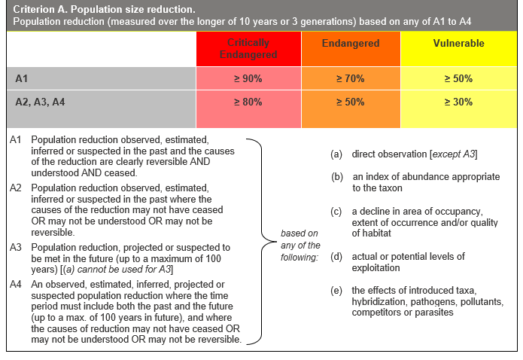

## Evidence:

**Eligible under Criterion A2 as Endangered**

The population reduction over the past 60 to 210 years is estimated to be 35 to 50%, based on (c) and (e) above.

Past decline is due to the plant being likely more palatable than other Victorian taxa. The taxon has possibly been eliminated from Mt Fainter which was the most heavily grazed peak in the Victorian Alps, since it was in the path of a stock route from Kiewa Wally to Bogong High Plains. There has been a possible historic decline of at least 50% due to grazing, although there has been recovery in areas withdrawn from cattle grazing in 1992, as well as some post-grazing recovery from 2003-2008.

The causes of the reduction may not have ceased, be understood or be reversible.

**Eligible under Criterion A3 as Vulnerable**

The population reduction over the next 60 to 100 years is estimated to be 25 to 35%, based on (c) above.

The taxon is less at risk from fire than other alpine species, since it is usually associated with flowing streams, rocks, gravel pavements, but for the same reason is at high risk from drying of habitat. A short to medium term recovery was anticipated from 2008-2020, based on observation of recovery between 1993-2008 at Mt Nelse, followed by long-term decline. A net decline is anticipated over the next 100 years, plausibly in the 30% range, given removal of cattle grazing from the taxon’s stronghold and the effects of climate change.

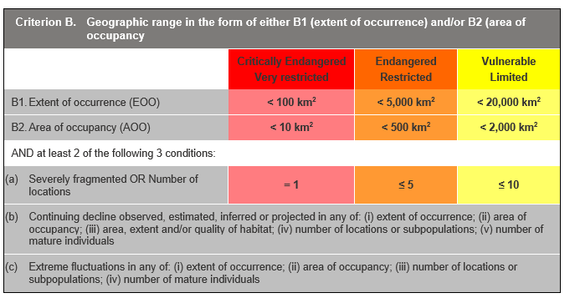

## Evidence:

**Eligible under Criterion B1 as Endangered**

The Extent of Occurrence (EoO) across the taxon's range is estimated to be 933 km², based on accepted, post-1970 records from the Victorian Biodiversity Atlas (VBA).

It is estimated to have 2 locations, and has a continuing decline in (i), (ii), (iii) and (v) above, based on Alpine taxa being prone to range contraction due to climate change, of which the impacts are likely to be seen first in marginal, lower-elevation sub-populations, and large fires becoming more frequent.

**Eligible under Criterion B2 as Endangered**

The Area of Occupancy (AoO) across the taxon's range is estimated to be 116 km², based on 2 x 2 km grids derived from accepted, post-1970 records in the VBA.

As above, the taxon has 2 locations, and has a continuing decline in (i), (ii), (iii) and (v) above.

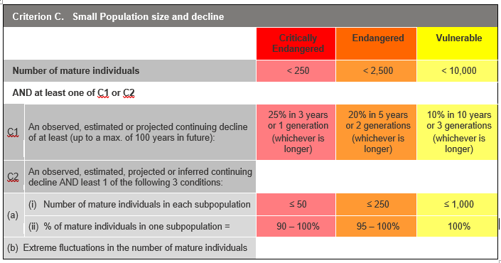

## Evidence:

**Ineligible under Criterion C**

It is inferred that there are 5,000 to 15,000 mature individuals, but other thresholds under this criterion have not been met.

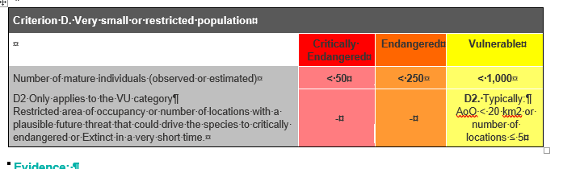

## Evidence:

**Eligible under criterion D2 as Vulnerable**

The taxon is estimated to be very restricted.

### Criterion E (Quantitative Analysis) was not addressed as the taxon does not have a detailed Population Viability Analysis.

## References

DEPI (2014). *Advisory list of rare or threatened plants in Victoria - 2014*. Department of Environment and Primary Industries, Melbourne.

Gray, M., and Given D.R. (1999). New species and a new combination in Australian *Celmisia* Asteraceae-Astereae) *Australian Systematic Botany* 12(2) 201-206.

SAC (1992). Flora and Fauna Guarantee Scientific Advisory Committee: Final Recommendation on a Nomination for Listing. Nomination No. 220 *Celmisia sericophylla*

VicFlora (2019). Flora of Victoria, Royal Botanic Gardens Victoria: *Celmisia sericophylla*. Retrieved from: https://vicflora.rbg.vic.gov.au/flora/taxon/a500c9cf-9003-4da4-87dd-1a485d673d67