|  |
| --- |
| Threatened Species Assessment |
| *Hovea purpurea*  Tall Hovea |

## Taxonomy

*Hovea purpurea* Sweet

## Current conservation status

Categorised as Rare in the 2014 Advisory list of rare or threatened flora (DEPI 2014).

## Proposed conservation status

Critically Endangered in Victoria

Criteria B1ab(iii)+2ab(iii); D

## Species Information

### Description and Life History

Shrub to 3 m high; branchlets villous with curled appressed and/or spreading hairs. Leaves narrowly ovate, elliptic or oblong, 1.2–7 cm long, 0.4–1.0(–1.7) mm wide; apex obtuse or acute, usually shortly mucronate; upper surface dark green, ± flat either side of depressed midrib; lower surface with dense, curled, white or tawny hairs; margins slightly recurved; stipules narrowly ovate or subulate, to 2 mm long. Inflorescence sessile, mostly 2-flowered; pedicels 1.5–2.5 mm long; bract broadly ovate, ovate or obovate, usually inserted immediately below bracteoles; bracteoles obovate to oblong, 2.5–4 mm long, obtuse or subacute; upper lobes of calyx 5.2–8.5 mm long (including tube); corolla mauve or lilac, occasionally white; standard 11.5–17 mm long (including claw), usually longer than wide; keel subequal to or slightly longer than wings; stamen-filaments 8.5–16 mm long, usually persisting. Pods sessile or almost so. The taxon flowers in September (VicFlora 2017).

### Generation Length

The generation length of *Hovea purpurea* is estimated to be 10 to 30 years. Pea taxa are generally reasonably short-lived, germinating and dying between fire events. As a result, most peas may be expected to live for around 10 to 20 years. Some *Hovea* taxa can resprout after fire possibly allowing them to be slightly longer-lived.

### Distribution

In Victoria, the taxon is known only from the upper Genoa River and with certainty only from one site on the river 500 metres directly south from its confluence with Yambulla Creek. It is also found in New South Wales and South Australia.

A single collection housed at the Hobart Herbarium from Lake Cobbler was identified as [*H.*](https://vicflora.rbg.vic.gov.au/flora/taxon/c81a1511-0523-4a40-bfca-ac2de6301d29) aff.*purpurea*. This collection is highly disjunct from the Genoa River populations and its identification requires further investigation (VicFlora 2017).

### Habitat

In Victoria, *H. purpurea* occurs in riparian forest of *Eucalyptus viminalis* (Manna Gum) and *E. elata* (River Peppermint) with a shrubby understorey of *Sannantha pluriflora* (Tall Baeckia), *Bursaria spinosa* (Sweet Bursaria), *Oxylobium arborescens* (Tall Oxylobium) and *Olearia lirata* (Snowy Daisy-bush) on rocky ledges and coarse sandy alluvium.

### Threats

Frequent and more severe fires and extreme weather events may become more severe in the future due to climate change. High rainfall causing flooding of the Genoa River could potentially lead to erosion and dislodge or destroy plants. Conversely, prolonged droughts are also likely to be detrimental given that *H. purpurea* favours moist, mesic, riparian sites in Victoria. Too infrequent fire may limit fire-induced seed germination, whilst too frequent fire potentially kills plants before they are mature enough to reproduce.

## IUCN Criteria

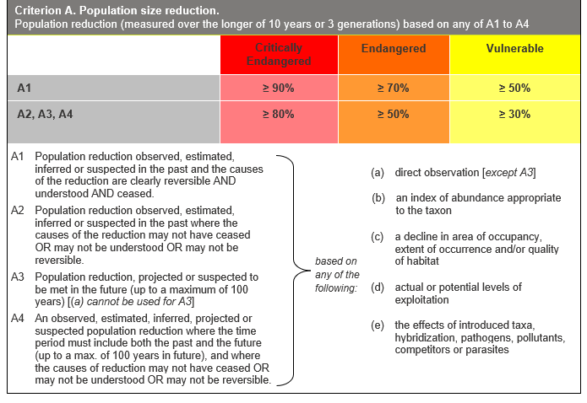

## Evidence:

**Ineligible under Criterion A**

The past population reduction does not meet the threshold for eligibility under Criterion A2 and the future population reduction does not meet the threshold for eligibility under Criterion A3.

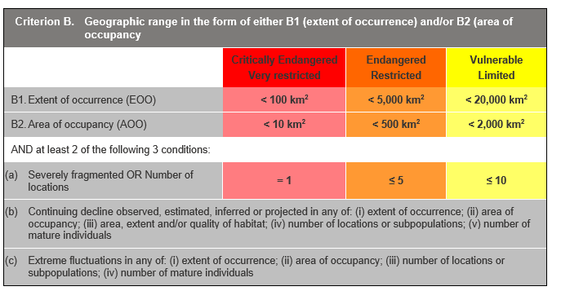

## Evidence:

**Eligible under Criterion B1 as Critically Endangered**

The Extent of Occurrence (EoO) across the taxon's range is estimated to be 4 km², based on accepted, post-1970 records from the Victorian Biodiversity Atlas (VBA).

The taxon is estimated to have one location, as it has been collected from, and is certainly known from, only one site in Victoria. As a result, all individuals in the population may be rapidly affected by the same threats.

It has a continuing decline in (iii) above based on the identified threats, notably the effects of climate change.

**Eligible under Criterion B2 as Critically Endangered**

The Area of Occupancy (AoO) across the taxon's range is estimated to be 4 km², based on 2 x 2 km grids derived from accepted, post-1970 records in the VBA. As above, the taxon has one location, and has a continuing decline in (iii) above.

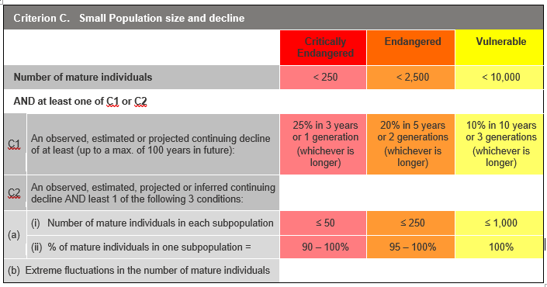

## Evidence:

**Ineligible under Criterion C**

It is estimated that there are 30 to 80 mature individuals, but other thresholds under this criterion have not been met.

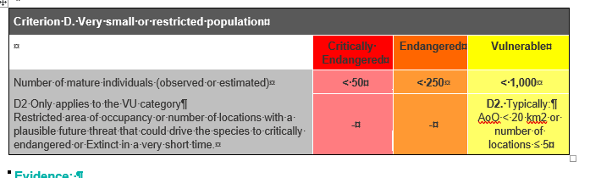

## Evidence:

**Eligible under Criterion D as Critically Endangered**

The taxon is estimated to have 30 to 80 mature individuals. A collection made in 2000, at the one certain site of occurrence of *H. purpurea* in Victoria, reported that between 30 and 40 plants existed in the area. This demonstrates that population growth has likely taken place since 1988, when a lower number of individuals was reported. Assuming the same rate of population growth, the number of individuals may currently be as much as 80, however, assuming no population decline or increase since 2000, it may also be as low as 30.

### Criterion E (Quantitative Analysis) was not addressed as the taxon does not have a detailed Population Viability Analysis.

## References

Berg, R.Y. (1975). Myrmecochorous plants in Australia and their dispersal by ants. *Australian Journal of Botany* 23: 475-508.

DEPI (2014). *Advisory list of rare or threatened plants in Victoria* *- 2014*. Department of Environment and Primary Industries, Melbourne.

Thompson, I.R. (2001). Morphometric analysis and revision of Eastern Australian *Hovea* (Brogniartieae-Fabaceae). *Australian Systematic Botany* 14: 1-99.

VicFlora (2017). Flora of Victoria, Royal Botanic Gardens Victoria: *Hovea purpurea*. Retrieved from: https://vicflora.rbg.vic.gov.au/flora/taxon/9771625a-4d06-4905-9cca-b99649b77bc7