|  |
| --- |
| Threatened Species Assessment |
| *Euastacus yanga*  Variable Spiny Crayfish |

## Taxonomy

*Euastacus yanga* Morgan, 1997

## Current conservation status

Categorised as Vulnerable in the 2009 Advisory list of threatened invertebrate fauna in Victoria (DSE 2009).

## Proposed conservation status

Endangered in Victoria

Criteria B1ab(i,ii,iii,v)+2ab(i,ii,iii,v)

## Species Information

### Description and Life History

The Variable Spiny Crayfish is a moderate sized species of spiny crayfish with a maximum recorded occipital carapace length (OCL) of 75 mm (McCormack 2012, though cited by Morgan 1997 as 61.2mm). It can be found foraging during the day but is far more active at night. Most species of *Euastacus* are moderate burrowers, seeking refuge under rock ledges and amongst submerged, in-stream tree roots (Zeidler 1982). TheVariable Spiny Crayfish is an extensive burrower in intermittent streams and swamps, and burrows start just below the water line (McCormack 2012). The diet of spiny freshwater crayfish consists primarily of aquatic to semi-aquatic vegetation and benthic invertebrates (Goddard 1988). Fungi and bacteria found in rotting detrital matter is also consumed (DCE 1992). Maturity is reached at about 40 mm OCL, and mating activity commences in mid-May. Eggs are large, burgundy in colour and females carry from 50 to 250 eggs per clutch under their tail (McCormack 2012). After hatching from eggs, the dependent juvenile crayfish are carried beneath the tail until their release. The yolk of the egg is retained by the young hatchlings as a yolk sac supplying food during early growth. Once the yolk sac has been completely absorbed, the juveniles disperse to fend for themselves. A relatively robust species, they can survive dry spells by sheltering in their deep burrows (McCormack 2012).

### Generation Length

The generation length of the Variable Spiny Crayfish is inferred to be 5 to 15 years. Several reproductive studies show *Euastacus* spp. mature late with females only becoming reproductive at >5-8 years in most species (Honan and Mitchell 1995, Turvey and Merrick 1997, Furse and Wild 2004). The minimum generation is therefore set at 5 years. Studies on large species of *Euastacus* show ages of up to 30 years and above (e.g. Turvey and Merrick 1997). As a small species, the generation length for *E. yanga* is nominally set at 15 years. There has been no research into age in this taxon.

### Distribution

The Variable Spiny Crayfish is found in coastal catchments in southern New South Wales and extends a short distance over the border into coastal eastern Victoria near Mallacoota (Genoa and Wallagaraugh river drainages). It is restricted in Victoria to between 50-300 m in elevation (Morgan 1997, McCormack 2012).

### Habitat

The taxon is found in large permanent rivers as well as smaller streams and intermittent creeks; also known to colonise isolated ponds and pools away from the main stream (McCormack 2012). Found in forested catchments consisting of rainforest or sclerophyll vegetation and also in streams in rocky environments where suitable sites for burrows may be rare (Morgan 1997, McCormack 2012).

### Threats

The major threat to taxa of spiny crayfish in Victoria is the decline in quality and quantity of habitat, both underground and at the surface. This can be caused by a range of factors, many of which are predicted to be exacerbated by climate change. These include decline in quantity and quality of streamflows and/or groundwater; decline or loss of vegetation due to removal or disturbance; soil disturbance; sedimentation or smothering from overland debris flow during high rainfall events following soil disturbance; the impact of chemicals and loss of areas of suitable soil profile in which to construct burrows.

These threats may be driven by a range of land and water management activities, including urban and agriculture development, road construction and maintenance, bushfire prevention and suppression, water extraction and forestry operations. These threats may also be triggered or exacerbated by natural events such as droughts, floods and bushfires.

Bushfires have the potential to degrade water quality and alter the dynamics of stream ecosystems. Most critical effects occur if there is heavy rain soon after fire, as loss of vegetation and altered soil structure can make fire-affected soils more erodible. Runoff can carry sediments and pollutants that affect aquatic environments and consequently aquatic species.

Loss of food resources due to soil disturbance or loss of riparian vegetation can lead to various ecological changes, particularly sedimentation affecting instream processes, increased water temperature from greater incidence of light, and reduction in the type and amount of debris accumulation in streams, changes which generally reduce the suitability of streams as habitat for *Euastacus* species. The coarse woody debris provides important crayfish habitat and the finer debris would provide an important food source for the species.

The introduction of exotic biota could also be a threat due to predation, competition, or the spread of disease (Horwitz 1990b). Introduced fish, including Brown Trout *Salmo trutta*, occur throughout many of the river systems within the taxon's range, and predation may have a detrimental impact on populations of the crayfish.

The overall level of threat and the relative contribution of each of the land management activities and natural events varies according to the circumstances of each species.

In the case of the Variable Spiny Crayfish, its habitat is largely forested, including parks and reserves, State forest and private land. This taxon’s habitat was severely impacted by the 2019-20 bushfires: the entire known Victorian range falls within the fire boundary. As a precautionary measure, young individuals were extracted immediately following the bushfire but no adults were located (DELWP 2020). The taxon has very restricted distribution in Victoria and is therefore at high risk of inbreeding and consequent reduction in its adaptability under climate change.

Spatial analysis of catchments occupied by this taxon on all land tenures indicates that 40% occurs within the Comprehensive, Adequate and Representative (CAR) reserve system, including parks and reserves and special protection zones in State forest. Further areas are excluded from harvesting by prescription under the Victorian Code of Practice for Timber Production 2014 (the Code). There are no species-specific prescriptions for the Variable Spiny Crayfish in the Code, however general forestry prescriptions such as protection and buffering of waterways provide protection from forestry operations. In recent years, modified harvesting and forest regeneration practices have been implemented in native forest that are designed to further mitigate the potential threat from forestry operations to threatened species and their habitats.

## IUCN Criteria

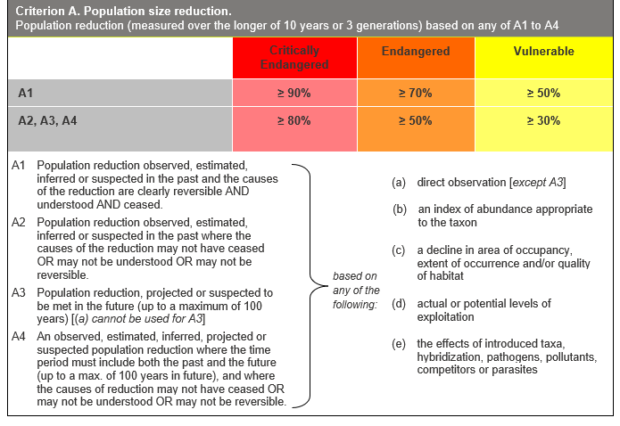

## Evidence:

**Eligible under Criterion A3 as Vulnerable**

The population reduction over the past 15 to 45 years is projected to be 45%, based on (c) above.

This is based on the assumption that the known threats will continue to impact the taxon, and that there will be a reduction in quality and quantity of habitat due to climate change.

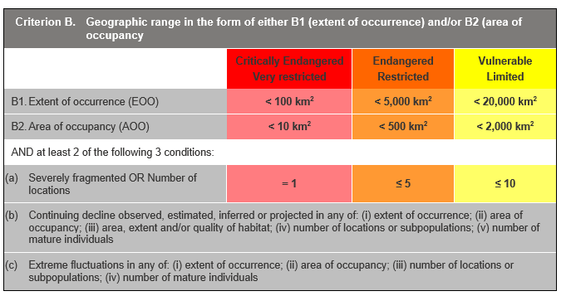

## Evidence:

**Eligible under Criterion B1 as Endangered**

The Extent of Occurrence (EoO) across the taxon's range is estimated to be 130 km², based on accepted, post-1970 records from the Victorian Biodiversity Atlas (VBA).

It is estimated to have one location, based on the main threats impacting all subpopulations at one time - e.g. climate change-induced impacts such as drought, fire, etc.

. It has a continuing decline in (i), (ii), (iii) and (v) above, based on the impacts of the identified threats. Impairment and modification to instream and riparian habitat and extreme events have occurred and continue to occur within the known range of the species therefore future population trends are inferred as declining.

**Eligible under Criterion B2 as Endangered**

The Area of Occupancy (AoO) across the taxon's range is estimated to be 36 km², based on 2 x 2 km grids derived from accepted, post-1970 records in the VBA. As above, it is estimated to have one location and has a continuing decline in (i), (ii), (iii) and (v) above.

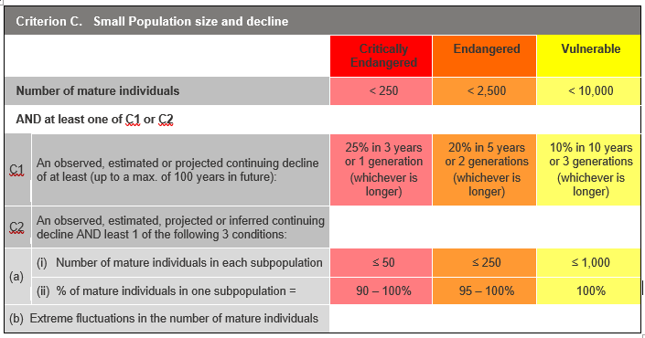

## Evidence:

**Ineligible under Criterion C as Data Deficient**

There is insufficient evidence to determine the number of mature individuals. The taxon has a restricted distribution in small streams in southern Victoria. Collections of the taxon reveal it is generally found in relatively low numbers (Koster et al. 1999, Bryant et al. 2012) at the sites it inhabits.

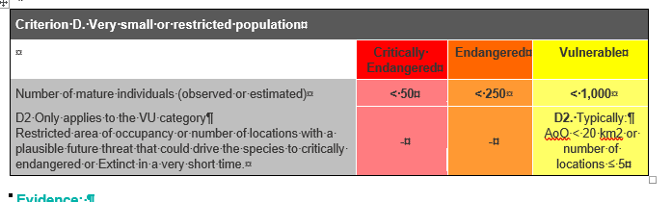

## Evidence:

**Eligible under criterion D2 as Vulnerable**

The taxon is estimated to be very restricted.

### Criterion E (Quantitative Analysis) was not addressed as the taxon does not have a detailed Population Viability Analysis.

## References

DCE (1992). *Spiny Freshwater Crayfish*. *Fisheries Management Information Sheet No*. **78**. Department of Conservation and Environment, Victoria, 6 pp.

DELWP (2020) *Victoria's bushfire emergency: biodiversity response and recovery. Preliminary report - Version 2.* Department of Environment, Land, Water and Planning. East Melbourne. Retrieved from https://www.wildlife.vic.gov.au/__data/assets/pdf_file/0030/484743/Victorias-bushfire-emergency-Biodiversity-response-and-recovery-Version-2-1.pdf

DSE (2009) *Advisory list of threatened invertebrate fauna in Victoria - 2009.* Department of Sustainability and Environment, Melbourne. Retrieved from: https://www.environment.vic.gov.au/__data/assets/pdf_file/0016/50452/Advisory_List_of_Threatened_Invertebrate_Fauna_2009_FINAL_Sept_2009.pdf

Furse, J.M. and Wild, C.H. (2004). Laboratory moult increment, frequency, and growth in *Euastacus sulcatu*s, the Lamington Spiny Crayfish. *Freshwater Crayfish*, **14**: 205-211.

Goddard, J. S. (1988). Food and feeding. Chapter 6 in: Holditch, D. M. and Lowery, R. S. (eds.) *Freshwater Crayfish: Biology, Management and Exploitation.* Croon Helm, London pp: 145-66.

Honan, J. A. & Mitchell, B.D. 1995. Growth of the large freshwater crayfish *Euastacus bispinosus* Clark (Decapoda: Parastacidae). *Freshwater Crayfish,* **10**: 118-131.

Horwitz, P. (1990) The conservation status of Australian freshwater crustacea. *Australian National Parks and Wildlife Service Report No* 14. ANP&WS, Canberra.

Koster, W.M., Raadik, T.A. and Kefford, B.J. (1999). Observations on the distribution, habitat requirements, and aspects of the biology of the Central Highlands Spiny Crayfish, Southern Victorian Spiny Crayfish and South Gippsland Spiny Crayfish. An Unpublished Report. Freshwater Ecology, NRE Heidelberg, Victoria.

McCormack, R. B. (2012). *A guide to Australia's Spiny Freshwater Crayfish.* CSIRO publishing, Collingwood, Victoria pp 155-157.

Morgan, G.J. (1997). Freshwater crayfish of the genus *Euastacus* Clark (Decapoda: Parastacidae) from New South Wales, with a key to all species of the genus. *Rec. Aust. Mus.,* (Supplement) **23**: 110.

Turvey, P. & Merrick, J.R. (1997). Growth with age in the freshwater crayfish, *Euastacus spinifer* (Decapoda: Parastacidae), from the Sydney region, Australia. *Proc. Linn. Soc. N.S.W*., **118**: 205-215.

Zeidler, W. (1982). South Australian freshwater crayfish. *South Australian Naturalist* **56** (3): 37-43.