Threatened Species Assessment
Prostanthera lasianthos var. subcoriacea

Grampians Christmas-bush

Taxonomy
Prostanthera lasianthos var. subcoriacea F. Muell. ex Benth.

Current conservation status
Categorised as Rare in the 2014 Advisory list of rare or threatened flora (DEPI 2014).

Proposed conservation status
Vulnerable in Australia
Criterion D2

Species Information

Description and Life History
The taxon is a medium-sized compact shrub or, occasionally, a small tree, 1-6 m high, aromatic; branches glabrous or sparsely covered with short, curled hairs and subsessile glands. Leaves ovate 30-46 mm long, 12-20 mm wide, length-to-width ratio 2.3-2.7, thickish in texture, dark green above, paler below, glabrous, base cuneate to shortly attenuate, slightly oblique, margin toothed, occasionally teeth reduced or absent, apex acute to acuminate; petiole 6-10 mm long. Flowers in a terminal racemose or paniculate inflorescence; bracteoles persistent, 2-4 mm long, 0.2-0.4 mm wide. Calyx 4-5 mm long, tube 2-3 mm long, adaxial lobe 1.5-3 mm long (enlarged in fruit); corolla white to pale mauve with purple spots in throat, 10-15 mm long; anther appendage c. 1.5 mm long. Flowers December to March (VicFlora 2018a; 2018b).

Generation Length
The generation length of Prostanthera lasianthos var. subcoriacea is estimated to be 45 to 80 years. This is based on a plausible longevity of 35-80 years, and a combination of episodic recruitment following fire as well as some low level continuous recruitment in response to localised site disturbance events. The taxon is inferred to be a fire-sensitive obligate seed regenerator with limited capacity to resprout following low intensity fire only. Its pre-settlement fire interval is likely to have been in the 45-90 year range depending on landscape context and vegetation density which determine fuel accumulation rates.

Distribution
The taxon is endemic in the Grampians (VicFlora 2018b). Its stronghold appears to be the summit of Mt William, with outlying occurrences at the intersection of Asses Ears Road and Wallaby Rocks Road, at Fyans Creek 1 km upstream of the Grampians Road near Halls Gap, on the extreme south edge of the Major Mitchell Plateau, on Mt Rosea Track north-west of Mt Rosea, and on Fortress Walking Track at Deep Creek on the west slopes of the Victoria Range.

Habitat
The taxon is occasional on exposed summits and upper slopes of higher mountains (VicFlora 2018b), however site and specimen data indicate the taxon has a wider habitat range than suggested by VicFlora (2018b), extending to lower and mid slopes where it occupies dry, marginally rocky sites in association with, for example, Eucalyptus baxteri (Brown Stringybark), and is sometimes locally abundant. Specimen data indicates that the taxon occurs in riparian habitats at the intersection of Asses Ears Road and Wallaby Rocks Road, at Fyans Creek, and at Deep Creek.

Threats
Historic decline through habitat loss is unlikely to have been significant since the taxon occupies sites of low productivity which have never been exploited for agricultural or forestry purposes, and are now protected within the Grampians National Park.
The only identifiable current or future threats are drought-induced recruitment failure, possibly herbivory under extreme drought conditions, and very high herbivore density operating continuously over successive seasons resulting in mortality and localised population decline. Red Deer (Cervus elaphus) and feral goats are currently the most significant exotic herbivores in the Grampians, although Swamp Wallabies (Wallabia bicolor) may also exert significant browsing pressure in denser forest vegetation at lower elevations. Should Sambar Deer (Rusa unicolor) extend its range into the Grampians in the future, then it would pose a significant long-term threat to the taxon.
The taxon may also be threatened by repeat fire events at intervals approaching its tolerable fire interval (TFI) for the taxon. Exposed summits and upper slopes of higher mountains are unlikely to accumulate sufficient fuel to carry fire at such intervals, although denser vegetation on lower slopes may accumulate sufficient fuel to carry planned burns or bushfires at intervals approaching the TFI.

IUCN Criteria
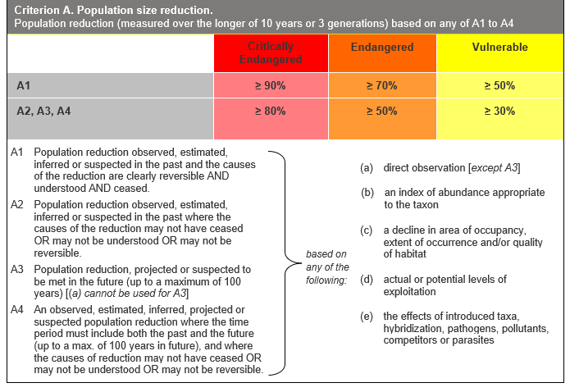

Evidence:
Ineligible under Criterion A
The population reduction for this taxon is below the threshold for eligibility under criterion A.
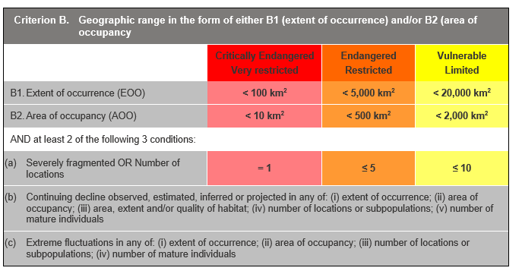

Evidence:
Ineligible under Criterion B
The Extent of Occurrence (EoO) across the taxon's range is estimated to be 535 km² and the Area of Occupancy (AoO) is estimated to be 24 km², but other thresholds under this criterion have not been met.
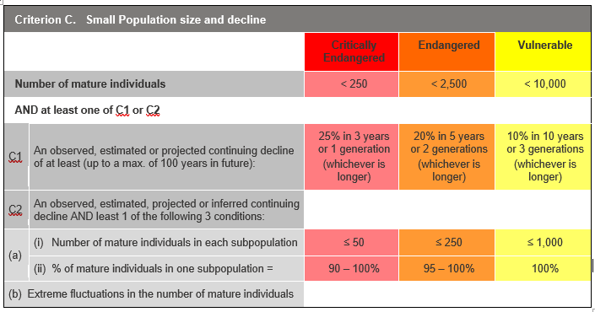

Evidence:
Ineligible under Criterion C as Data Deficient
There is insufficient evidence to determine the number of mature individuals.
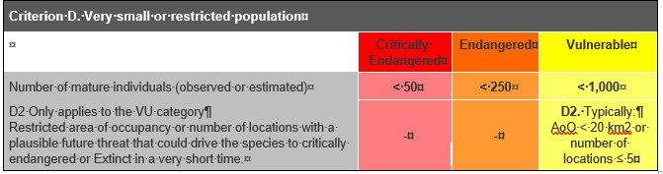

Evidence:
Eligible under Criterion D2 as Vulnerable
The taxon is estimated to be very restricted. The taxon has a restricted distribution, occurring in a single location, such that this restriction makes the taxon capable of becoming Critically Endangered or Extinct within a time frame of one or two generations. This is in response to the impact of the identified long-term threats, notably recruitment failure, herbivory, and repeat fire events.

Criterion E (Quantitative Analysis) was not addressed as the taxon does not have a detailed Population Viability Analysis.

References
DEPI (2014). Advisory list of rare or threatened plants in Victoria - 2014. Department of Environment and Primary Industries, Melbourne.
VicFlora (2018a). Flora of Victoria, Royal Botanic Gardens Victoria: Prostanthera lasianthos. Retrieved from: https://vicflora.rbg.vic.gov.au/flora/taxon/ea703b78-5fba-4748-aee8-7654fbfd36c7
VicFlora (2018b). Flora of Victoria, Royal Botanic Gardens Victoria: Prostanthera lasianthos var. subcoriacea. Retrieved from: https://vicflora.rbg.vic.gov.au/flora/taxon/df64a6a5-071f-4e2c-9c3c-4735b176c1a0

