Threatened Species Assessment
Geminoropa scindocataracta

Land Snail

Taxonomy
Geminoropa scindocataracta (Gabriel, 1930)

Current conservation status
Listed as threatened under the Flora and Fauna Guarantee Act 1988 (SAC 2002).
Categorised as Vulnerable in the 2009 Advisory list of threatened invertebrate fauna in Victoria (DSE 2009).

Proposed conservation status
Endangered in Australia
Criteria B1ab(ii,iii,v)+2ab(ii,iii,v)

Species Information

Description and Life History
Geminoropa scindocataracta is a species of small air-breathing land snails, terrestrial pulmonated gastropod mollusc in the family Charopidae. This species is endemic to Australia.

Generation Length
The generation length of Geminoropa scindocataracta is estimated to be 2 to 4 years. The age of mature snails can be estimated from growth interruption markings on the shell. The estimation across a broad selection of charopids is that they do not live greater than 3 years.

Distribution
The type locality is in the Otway Ranges, where the taxon is endemic and unique to the area. It is a rare and extreme localised Victorian land snail, occupying a narrow distribution range in terms of abundance and distribution. However, in many cases insufficient collecting has been carried out to give exact range dimensions for the taxon.

Habitat
The taxon occurs in Cool Temperate Rainforest and Wet Forest.

Threats
Past land clearing and historic forestry activities would have had the greatest impact, especially as source/ refuge habitat such as riparian/ wet forest was not well protected.
The biggest threat to the wet forest malacofauna of the Otway Ranges is climate change, with a preliminary prediction being for a notable reduction of this taxon’s habitat by 2080 (Miles 2010). While a single bushfire event is considered to be an important potential impact, arguably this impact is relatively short term. By far, land clearing and climate change (and associated droughts and altered fire regimes) are the most important factors underpinning long term trends in declines or recovery.
It should be noted that native forest timber harvesting on public land has been phased out in the Otway Ranges since 2008. Harvesting on private land and in plantations may continue to have an impact, however the Code of Practice for Timber Production 2014 applies to timber harvesting and the management of plantations on public and private land, including the requirement to protected and buffer rainforest and waterways.

IUCN Criteria
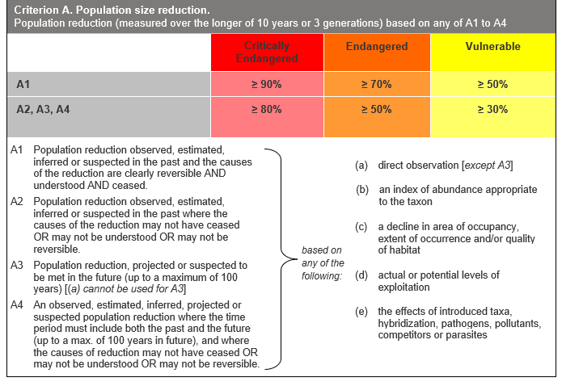

Evidence:
Ineligible under Criterion A
Population reductions over the past of future 10 to 12 years are suspected or estimated to be less than 30%.
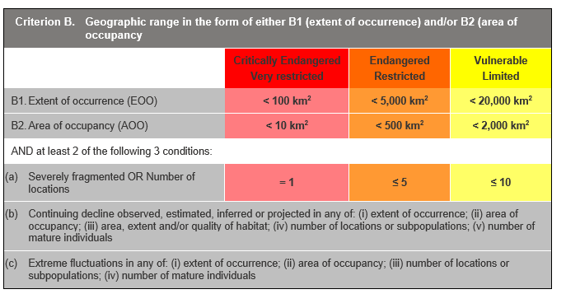

Evidence:
Eligible under Criterion B1 as Endangered
The Extent of Occurrence (EoO) across the taxon's range is estimated to be 840 km², based on accepted, post-1970 records from the Victorian Biodiversity Atlas (VBA).
The taxon is estimated to be severely fragmented. Being of low vagility, recovery and recolonisation is typically slow and can take decades, depending on distance from source and demographics.
It is estimated to have one location, as all key identified threats apply across its range and can rapidly affect all individuals of the taxon present. It has a continuing decline in (ii), (iii) and (v) above, based on the future impacts of the identified threats.
Eligible under Criterion B2 as Endangered
The Area of Occupancy (AoO) across the taxon's range is estimated to be 420 km², based on 2 x 2 km grids derived from accepted, post-1970 records in the VBA .As above, is severely fragmented, has one location and a continuing decline in (ii), (iii) and (v) above.
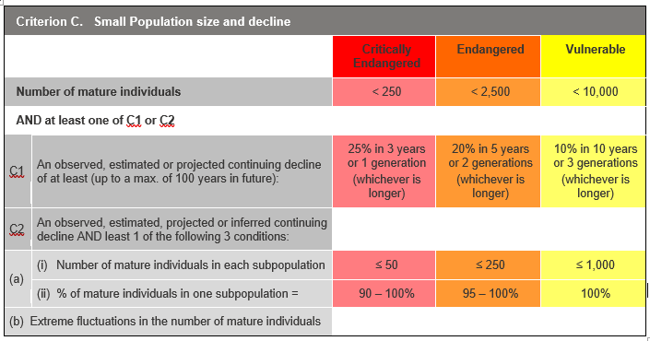

Evidence:
Ineligible under Criterion C
It is estimated that there are 20,000 to 30,000 mature individuals, which exceeds the thresholds for criterion C.
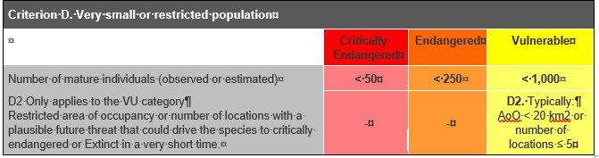

Evidence:
Ineligible under Criterion D
It is estimated that there are 20,000 to 30,000 mature individuals.

Criterion E (Quantitative Analysis) was not addressed as the taxon does not have a detailed Population Viability Analysis.

References
DSE (2009) Advisory list of threatened invertebrate fauna in Victoria - 2009. Department of Sustainability and Environment, Melbourne.
Miles (2010) Quantifying and Assessing Uncertainty in Climate Change Projections for Cool Temperate Rainforests of South-eastern Australia. Master's thesis. University of Melbourne.
New, T.R.; van Praagh, B.D. and Yen, A.L. (2012) Invertebrate conservation status and the limits of reliable information: Examples from Victoria, Australia. The Victorian Naturalist, 129 (3) 68-76.
SAC (2002). Flora and Fauna Guarantee Scientific Advisory Committee: Final Recommendation on a Nomination for Listing. Nomination No. 581 Geminoropa scindocataracta.
Stanisic, J; Shea, M; Potter, D; Griffiths, O. (2017). Australian Land Snails Volume 2 - A field guide to southern, central and western species. Bioculture Press Mauritius.

