Completing ResourceSmart actions: a quick guide
An important part of being a ResourceSmart School (RSS) is capturing the sustainability work you are doing. We do this in the ResourceSmart Schools Online system (RSS Online). Think of RSS Online as a repository for all the evidence of your sustainability journey. This guide can help you to get organised.

ResourceSmart Schools program snapshot
General
The RSS program has five modules.
To meet sustainability requirements of modules, schools must complete a set of actions. There are compulsory and recommended actions, which vary depending on the module.
Once the sustainability requirements are met, Sustainability Victoria will certify your module and your school will receive a certificate.
Once your school has completed a module, you can opt in for star progression. If you are successful, your school will receive a sign to display your stars.
Modules
The Core Module is focused on school operations.
The Biodiversity, Waste, Water and Energy Modules include actions that will assist your schools to reduce resource use, make cost savings, integrate sustainability into the curriculum and share learnings beyond the school gate.
You might choose to focus on one module at a time (this might sit well with a project you are undertaking) or dip into some or all the modules at the same time.

Step 1: Organise your supporting documentation
Many of the module actions require evidence to be uploaded. You can upload as many pieces of evidence as you want to an action. Some actions have specific requirements. More information about those can be found in the modules.
The system will allow you to upload a range of file formats
photos (jpeg format),
website links,
Word, Excel or PowerPoint documents
and PDFs work best.
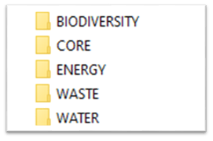
Be wary of uploading password-protected links. These can become obsolete, and we may not be able to access the material.
A great way to organise evidence is to create a folder for documents associated with each module on your computer. If this folder is in a shared drive, everyone can add documents to the folder. Refer to figure 1 as an example.

Figure 1. Image of folders using ResourceSmart Schools module names: Biodiversity, Core, Energy, Waste, and water.
Supporting documentation can take different forms. Some examples are:
Screenshot of social media posts
newsletters grabs
school policies
learning outlines and lesson plans
photos with captions
surveys/results
copies of emails
copies of student work
grant applications
action plans
school learning stories and/or
presentations notes, cue cards or slide decks.
Clear supporting documentation enables the person certifying your module to contextualise your school actions and reduces the need to provide further details.

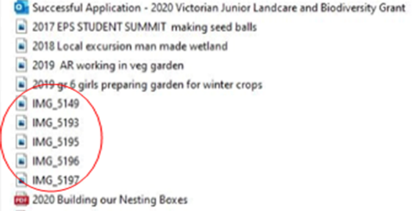
Step 2: Use naming conventions
Make sure the supporting documentation is accurately named. This makes it easy to find your files and when it comes to certifying the module.
Try to include a date or year in the document name.

Figure 2. Image of folder with documents. Some files are accurately named, reflecting a name convention, whereas other documents marked in the red oval have random names.
Refer to Figure 2 as an example. The documents out of the red oval are named in a way that someone who is unfamiliar with the school’s work can understand what the evidence refers to. However, the generic names in the red oval really are not clear.
Use a naming convention for your documents to help you keep track of your documentation and simplify certification.

Step 3: Check the module checklist to see if your evidence can be linked to multiple modules/actions
Each module has two key resource documents to support you:
Module checklists and
Quick Guides.
These are fantastic resources. Use these guides to check if your piece of evidence can support actions across modules.
For example: You have written a newsletter article that shows how the school is working hard to collect all your food waste. This is used to feed chooks, the worm farm and is also composted. The newsletter article will support actions in the Waste and Biodiversity modules.
If the work you are doing in this area has been linked to student learning – such as an understanding of soils, worms, waste reduction, you can link it to the Learning and Teaching Actions (B Actions) in both the Biodiversity and Waste modules.
Perhaps the newsletter article included some tips and tricks to help people start their own compost at home. Then you can also link this piece of evidence to Community and Communication Links actions (C Actions)
The trick here is to work smarter! Make a list of all the relevant actions addressed by the supporting evidence before you begin to upload.

Step 4: Writing a great comment
Many RSS actions require you to enter a comment. When writing these, consider:
- when,
- what,
- who and
- where.
For example: We participated in local biodiversity activities on July 7th. The grade 3 to 6 children attended a tree planting day coordinated by the Mytown Landcare group to increase biodiversity of the Best River nature reserve.

