Introduction
Biodiversity Response Planning (BRP) is a long-term area-based planning approach to biodiversity conservation in Victoria. It is designed to strengthen alignment, engagement and participation between government, Traditional Owners, non-government agencies and the community.
DELWP Regional staff have been working with stakeholders on actions to conserve biodiversity in specific landscapes, informed by the best available science and local knowledge.
These Fact Sheets capture a point in time, reflecting data and knowledge available in 2020. They provide information for many (but not all) landscapes across Victoria, containing general information on the key values and threats in each area, as well as the priority cost-effective actions that provide the best protection of biodiversity. Fact Sheets are intended to provide useful biodiversity information for the community, non-government and government organisations during project planning and development.
Further information and the full list of Fact Sheets is available on the Department’s Environment website.

Landscape description
This 33,623 hectare focus landscape is made up of Mountain ash (Eucalyptus regnans) within the Marysville area. Mountain Ash are the tallest flowering plant in the world; most mature trees are around 350 years old but can live to more than twice that age. This area was burnt severely during the 2009 Black Saturday bushfires.
This focus landscape was selected due to its key Ecological Vegetation Class (EVC): the Cool Temperate Rainforest which is classed as Endangered. Other EVCs such as Wet Forest, Damp Forest, and Herb-Rich Foothill Forest, contain habitat for species of phascogales, gliders and possums, some of which are threatened or endangered.
This landscape has a partial overlap with the Eastern Yarra Ranges landscape. For more information please refer to the Eastern Yarra Ranges Fact Sheet in the full list of Fact Sheets.

Cultural importance
We recognise that the entire landscape has high cultural value for Traditional Owners. Landscapes identified as having “notable” cultural importance are based on the density of recorded cultural heritage sites and knowledge shared by Traditional Owners. We also recognise that there are locations important to Traditional Owners that are not within this focus landscape. This area falls within the Country of the Taungurung and Wurundjeri Peoples.

Stakeholder interest
As part of the BRP process, in October 2020 stakeholders were asked to nominate focus landscapes, values, threats and potential biodiversity actions. DELWP, Parks Victoria, Trust for Nature, Goulburn Broken Catchment Management Authority, North East Catchment Management Authority, Taungurung Land and Waters Council, Yorta Yorta Nation Aboriginal Corporation, and the Alpine Resorts agreed on the boundaries and key aspects of this landscape.

Habitat Distribution Models identify 47 species with more than 5% of their Victorian range in this landscape area*
There are 45 plants with more than 5% of their Victorian range in this focus landscape, including:
- Shiny Nematolepis (Nematolepis wilsonii), which is Vulnerable, 35% of Victorian range in this landscape
- Lake Mountain Grevillea (Grevillea monslacana), which is Rare, 28% of Victorian range in this landscape
- Forest Sedge (Carex alsophila), which is Rare, 23% of Victorian range in this landscape
There is 1 mammal with more than 5% of their Victorian range in this landscape:
- The Leadbeater’s Possum (Gymnobelideus leadbeateri) listed as Endangered, 23% of Victorian range in this landscape
There is 1 bird with more than 5% of their Victorian range in this landscape:
- Large-billed Scrub-wren (Sericornis magnirostris) which has 5% of Victorian range in this landscape

Strategic Management Prospects
Strategic Management Prospects (SMP) models biodiversity values such as species habitat distribution, landscape-scale threats and highlights the most cost-effective actions for specific locations. More information about SMP is available in NatureKit.
*Please note that the SMP analysis was completed for a similar polygon, which was used as a base for discussion, but the data summary included here is not considered complete. Due to last minute boundary changes, the SMP modelled output is only an estimate. A further update will be provided as soon as possible – please contact the regional Natural Environment Programs team for updated information.

Additional threats
Threats to biodiversity (in addition to those modelled in SMP) identified through the consultation process are:
- timber harvesting
- inappropriate fire regimes
- degradation and fragmentation of habitat due to land use change (resulting from proximity to urban areas)
Some individual threatened species may also require targeted intervention to improve their future prospects beyond actions to manage landscape-scale threats.

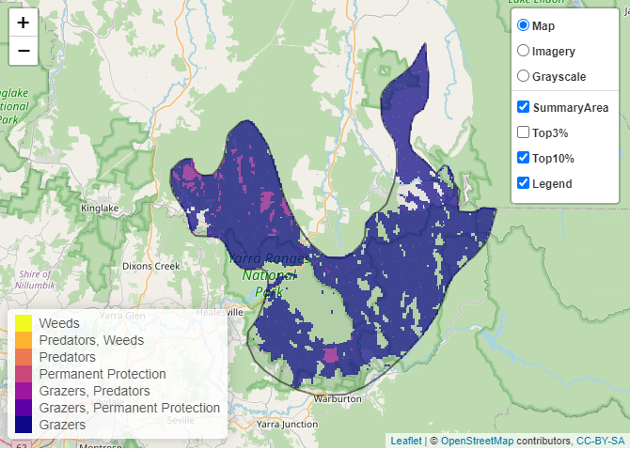
Which landscape-scale actions are most cost-effective in this landscape?
The coloured areas indicate where the identified landscape-scale actions and locations are most cost-effective and will maximise biodiversity benefit across Victoria for multiple species.

The three top actions of the Strategic Management Prospects (SMP) priority actions which rank among the top 10% for cost-effectiveness across the state for much of the landscape are:
Control deer 47,527 hectares
Control goats 26,851 hectares
Control total grazing pressure 6,060 hectares

Of the top 10% cost-effective actions, controlling deer provides the most cost-effective biodiversity benefits when considering the conservation of all flora and fauna in this landscape.
Other biodiversity protection and enhancement activities (in addition to those modelled in SMP) identified through the consultation process are:
- investment into re-seeding (Mountain and Alpine Ash) programs (thereby ensuring these areas can be suitably managed following severe or frequent bushfires)
- encouraging permanent protection on private land via Trust for Nature conservation covenants to increase area of protected and managed habitat and create connectivity
- invasive weed control
- surveys and monitoring for threatened species
Undertaking these activities on private land are important to assist with overall biodiversity enhancement and species management.

The most cost-effective action for flora and fauna
Plants, mammals, reptiles, birds, amphibians – Control deer

For a further in depth look into SMP for this landscape, please refer to NatureKit.

