|  |
| --- |
| Air Quality Improvement Precincts  2025 Grant Round |

|  |
| --- |
| Acknowledgment  We acknowledge and respect Victorian Traditional Owners as the original custodians of Victoria's land and waters, their unique ability to care for Country and deep spiritual connection to it. We honour Elders past and present whose knowledge and wisdom has ensured the continuation of culture and traditional practices.  We are committed to genuinely partner, and meaningfully engage, with Victoria's Traditional Owners and Aboriginal communities to support the protection of Country, the maintenance of spiritual and cultural practices and their broader aspirations in the 21st century and beyond. |
| © The State of Victoria Department of Energy, Environment and Climate Action 2025  LogoThis work is licensed under a Creative Commons Attribution 4.0 International licence. You are free to re-use the work under that licence, on the condition that you credit the State of Victoria as author. The licence does not apply to any images, photographs or branding, including the Victorian Coat of Arms, the Victorian Government logo and the Department of Energy, Environment and Climate Change (DEECA) logo. To view a copy of this licence, visit <http://creativecommons.org/licenses/by/4.0/>  Disclaimer  This publication may be of assistance to you but the State of Victoria and its employees do not guarantee that the publication is without flaw of any kind or is wholly appropriate for your particular purposes and therefore disclaims all liability for any error, loss or other consequence which may arise from you relying on any information in this publication.  Accessibility  If you would like to receive this publication in an alternative format, please telephone the DEECA Customer Service Centre on 136186, email [customer.service@deeca.vic.gov.au](mailto:customer.service@deeca.vic.gov.au) or via the National Relay Service on 133 677 [www.relayservice.com.au](http://www.relayservice.com.au). This document is also available on the internet at [www.deeca.vic.gov.au](http://www.deeca.vic.gov.au). |

Contents

1. What is the AQIP program? 2

2. Who can apply? 2

3. Who cannot apply? 3

4. What might be funded? 3

5. What will not be funded? 4

6. What are the funding details? 4

7. What are the assessment criteria? 4

8. What supporting documents will need to be provided? 5

9. What are the funding conditions? 5

10. What is the application process? 6

11. Additional information 7

12. What is the notification process? 7

13. Key dates 7

14. Checklist 7

15. Where are the Air Quality Improvement Precincts? 8

# 

## What is the AQIP program?

The Air Quality Improvement Precinct program provides grants to eligible applicants for initiatives that improve air quality in specific areas with high levels of pollution.

The AQIP areas are shown at the end of these guidelines (**Where are the Air Quality Improvement Precincts?**)

The Victorian Government is funding these grants to address the issues of poor air quality. The primary goal of the AQIP program is to reduce air pollution in areas with poor air quality, particularly in urban regions affected by industrial, transport, and other pollution sources.

## Who can apply?

This round of AQIP grants is open to the below organisations, either located in or whose projects significantly benefit Victoria’s Inner or Outer West Precincts, both at the time of application and for the project’s duration:

* Municipal councils
* Citizen science groups connected to established non-government programs, organisations or associations with an air quality purpose, connection or interest
* Peak bodies and incorporated associations/organisations with an air quality purpose, connection or interest
* Research/academic institutions
* Not-for-profit incorporated associations
* Private and non-government organisations, including small business and associated business groups
* Schools.

Applicants must:

* Have a current Australian Business Number (ABN). If the applicant is a Trust, the Trust as the trading entity must meet this requirement. If the applicant is a Citizen Science Group, the associated program, organisation or association must meet this requirement
* be an incorporated body, cooperative or association (including business associations)
* Be able to demonstrate financial viability to undertake the project
* Agree to comply with the Terms of Participation in Grant Programs
* Agree to comply with the Funding Agreement Terms and Conditions.

Eligible businesses may apply either as a single organisation or as a Collaborative Partnership involving multiple businesses. If applying as a Collaborative Partnership, a Lead Applicant must be designated. The Lead Applicant serves as the responsible Contracting Party, accountable for both the application and project delivery, including the coordination of Collaborative Partners. Grant funding will be received solely by the Lead Applicant.

Applicants (and their Related Entities and, if applicable, their Project Partners and/or Project Participants) must:

* have had no Environmental, Safety or Workplace Breaches in the last five years or, if there was a breach, we may assess that the Applicant’s breach poses a satisfactory level of risk
* have not been the subject of an enforceable undertaking or successful litigation by the Fair Work Ombudsman for a breach of the *Fair Work Act 2009* or a fair work instrument within the last five years
* demonstrate financial capability to undertake the project
* have adequate insurance as outlined in the funding agreement such as:
* Public liability $10M minimum
* Professional indemnity $5M minimum
* WorkCover
* have not failed to satisfactorily progress or complete previous projects funded by DEECA within funding program timelines and without sufficient reason
* manage any conflicts of interest adequately.

**Note**: If the applicant is a Trust, the Funding Agreement must be executed by the Trustee of the Trust, for instance, XYZ Pty Ltd acting as The Trustee for the XYZ Trust. The Trust, as the trading entity, must meet all the fund's eligibility requirements (for example, having an ABN).

### **Auspice information**

Applicants who are unincorporated entities can still apply for funding but must operate under an Auspice organisation that meets the eligibility. An Auspice organisation will be required to enter the Common Funding Agreement and agree to provide:

* financial management of the grant funds
* accountability for project deliverables and acquittal
* responsibility for the project's occupational health and safety requirements
* a letter of support from the Auspice organisation agreeing to auspice the project application.

## Who cannot apply?

The following organisations and individuals cannot apply for funding:

* individuals, including Sole traders
* State Government departments, agencies or statutory authorities.

## What might be funded?

Projects must be implemented within, or adjacent to the AQIP areas and demonstrate clear benefits to the air quality of the region.

Projects must have a measurable impact on reducing air pollution or mitigating its effects, such as by reducing emissions, enhancing monitoring systems, or fostering community awareness and behaviour change.

### Stream 1: Capital works and infrastructure or asset upgrades

Projects funded under this Stream will contribute toward improving air quality through capital, technological, or infrastructural works or upgrades. Interventions will result in minimising, mitigating or eliminating localised PM2.5 or PM10 emissions produced through smoke or dust.

Grant funding under this category may include, but are not limited to the following:

* Air pollution control equipment that reduces smoke and dust, such as scrubbers, electrostatic precipitators, bag houses or filters.
* Installing hardstands or sealing work areas and private roadways to reduce dust.
* Wheel washing stations to remove dust from trucks and vehicles before leaving site.
* Upgrades to mobile or fixed plant to reduce PM2.5 and PM10 emissions from non-road diesel engines.
* Misting sprays along fence boundaries to suppress dust.
* Planting of vegetation barriers.
* Other innovative solutions that will reduce the emission of smoke and dust.

### Stream 2: Innovation and collaboration

Projects funded under this stream will support innovative technologies to reducing localised air pollution or support collaborations across groups / individuals.

Projects funded under this category may include, but are not limited to the following:

* Implementing or revising instruments (such as EPA Better Environment Plans or licences) that adopt innovative, collaborative, or best practice approaches to reducing localised pollution, going beyond mere compliance.
* Research, deployment or testing of emerging technologies.
* Developing local strategies to reduce ambient air pollution and its impacts.
* Addressing gaps in air quality research, data collection, or information.
* Enhancing access to information on air pollution levels, trends, and sources.

### Stream 3: Place-based strategies or initiatives

Developing / implementing place-based strategies or initiatives, aimed at improving capacity to identify and manage sources of air pollution.

Projects funded under this category may include, but are not limited to the following:

* Community-based monitoring such as setting up local networks to engage residents in tracking air quality in their area.
* Public awareness campaigns to raise awareness about air pollution sources and encourage behaviour changes, such as reducing car usage or promoting the use of cleaner energy sources.
* Developing and implementing strategies within a specific area to reduce emissions from major pollution sources, such as industrial facilities, transport, or household heating.
* Policy changes or regulatory pilot programs such as changes to local planning laws or stricter local emission standards.
* Implementing localised program designed to change habits, such as promoting cycling or public transport.

## What will not be funded?

The AQIP program will not fund the following activities:

* the purchase of land
* routine or ongoing maintenance activities
* activities that have already started
* where duplicate services are in operation or planned for in a targeted community
* recurrent operating costs, for example rent and utility costs, and/or activities establishing expectations of ongoing funding
* activities located outside the State of Victoria
* Projects undertaken to comply with regulation or a regulatory notice or order
* Projects that have received funding or support for the same activities from other sources, including other grant programs
* Projects that do not meet regulatory or planning requirements.

The following costs are ineligible for funding:

* All expenditure items that are not directly related to the project
* Operational expenses that are considered as ongoing costs
* Personal expenses
* Lease or purchase of land
* Routine or cyclical maintenance works
* Repair of facilities damaged by vandalism, fire or other natural disasters where damage should be covered by insurance
* Internal project management costs
* Pre-construction (site preparation) such as site clearing, earthworks or site accessibility works
* Marketing, advertising, and promotional costs
* Equipment leasing
* Contingency costs
* Fuel costs
* Trucks or vehicles (fleet or other) and costs associated with modifying trucks, cars or motor vehicles.

## What are the funding details?

The Victorian Government is investing up to $1 million through the Air Quality Improvement Precincts program. There is no cap on funds that applicants can apply for. Projects must be completed by 30 June 2026.

Preference will be given to Stream 1 projects, or projects that result in measurable air quality improvements.

Grant funding will not fund projects that have commenced before the applicant is notified, in writing, that their grant application has been successful.

**Note:** if applicants fail to execute a Funding Agreement, their eligible costs will not be reimbursed.

C Co-contribution from the applicant is not a requirement, but it may be included as part of the application, particularly if the proposal exceeds the funding limits of this grant program. **Applications that demonstrate co-contribution will be prioritised**. While not mandatory, offering co-contribution will be considered a positive factor during evaluation and will strengthen the overall application.

Applicants’ contributions can be financial or in-kind.

## What are the assessment criteria?

First, applications will be checked for eligibility to make sure that the applicant and their activity are eligible for funding. After that, eligible applications will be assessed using the criteria listed below. Each criterion is given a percentage weighting to indicate its relative importance in the assessment process. Applications should address all relevant criteria.

### What? 30%

* All - Describe how the proposal aligns with the program criteria.
* Stream 1: Describe the infrastructure or capital works to be undertaken. Demonstrate relationship between works undertaken and reduction of localised PM2.5 or PM10 air pollution. If purchasing equipment, explain why it is essential for the project and how the equipment will specifically reduce PM2.5 and PM10 emissions.
* Stream 2: Describe how the proposal supports innovative technologies or supports collaborations to improve localised air quality. Describe whether the proposal demonstrates any other innovation or creativity such as the introduction of novel approaches or methodologies to address air quality issues.
* Stream 3: Describe what behaviour or capacity improvements will be targeted by the place-based strategy or proposed programs. Demonstrate the relationship between these behaviours and air pollution or air quality.

### Why? 30%

* Demonstrate why the project will help address the AQIP program’s objective of reducing localised PM2.5 and PM10 air pollution. Applications should include a clear rationale for the proposed project and how it has been identified as important or priority.

### Who? 20%

* Demonstrate that the applicant and/or collaborative partners (if relevant) has the appropriate expertise, capability, and capacity to deliver the project.

### How? 20%

* Describe how the project will be delivered including key steps, an overview of the project timeline, and details of who will oversee and manage the program of works.
* Include clear and realistic project plan, timeline, and budget.
* Justification of costs and clear demonstration of efficient use of grant funds.

## What supporting documents will need to be provided?

Please submit the following documents with your application:

1. evidence of confirmation of other funding sources
2. written consent from the relevant public land manager or private landowner to undertake the activity
3. approval for appropriate works permit/s from councils or other authorities
4. A project budget, outlining anticipated costs and sources of funding
5. CVs or credentials of key project personnel
6. Letters of support from partners or stakeholders (if applicable)
7. Evidence of experience with similar projects or initiatives (optional but recommended)

## What are the funding conditions?

### Funding agreements

Successful applicants must enter into a funding agreement with Department of Energy, Environment and Climate Action (DEECA). The Victorian Common Funding Agreement is used for funding agreements with not-for-profit organisations and Local Government Authorities.

It is recommended that applicants review the terms and conditions before applying. Information about the Victorian Common Funding Agreement is available on <https://www.vic.gov.au/victorian-common-funding-agreement>

The activity does not include using the Funding for political campaigning or advocacy activities for political parties.

### Legislative and regulatory requirements

In delivering the activity grant recipients are required to comply with all relevant Commonwealth and state/territory legislations and regulations, including but not limited to:

* *The Privacy Act 1988 (Commonwealth)*
* *The Freedom of Information Act 1982 (Vic)*
* *Occupational Health and Safety Act 2004*
* *Environment Protection Act (2017)*

### Tax implications

Applicants should consult the Australian Taxation Office or seek professional advice on any taxation implications that may arise from this grant funding.

### Acknowledging the Victorian Government’s support

Successful applicants are expected to acknowledge the Victorian Government’s support and promotional guidelines (<https://www.deeca.vic.gov.au/grants>) will form part of the funding agreement. Successful applicants must liaise with the departmental program area to coordinate any public events or announcements related to the project.

### Payments

Payments will be made as long as:

* the funding agreement has been signed by both parties;
* grant recipients provide reports as required, or otherwise demonstrate that the activity is progressing as expected;
* other terms and conditions of funding continue to be met.

### Due Diligence Checks

We may conduct due diligence checks on the Project Partners and/or Project Participants involved in the delivery of the project. The Applicant must ensure that any Project Partners and/or Project Participants agree to cooperate with this requirement and will provide information at DEECA’s request.

We reserve the right not to award funding to Applicants where the due diligence risk (including that of Project Partners and Project Participants) is unsatisfactory or not able to be managed.

### Monitoring

Grant recipients are required to comply with project monitoring and reporting requirements as outlined in the funding agreement. This may include progress reports, site inspections, completion reports and acquittal documentation.

### Privacy

Any personal information about you or a third party in your application will be collected by the department for the purposes of administering your grant application and informing Members of Parliament of successful applications. Personal information may also be disclosed to external experts, such as members of assessment panels, or other Government Departments for assessment, reporting, advice, comment or for discussions regarding alternative or collaborative grant funding opportunities. If you intend to include personal information about third parties in your application, please ensure that they are aware of the contents of this privacy statement.

Any personal information about you or a third party in your correspondence will be collected, held, managed, used, disclosed or transferred in accordance with the provisions of the *Privacy and Data Protection Act 2014* and other applicable laws.

DEECA is committed to protecting the privacy of personal information. You can find the DEECA Privacy Policy online at www.deeca.vic.gov.au/privacy.

Requests for access to information about you held by DEECA should be sent to the Manager Privacy, P.O. Box 500 East Melbourne 8002 or contact by emailing [Foi.unit@deeca.vic.gov.au](mailto:Foi.unit@deeca.vic.gov.au).

## What is the application process?

Applications are submitted online using the Grants Online portal.

To apply, go to the grant program web page <http://www.environment.vic.gov.au/grants/AQIP-grants-2025> and click on the ‘Start New Application’ button. To return to a saved draft application, click on the ‘Access Saved Application’ button.

### Attaching required documents:

Supporting documents must be in an acceptable file type, such as Word, Excel, PDF, or JPEG. The maximum file size for each file is 10MB.

You will receive an application number when you submit an application online. Please quote this number in all communications with the department relating to your application.

If you have documents to submit that cannot be attached to your online application you can email them to [grantsinfo@deeca.vic.gov.au](mailto:aqip@deeca.vic.gov.au), quoting your application number. Attach all documents to one email, zipping the files if required.

Make sure your application is submitted by **5pm AEST on 10 June 2025.**

**Note:** No hard copy applications will be accepted. Late and incomplete applications will not be considered.

## Additional information

Additional information is available at the program web page.

|  |
| --- |
| If you require assistance submitting your application online, email grantsinfo@deeca.vic.gov.au. |

## What is the notification process?

Successful and unsuccessful applicants will be notified in writing after the assessment process is completed. All decisions are final and are not subject to further review. Unsuccessful applicants can ask for feedback on their application.

## Key dates

|  |  |
| --- | --- |
| Applications open | 13 May 2025 |
| Applications close | 10 June 2025 |
| Applicants notified | July 2025 |
| Activities completed and acquittal reports submitted | 30 June 2026 |

## Checklist

Read these guidelines and the information about this grant program at the grant webpage before applying and complete the following checklist.

Have you:

* Read these guidelines carefully?

* Checked if your organisation is eligible for this grant funding?

* Checked if your activity is eligible for this grant funding?

* Checked that you would be able to comply with all relevant laws and regulations in delivery of your activity?

* Prepared the appropriate supporting documents?

## Where are the Air Quality Improvement Precincts?

The image below shows the two AQIP areas:

* **Outer West** precinct covering parts of the local government areas of Brimbank, Maribyrnong, Hobsons Bay, Wyndham and Melton
* **Inner West** precinct covering parts of the local government areas of Melbourne, Port Phillip, Maribyrnong and Hobsons Bay.

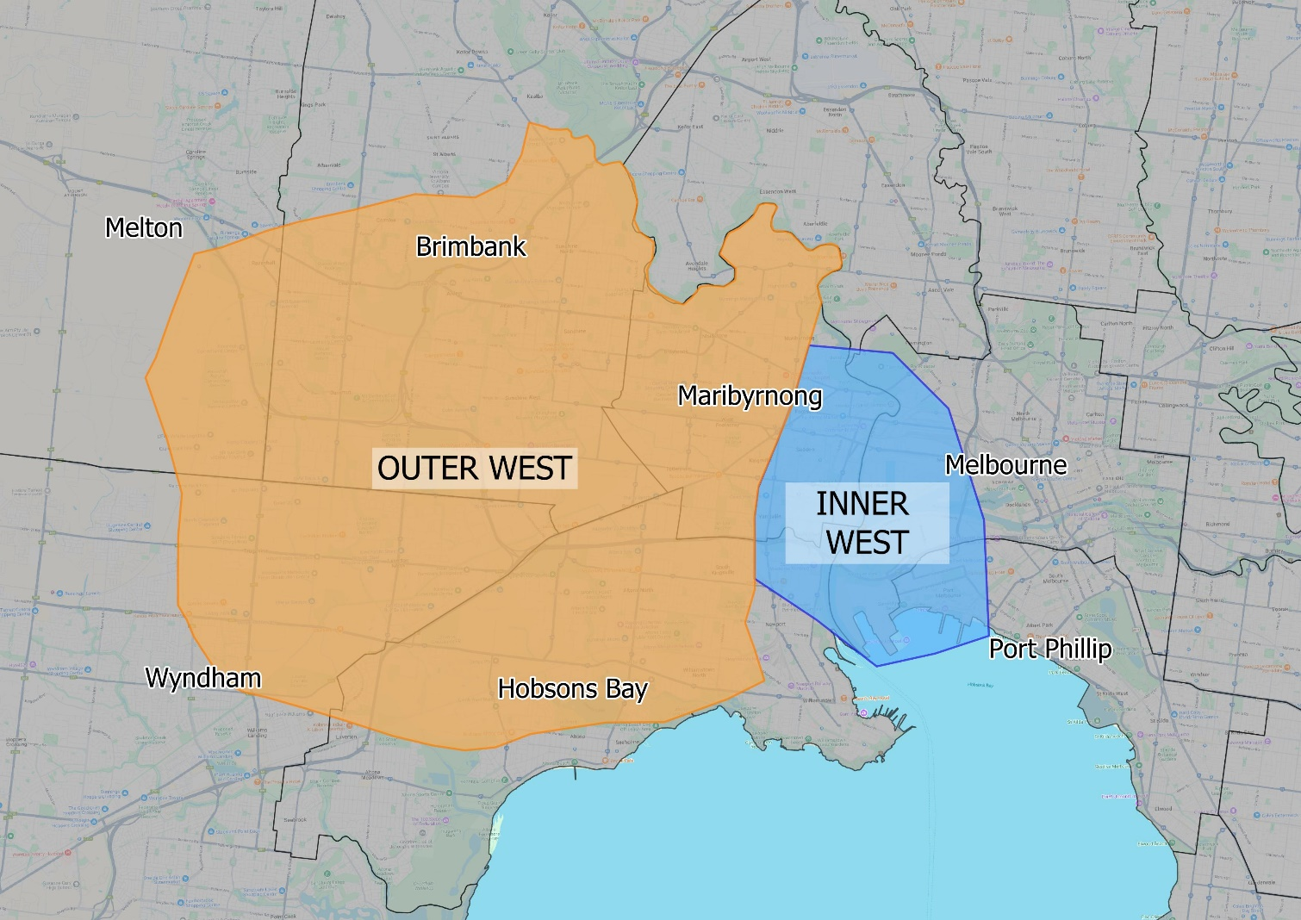

deeca.vic.gov.au