Introduction
Biodiversity Response Planning (BRP) is a long-term area-based planning approach to biodiversity conservation in Victoria. It is designed to strengthen alignment, engagement and participation between government, Traditional Owners, non-government agencies and the community.
DELWP Regional staff have been working with stakeholders on actions to conserve biodiversity in specific landscapes, informed by the best available science and local knowledge.
These Fact Sheets capture a point in time, reflecting data and knowledge available in 2020. They provide information for many (but not all) landscapes across Victoria, containing general information on the key values and threats in each area, as well as the priority cost-effective actions that provide the best protection of biodiversity. Fact Sheets are intended to provide useful biodiversity information for the community, non-government and government organisations during project planning and development.
Further information and the full list of Fact Sheets is available on the Department’s Environment website.

Landscape description
This 8,703 hectare Focus Landscape covers the Mountain ash (Eucalyptus regnans) forest within Kinglake National Park. Mountain Ash are the tallest flowering plant in the world; most mature trees are around 350 years old and can live to more than twice that age. This area was burnt severely during the 2009 Black Saturday bushfires.
This landscape was selected due to the Ecological Vegetation Classes (EVCs) present, namely Wet Forest, Damp Forest and Herb-Rich Foothill Forest. These forests contain habitat for species such as phascogales, gliders and possums, some of which are threatened or endangered.
This landscape has a partial overlap with the North East Region Focus Landscape. For more information, please refer to the North East Region Fact Sheet in the full list of Fact Sheets.

Cultural importance
We recognise that the entire landscape has high cultural value for Traditional Owners. Landscapes identified as having “notable” cultural importance are based on the density of recorded cultural heritage sites and knowledge shared by Traditional Owners. We also recognise that there are locations important to Traditional Owners that are not within this focus landscape. This area falls within the Country of the Taungurung and Wurundjeri Peoples.

Stakeholder interest
As part of the BRP process, in October 2020 stakeholders were asked to nominate focus landscapes, values, threats and potential biodiversity actions. DELWP, Parks Victoria, Trust for Nature, Goulburn Broken Catchment Management Authority, North East Catchment Management Authority, Taungurung Land and Waters Council, Yorta Yorta Nation Aboriginal Corporation, and the Alpine Resorts agreed on the boundaries and key aspects of this landscape.

Strategic Management Prospects
Strategic Management Prospects (SMP) models biodiversity values such as species habitat distribution, landscape-scale threats and highlights the most cost-effective actions for specific locations. More information about SMP is available in NatureKit.
*Please note that the SMP analysis was completed for a similar polygon, which was used as a base for discussion, but the data summary included here is not considered complete. Due to last minute boundary changes, the SMP modelled output is only an estimate. A further update will be provided as soon as possible – please contact the regional Natural Environment Programs team for updated information.

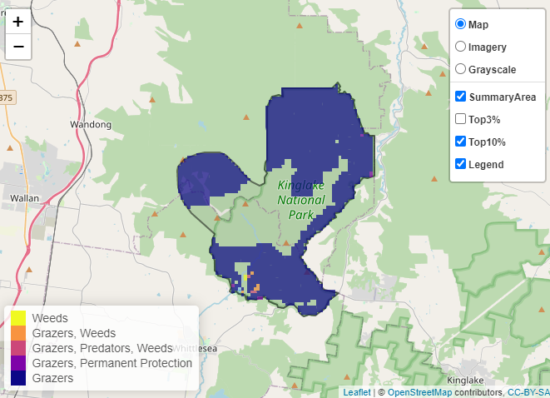
Which landscape-scale actions are most cost-effective in this landscape?
The coloured areas indicate where the identified landscape-scale actions and locations are most cost-effective and will maximise biodiversity benefit across Victoria for multiple species.
The top three SMP priority actions which rank among the top 10% for cost-effectiveness of that action across the state are shown on the map and listed below.

Control pigs 8,571 hectares
Control goats 3,205 hectares
Control total grazing pressure
795 hectares

Of the top 10% of cost-effective actions, controlling pigs provides the most cost-effective biodiversity benefit when considering the conservation of all flora and fauna.
Other biodiversity protection and enhancement activities (in addition to those modelled in SMP) identified through the consultation process are controlling deer, which is considered to be a major threat in this landscape.
Current biodiversity management activities being undertaken include cat, fox and deer monitoring and control and weed control.

Additional threats
Threats to biodiversity (in addition to those modelled in SMP) identified through the consultation process were feral animals, including foxes, goats, pigs and deer.
Some individual threatened species may also require targeted intervention to improve their future prospects, beyond actions to manage landscape scale threats.

The most cost-effective action for flora and fauna
Plants, mammals, reptiles, birds, amphibians – Control pigs

For a further in-depth look into SMP for this landscape please refer to NatureKit.

