Introduction
Biodiversity Response Planning (BRP) is a long-term area-based planning approach to biodiversity conservation in Victoria. It is designed to strengthen alignment, engagement and participation between government, Traditional Owners, non-government agencies and the community.
DELWP Regional staff have been working with stakeholders on actions to conserve biodiversity in specific landscapes, informed by the best available science and local knowledge.
These Fact Sheets capture a point in time, reflecting data and knowledge available in 2020. They provide information for many (but not all) landscapes across Victoria, containing general information on the key values and threats in each area, as well as the priority cost-effective actions that provide the best protection of biodiversity. Fact Sheets are intended to provide useful biodiversity information for the community, non-government and government organisations during project planning and development.
Further information and the full list of Fact Sheets is available on the Department’s Environment website.

Landscape description
The Box Gum Grassy Woodland focus landscape covers 242,118 hectares. A total of 27% of this landscape is covered by native vegetation, and 8% is listed as public land. Protection and enhancement of priority areas and remnant vegetation are of great importance within this fragmented landscape. Paddock tree protection and remnant enhancement is extremely important, as these elements act as refuges for biodiversity and create connectivity within the landscape.

Cultural importance
We recognise that the entire landscape has high cultural value for Traditional Owners. Landscapes identified as having “notable” cultural importance are based on the density of recorded cultural heritage sites and knowledge shared by Traditional Owners. We also recognise that there are locations important to Traditional Owners not within these focus landscapes. This landscape includes areas within the Country of the Taungurung and Yorta Yorta Peoples respectively.

Stakeholder interest
As part of the BRP process, in October 2020 stakeholders were asked to nominate focus landscapes and actions of interest. Representatives from DELWP, Parks Victoria, Trust for Nature, Goulburn Broken Catchment Management Authority, North East Catchment Management Authority, Taungurung Land and Waters Council, Yorta Yorta Nation Aboriginal Corporation, and the Alpine Resorts agreed on this nominated area.
Habitat Distribution Models identified 106 species with more than 5% of their Victorian range in this landscape area
According to SMP, there are 92 Plants with more than 5% of their Victorian range in this polygon, notably:
- Lace leek-orchid (Prasophyllum aff. diversiflorum (North-east)) which is Endangered and has 42% proportional distribution,
- Petite Leek-orchid (Prasophyllum aff. petilum (Murchison)) also Endangered and with 41% proportional distribution, and
- Mueller Daisy (Brachyscome muelleroides) which is Endangered and has 39% proportional distribution.
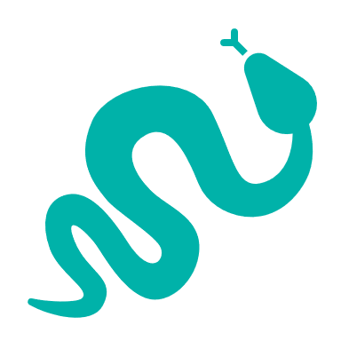 | There are 3 Reptiles with more than 5% of Victorian range in this polygon. These are:  - Southern Rainbow Skink (Carlia tetradactyla) with a 9% proportional distribution,  - Dwyer’s Snake (Parasuta dwyeri) with 6% proportional distribution, and  - Woodland Blind Snake (Ramphotyphlops proximus), which is Near Threatened, and has a proportional distribution of 5%.
There are 6 Birds with more than 5% of Victorian range within this polygon, which include:
- Grey-crowned Babbler (Pomatostomus temporalis temporalis) which is Endangered with 12% proportional distribution,
- Bush Stone-Curlew (Burhinus grallarius) which is Endangered with a 9% proportional distribution, and
- Brolga (Grus rubicunda) which is listed as Vulnerable and has a 6% proportional distribution.
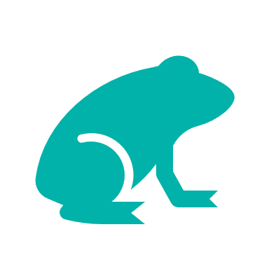 | There are 4 Amphibians with more than 5% of Victorian range in this polygon:  - Sloane’s Froglet (Crinia sloanei) with 11% proportional distribution,  - Giant Bullfrog (Limnodynastes interioris) which is Critically Endangered and has 10% proportional distribution,  - Rugose Toadlet (Uperoleia rugosa) which is Endangered and has 7% proportional distribution, and  - Pobblebonk frog (Limnodynastes dumerilii dumerilii) which has 5% proportional distribution.
 | 1 Mammal with more than 5% of Victorian range in this polygon, is the Squirrel Glider (Petaurus norfolcensis) which is Endangered and has a 12% proportional distribution.

Strategic Management Prospects
Strategic Management Prospects (SMP) models biodiversity values such as species habitat distribution, landscape-scale threats and highlights the most cost-effective actions for specific locations. More information about SMP is available in NatureKit.

Additional threats
In addition to those modelled in SMP, threats identified through the consultation process were:
- Noisy Miners, which impact Victorian Temperate Woodland bird communities (specifically impacting Swift Parrots and Regent Honeyeaters)
- Pest plants
- Pest animal (specifically foxes)
- Afforestation (where grassy woodlands are converting to forests, with loss of understorey biodiversity)
- Changing land use (from native pasture to cropping) causing major loss to native and derived native grasslands and grassy woodlands

Which landscape-scale actions are most cost-effective in this landscape?
The coloured areas on the map indicate where the landscape-scale actions and locations are most cost-effective and will maximise biodiversity benefit across Victoria for multiple species.
The top 3 actions of the SMP priority actions which rank among the top 10% for cost-effectiveness of that action across the state for much of the landscape are shown on the map and list.
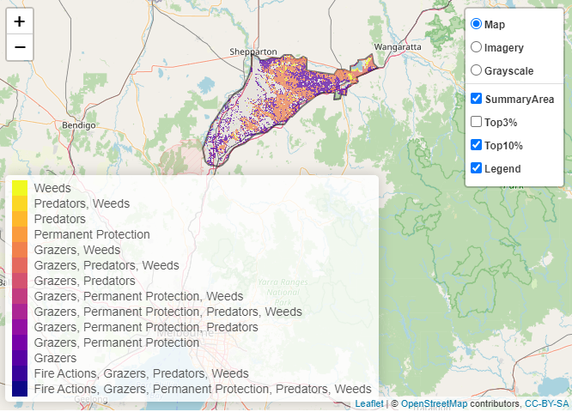

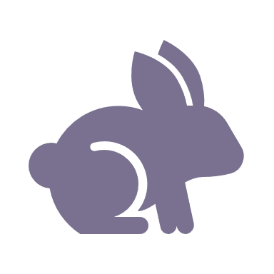 | Control rabbits 133,073 hectares
 | Control weeds 77,390 hectares
 | Control overabundant kangaroos 8,930 hectares

Of the top 10% of cost-effective actions, controlling rabbits provides the most cost-effective biodiversity benefits when considering all flora and fauna.
Biodiversity activities identified through the consultation process in addition to those modelled in SMP include:
- Revegetation is a key priority, and habitat restoration/improvement. Waterways in particular have been identified as under-protected, requiring revegetation, weed control and other management.
- By developing and enhancing biodiversity linkages with emphasis on private land, roadsides, linear reserves and within existing reserves to reduce fragmentation, we are developing resilient landscapes in changing climates.
- More responsive management of grazing by livestock has been recommended by partners.
There are also opportunities to continue and expand cultural burns in remnant reserves and private lands by Yorta Yorta, and to reintroduce traditional land management practices. Trust for Nature Permanent Protection Covenants are also suggested.
The most cost-effective action for flora and fauna:
Plants, Birds, Mammals, Amphibians, Reptiles – Control rabbits

For a further in depth look into SMP for this landscape please refer to NatureKit.
