Introduction
Biodiversity Response Planning (BRP) is a long-term area-based planning approach to biodiversity conservation in Victoria. It is designed to strengthen alignment, engagement and participation between government, Traditional Owners, non-government agencies and the community.
DELWP Regional staff have been working with stakeholders on actions to conserve biodiversity in specific landscapes, informed by the best available science and local knowledge.
These Fact Sheets capture a point in time, reflecting data and knowledge available in 2020. They provide information for many (but not all) landscapes across Victoria, containing general information on the key values and threats in each area, as well as the priority cost-effective actions that provide the best protection of biodiversity. Fact Sheets are intended to provide useful biodiversity information for the community, non-government and government organisations during project planning and development.
Further information and the full list of Fact Sheets is available on the Department’s Environment website.

Landscape description
The Lower Goulburn System covers an area of 38,584 hectares, of which 27% is public land and 38% is covered by native vegetation. The Goulburn catchment is Victoria’s largest river basin; it is an iconic heritage river because of its environmental, Aboriginal cultural heritage and recreational values. The Goulburn Weir regulates flows into the lower Goulburn system to meet irrigation, stock, domestic and urban demand. The Lower Goulburn River is an excellent example of a major floodplain system, consisting of a large area of habitat for fauna such as waterbirds and fish and containing a variety of wetland and vegetation types. The Lower Goulburn River is listed in the Directory of Important Wetlands in Australia as a wetland of national importance.

Cultural importance
We recognise that the entire focus landscape has high cultural value for Traditional Owners. Landscapes identified as having “notable” cultural importance are based on the density of recorded cultural heritage sites and knowledge shared by Traditional Owners. We also recognise that there are locations important to Traditional Owners that are not within this focus landscape. This area falls within the Country of the Yorta Yorta People.

Stakeholder interest
As part of the BRP process, in October 2020 stakeholders were asked to nominate focus landscapes, values, threats and potential biodiversity actions. Representatives from DELWP, Parks Victoria, Trust for Nature, Goulburn Broken Catchment Management Authority, North East Catchment Management Authority, Taungurung Land and Waters Council, Yorta Yorta Nation Aboriginal Corporation, and the Alpine Resorts agreed on the boundaries and key aspects of this landscape.

Strategic Management Prospects
Strategic Management Prospects (SMP) models biodiversity values such as species habitat distribution, landscape-scale threats and highlights the most cost-effective actions for specific locations. More information about SMP is available in NatureKit.

Habitat Distribution Models identified 1 species with more than 5% of their Victorian range in this focus landscape
Habitat Distribution Models identified one plant species with more than 5% of their Victorian range in this landscape area:
- Velvet Knotweed (Persicaria attenuata subsp. attenuata) which is ‘poorly known’ in terms of ecological needs and distribution and has a proportional distribution of 6%
Traditional Owners and other stakeholders also identified the following aquatic species of interest: Golden Perch, Macquarie Perch, Murray Cod

Which landscape-scale actions are most cost-effective in this landscape?
The coloured areas indicate where landscape-scale actions are most cost-effective and will maximise biodiversity benefit across Victoria for multiple species. The top three SMP priority actions, which rank among the top 10% for cost-effectiveness of that action across the state, are listed below:
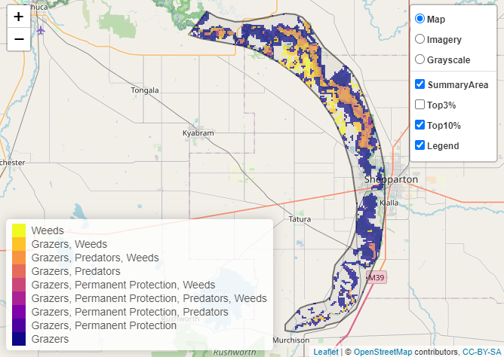

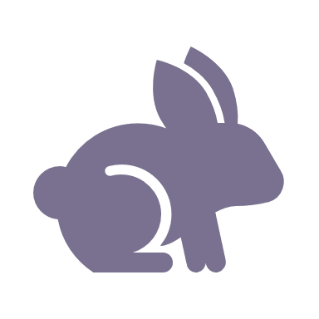 | Control rabbits 13,654 hectares
 | Control pigs 13,978 hectares
 | Control goats 11,558 hectares

Of the top 10% of cost-effective actions, controlling pigs provides the most cost-effective biodiversity benefits when considering all flora and fauna.
Biodiversity activities identified (in addition to those modelled in SMP) through the consultation process include deer control.

Additional threats
Threats identified through the consultation process (in addition to those modelled in SMP) are deer, as despite there currently being a relatively small population, stakeholders felt it was important to control.
Some individual threatened species may also require targeted intervention, beyond actions to manage landscape-scale threats, to improve their future prospects.

The most cost-effective actions for flora and fauna
 | Plants, Amphibians – Control rabbits
 | Birds – Control goats
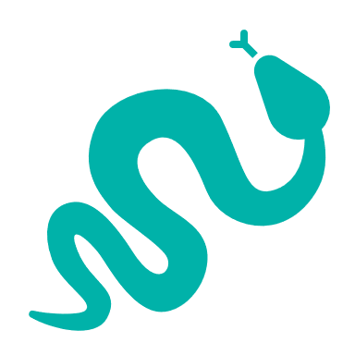 | Reptiles, Mammals – Control pigs

For a further in depth look into SMP for this landscape please refer to NatureKit.

