Introduction
Biodiversity Response Planning (BRP) is a long-term area-based planning approach to biodiversity conservation in Victoria. It is designed to strengthen alignment, engagement and participation between government, Traditional Owners, non-government agencies and the community.
DELWP Regional staff have been working with stakeholders on actions to conserve biodiversity in specific landscapes, informed by the best available science and local knowledge.
These Fact Sheets capture a point in time, reflecting data and knowledge available in 2020. They provide information for many (but not all) landscapes across Victoria, containing general information on the key values and threats in each area, as well as the priority cost-effective actions that provide the best protection of biodiversity. Fact Sheets are intended to provide useful biodiversity information for the community, non-government and government organisations during project planning and development.
Further information and the full list of Fact Sheets is available on the Department’s Environment website.

Landscape description
This 34,621ha focus landscape covers the Barmah National Park and Ramsar wetland located in northern Victoria. This area has a native vegetation cover of 70%, and 79% of the area is public land. Barmah-Millewa Forest is within the National Park and is considered is the largest River Red Gum forest in Australia. The Ramsar site encompasses a total of 66,000ha of wetland and is listed in the Directory of Important Wetlands in Australia.

Cultural importance
We recognise that the entire landscape has high cultural value for Traditional Owners. Landscapes identified as having “notable” cultural importance is based on the density of recorded cultural heritage sites and knowledge shared by Traditional Owners. We also recognise that there are locations important to Traditional Owners not within these landscapes of interest. This area falls within the Country of the Yorta Yorta People.

Stakeholder interest
As part of the BRP process, in October 2020 stakeholders were asked to nominate focus landscapes and actions of interest. DELWP, Parks Victoria, Trust for Nature, Goulburn Broken Catchment Management Authority, North East Catchment Management Authority, Taungurung Land and Waters Council, Yorta Yorta Nation Aboriginal Corporation, and the Alpine Resorts agreed on this nominated area.
There is a Joint Management Plan for Barmah National Park (between Yorta Yorta Nations Aboriginal Corporation and Parks Victoria).

Habitat Distribution Models identify 22 species with more than 5% of their Victorian range in this focus landscape
There are 21 plants with more than 5% of their Victorian range in this landscape area. Some of these include Velvet knotweed (Persicaria attenuata) which has approximately 31% proportional distribution, Mueller Daisy (Brachyscome muelleroides) which is Endangered and has a 28% proportional distribution, and Slender Love-grass (Eragrostis exigua) which is Endangered and has a 17% proportional distribution
Turtles are considered a totem animal for Yorta Yorta people, specifically Broad Shell and Eastern Long Neck turtles
The Superb Parrot (Polytelis swainsonii) which is Endangered, has an 8% proportional distribution (of its Victorian range located within this landscape)

Strategic Management Prospects
Strategic Management Prospects (SMP) models biodiversity values such as species habitat distribution, landscape-scale threats and highlights the most cost-effective actions for specific locations. More information about SMP is available in NatureKit.

Additional threats
Threats in addition to those modelled in SMP were identified through the consultation process. These include:
- Drought and river regulation which reduces the number of small to medium sized flood events. Provision of environmental water is used to counteract this and support flooding of the site, as well as adding to natural flows etc to reinstate flooding regimes.
- Feral animals including foxes, goats, pigs, horses, and rabbits are key threats to parts of this landscape.
- Threats to turtle populations include fox predation on both nests and adults. Impacts in some areas are managed through fox baiting programs which need to be maintained.
- Additional threats to turtles include inappropriate timing of watering regimes, which results in flooding and inundation of turtle nests.
- Some individual threatened species may also require targeted intervention, beyond actions to manage landscape-scale threats, to improve their future prospects.
The Murray-Darling Basin Authority’s The Living Murray Project includes activities at Barmah. More information can be found in the project’s summary and report card.

Which landscape-scale actions are most cost-effective in this landscape?
The coloured areas on the map below indicate the landscape-scale conservation actions and locations which are most cost-effective and will maximise biodiversity benefit for multiple species.
The top three SMP priority actions which rank among the top 10% for cost-effectiveness of that action across the state for much of the landscape are shown on the map and listed on the next page.

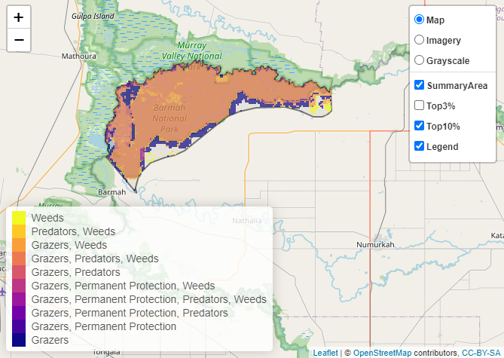
 | Control Pigs 31,038 hectares
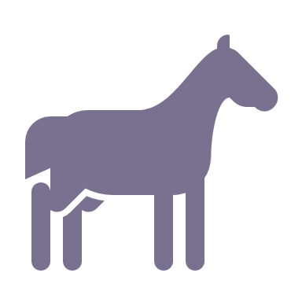 | Control Horses 29,393 hectares
 | Combined Horse and Pig Control 29,044 hectares

Of the top 10% cost-effective actions, controlling pigs provides the most cost-effective biodiversity benefits when considering benefit to all flora and fauna.
Biodiversity activities (in addition to those modelled in SMP) identified through the consultation process were fencing to exclude stock, undertaking revegetation and weed control, and feral animal control (specifically fox, goat, pig, and rabbit). It has also been identified that feral horses within Barmah and the surrounding landscape are a major management issue.

The most cost-effective actions for flora and fauna
Plants – Control total grazing pressure (all grazers)
Mammals, Birds, Amphibians and Reptiles – Control cats and foxes
For a further in depth look into SMP for this focus landscape, please refer to NatureKit.

