More Trees for Melbourne Funding Guidelines
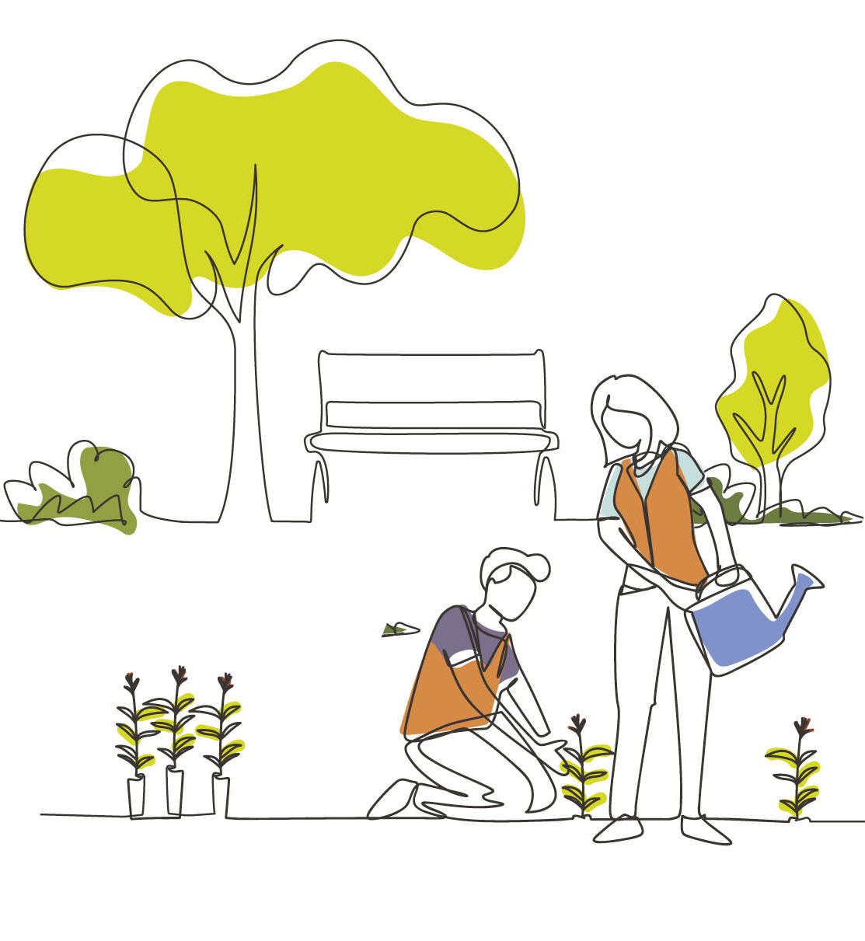
environment.vic.gov.au/more-trees
Table of Contents
What is the More Trees for Melbourne Program? 4
This program aims to: 5
Stream 1: More Trees for Melbourne 6
Who can apply for Stream 1? 7
Stream 1b: RAP specific funding arrangements and application process 8
Stream 2: Cooler Melbourne Streets 9
Who can apply for Stream 2? 9
Who cannot apply? 10
What might be funded? 11
Stream 1 – More Trees for Melbourne 11
Stream 2 – Cooler Melbourne Streets 11
What will not be funded? 12
What are the funding details? 13
Stream 1 – More Trees for Melbourne 13
Stream 2 – Cooler Melbourne Streets 14
What are the assessment criteria? 15
Program-wide criteria 15
Stream 1b: Planting on Country assessment criteria 20
What supporting documents will need to be provided? 21
What are the funding conditions? 22
Funding agreements 22
Legislative and regulatory requirements 22
Tax implications 23
Acknowledging the Victorian Government’s support 23
Payments 23
Monitoring 23
Privacy 24
What is the application process? 25
Attaching required documents 25
Additional information 25
What is the notification process? 25
Key dates 26
Publication information 28
Acknowledgement of Victorian Traditional Owners 28
Copyright 28
Creative Commons 28
Disclaimer 28
Accessibility 29

What is the More Trees for Melbourne Program?
In 2018, Metropolitan Melbourne had an urban tree canopy cover of 15.3%. Since then, the Victorian Government has been investing in cooling and greening priority areas in Melbourne’s west since 2021 through the More Trees for a Cooler Greener West program.
In 2025 a further $9.5 million investment was announced to improve canopy cover and reduce the impacts of heat vulnerability through the More Trees for Melbourne program. This program aims to plant 500,000 trees in urban areas with the lowest tree canopy cover.
Planting trees provides benefits including:
- Increasing the urban forest and canopy cover for increased shading and cooling.
- Increasing biodiversity by planting a variety of tree sizes and species and contributing to wildlife corridors.
- Reducing urban temperatures, which will help reduce heat-related illness and death. Canopy trees not only cool the surrounding air, but can reduce the temperature of surfaces they shade (e.g. buildings and roads) by 10-25°C.
- Helping clean the air by filtering pollutants and providing oxygen, as well as helping meet Victoria’s goal of net-zero emissions by 2045.
- Providing more accessible green spaces for urban residents for recreation and amenity to increase connections with nature and improve mental and physical health.
- Improving stormwater management through increased filtering and reduced runoff.

Climate change continues to impact Victorians, irrespective of where they live, but the impact of extreme heat in metropolitan areas creates heat islands in Melbourne’s suburbs that increase the risks of heat vulnerability and the associated environmental, economic, social and health impacts.
This program will provide more shade and green spaces, drive down pollution, reduce the impacts of urban heat and improve air quality. The new trees will assist Victoria in achieving world-leading targets to cut the state’s greenhouse gas emissions and achieve net zero emissions by 2045.
The Victorian Government recognises that not all areas of Melbourne are suitable for increasing canopy cover through tree planting and all Victorians deserve the opportunity to be surrounded by nature and reap the extensive benefits of living in a greener, cooler environment.
The More Trees for Melbourne program is making funding available through two targeted funding streams to keep Melbourne as the world’s most liveable and coolest cities.

This program aims to:
- Contribute to urban cooling and greening in Melbourne by planting more trees and reducing heat island effects.
- Improve comfort, safety and amenity in busy urban areas that support economic growth and community connection, such as local shopping strips.
- Increase shade in pedestrian movement networks that connect neighbourhoods or transport routes.
- Support more resilient and liveable urban environments for communities, workers and visitors.
Increase community connection to nature and support biodiversity outcomes.

Stream 1: More Trees for Melbourne
Funding is available to increase the tree canopy in local government areas with low tree canopy and high heat vulnerability.
The Heat Vulnerability Index includes 2 key dimensions:
- Heat Sensitivity – how susceptible a community is to the effects of heat, based on age, health conditions, population density and the local built environment.
- Adaptive Capability – how well people can respond, including the ability to afford cooling or access green space and community support.
Heat Vulnerability Scoring ranges from 1 – low vulnerability – low exposure, low sensitivity or high adaptive capacity to 5 – high vulnerability – high exposure, high sensitivity (dense population) or low adaptive capacity.
Figure 1: Map showing the Heat Vulnerability Index for Melbourne
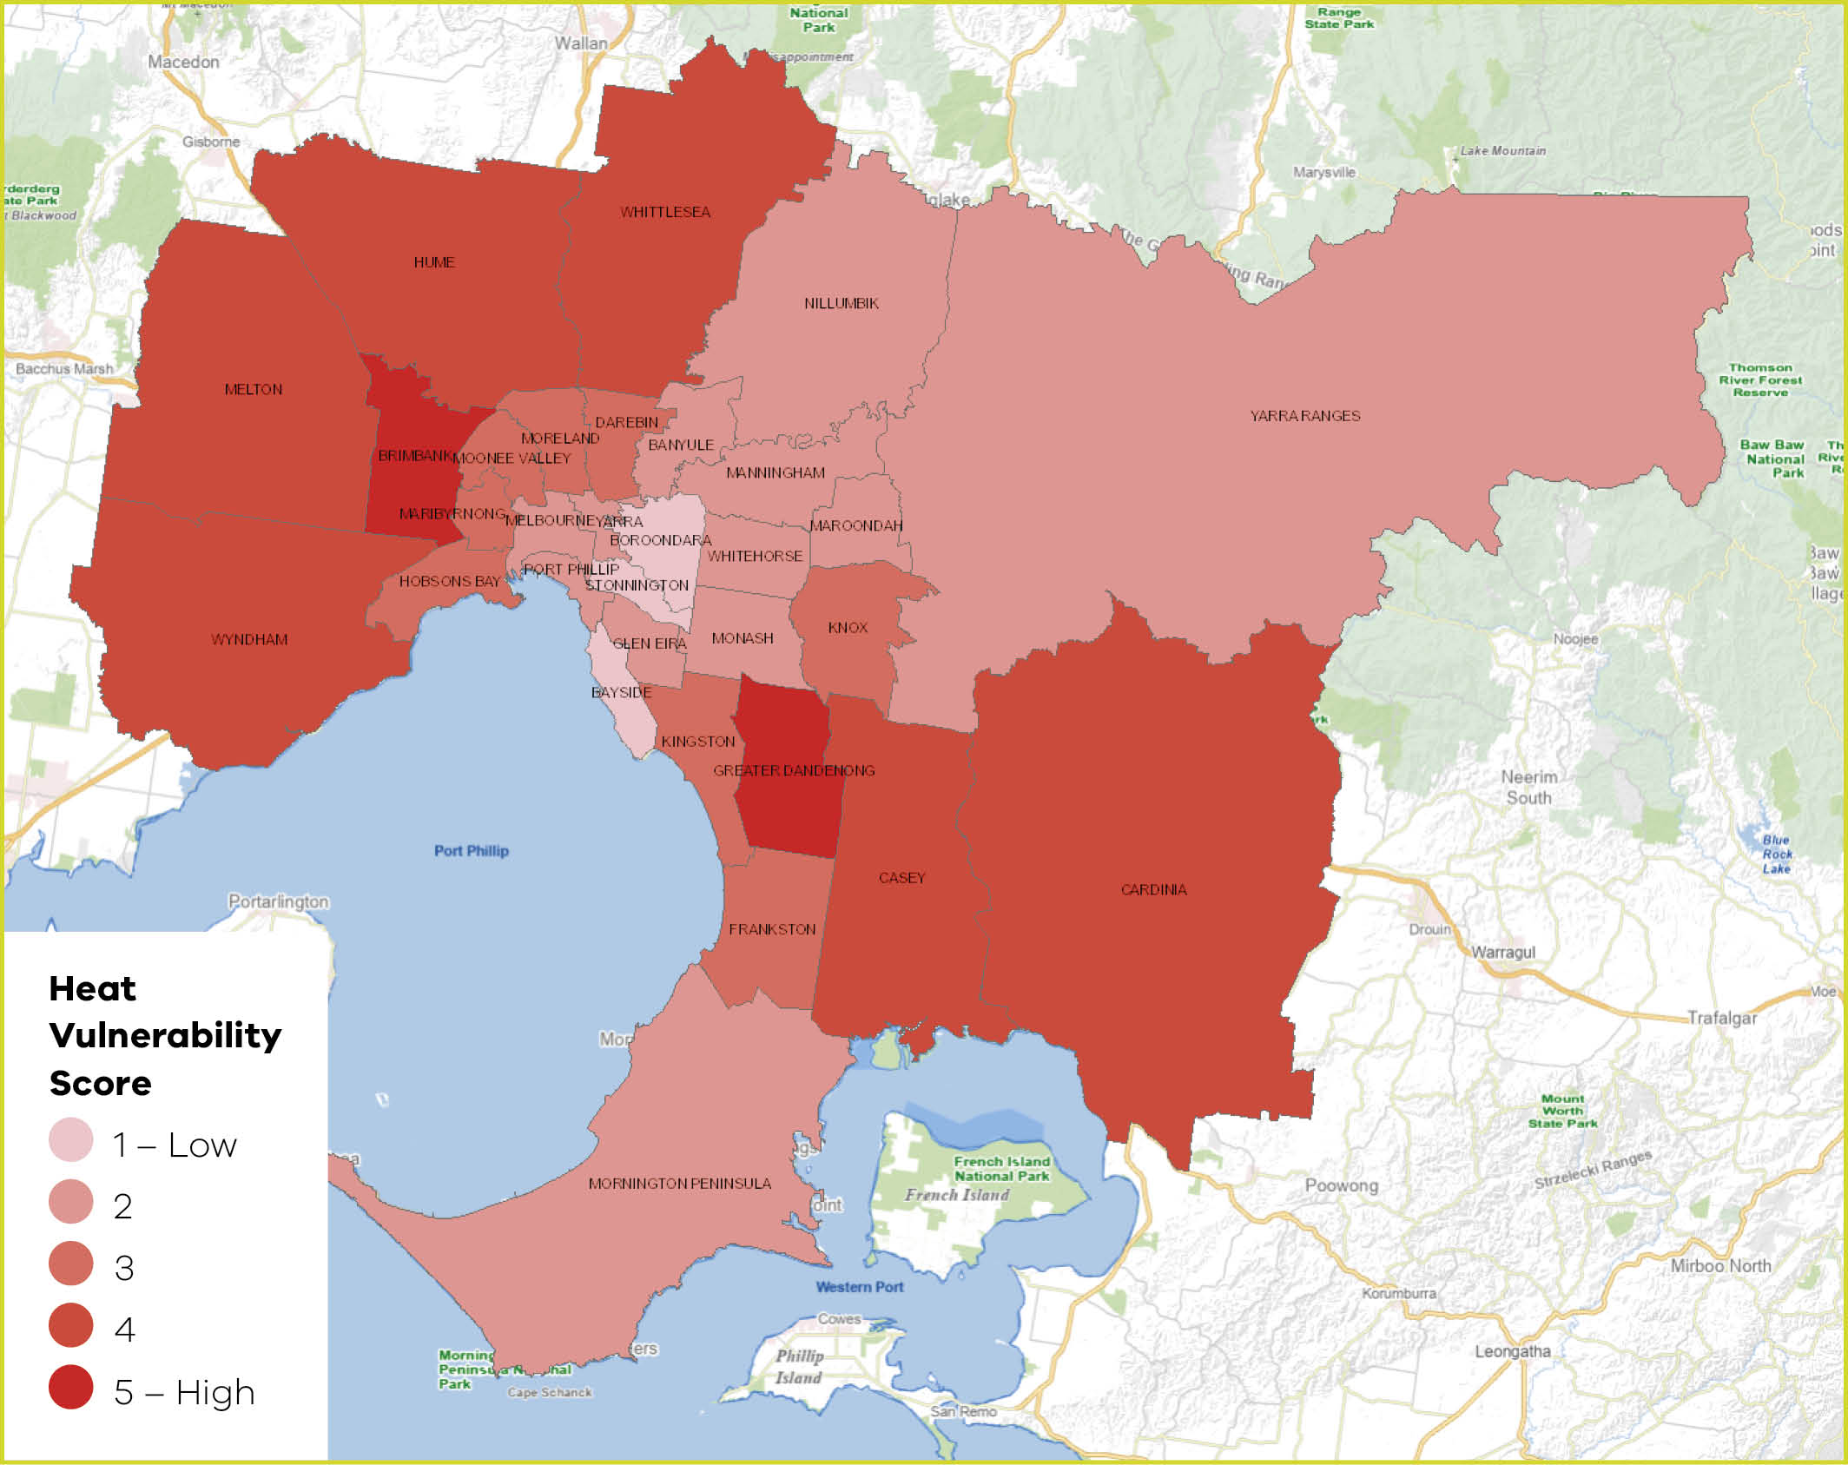

Who can apply for Stream 1?
This funding stream will provide funds for tree planting projects located predominantly on public land within any of the following Local Government Areas (LGAs) of Melbourne, which are classified as having a heat vulnerability index of above 3.
Table 1: Local Government Area (LGA) | Heat Vulnerability Index score
Local Government Area | Score
Brimbank City Council | 5
Greater Dandenong City Council | 5
Wyndham City Council | 4
Melton City Council | 4
Hume City Council | 4
Whittlesea City Council | 4
Cardinia Shire Council | 4
Casey City Council | 4
Hobsons Bay City Council | 3
Maribyrnong City Council | 3
Moonee Valley City Council | 3
Merri-bek City Council | 3
Darebin City Council | 3
Knox City Council | 3
Kingston City Council | 3
Frankston City Council | 3

The following organisations can apply for funding for projects delivered in areas classified as having a heat vulnerability index above 3:
- Local Government Authorities of the above areas
- Melbourne Water
- Greater Western Water
- Yarra Valley Water
- South East Water
- Registered Aboriginal Parties (RAPs):
- Wurundjeri Woi Wurrung Cultural Heritage Aboriginal Corporation
- Wadawurrung Traditional Owners Aboriginal Corporation
- Bunurong Land Council Aboriginal Corporation.
- In addition, to be eligible for funding applicants must:
- be an incorporated body, cooperative or association (including business associations
- be financially solvent.

Stream 1b: RAP specific funding arrangements and application process
- RAPs within the program area are eligible to apply for an additional component of project management funding of up to $10,000 to assist with the grant reporting and acquittal process.
- RAP applications will be assessed in isolation from the general organisation pool to ensure equity of access.

Stream 2: Cooler Melbourne Streets
Funding is available for innovative projects that cool and green urban heat islands, particularly to improve comfort, safety and amenity in busy urban areas that support economic growth and community connection, such as:
- local shopping strips
- pedestrian movement networks that connect neighbourhoods or transport routes where canopy cover is not possible.

Who can apply for Stream 2?
This funding stream will provide funds for projects located predominantly on public land within any of the following 31 Local Government Areas (LGAs) of Metropolitan Melbourne which can demonstrate a localised high urban heat impact and low level of natural vegetation.
Eligible Local Government Authorities:

- Banyule
- Bayside
- Boroondara
- Brimbank
- Cardinia
- Casey
- Darebin
- Frankston
- Glen Eira
- Greater Dandenong
- Hobsons Bay
- Hume
- Kingston
- Knox
- Manningham
- Maribyrnong
- Maroondah
- Melbourne
- Melton
- Merri-bek (formerly Moreland)
- Monash
- Moonee Valley
- Mornington Peninsula
- Nillumbik
- Port Phillip
- Stonnington
- Whitehorse
- Whittlesea
- Wyndham
- Yarra
- Yarra Ranges

Who cannot apply?
The following cannot apply for funding:
- individuals;
- private sector businesses and agencies other than those listed above; and
- local government authorities not on the above list.

What might be funded?

Stream 1 – More Trees for Melbourne
Eligible organisations can apply for funding for the following activities:
- purchase tubestock (trees and large shrubs) to be planted in agreed locations and associated funding for site preparation, planting, and establishment maintenance of two years (up to a total cost of $15 per tubestock).
- planting semi-advanced and advanced trees (capped at 50 trees, and a maximum rate of $300 per tree) in priority local streets, roads, and reserves.
- RAPs in the program area can also apply for an additional sum capped at $10,000 for project management expenses.
- use of rigid biodegradable guards or equivalent sustainable options is preferred.

Stream 2 – Cooler Melbourne Streets
The program will fund projects (up to $250,000) that cool and green shopping streets, plazas and other high pedestrian traffic areas in areas of high urban heat.
Eligible organisations may also use a component of the grant funding to complete:
- project planning and approvals
- concept and detail design
- community consultation
- project management costs
However, these costs cannot exceed an amount greater than 10% of the total grant funding. A minimum of 90% of the grant funding must be used for construction of the project.
Applications for projects that can commence as soon as possible to maximise canopy cover and cooler streets will be highly regarded.
Each Council can submit up to two project applications for Stream 2.

What will not be funded?
The program will not fund the following activities:
- activities that were already planned and funded
- the purchase of land
- maintenance activities (outside the two-year establishment window)
- removal of native vegetation
- remediation of contaminated land

What are the funding details?

Stream 1 – More Trees for Melbourne
Eligible organisations are encouraged to contribute towards the overall cost of the project(s). These contributions can be a combination of in-kind support (time spent planning and delivering the projects) as well as cash contributions (such as planting and maintenance costs).
Note: if applications are oversubscribed, DEECA may provide partial grants rather than the full funding amount requested by applicants. Funding opportunities are detailed in Table 2.
Table 2: Funding opportunities for eligible organisations
Funding category | All eligible organisations | Eligible RAP Organisations
What can be  applied for? | Funding for purchase of tubestock procured by delivery partner, stakes and guards, site preparation, planting labour and maintenance.  Funding for planting semi-advanced and advanced tree  stock procured by delivery partner. | Tree planting on Country in line with the guidelines.
Funding available | Maximum rate of $15 per tubestock tree. No cap on number of tubestock.  Maximum rate of $300 per advanced tree (capped up to 50 trees and a total value of $15,000). | Maximum rate of $15 per tubestock tree. No cap on number of tubestock.  Maximum rate of $300 per advanced tree (capped up to 50 trees and a total value of $15,000).  An additional $10,000 per RAP for project management costs.
Timing | Projects must be complete by no later than 30 September 2028 and must include some planting in 2026 and/or 2027.

Stream 2 – Cooler Melbourne Streets

Co-Contribution Requirements for Projects
All Stream 2 applications must demonstrate a co-contribution of 50 cents to every dollar of funding. All co-contributions must be financial (i.e. not in-kind). Co-contributions can be from council and/or another funding source.
Table 3: Indicative cash co-contributions and project budgets
Applicant Funding Request | Applicant cash  co-contribution required | Total Project Budget
$50,000 | $25,000 | $75,000
$100,000 | $50,000 | $150,000
$150,000 | $75,000 | $225,000
$200,000 | $100,000 | $300,000
$250,000 | $125,000 | $375,000
Funding opportunities are detailed in the Table 4:
Table 4: Funding opportunities
Funding category | Cooler Melbourne Streets
What can be  applied for? | Projects that deliver cooling and greening outcomes in shopping streets, plazas and other areas of high pedestrian activity that experience demonstrably high levels of urban heat exposure.
Funding available | Maximum funding request of $250,000.  Projects must adhere to the co-contribution requirements.
Timing | Projects must be delivered by 30 September 2028, with projects able to commence as soon as possible highly regarded.

What are the assessment criteria?
Project applications will be checked for eligibility to make sure that the applicant and their proposed projects are eligible for funding and/or trees. Eligible applications will be assessed using the criteria listed below. Each criterion is given a percentage weighting to indicate its relative importance in the assessment process. Applications should address all relevant criteria.

Program-wide criteria
The following program-wide factors will be considered:
- Geographic distribution: subject to the quality of the submitted applications and supporting documentation in terms of meeting the assessment criteria, the total available program funds will be distributed across eligible organisations as equitably as is reasonably possible.
- Projects that have delivery partners’ contributions and attract further public,
not-for-profit or private sector investment are strongly encouraged.
- Delivery partners’ previous performance in delivering DEECA projects, including projects funded under previous DEECA programs will also be considered in the assessment.
Table 5: Assessment criteria for Stream 1a: More Trees for Melbourne
Assessment criterion (weighting) | What applications must demonstrate
Why is this project required? (30%) | Applications must demonstrate:  - How the project supports any relevant strategies or plans (e.g. urban forest strategies).  - How the project targets areas with demonstrated heat vulnerabilities, including areas that score highly on the heat vulnerability index or localised vulnerable sites, such as areas of high foot traffic, shopping strips or pedestrian transport links.  - How the project contributes to urban greening in locations with low levels of greenery adding to the urban forest.
Who will this project benefit and how? (20%) | Applications must demonstrate who will benefit from the  project:  - How the project contributes to urban cooling in locations of socio-economic vulnerability and high community use or public access, especially by those particularly vulnerable to the effects of urban heat (e.g. young children, older people, people with disabilities).  - How the project will meet the needs of a growing and/or changing population in a built-up area.
What will this project deliver? (30%) | Applications must detail what the funding will be used for, and must demonstrate how it will:  - Consider passive watering/integrated water management principles to utilise all sources of water to increase survivability.  - Include tree/plant species and sizes appropriate for the location and future climate conditions and demonstrate that fire risk or any other relevant hazards have been considered.  - Add to existing tree planting activities to deliver a net increase on existing canopy cover.  - Include opportunities for local community involvement and volunteering, where practicable.
How will this project be delivered? (20%) | Applications must:  - Outline how the project can be delivered within program timeframes: planting to be delivered in either one season or successive planting seasons, starting in either 2026 or 2027, with planting to be completed by 30 September 2028 and final report and financial acquittal by 31 October 2028.  - Demonstrate the project is financially viable and represents value for money.  - Have all relevant planning, approvals and management plans (e.g. cultural heritage), or able to demonstrate that those planning considerations can be factored into the projects and still be delivered within the required timeframes.  - Outline the proposed funding contributions for the project, including capacity for the applicant to manage its delivery and ongoing maintenance.  - Have considered and addressed any potential impacts on Traditional Custodians.  - Have considered and addressed any potential impacts on gender equity.  - Have considered and addressed any relevant project risks.

Table 6: Assessment criteria for Stream 2: Cooler Melbourne Streets
Assessment criterion (weighting) | What applications must demonstrate
Why is this project required? (30%) | Applications must demonstrate:  - How the project supports any relevant strategies or plans (e.g. urban forest strategies).  - How the project targets areas with demonstrated heat vulnerabilities, including areas that score highly on the heat vulnerability index or localised vulnerable sites, such as areas of high foot traffic, shopping strips or pedestrian transport links.  - How the project contributes to urban greening in locations with low levels of greenery adding to the urban forest.
Who will this project benefit and how? (20%) | Applications must demonstrate who will benefit from the  project:  - How the project contributes to urban cooling in locations of socio-economic vulnerability and high community use or public access, especially by those particularly vulnerable to the effects of urban heat (e.g. young children, older people, people with disabilities).  - How the project will meet the needs of a growing and/or changing population in a built-up area.
What will this project deliver? (30%) | Applications must detail what the funding will be used for, and must demonstrate how it will:  - Consider passive watering/integrated water management principles to utilise all sources of water to increase survivability.  - Include tree/plant species and sizes appropriate for the location and future climate conditions and demonstrate that fire risk or any other relevant hazards have been considered.  - Include green infrastructure that will provide cooler streets for areas with high foot traffic.  - Consider the ongoing maintenance of the plants and infrastructure.
How will this project be delivered? (20%) | Applications must:  - Outline how the project can be delivered within program timeframes: projects to be delivered and completed by 30 September 2028 and final report and financial acquittal by 31 October 2028. Projects that can commence as soon as possible will be highly regarded.  - Demonstrate the project is financially viable and represents value for money.  - Have all relevant planning, approvals and management plans (e.g. cultural heritage), or able to demonstrate that those planning considerations can be factored into the projects and still be delivered within the required timeframes.  - Outline the proposed funding contributions for the project, including capacity for the applicant to manage its delivery and ongoing maintenance.  - Have considered and addressed any potential impacts on Traditional Custodians.  - Have considered and addressed any potential impacts on gender equity.  - Have considered and addressed any relevant project risks.

Stream 1b: Planting on Country assessment criteria

Criterion 1: What will this project deliver? (50%)
Applications must detail what the funding will be used for and must demonstrate how it will contribute to planting on Country aspirations.

Criterion 2: How will this project be delivered? (50%)
Applications must:
- Include planting to be delivered in either one season or successive planting seasons, starting in either 2026 or 2027, with planting to be completed by 30 September 2028 and final report and financial acquittal by 31 October 2028
- Demonstrate the project is financially viable
- Outline the proposed funding contributions for the project, including capacity for the applicant to manage its delivery.

What supporting documents will need to be provided?
Please submit the following documents with your application as appropriate:
- site location map
- design concept
- information about any community consultation undertaken at the proposed project site
- documentation relating to any contamination at the site, including a preliminary site investigation that demonstrates the land is not contaminated or potentially contaminated
- evidence of confirmation of other funding sources
- written consent from the relevant public land manager or landowner to undertake the activity (not required if the applicant owns and manages the land)
- approval for appropriate works permit/s from councils or other authorities
- any relevant supporting strategies or plans (e.g. Urban Forest, Urban Cooling or
Vegetation strategies, etc).

What are the funding conditions?

Funding agreements
Successful applicants must enter into a funding agreement with DEECA. The Victorian Common Funding Agreement is used for funding agreements with
not-for-profit organisations and Local Government Authorities. It is recommended that applicants review the terms and conditions before applying. Information about the
Victorian Common Funding Agreement is available on
https://www.vic.gov.au/victorian-common-funding-agreement.
The DEECA Transfer Payment Funding Agreement is used for Victorian public entities, as defined under section 5 of the Public Administration Act 2004.
The activity does not include using the Funding for political campaigning or advocacy activities for political parties.

Legislative and regulatory requirements
In delivering the activity grant recipients are required to comply with all relevant Commonwealth and state/territory legislations and regulations, including but not limited to:
- The Privacy Act 1988 (Commonwealth)
- The Freedom of Information Act 1982 (Vic)
- Occupational Health and Safety Act 2004 (Vic)
- Planning and Environment Act 1987 (Vic)
- Heritage Act 2017 (Vic)
- Aboriginal Heritage Act 2006 (Vic)

Tax implications
Applicants should consult the Australian Taxation Office or seek professional advice on any taxation implications that may arise from this grant funding.
Successful applicants without an ABN will need to provide a completed Australian Taxation Office form ‘Statement by a Supplier” so that no withholding tax is required from the grant payment.

Acknowledging the Victorian Government’s support
Successful applicants are expected to acknowledge the Victorian Government’s support and must liaise with the departmental program area to coordinate any public events or announcements related to the project and must comply with the Acknowledgement and Publicity Guidelines.

Payments
Payments will be made as long as:
- the funding agreement has been signed by both parties
- grant recipients provide reports as required and are accepted by the Department, or otherwise demonstrate that the activity is progressing as expected
- other terms and conditions of funding continue to be met.

Monitoring
Grant recipients are required to comply with project monitoring and reporting requirements as outlined in the funding agreement. This may include progress reports, site inspections, completion reports and acquittal documentation.

Privacy
Any personal information about you or a third party in your application will be collected by the department for the purposes of administering your grant application and informing Members of Parliament of successful applications. Personal information may also be disclosed to external experts, such as members of assessment panels, or other Government Departments for assessment, reporting, advice, comment or for discussions regarding alternative or collaborative grant funding opportunities. This may include disclosure to contracted service providers engage by DEECA to undertake financial risk assessment on DEECA’s behalf as required by the program guidelines. If you intend to include personal information about third parties in your application, please ensure that they are aware of the contents of this privacy statement.
Any personal information about you or a third party in your correspondence will be collected, held, managed, used, disclosed or transferred in accordance with the provisions of the Privacy and Data Protection Act 2014 and other applicable laws.
DEECA is committed to protecting the privacy of personal information. You can find the DEECA Privacy Policy online at http://www.deeca.vic.gov.au/privacy.
Requests for access to information about you held by DEECA should be sent to the Manager Privacy, P.O. Box 500 East Melbourne 8002 or contact by emailing FOI Unit.

What is the application process?
Applications are submitted online using the Grants Online Portal.

Attaching required documents
Supporting documents must be in an acceptable file type, such as Word, Excel, PDF, or JPEG. The maximum file size for each file is 10MB.
You will receive an application number when you submit an application online. Please quote this number in all communications with the department relating to your application.
If you have documents to submit that cannot be attached to your online application you can email them to grants-info@deeca.vic.gov.au, quoting your application number. Attach all documents to one email, zipping the files if required.
Applications must be submitted by 5pm on 6 July 2026.
Note: No hard copy applications will be accepted. Late and incomplete applications will not be considered.

Additional information
Additional information is available at the More Trees for Melbourne Program web page.
The Environmental Resilience team can be contacted at enviro.grants@deeca.vic.gov.au

What is the notification process?
Successful and unsuccessful applicants will be notified in writing after the assessment process is completed. All decisions are final and are not subject to further review. Unsuccessful applicants can ask for feedback on their application.

Key dates
- Program briefing: Wednesday 10 June 2026
- Applications close: Monday 6 July 2026
- Projects delivered by: 30 September 2028
- Activities completed and acquittal reports submitted: No later than 31 October 2028
Note: Key dates may be subject to change – eligible organisations will be advised of any changes accordingly.
Before applying, complete the checklist below.
Have you:
- read these guidelines carefully?
- checked if your project is eligible for this funding?
- checked if you are, or your organisation is, eligible for this funding?
- checked that you would be able to comply with all relevant laws and regulations in delivery of your project?
- prepared the appropriate supporting documents?

If you require assistance submitting your application online, email:
grants-info@deeca.vic.gov.au

Publication information

Acknowledgement of Victorian Traditional Owners
We acknowledge and respect Victorian Traditional Owners as the original custodians of Victoria’s land and waters, their unique ability to care for Country and deep spiritual connection to it.
We honour Elders past and present whose knowledge and wisdom has ensured the continuation of culture and traditional practices.
DEECA is committed to genuinely partnering with Victorian Traditional Owners and Victoria’s Aboriginal community to progress their aspirations.

Copyright
© The State of Victoria Department of Energy, Environment and Climate Action, May 2026.

Creative Commons
This work is licensed under a Creative Commons Attribution 4.0 International licence, visit the Creative Commons website (http://creativecommons.org/licenses/by/4.0/).
You are free to re-use the work under that licence, on the condition that you credit the State of Victoria as author. The licence does not apply to any images, photographs or branding, including the Victorian Coat of Arms, and the Victorian Government and Department logos.
ISBN 978-1-76176-854-5 (pdf/online/MS word)

Disclaimer
This publication may be of assistance to you but the State of Victoria and its employees do not guarantee that the publication is without flaw of any kind or is wholly appropriate for your particular purposes and therefore disclaims all liability for any error, loss or other consequence which may arise from you relying on any information in this publication.

Accessibility
To receive this document in an alternative format, phone the Customer Service Centre on 136 186, email customer.service@delwp.vic.gov.au, or contact National Relay Service on 133 677 or visit http://www.accesshub.gov.au/. Available at DEECA website (www.deeca.vic.gov.au).
End of document.

