Nomination No. 910
Potentially threatening process

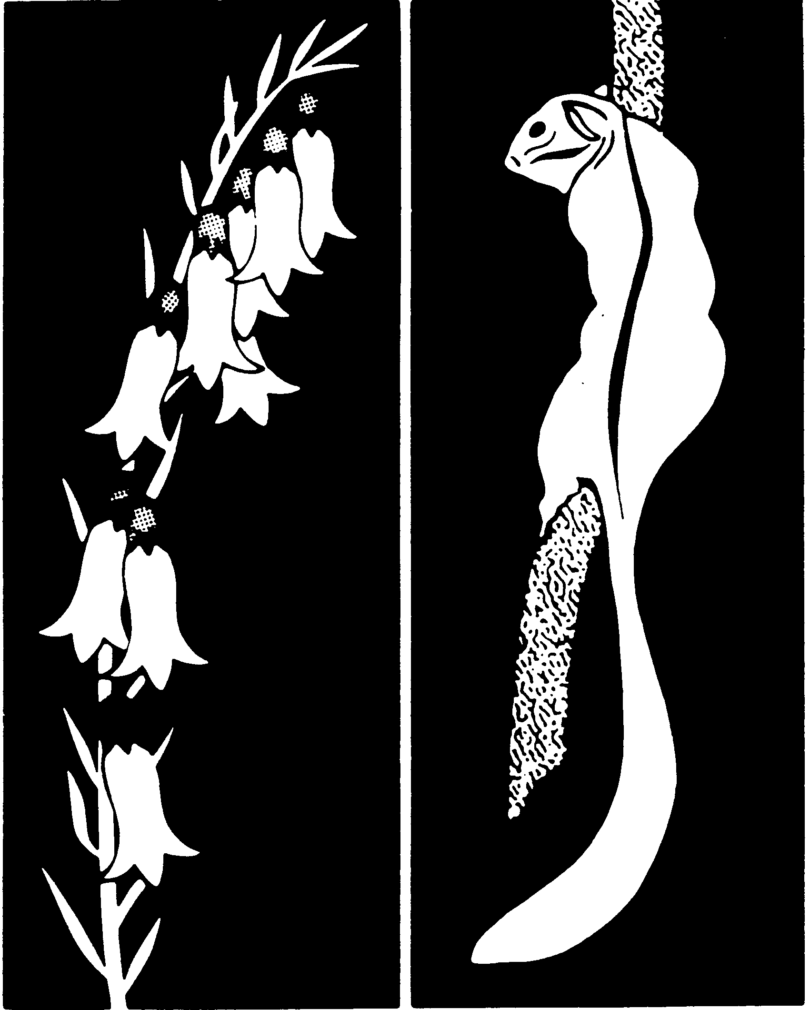
Flora & Fauna
Guarantee
FLORA AND FAUNA GUARANTEE - SCIENTIFIC ADVISORY COMMITTEE

FINAL RECOMMENDATION ON A NOMINATION FOR LISTING

Degradation and loss of freshwater and estuarine habitats and impact on native fish caused by European Carp (Cyprinus carpio)

(Potentially Threatening Process)

DOCID107-417469679-742
Preliminary recommendation date
25 August 2025

Validity
The nomination is for a valid item.

Prescribed Information
The prescribed information was provided.

In the opinion of the Scientific Advisory Committee (SAC) the Potentially Threatening Process (PTP) is adequately defined and described. The nominated process is defined as ‘Degradation and loss of freshwater and estuarine habitats and impact on native fish caused by European Carp (Cyprinus carpio)’.

Eligibility for listing as a PTP under the Flora and Fauna Guarantee Act 1988

The SAC has assessed the eligibility of this nomination in accordance with Section 16C of the Flora and Fauna Guarantee Act 1988 (the FFG Act) and the criteria for determining eligibility for listing prescribed in the Flora and Fauna Guarantee Regulations 2020 (FFG Regulations).

Process information

Originating in east Asia and Europe, Cyprinus carpio (hereafter ‘carp’) are a ray-finned fish that inhabit a range of freshwater and estuarine environments in over 91 countries (Smith 2005; Stuart et al. 2021). Globally, carp are considered amongst the top 100 most invasive species and are the third most introduced species worldwide (GISD 2025).

In the 1960’s the Boolarra strain of carp was imported from Germany for aquaculture, spread throughout farm dams in Gippsland and was later discovered in Serpentine Creek and the Yallourn Storage Dam in the Latrobe Valley. Boolarra carp were stocked into farm dams near Mildura and flooding in 1974/75 allowed carp to disperse throughout the Murray-Darling system (Smith 2005). Today, carp are found throughout south-eastern Australia, and localised spots in Western Australia.

In Victoria, carp are present in almost all fresh waterbodies, including all tributaries of the Murray-Darling Basin, where they are estimated to comprise 90% of the entire fish biomass (DELWP 2017). Carp occur at high densities across south-eastern Australia, where they now occupy over 54% of wetlands and 97% of large rivers (Stuart et al. 2021). Carp occupy rivers, wetlands, floodplains, irrigation channels and have been reported in estuaries (DELWP 2017).

Carp are listed as a noxious aquatic species in Victoria under the Fisheries Act 1995 and are recognised as a major threat to aquatic systems globally (Fanson et al. 2024). Under their listing as a noxious species, carp may be caught but must not be returned to the water alive. Fishing for consumption is allowed, provided they are killed immediately. Other forms of control are also accepted such as electrofishing, netting and trapping to manage populations.

Carp are known to adversely impact aquatic habitats in two main ways:
- direct consumption of native macrophytes, fish and invertebrates, and
- environmental degradation and habitat modification, including decrease in water quality, increase of nutrients, modification of benthic substrate, and competition with native species (Stuart et al. 2021; Peterson et al. 2022; Fanson et al. 2024).

Carp modify ecosystems with their benthic feeding behaviour (FRDC 2022a) and have been shown to significantly reduce aquatic vegetation cover and richness using experimental exclusion cages (Jones et al. 2020). As carp feed, they uproot aquatic macrophytes from the riverbed, this suspends sediments and facilitates release of nutrients such as phosphorus and nitrogen into the water column (Peterson et al. 2022). Turbid conditions created by carp, along with carp predation on invertebrates can increase phytoplankton production, which can lead to algal blooms (Mutethya & Yongo 2021). These behaviours create feedback effects which lead to persistent changes in the community composition and abundance of aquatic vegetation, benthic invertebrates, fishes and water birds (Peterson et al. 2022).

In Australia, carp are also responsible for the spread of the ectoparasitic Anchor worm (Lernaea cyprinacea) which parasitizes freshwater fish and occasionally amphibians, with widespread infestations recorded throughout Victoria (Hassan et al. 2008; Zhu et al. 2020).

Carp are abundant and widespread throughout Australia (Fig. 1; Stuart et al. 2021). Approximately 96% of total carp biomass within Australia is in eastern Australia (Stuart et al. 2021). The density of carp exceeds the biodiversity threat threshold of 80-100kg/ha in 54% of wetlands, 70% of stream area for rivers and 97% of stream area in large lowland rivers (>40m wide) throughout its distribution (Stuart et al. 2021). This threshold of 80-100kg/ha is a global indicator that the species is causing significant ecological harm (Miller & Crowl 2006; Bajer et al. 2009; Badiou & Goldsborough 2014; Vilizzi et al. 2015).

Carp densities of 100 kg/ha start to impact aquatic plants, whereas carp densities of 150 kg/ha start to reduce water clarity (FRDC 2022b). Research has suggested that carp densities of 250kg/ha are enough to reduce macrophyte and macroinvertebrate abundance by ~50 % and in some areas carp are predicted to reduce macrophyte abundance by ~90% (Fanson et al. 2024). Carp densities in Australia are commonly 200-400 kg/ha with some areas (particularly shallow lakes) exceeding 1800kg/ha, which is 22.5 times higher than the lowest environmental damage threshold (Stuart et al. 2021).

Carp have extremely high environmental tolerances and high fecundity which give them a competitive advantage over native fish species (Koehn et al. 2016; Peterson et al. 2022). They demonstrate early sexual maturity, with males reaching maturity at one year and females at two years (McDowall 1980). Females are highly fecund, can spawn multiple times a year, and can produce up to one million eggs per annum (Sivakumaran et al. 2003). Although carp preferentially inhabit slow flowing rivers and weir pools, they are habitat generalists and can thrive in rivers, wetlands, floodplains, irrigation channels and estuaries (Gehrke & Harris 2000). Carp are fast growing and experience limited predation after reaching 400mm in size (Koehn et al. 2016).

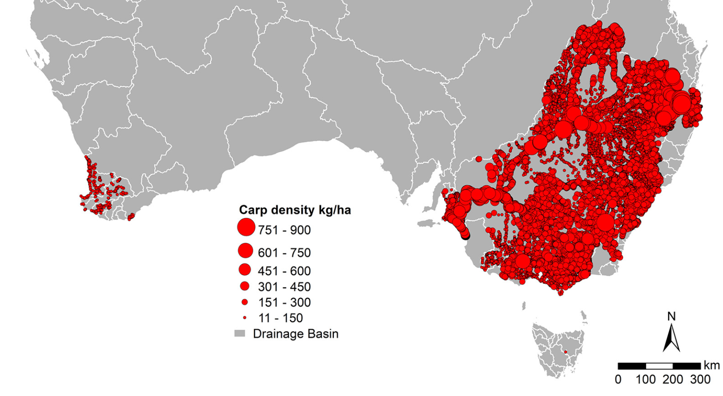

Figure 1. Distribution and predicted density of carp in Australia (Smith et al. 2021).

Decision by the Scientific Advisory Committee

The eligibility of the nominated PTP to be specified in the Processes List must be determined in accordance with the eligibility criteria prescribed for the purposes of Division 2 of Part 3 of the FFG Act. The relevant eligibility criteria are prescribed in Schedule 3 of the FFG Regulations, which provides that if a criterion is met, the PTP is eligible to be specified in the Processes List.

Criterion 1.1 the potentially threatening process poses or has the potential to pose, a significant threat to the survival of two or more taxa.

Evidence:

Carp pose a serious threat to a variety of threatened species in Australia and Victoria. Carp threaten the survival of at least 22 listed fauna species from six different classes, and at least 5 listed plant species. These species are listed either under the FFG Act and/or Commonwealth Environment, Protection and Biodiversity Conservation Act 1999 (EPBC Act) (Tables 1 and 2) The main impacts to native species by carp are modification of habitat, modification of water quality, removal of submerged vegetation, competition, predation and as a vector of disease.

The environmental tolerances of carp make them a particularly threatening process to native species. A study by Koehn (2004) found that carp can tolerate existing threats in the Murray-Darling Basin better than native fish species. Carp are at a substantially lower risk of being affected by threats such as habitat destruction, changes in water quality, water temperature, altered flows and increased sedimentation than threatened native species such as Macquarie Perch, Trout Cod and Silver Perch (Koehn 2004). This allows carp to thrive in a system that is already exerting pressures on threatened native species survival.

Significant threats to native species can be observed in both direct and indirect impacts. Carp directly impact native species through predation. Juvenile carp up to 10cm in length feed primarily on zooplankton and, when abundant, juvenile carp are capable of altering zooplankton communities, allowing unregulated proliferation of phytoplankton communities (FRDC 2022c). This is a ‘trophic effect’ and increases the presence of harmful algae and the risk of harmful blue-green algae blooms (FRDC 2022c). Adult carp are primarily benthic feeders and syphon food from substrata (DELWP 2017). They are omnivores and detritivores, that feed on benthic and epibenthic macroinvertebrates, fish eggs, macrophytes and detritus, causing top-down effects when in high abundance and competing with native species for food (DELWP 2017). Using exclusion cages in northern Victoria, carp have been shown to significantly impact aquatic vegetation richness and cover, with dramatic recovery of vegetation in most exclosures within a few years (Jones et al. 2020).

These direct and indirect impacts of carp act cumulatively alongside existing threats (such as climate change and modification of waterways).

Table 1. Threatened fauna species at risk from carp in Victoria.
Conservation status: EX = extinct, CR = critically endangered, EN = endangered, VU = vulnerable.

Species (scientific and common name) | EPBC Act conservation status | FFG Act conservation status | Distribution within Victoria | Main impacts
Mammals
Platypus (Ornithorhynchus anatinus) | n/a | VU | East and south-east coast of Victoria | Impact habitat quality and productivity by increasing turbidity, accelerating algae bloom production and nutrient levels, and dislodging aquatic plants (Zukowski & Whiterod 2022).
Reptiles
Broad-shelled Turtle (Chelodina expansa) | n/a | EN | Throughout the Murray-Darling Basin | Predation on juvenile Broad-shelled Turtles which reduces recruitment (NCCMA 2010).
Murray River Short Necked Turtle (Emydura macquarii) | n/a | CR | Central and North Victoria - found in the Murray and major tributaries | Changes to water turbidity and macrophyte abundance which has been linked to changes in E.macquarii diet and alteration of habitat which may lead to increased predation of hatchling and juvenile turtles. Impacts to recruitment may drive declines in turtle populations across the Murray River (Petrov et al. 2018).
Fishes
Australian Grayling (Prototroctes maraena) | VU | EN | Found in coastal rivers and streams. Found southward of the Great Dividing Range to Otway Ranges of Victoria | Carp are a vector and transmit parasites (Lernaea sp,) which infect Australian Grayling (TSSC 2021a).
Agassiz’s Glassfish (Ambassis agassizi) | n/a | EX | Recently rediscovered in Victoria but still listed as extinct pending amendment | Reduce and degrade instream aquatic vegetation. Predation on Agassiz’s Glassfish eggs and juveniles (NSW DPI 2013; AMDBA 2024).
Dwarf Galaxias (Galaxiella pusilla) | n/a | EN | Coastal streams in southern Victoria (Mitchell River Basin near Bairnsdale, west to Dandenong Creek near Melbourne in Victoria) | Reduce and degrade suitable habitat by increasing turbidity, nutrient levels, and reducing vegetation (Saddlier et al. 2010).
Little Galaxias (Galaxiella toourtkoourt) | n/a | EN | Upper Barwon River system near Barwon Downs, Victoria | Carp have been shown to damage aquatic vegetation and could reduce suitable habitat for the little galaxias (Saddlier et al. 2010; DELWP 2017).
Flat-headed Galaxias (Galaxias rostratus) | n/a | VU | Southern part of the Murray-Darling Basin | Increase competition on preferred food source (aquatic insects and microcrustaceans). Loss of vegetation and habitat due to benthic feeding behaviour. Predation on the species (TSSC 2016).
Freshwater catfish (Tandanus tandanus) | n/a | EN | Lower reaches of the Murray-Darling Basin | Predation on freshwater catfish eggs, and nest disturbance. Competition for resources such as suitable breeding ground and food (macroinvertebrates). Introduce and carry parasites such as Lernaea sp, which are known to infect Freshwater Catfish (Lintermans 2023).
Murray Cod (Maccullochella peelii) | VU | EN | Murray-Darling Basin | Habitat modification through increased turbidity, reduced plankton and aquatic invertebrate abundance, and increased risk of cyanobacteria algae blooms.  Introduce and carry parasites such as Lernaea sp, which are known to infect Murray Cod (Lintermans 2023; TSSC 2024a).
Murray Hardyhead (Craterocephalus fluviatilis) | EN | CR | Lower regions of the Murray-Darling Basin | Predation on submerged macrophytes which provide food and habitat.  Predation on Murray Hardyhead and competition for resources.  Introduce and carry parasites such as Bothriocephalus acheilognathi, which are known to infect Murray Hardyhead (TSSC 2012).
Silver Perch (Bidyanus bidyanus) | EN | EN | Murray-Darling Basin | Loss of macrophyte habitat for juvenile silver perch.  Increased turbidity which modifies suitable habitat.  Competition for habitat and resources for adult, juvenile and larval silver perch.  Introduced and carry parasites such as Lernaea sp. and L. cyprinacea, which are known to infect silver perch (TSSC 2024b; Lintermans 2023).
Macquarie Perch (Macquaria australasica) | EN | EN | Lake Dartmouth, Mitta Mitta River and the Goulburn River Catchment | Competition for resources such as food (aquatic insects).  Predation on eggs and juveniles  Introduced and carry parasites such as Lernaea sp and Chilodonella cyprini, which are known to infect Macquarie perch (TSSC 2013; Lintermans 2023).
Southern Purple-spotted Gudgeon (Mogurnda adspersa) | EN (draft) | CR | Kerang | Competition for resources such as food (macroinvertebrates).  Predation on species, including eggs. Habitat degradation including increased turbidity, and decreased macrophyte abundance (Stoessel et al. 2022).
Trout Cod (Maccullochella macquariensis) | EN | EN | Southern Murray-Darling Basin | Competition for resources such as food (macroinvertebrates) and habitat.  Habitat modification through increased turbidity, reduced plankton and aquatic invertebrate abundance, and increased risk of cyanobacteria algae blooms. (TSSC 2024c).
Variegated Pygmy Perch (Nannoperca variegata) | VU | EN | Glenelg River System | Decrease aquatic macrophytes reducing suitable habitat (TSSC 2024d).
Yarra Pygmy Perch (Nannoperca obscura) | EN | VU | South and South-east Victoria | Decrease aquatic macrophytes reducing suitable habitat (TSSC 2023).
Southern Pygmy Perch (Murray-Darling Basin lineage) (Nannoperca australis) | VU | VU | Southern area of the Murray-Darling Basin | Destroy submerged macrophytes which reduces suitable habitat.  Increase turbidity which reduces suitable habitat.  Introduced and carry parasites such as Lernaea sp. which are known to infect Southern Pygmy Perch (TSSC 2021b; Lintermans 2023).
Invertebrates
Glenelg Freshwater Mussel (Hyridella glenelgensis) | CR | CR | Crawford River | Predation on juvenile mussels.  Habitat modification through increased turbidity, damage and reduce aquatic macrophytes, and compete with native fish which Glenelg Freshwater Mussels rely on for recruitment (TSSC 2010).
Murray Spiny Crayfish (Euastacus armatus) | VU |  | Southern area of the Murray-Darling Basin | Predation increases mortality rates of juveniles (TSSC 2025).
Amphibians
Growling Grass Frog (Litoria raniformis) | VU | VU | Widespread throughout Victoria | Predation on eggs and tadpoles.  Reduction of aquatic macrophytes and increase turbidity reduce suitable spawning habitat (TSSC 2024e).

Table 2. Threatened flora species at risk from carp in Victoria.
Conservation status: EX = extinct, CR = critically endangered, EN = endangered, VU = vulnerable.

Species (Scientific and common name) | EPBC Act conservation status | FFG Act conservation status | Distribution | Main impacts
Ridged Water-milfoil (Myriophyllum porcatum) | VU | CR | North and north-west Victoria | Habitat modification and increased turbidity from carp feeding mechanisms (Murphy 2006).
River Swamp Wallaby-grass (Amphibromus fluitans) | VU |  | Widespread throughout Victoria | Carp numbers have grown in some systems and have decimated the populations of aquatic plants and communities to the extent that they have largely been removed from some systems. Species are heavily impacted by carp mumbling affecting the floor of wetlands and making plant establishment difficult (Dylan Osler, personal communication 22 December 2025).
Water Nymph (Najas tenuifolia) |  | EN | Southern Murray-Darling Basin
Wavy Marshwort (Nymphoides crenata) |  | EN | North-central Victoria
Open Marshwort (Nymphoides geminata) |  | EN | Central and eastern Victoria

Criterion 1.2 The potentially threatening process poses or has the potential to pose, a significant threat to the survival of a community.

Evidence:

Carp are a serious threat to the survival of at least one listed fish community; the FFG Act listed Lowland Riverine Fish Community of the Southern Murray-Darling Basin (Table 3). The geographic range of this fish assemblage can be broadly defined as the lowland river reaches and associated floodplains of the Murray River tributaries in Victoria that drain the northern slopes of the Great Dividing Range, together with the lowland section and floodplain of the Murray River upstream of the South Australian border (FFG SAC n.d). Carp are known to be present in all waterbodies where the listed community occurs.

Many of the species in this community have undergone significant reductions in abundance and range since European settlement, due to considerable changes to habitats across its distribution. A significant contributor of these declines has been attributed to the introduction of invasive species such as carp (FFG SAC n.d). This threat is compounded amongst other threats such as habitat degradation and flooding events which allow carp to thrive, unlike native fish species (DELWP 2017).

Table 3. Threatened communities at risk from Carp in Victoria

Community name | Listing | Distribution | Main impacts
Lowland Riverine Fish Community of the Southern-Murray-Darling Basin | FFG Act | Southern-Murray-Darling Basin | Impact habitat quality and productivity by increasing turbidity, accelerating algal bloom production and nutrient levels, and dislodging aquatic plants.  Predation on native species including eggs.  Competition for resources such as food, habitat, suitable spawning grounds.  (TSSC 2013, Zukowski & Whiterod 2022).

Criterion 2.1 The potentially threatening process poses or has the potential to pose a significant threat to the evolutionary development of two or more taxa.

Evidence:

By impacting species that are already at risk of extinction, carp are jeopardising the evolutionary development of a range of species, for example the Glenelg Freshwater Mussel (Raadik et al. 2022) and the Southern Pygmy Perch (Pearce et al. 2018) (Table 1).

Glenelg Freshwater Mussel
The Glenelg Freshwater Mussel (Hyridella glenelgensis) is listed as Critically Endangered under the EPBC Act and FFG Act. The Glenelg Freshwater Mussel is restricted in its distribution and carp were confirmed in the Glenelg River system in 2002 and have now spread to the lower reaches of the Glenelg River (Brown et al. 2003).

There are only four known subpopulations of Glenelg Freshwater Mussel, all are isolated and small, have declining genetic diversity and are at risk from inbreeding (TSSC 2010; Raadik et al. 2022). As major threats are likely to continue, alongside carp predation and habitat modification, there is considerable likelihood that populations will continue to decline into the future. This may lead to increased extinction risk from further loss of genetic diversity, reducing the capacity for the species to respond and adapt to changing environmental conditions. Increasing carp populations have been described as an emerging threat to the long-term persistence of Glenelg Freshwater Mussel (Raadik et al. 2022).

Southern Pygmy Perch
Southern Pygmy Perch (Murray-Darling Basin lineage) (Nannoperca australis) is listed as Vulnerable under the EPBC Act and FFG Act. The Southern Pygmy Perch does not co-exist with carp where they are observed in high numbers (Pearce 2014; Todd et al. 2017). Declines in abundance of Southern Pygmy Perch have also been attributed to loss of aquatic vegetation and habitat alteration, both of which are pressures carp exert on freshwater ecosystems (Villizzi et al. 2014; TSSC 2021b). A loss of aquatic habitat increases the species vulnerability to predation and competition with invasive species such as carp, redfin and Eastern Gambusia (Gambusia holbrooki) (Pearce et al. 2018; Koehn et al. 2020).

The potential loss of a Southern Pygmy Perch subpopulation from the Murray-Darling Basin system through the direct and indirect impacts of carp could have evolutionary implications by reducing the species adaptability to changing environments into the future.

Documentation

The published information provided to and sourced by the SAC has been assessed. To the best of their knowledge, the SAC believes that the data presented are not the subject of scientific dispute and the inferences drawn are reasonable and well supported.

Advertisement for public comment
In accordance with the requirements of Section 16D of the FFG Act, the preliminary recommendation was advertised for a period of at least 30 days.
The preliminary recommendation was advertised in:
Victorian Government Gazette on 4 December 2025
Engage Victoria
Public submissions closed on 5 January 2026

Additional information considered by the Scientific Advisory Committee
Following publication of the preliminary recommendation, the SAC received 35 submissions, with very strong overall support for the recommendation. In making its final recommendation on this item, the SAC considered the submissions and was not aware of any compelling evidence to warrant a change to the preliminary recommendation that the nominated PTP is eligible for listing.

Final Recommendation of the Scientific Advisory Committee

As outlined above, the nominated PTP satisfies at least one criterion of the set of criteria prepared and maintained under Division 2 of Part 3 of the FFG Act and stated in Schedule 3 of the FFG Regulations.

The SAC concludes that on the evidence available, the nominated PTP is eligible for listing because Criteria 1.1, 1.2, 2.1 of the FFG Regulations have been satisfied.

The Scientific Advisory Committee therefore makes a final recommendation that the nominated PTP be supported for listing under the Flora and Fauna Guarantee Act 1988.

Endorsement by the Convenor of the Scientific Advisory Committee

Dr. Michelle T. Casanova
Convenor

4 March 2026

References

AMBDA (Australian Murray-Darling Basin Authority) (2024). Saving the glassfish from extinction, AMBDA, accessed April 2025.

Bajer, P., Sullivan, G., Sorensen, P. (2009). Effects of a rapidly increasing population of common carp on vegetative cover and waterfowl in a recently restored Midwestern shallow lake. Hydrobiologia, 632: 235-245.

Bardiou, H. & Goldsborough, L. (2014) Ecological impacts of an exotic benthivorous fish, the common carp (Cyprinus carpio L.), on water quality, sedimentation, and submerged macrophyte biomass in wetland mesocosms. Hydrobiologia, 755: 107-121.

Brown, P., Sivakumaran, K.P., Stoessel, D., Giles, A., Green, C. & Walker T. (2003). Carp Population Biology in Victoria. Report 56. Marine and Freshwater Resources Institute, Department of Primary Industries, Snobs Creek. Victoria.

DELWP (Department of Land Water and Planning) (2017). Impacts of Carp in wetlands, DELWP, accessed April 2025.

Fanson, B., R. Hale, R., Thiem, J., Lyon, J., Koehn, J., Bennett, A., Stuart, I. (2024). "Assessing impacts of a notorious invader (common carp Cyprinus carpio) on Australia's aquatic ecosystems: Coupling abundance-impact relationships with a spatial biomass model. Biological Conservation, 290: 110420.

FFG SAC (Flora and Fauna Guarantee Act 1988 - Scientific Advisory Committee) (n.d). Flora and Fauna Guarantee Act 1988 – Threatened List - Characteristics of Threatened Communities – accessed March 2025.

FRDC (Fisheries Research and Development Corporation) (2022a). The carp problem, FRDC, accessed April 2025.

FRDC (Fisheries Research and Development Corporation) (2022b). The National Carp Control Plan, FRDC, accessed April 2025.

FRDC (Fisheries Research and Development Corporation) (2022c). NCCP Technical Paper 1 - Carp Biocontrol Background, FRDC, accessed April 2025.

Gehrke, P. & Harris, J. (2000). Large-scale patterns in species richness and composition of temperate riverine fish communities, southeastern Australia. Marine and Freshwater Research, 51, 165-182.

GISD (Global Invasive Species Database) (2025). Species Profile: Cyprinus carpio, GISP, accessed April 2025.

Hassan, M., Beatty, S., Morgan, D., Doupé, R., Lymbery, A. (2008). An introduced parasite, Lernaea cyprinacea L., found on native freshwater fishes in the southwest of Western Australia. Royal Society of Western Australia, 91, 149-:53.

Jones, C., Vivian, L., Mole, B., Backstrom, A., White, D., Tonkin, Z., Menkhorst, P. (2020). Quantifying the impacts of carp and waterbirds on aquatic vegetation within a regulated lowland river. Proceedings of the 10th Australian Stream Management Conference 2020, Kingscliff, NSW.

Koehn, J. (2004). Carp (Cyprinus carpio) as a powerful invader in Australian waterways. Freshwater biology, 49(7): 882-894.

Koehn, J., Todd, C., Thwaites, L., Stuart, I., Zampatti, B., Ye, Q., Conallin, A., Dodd, L., Stamation, K. (2016). Managing flows and carp. Arthur Rylah Institute for Environmental Research Technical Report Series No. 255. Arthur Rylah Institute for Environmental Research, Department of Environment, Land, Water and Planning, Heidelberg, Victoria.

Koehn, J., Raymond, S., Stuart, I., Todd, C., Balcombe, S., Zampatti, B., Bamford, H., Ingram, B., Bice, C., Burndred, K., Butler, G., Baumgartner, L., Clunie, P., Ellis, I., Forbes, J., Hutchison, M., Koster, W., Lintermans, M., Lyon, J., Mallen-Cooper, M., McLellan, M., Pearce, L., Ryall, J., Sharpe, C., Stoessel, D., Thiem, J., Tonkin, Z., Townsend, A., Ye, Q .(2020). A compendium of ecological knowledge for restoration of freshwater fishes in Australia’s Murray–Darling Basin. Marine and Freshwater Research, 71(11): 1391–1463.

Lintermans, M. (2023). Fishes of the Murray–Darling Basin, Australian River Restoration Centre Limited, Australia.

McDowall, R. (1980). Freshwater fishes of south-eastern Australia: New South Wales, Victoria and Tasmania.

Miller, S & Crowl, T. (2006). Effects of common carp (Cyprinus carpio) on macrophytes and invertebrate communities in a shallow lake. Freshwater Biology, 51(1): 85-94).

Mutethya, E. & Yongo, E (2021). A comprehensive review of invasion and ecological impacts of introduced common carp (Cyprinus carpio) in Lake Naivasha, Kenya. Lakes & Reservoirs: Research & Management, 26(4): e12386.

Murphy, A. (2006). National Recovery Plan for the Ridged Water-milfoil Myriophyllum porcatum, Department of Sustainability and Environment, Melbourne.

NCCMA (North Central Catchment Management Authority) (2010). Endangered Turtle in the Spotlight NCCMA MEDIA RELEASE, accessed May 2025.

NSW DPI (New South Whales Department of Primary Industries) (2018). Olive Perchlet (western population) -
Ambassis agassizii. 2 ed. NSW DPI, accessed May 2025.

Pearce, L. (2014). Conservation management of southern pygmy perch (Nannoperca australis) in NSW, in the context of climactic extremes and alien species. MSc Thesis, Charles Sturt University.

Pearce, L., Silva, L., Mabon, S., Horta, A., Duffy, D., Ning, N., Baumgartner, L. (2018). Finding forgotten fishes, the search for two endangered species in the NSW Murray Catchment. Institute for Land, Water and Society, Charles Sturt University. 81 pp.

Peterson, D. Pearson, J., Simpson, W. (2022). Effects of common carp on water quality and submerged vegetation: results from a short-term mesocosm experiment in an artificial wetland. Marine and Freshwater Research, 73(7): 973-994.

Petrov, K., Lewis, J., Malkiewicz, N., Van Dyke, J., Spencer, R. (2018). Food abundance and diet variation in freshwater turtles from the mid-Murray River, Australia. Australian Journal of Zoology, 66: 67–76.

Raadik, T., Stoessel, S., Ryan, Murphy, N. (2022). Locating the threatened Glenelg Freshwater Mussel in the lower Glenelg River system: Remote sensing and physical sampling. Arthur Rylah Institute for Environmental Research Technical Report Series No. 345. Department of Environment Land Water and Planning, Heidelberg, Victoria.

Saddlier, S., Jackson, J., Hammer, M. (2010). National Recovery Plan for the Dwarf Galaxias: Galaxiella Pusilla, Department of Sustainability and Environment Melbourne, Victoria, Australia.

Sivakumaran, K., Brown, P., Stoessel, D., Giles, A. (2003). Maturation and reproductive biology of female wild carp, Cyprinus carpio, in Victoria, Australia. Environmental Biology of Fishes, 68, 321-332.

Smith, B. (2005). The state of the art: a synopsis of information on common carp (Cyprinus carpio) in Australia. SARDI Research Report Series No 77. Prepared by the South Australian Research and Development Institute for the Pest Animal Control Cooperative Research Centre.

Stoessel, D., Raadik, T., Adams, M., Shelley, J., Hatley, T., Lervasi, D., Rose, P., Russell, A., Murphy, N. (2022). Status of Southern Purple-spotted Gudgeon (Mogurnda adsperaI) in the Kerang region, Victoria. Arthur Rylah Institute for Environmental Research. Technical Report Series No. 343. Department of Environment, Land, Water and Planning, Heidelberg, Victoria.

Stuart, I., Fanson, B., Lyon, J., Stocks, J., Brooks, S., Norris, A., Bennett, A. (2019). A national estimate of carp biomass for Australia. Unpublished Client Report for the Fisheries Research and Development Corporation. Arthur Rylah Institute for Environmental Research, Department of Environment, Land, Water and Planning, Heidelberg, Victoria.

Stuart, I., Fanson, B., Lyon, J., Stocks, J., Brooks, S., Norris, A., Thwaites, L., Beitzel, M. Hutchison, M., Ye, Q. (2021). Continental threat: How many common carp (Cyprinus carpio) are there in Australia? Biological Conservation, 254: 108942.

Todd, C., Koehn, J., Pearce, L., Dodd, L., Humphries, P., Morrongiello, J. (2017). Forgotten fishes: What is the future for small threatened freshwater fish? Population risk assessment for southern pygmy perch, Nannoperca australis. Aquatic Conservation: Marine and Freshwater Ecosystems, 27: 1290-1300.

TSSC (Threatened Species Scientific Committee) (2010). Approved Conservation Advice for Hyridella glenelgensis (Glenelg Freshwater Mussel). Department of Climate Change, Energy, the Environment and Water, Environment Protection and Biodiversity Conservation, accessed May 2025.

TSSC (Threatened Species Scientific Committee) (2012). Approved Conservation Advice for Craterocephalus fluviatilis (Murray hardyhead). Department of Climate Change, Energy, the Environment and Water, Environment Protection and Biodiversity Conservation, accessed May 2025.

TSSC (Threatened Species Scientific Committee) (2013). Approved Conservation Advice for Macquaria australasica (Macquarie perch). Department of Climate Change, Energy, the Environment and Water Environment Protection and Biodiversity Conservation, accessed May 2025.

TSCC (Threatened Species Scientific Committee) (2016). Approved Conservation Advice Galaxias rostratus flathead galaxias. Department of Climate Change, Energy, the Environment and Water, Environment Protection and Biodiversity Conservation, accessed May 2025.

TSCC (Threatened Species Scientific Committee) (2021a). Approved Conservation Advice Prototroctes maraena Australian Grayling. Department of Agriculture, Water and the Environment, accessed May 2025.

TSCC (Threatened Species Scientific Committee) (2021b). Approved Conservation Advice Nannoperca australis Murray-Darling Basin lineage Southern Pygmy Perch-MDB. Department of Climate Change, Energy, the Environment and Water, Environment Protection and Biodiversity Conservation, accessed May 2025.

TSSC (Threatened Species Scientific Committee) (2023). Approved Conservation Advice for Nannoperca obscura (Yarra pygmy perch) Department of Climate Change, Energy, the Environment and Water, Environment Protection and Biodiversity Conservation, accessed May 2025.

TSSC (Threatened Species Scientific Committee) (2024a). Approved Conservation Advice for Maccullochella peelii (Murray cod). Department of Climate Change, Energy, the Environment and Water Environment Protection and Biodiversity Conservation, accessed May 2025.

TSSC (Threatened Species Scientific Committee) (2024b). Approved Conservation Advice Bidyanus bidyanus (silver perch). Department of Climate Change, Energy, the Environment and Water, Environment Protection and Biodiversity Conservation, accessed May 2025.

TSSC (Threatened Species Scientific Committee) (2024c). Approved Conservation Advice for Maccullochella macquariensis (trout cod). Department of Climate Change, Energy, the Environment and Water, Environment Protection and Biodiversity Conservation, accessed May 2025.

TSSC (Threatened Species Scientific Committee) (2024d). Approved Conservation Advice for Nannoperca variegata (variegated pygmy perch). Department of Climate Change, Energy, the Environment and Water, Environment Protection and Biodiversity Conservation, accessed May 2025.

TSSC (Threatened Species Scientific Committee) (2024e). Approved Conservation Advice for Litoria raniformis (southern bell frog). Department of Climate Change, Energy, the Environment and Water, Environment Protection and Biodiversity Conservation, accessed May 2025.

TSSC (Threatened Species Scientific Committee) (2025). Approved Conservation Advice Euastacus armatus Murray crayfish. Department of Climate Change, Energy, the Environment and Water, accessed May 2025.

Vilizzi, L., Thwaites, L., Smith, B., Nicol, J., Madden, C. (2014). Ecological effects of common carp (Cyprinus carpio) in a semi-arid floodplain wetland. Marine and Freshwater Research, 65: 802 – 817.

Vilizzi, L., Tarkan, A., Copp, G. (2015). Experimental evidence from causal criteria analysis for the effects of common carp Cyprinus carpio on freshwater ecosystems: a global perspective. Reviews in Fisheries Science and Aquaculture, 253-290, DOI 10.1080/23308249.2015.1051214.

Zhu, X., Barton, D., Wassens, S., Shamsi, S. (2020). Morphological and genetic characterisations of the introduced copepod Lernaea cyprinacea Linnaeus (Cyclopoida: Lernaeidae) occurring in the Murrumbidgee catchment, Australia. Marine and Freshwater Research, 72(6): 876-886.

Zukowski, S. & Whiterod, N. (2022). Platypus habitat suitability survey of the River Torrens, Aquasave–Nature Glenelg Trust, Victor Harbor.

