|  |
| --- |
| Stubble burning |
| **Protecting paddock trees** |

**Introduction**

Retention of crop stubble residues is preferred as it benefits soil health1. While this is well supported by many farmers, burning stubble is a management choice.

This note explains;

* the value of paddock trees to agriculture,
* how to reduce impacts to paddock trees during stubble burns,
* Victorian laws that apply to paddock trees.

# The value of paddock trees

Paddock trees are vital to a healthy farming landscape. Community and landholders value trees because of the economic, health and sustainable landscape benefits that they provide to a region2.

Trees give us:

**Production benefit:** Trees provide shelter during extreme heat, wind and cold. This reduces stock energy needed to regulate body temperature, decreases physical stress and increases production (such as live weight gain, wool growth and milk production). Permeable tree canopies reduce wind and water loss to crops.

**Soil health:** Trees sequester carbon, produce organic matter, cycle nutrients and improve soil biology and structure through their roots and connection to soil organisms.

**Erosion and salinity control:** Wide tree canopies help reduce the impacts of wind; healthy trees with strong roots reduce water erosion and dryland salinity.

**Wildlife habitat/connectivity:** Scattered trees connect to other native vegetation for native animal habitat.

**Natural pest control:** Native trees are shelter, nesting and roosting sites for predatory birds and bats that eat insect and rodent pests.

**Pollinator habitat:** Flowers supply pollen and nectar to bees and other pollinators essential for farm health.

**Seed stock:** Healthy trees provide large amounts of seed for future restoration.

**Natural beauty:** Significant aesthetic appeal in the landscape is created by trees; improving land value.

1. Agriculture Victoria [www.agriculture.vic.gov.au/agriculture/grains-and-other-crops/crop-production/stubble-burning](http://www.agriculture.vic.gov.au/agriculture/grains-and-other-crops/crop-production/stubble-burning)

2. Sustainable Farms: [www.sustainablefarms.org.au](http://www.sustainablefarms.org.au)

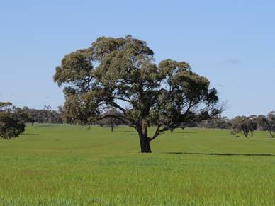

Once lost, paddock trees are not easily replaced. Prevent damage during stubble burns by applying practical actions outlined in this note.

**Burn permit requirements**

Landholders intending to burn during a declared Fire Danger Period within their municipality **must obtain a permit**. The Fire Danger Period generally runs between October and May, although specific declarations may vary between council areas and from year to year.

The CFA website3 has more information on the declared Fire Danger Period, including where and when these are in force and what fire restrictions apply.

3 CFA. [www.cfa.vic.gov.au](http://www.delwp.vic.gov.au)

## Preparing to burn stubble

* Reduce fuel load or create a fire break of **no less than three metres** from the edge of the canopy drip line (within cleared property boundary) around all trees.
* Fire breaks can be created by: slashing stubble, removing woody debris and wetting down the site and tree trunks.
* Avoid ploughing mineral earth breaks within the root zone or drip line of a tree and in native vegetation.
* Check the weather forecast on the day and for a few days afterward to safely manage the burn.
* Register your burn with the Emergency Services Telecommunications Authority on **1800 668 511** to avoid the CFA being called unnecessarily.
* Notify neighbours at least two hours before burning.
* Ensure you have an adequate water supply and equipment to extinguish the fire completely.

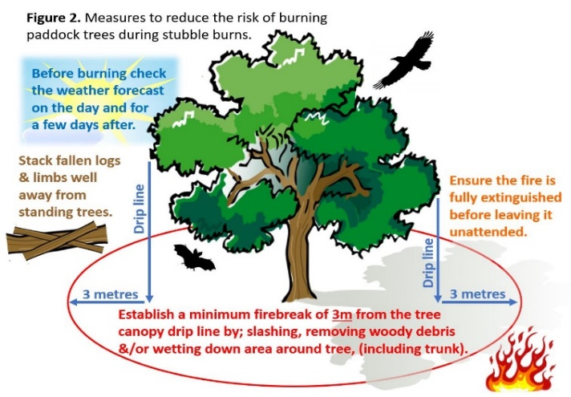

**Victorian laws**

**Burning is not permitted on days of Total Fire Ban.**

* A minimum firebreak of three metres is to be cleared around all flammable material (*Summary Offences Act 1966*)
* The *Country Fire Authority Regulations 2014* requires a Schedule 13 permit for burns started within the declared Fire Danger Period. This permit will only be granted for burning fine fuels such as grass or stubble. Course fuels such as woody debris should not be burnt during a declared Fire Danger Period.
* Native vegetation including paddock trees and standing dead trees are protected by law. Native vegetation guidelines are embedded in council planning schemes. A permit is generally required to remove, destroy or lop native vegetation. Always check your obligations with local council first.
* Conserve Aboriginal scar trees (which are protected by law *Aboriginal Heritage Act 2006*.)

|  |  |
| --- | --- |
| © The State of Victoria Department of Environment, Land, Water and Planning 2021  LogoThis work is licensed under a Creative Commons Attribution 4.0 International licence. You are free to re-use the work under that licence, on the condition that you credit the State of Victoria as author. The licence does not apply to any images, photographs or branding, including the Victorian Coat of Arms, the Victorian Government logo and the Department of Environment, Land, Water and Planning (DELWP) logo. To view a copy of this licence, visit http://creativecommons.org/licenses/by/4.0/  Disclaimer  This publication may be of assistance to you but the State of Victoria and its employees do not guarantee that the publication is without flaw of any kind or is wholly appropriate for your particular purposes and therefore disclaims all liability for any error, loss or other consequence which may arise from you relying on any information in this publication. | Accessibility  If you would like to receive this publication in an alternative format, please telephone the DELWP Customer Service Centre on 136186, email [customer.service@delwp.vic.gov.au](mailto:customer.service@delwp.vic.gov.au), or via the National Relay Service on 133 677 [www.relayservice.com.au](http://www.relayservice.com.au). This document is also available on the internet at [www.delwp.vic.gov.au](http://www.cfa.vic.gov.au). |