Introduction
Biodiversity Response Planning (BRP) is a long-term area-based planning approach to biodiversity conservation in Victoria. It is designed to strengthen alignment, engagement and participation between government, Traditional Owners, non-government agencies and the community.
DELWP Regional staff have been working with stakeholders on actions to conserve biodiversity in specific landscapes, informed by the best available science and local knowledge.
These Fact Sheets capture a point in time, reflecting data and knowledge available in 2020. They provide information for many (but not all) landscapes across Victoria, containing general information on the key values and threats in each area, as well as the priority cost-effective actions that provide the best protection of biodiversity. Fact Sheets are intended to provide useful biodiversity information for the community, non-government and government organisations during project planning and development.
Further information and the full list of Fact Sheets is available on the Department’s Environment website.

Landscape description
The Lake Mountain focus landscape is 29,461ha in size with over 80% of the area covered in native vegetation. The whole landscape is public land and includes part of Rubicon State Forest, Mount Bullfight Nature Conservation Reserve, Yarra Ranges National Park and Lake Mountain Resort. For area context, refer to the map at the end of this Fact Sheet.

Cultural importance
We recognise that the entire landscape has high cultural value for Traditional Owners. Landscapes identified as having “notable” cultural importance are based on the density of recorded cultural heritage sites and knowledge shared by Traditional Owners. We also recognise that there are locations important to Traditional Owners not within these focus landscapes. This landscape includes Country of the Taungurung Land and Waters Council.

Stakeholder interest
As part of the BRP process, in October 2020 stakeholders were asked to nominate focus landscapes, values, threats and potential biodiversity actions. Representatives from DELWP, Parks Victoria, Trust for Nature, Goulburn Broken Catchment Management Authority, North East Catchment Management Authority, Taungurung Land and Waters Council, Yorta Yorta Nation Aboriginal Corporation, and the Alpine Resorts agreed on the boundaries and key aspects of this landscape.
Possible future investment/project development in this landscape will be available to any interested stakeholders in addition to those who nominated this landscape.

Habitat Distribution Models identified 22 species with more than 5% of their Victorian range in this focus landscape
21 Plant species, including:
- Lake Mountain Grevillea (Grevillea monslacana) Rare, 47% Victorian range in area,
- Serpent Heath (Richea victoriana) Rare, 29% Victorian range in area,
- Subalpine Baeckea (Baeckea latifolia) Rare, 18% Victorian range in area
Other species and biodiversity communities identified by stakeholders include: Alpine bogs, peatlands, Mountain Plum-pine and several endangered Ecological Vegetation Classes.
- Leadbeater's Possum (Gymnobelideus leadbeateri) Endangered, 9% Victorian range in area
In addition to species identified in the modelling, stakeholders mentioned: Greater Glider, Eastern Pygmy-possum, Broad-toothed Rat
Bird Species identified by stakeholders include: Powerful Owl, Sooty Owl

Strategic Management Prospects
Strategic Management Prospects (SMP) models biodiversity values such as species habitat distribution, landscape-scale threats and highlights the most cost-effective actions for specific locations. More information about SMP is available in NatureKit.

Additional threats
Threats identified through the consultation process (in addition to those modelled in SMP) are:
- Weeds, which can have a negative impact on the biodiversity values and, through competition with native vegetation, can alter natural ecosystems. Managing weeds in adjoining areas, particularly modified sites is important for ensuring ongoing control. Weed control programs have been implemented in this area along with the other alpine areas (Baw Baw).
- Feral animals. Deer control is a high priority and subject to monitoring and control programs in collaboration between Parks Victoria and the Alpine Resorts. Incidental sightings of cats in the resort area has informed targeted monitoring programs with the inclusion of remote cameras. This work also includes foxes which are also present in the area and are a key threat to native species.
- Protection of habitat and monitoring of threatened species populations is a high priority in this landscape and more work is considered necessary to inform best management programs to address risks and threats to flora and fauna.

Which landscape-scale actions are most cost-effective in this landscape?
Some areas of this landscape of interest (coloured areas on the map below) have highly cost-effective actions which provide significant benefit for biodiversity conservation.
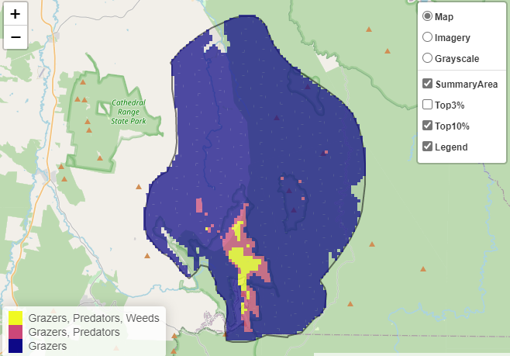

Control goats 28,304ha
Control deer 18,802ha

The SMP priority action which ranks among the top 3% for cost-effectiveness of that action across the state for much of the area (>1,000ha) is to Control goats. Of the top 10% of all cost-effective actions, controlling goats and deer provides the most cost-effective biodiversity benefits when considering all flora and fauna.
Biodiversity management activities identified through the consultation process (in addition to those modelled in SMP) are:
- monitoring of threatened species populations (Greater Glider, Leadbeater’s Possum and Barred galaxias) and bioacoustics monitoring of audible species (frogs, birds)
- Mountain Plum Pine fire recovery monitoring
- protection of frog habitat (Sphagnum Bogs)
- monitoring of alpine bogs for pest animal impact
- educational/engagement opportunities (such as creating alpine specific species nursery)

Additional recommended activities may be identified in consultation with partners.

The most cost-effective actions for flora and fauna
Amphibians, Plants – Control deer
Birds, Mammals – Control goats

For a further in depth look into SMP for this landscape, please refer to NatureKit.

