Introduction
Biodiversity Response Planning (BRP) is a long-term area-based planning approach to biodiversity conservation in Victoria. It is designed to strengthen alignment, engagement and participation between government, Traditional Owners, non-government agencies and the community.
DELWP Regional staff have been working with stakeholders on actions to conserve biodiversity in specific landscapes, informed by the best available science and local knowledge.
These Fact Sheets capture a point in time, reflecting data and knowledge available in 2020. They provide information for many (but not all) landscapes across Victoria, containing general information on the key values and threats in each area, as well as the priority cost-effective actions that provide the best protection of biodiversity. Fact Sheets are intended to provide useful biodiversity information for the community, non-government and government organisations during project planning and development.
Further information and the full list of Fact Sheets is available on the Department’s Environment website.

Landscape description
This 22,000ha area has a small amount of native vegetation (18% cover) and a small amount of public land (10%). It focuses partially on the Yarriambiack Creek and north to Wyperfeld National Park and includes some small reserves, roadside and private land remnants in an otherwise cleared landscape. The boundaries of this landscape are buffered 1km either side of the Yarriambiack Creek.
This focus landscape has a partial overlap with the Yarriambiack Creek Focus Landscape. For more information please refer to the Yarriambiack Creek fact sheet in the full list of Fact Sheets.

Cultural importance
We recognise that the entire landscape has high cultural value for Traditional Owners. Landscapes identified as having “notable” cultural importance is based on the density of recorded cultural heritage sites and knowledge shared by Traditional Owners. We also recognise that there are locations important to Traditional Owners not within these landscapes.
Notable cultural importance within this landscape of interest has not been identified.

Stakeholder interest
As part of the Biodiversity Response Planning process, in October 2020 stakeholders were asked to nominate focus landscapes and actions of interest. Mallee Catchment Management Authority nominated Yarriambiack Creek North.
Possible future investment/project development in this landscape will be available to any interested stakeholders in addition to those who nominated this landscape.
Specific stakeholder interests identified through the engagement process within this landscape include:
- Mallee Catchment Management Authority, Regional Catchment Strategy priority landscape – 17. North Wimmera Creeklines, Climate Change priority corridor 5 Yarriambiak. Focus on the restoration (for example, connectivity of and regeneration within isolated remnants) of high value habitat for priority species outcomes.

Community interest
There is high community interest in biodiversity values of remnant habitat on public and private land.

 | Habitat Distribution Models identify 0 species with more than 5% of their Victorian range in this landscape area | Traditional Owners, stakeholders and community groups identified the following species of interest
 |  | - Buloke
 |  | - Carpet Python
 |  | - Eastern Great Egret

Strategic Management Prospects
Strategic Management Prospects (SMP) models biodiversity values such as species habitat distribution, landscape-scale threats and highlights the most cost-effective actions for specific locations. More information about SMP is available in NatureKit.

Additional threats
Threats identified (in addition to those modelled in SMP) through the consultation process were:
- alterations to hydrology
- land salinisation
- soil erosion
- habitat degradation due to extremes of climate and weather
- lack of regeneration in some vegetation communities
- recreational activities causing fragmentation
- loss of vegetation, and erosion
- legacy use of public land
- private land use impacting biodiversity
- inappropriate land use planning
- inappropriate fire regimes (planned burning and bushfires)

Which landscape-scale actions are most cost-effective in this landscape?
Some areas of this focus landscape (coloured areas on the map) have highly cost-effective actions which provide significant benefit for biodiversity conservation.
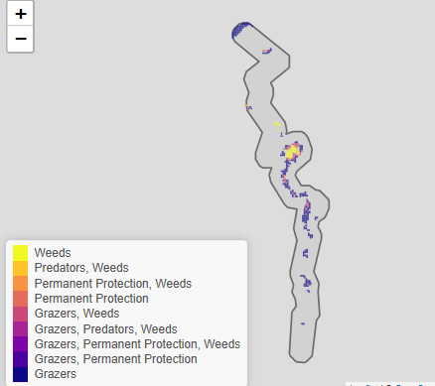
The SMP priority action which ranks among the top 3% for cost-effectiveness of that action across Victoria is Permanent Protection. Over a small area of the landscape, the top 10% actions are in order:
Control rabbits 1,175ha
Control weeds 572ha
Control goats 243ha

Of the top 10% of cost-effective actions, control rabbits provides the most cost-effective biodiversity benefits when considering all flora and fauna.

Additional actions suggested for this landscape through the nomination process are:
- control rabbits
- revegetation
- supplementary revegetation

The most cost-effective action for flora and fauna
Plants, birds – Combined cat and fox control

For a further in depth look into SMP for this landscape please refer to NatureKit.
