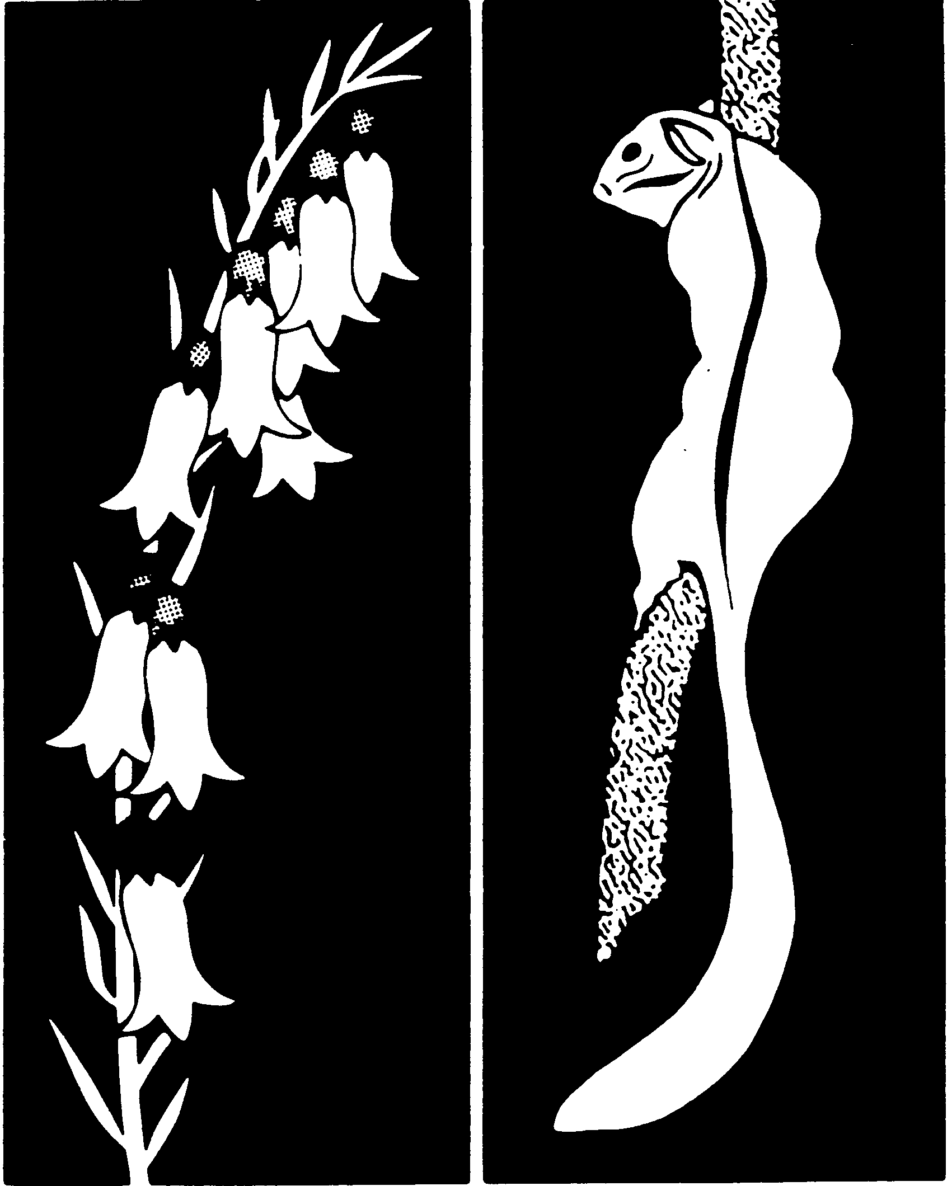
Flora & Fauna
Guarantee
FLORA AND FAUNA GUARANTEE - SCIENTIFIC ADVISORY COMMITTEE

FINAL RECOMMENDATION ON A NOMINATION FOR LISTING

Hibbertia porcata – Christmas Guinea-flower

DOCID107-417469679-742

Preliminary recommendation date
28 October 2025

Validity
The nomination is for a valid item. The nominated taxon is accepted by the Scientific Advisory Committee (SAC) as it has been formally described and is accepted as a valid taxon by Royal Botanic Gardens Victoria.

Prescribed Information
The prescribed information was provided.

Current conservation status
Hibbertia porcata is not currently listed as threatened in Victoria.

Eligibility for listing as a taxon under the Flora and Fauna Guarantee Act 1988
The SAC has assessed the eligibility of this taxon based on its extinction risk within Australia in accordance with Section 16C(3) of the Flora and Fauna Guarantee Act 1988 (FFG Act) and the criteria for determining eligibility for listing prescribed in Schedule 1 the Flora and Fauna Guarantee Regulations 2020 (FFG Regulations). A taxon is at risk of extinction in a particular category of threat if a primary criterion is met and is therefore eligible to be specified in the Threatened List.

In its application of the relevant eligibility criteria, the SAC has, as required by the Intergovernmental Memorandum of Understanding - Agreement on a Common Assessment Method for Listing of Threatened Species (to which Victoria is a signatory), assessed the taxon in accordance with the IUCN Red List Categories and Criteria (Version 3.1 second edition) and the Guidelines for Using the IUCN Red List Categories and Criteria (Version 16).

Assessment summary
Hibbertia porcata was assessed by the SAC as eligible for listing under the FFG Act as Endangered in Australia. The Committee’s assessment is provided in Attachment 1. The Committee’s assessment of the species’ eligibility against each of the listing criteria is:

- Criterion A: Insufficient data
- Criterion B: Endangered: B2ab(ii,iii,iv,v)
- Criterion C: Insufficient data
- Criterion D: Insufficient data
- Criterion E: Insufficient data
The main factors that make the species eligible for listing in the Endangered category are a restricted area of occupancy and number of locations and continuing decline in: the area of occupancy; area, extent and quality of habitat; number of locations; number of mature individuals.

Documentation
The published information provided to and sourced by the SAC has been assessed. To the best of their knowledge, the SAC believes that the data presented are not the subject of scientific dispute and the inferences drawn are reasonable and well supported.

Advertisement for public comment
In accordance with the requirements of Section 16D of the FFG Act, the preliminary recommendation was advertised for a period of at least 30 days.
The preliminary recommendation was advertised in:
Victorian Government Gazette on 4 December 2025
Engage Victoria
Public submissions closed on 5 January 2026

Additional information considered by the Scientific Advisory Committee
Following publication of the preliminary recommendation, the SAC received 11 submissions, all in support of the recommendation. In making its final recommendation on this item, the SAC considered the submissions and was not aware of any compelling evidence to warrant a change to the preliminary recommendation that the nominated taxon is eligible for listing.

Final Recommendation of the Scientific Advisory Committee
As detailed in Attachment 1, the nominated taxon satisfies at least one criterion of the set of criteria prepared and maintained under Division 2 of Part 3 of the FFG Act and stated in Schedule 1 of the FFG Regulations.

The SAC concludes that on the evidence available, the nominated taxon is eligible for listing as Endangered in Australia because Primary Criterion 4.1 – Subcriterion 4.1.2(a)(b)(ii,iii,iv,v) of the FFG Regulations have been satisfied (IUCN criterion B2ab(ii,iii,iv,v)).

Endangered, in relation to a taxon of flora or fauna, means that the taxon is not critically endangered but is facing a very high risk of extinction in the wild in the near future.

The Scientific Advisory Committee therefore makes a final recommendation that the nominated taxon be supported for listing as Endangered in Australia under the Flora and Fauna Guarantee Act 1988.

Endorsement by the Convenor of the Scientific Advisory Committee

Dr. Michelle T. Casanova
Convenor

3 March 2026

Attachment 1: Threatened Species Assessment
Flora & Fauna Guarantee Act 1988

Hibbertia porcata
Christmas Guinea-flower
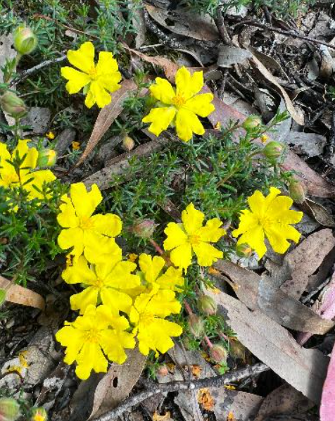

Hibbertia porcata © Warren Tomlinson (from Atlas of Living Australia)

Proposed conservation status

Endangered in Australia

Criterion B2ab(ii,iii,iv,v)

Current conservation status

Hibbertia porcata is not currently listed as threatened in Victoria, New South Wales or Australia.

Taxonomy
Hibbertia porcata Toelken was described in 2013 based on a type specimen collected by Gauba in 1949 at Lake George on the Southern Tablelands of New South Wales (Toelken 2013).
The Australian Plant Census (APC) recognises H. pedunculata as being a pro parte synonym of H. porcata. Hibbertia pedunculata is still a good taxon in its own right and some specimens and populations previously ascribed to that taxon are now recognised as H. porcata. Hibbertia porcata was included by Toelken (2013) in the informal H. pedunculata subgroup of the H. vestita species group. The H. vestita species group is considered by Toelken (2013) to be a natural group and easily distinguished from other groups in subgroup Hemistemma (Touars) Horn, mainly by the character of stamens being arranged around the ovaries. Whilst it shares this characteristic with species of subgroup Hibbertia, the H. vestita group differs in having hairy ovaries and narrow petiole bases not clasping the branches.

Members of the H. pedunculata subgroup have ericoid leaves, more or less pedicellate flowers, often with the pedicel recurved in fruit, an indumentum that includes fascicled as well as simple hairs, and stamens arranged around 2 or 3 hairy carpels. Hibbertia porcata can be easily distinguished from most other species in the subgroup by having a typically pronounced ridge along the length of the outer sepals that is accentuated by recurved distal margins, usually ± tuberculate and spreading, with simple hairs on the outer sepals and usually glabrous abaxial leaf surface (visible in young leaves and bracts). The leaves of H. porcata are similar to those of H. samaria, but that species has fascicled hairs on the stems and an abaxial leaf lamina (usually only visible in young leaves), 10-15 stamens, and long anthers (1.5-2 mm long). Hibbertia porcata has a similar indumentum and androecium to H. pedunculata but is distinguished by its acute to pointed outer sepals with a pronounced central ridge. Hibbertia pedunculata typically occurs in coastal areas in central and northern N.S.W., whereas H. porcata occurs further inland, in localities that skirt the northern and north-western subalpine regions (Hammer & Thiele 2021).
In Victoria, H. porcata can be distinguished from other taxa previously assigned to H. pedunculata (i.e. H. dispar, H. exponens, H. exposita, and H. samaria) by the prominent central ridge of the calyx which is accentuated by its recurved margins, and the long, simple, tubercle-based hairs on the upper surface of leaves and the calyx. Hairs on the upper surface of leaves are seldom forked, a feature of H. samaria, and leaves are glabrous on the lower surface. H. porcata closely resembles H. samaria but can be readily distinguished from that taxon by the presence of stellate hairs on the lower leaf surface, calyx and ovary (VicFlora 2018).

Prior to the publication by Toelken (2013) of H. porcata and other members of the H. pedunculata subgroup, field workers assigned records of the taxon not only to H. pedunculata s.l. but occasionally also to H. stricta, H riparia, H. serpyllifolia or H. vestita, despite the last four taxa having sessile or subsessile flowers, at least across regions inhabited by H. porcata. As discussed by Toelken (2013), several aberrant outlier occurrences of H. porcata have sessile or subsessile flowers, adding to the confusion regarding the group or species identity of unvouchered site records, including those supported by images in iNaturalist. Specimen records assigned to Hibbertia taxa not closely related to the H. pedunculata subgroup of the H. vestita group recognised by Toelken (2013) have occasionally been found to be referable to H. porcata, for example H. stricta, H. ?stricta and H. ?humifusa, which are not in the H. vestita species group.

Description

Simple description

Hibbertia porcata is a small shrub spreading by prostrate stems or stolons to form ground-hugging mats, with narrow leaves 4-6 mm long and 0.5-0.7 mm wide. Flowers are yellow, 20 mm wide, softly hairy, hanging on stalks 4-10 mm long, with 15-25 stamens. Plants flower in Spring from October to November.

Formal taxonomic description
Hibbertia porcata is a decumbent to prostrate shrub to 0.25 (-0.45) m high, with several wiry- to rigid-woody branches and with pubescent to hirsute decurrent leaf bases. Young stems are sparsely to moderately pubescent to hirsute with scattered antrorse simple hairs of varying lengths. Vestiture on branches, leaves, flower stalk and calyx is persistent, with ± dense longer spreading simple hairs (pustulate on leaves) over short simple ones. Leaves are shortly to distinctly petiolate, with dense intrapetiolar tufts of hairs up to 1 mm and usually decurrent on both sides of the leaf bases; the petiole is 0.3-1.2 mm long; the lamina linear-lanceolate to linear, (1.3-) 4-6 (-7.4) × 0.5-0.7 (-0.8) mm, usually scarcely constricted into petiole, acute often becoming obtuse, with apex of central vein usually scarcely protruding, recurved and with short tuft of hairs, above flat, sparsely hirsute to glabrescent, rarely pilose, but scattered basal pustules visible, below with slender recessed central vein overtopped by revolute margins and rarely with rows of teeth between them, with glabrous undersurface rarely visible, similarly hirsute to glabrescent as above. The flowers are single, terminal on main and axillary branches, with a rounded base, pedicellate or, rarely, subsessile, with pedicels (2-) 4-10 (-16.8) mm long. The primary bracts are usually towards the base or rarely up to the middle; the buds are broadly ovoid to ellipsoidal; primary bracts linear, linear-lanceolate, (1.3-) 4-6 (-7.8) × (0.4-) 0.5-0.8 (-1) mm, acute, leaf-like with distinctly revolute margins at least distally, usually glabrescent; additional bracts (0) 1-3, with more pronounced revolute margins, grading into cauline leaves. The calyx lobes are unequal; outer calyx lobes lanceolate to lanceolate-elliptic, (5-) 6-7 (-7.8) × (1.2-) 1.4-1.8 mm, often ± longer than inner ones, acute, with central ridge usually well-developed usually along the full length, outside hirsute to strigose, inside pubescent to puberulous on distal third; inner calyx lobes broadly ovate to oblong-elliptic, (4.6-) 5.5-6.8 (-7.3) × (2.6-) 2.8-3.3 mm, rounded to mucronate or emarginate, slightly ridged, outside strigose along the central ridge and pubescent to puberulous towards the membranous margins. There are five petals, yellow, broadly obovate, up to 11.7 mm long, emarginate. Stamens 15-25, rarely with few staminodes, arranged around the ovaries; filaments filiform to strap-like, ± free, 1.6-3 mm long, broadened but usually scarcely connate basally; anthers obloid, 1.1-1.6 mm long, abruptly constricted above, tapering into the filaments below, dehiscing by ± introrse longitudinal slits; staminodes absent or few, filiform. Carpels 3; ovaries obovoid, each with 4-6 ovules, hirsute; styles c. 3.5 mm long, attached to the upper outer margin of the ovaries, then curved upwards and ± erect and with stigmas above the anthers. Fruit recurved, hirsute. Seeds obloid-obovoid to comma-shaped, 2.6 × 1.8 mm, dark brown; aril with oblique fleshy attachment surmounted by a membranous cup covering more than a third of one side of the seed (Toelken 2013, VicFlora 2018, Hammer & Thiele 2021).

Diagnostic features
Decumbent to prostrate shrubs to 0.25 (-0.45) m high; leaves sparsely hirsute to pilose, linear-lanceolate to linear, the margins revolute and usually completely obscuring the abaxial lamina; flowers pedicellate or, rarely, subsessile, the pedicels (2-) 4-10 (-16.8) mm long; primary bract near the base (rarely near the middle) of the pedicel; outer sepals with a distinct ridge for ± their whole length, with spreading, tubercle-based hairs; stamens 15-25, all around the carpels; staminodes absent or few; carpels 3, hirsute, 4-6-ovulate (Hammer & Thiele 2021).
Hibbertia porcata is a very variable species known from many isolated subpopulations. It is easily recognised by the usually pronounced ridge along the length of the outer calyx lobes, accentuated by recurved distal margins. The long simple hairs on the calyx, especially on the outer calyx lobes usually have pronounced basal tubercles. It has a glabrous, usually granulate leaf undersurface, mainly visible on bracts and on prophylls at the base of lateral branches, and the anthers are usually longer than 1.5 mm. The ± linear leaves with long simple hairs resemble those of H. samaria, but H. porcata differs by having only simple hairs on all parts of the plants (or rarely the odd forked hair on the inner calyx lobes) and the undersurface of the leaves is glabrous or rarely with a few fine teeth on the (revolute) leaf margins. H. porcata shares vestiture and the large flowers with many stamens with H. pedunculata but is distinguished by its acute to pointed outer calyx lobes with a pronounced central ridge. It also usually has a very much broader central vein than the revolute margins at mid-leaf and occurs mainly in inland localities more or less skirting the northern and north-western subalpine regions of New South Wales, whereas H. pedunculata is mainly restricted to the coastal regions of central and northern New South Wales. Similarly, sessile-flowered specimens of H. porcata from, for instance, Tumut have sometimes been identified as H. vestita, a species from the coast of northern New South Wales and southern Queensland. These are mainly distinguished by their broader central vein, which is more or less tightly wedged in between the revolute margins (Toelken 2013).

Variation
The length of leaves and hairs varies greatly in different populations in this species, as is commonly found in species of this group. The most noteworthy variation, sessile or subsessile flowers found in three specimens from the vicinity of Tumut, also affects the concept of the H. pedunculata subgroup, which is mainly distinguished by stalked flowers. Specimens from further south, viz. Tumbarumba and Khancoban, however, have stalked flowers. Furthermore, records from the northern parts of the distribution, especially from north of Orange also have subsessile flowers, as well as a more erect habit (in one case up to 45 cm high, apparently decumbent on other plants). Some of these specimens also have a larger number of stamens or finer hairs on the whole plant, but all these extreme characters occur in plants from populations peripheral to the main distribution of the species (Toelken 2013). It has subsequently become evident that additional occurrences also include specimens with subsessile flowers, most notably at Walwa in far north-east Victoria.

Distribution
Hibbertia porcata is an Australian endemic, with records from Victoria and New South Wales.

Due to the relatively recent recognition of the taxon (Toelken 2013), there are numerous records from older determinations (both specimen and site records) that could plausibly represent H. porcata, most notably those previously assigned to H. pedunculata in areas outside the known range of that taxon, but also from other taxa.

Victoria
Although the Flora of Victoria states that H. porcata is known in Victoria from a single record near Christmas Hills, north-east of Melbourne (VicFlora 2018), there is another small subpopulation in the region north-east of Melbourne, and at least two historical occurrences near the New South Wales border in the north-east of the state where the taxon may now be locally extinct (ALA 2025b, AVH 2025).
Hibbertia porcata has been monitored for at least forty years on freehold land belonging to the Round the Bend Conservation Cooperative at the Bend of Islands near Christmas Hills (Frank Pierce personal communication 12 October 2023). In 2002 a second occurrence was recorded at Boomers Nature Conservation Reserve between Panton Hills and Smiths Gully, 7.5 km north-west of the Bend of Islands occurrence (ALA 2025b).
There have been two historical collections of H. porcata in far north-east Victoria near the New South Wales border. In 1874 it was collected at Towong near the Murray River and in 1980 it was collected in the Red Bank Creek area 3 km north-west of Walwa and south of Jingellic. In the absence of targeted searching, it is unknown whether either of these occurrences have survived the long history of land clearance associated with European settlement of these two districts, particularly in the Towong district. In 1888 there was a collection from the Upper Murray River but with no further location details provided, it is unclear if this is from the same area as the 1874 collection. In 1939 H. porcata was collected on a spur near the Berrima River in the Ingeegoodbee district in the vicinity of the New South Wales border in the far north of East Gippsland (AVH 2025). Although recorded as collected in New South Wales, the specimen record plots to the border on the Australian Virtual Herbarium (AVH) database (2025). A careful interpretation of the collector's notes confirms this specimen can only have been collected on the Victorian side of the border. In the absence of targeted searching, it is unknown whether H. porcata survives in this remote and relatively intact landscape. Unvouchered quadrat records in the Victorian Biodiversity Atlas (VBA) of H. riparia taken in 2012 in the Red Bank Creek area 4 km south-west of the 1980 collection site are also likely to be H. porcata, noting that the 1980 specimen was described as having 'sessile flowers all galled', accounting for the identification in 1980 as Hibbertia ?stricta and presumably also the identification of the quadrat records as H. riparia.
New South Wales
In New South Wales, H. porcata has been collected from the Khancoban, Talbingo, Tumut, Ulandra, Sutton, Dalton, Lake George, Mullion Creek, Glen Alice and Dunns Swamp areas in the Southern Tablelands, Central Tablelands, South Western Slopes and Central West Slopes bioregions (ALA 2025b, DCCEEW 2025, iNaturalist 2025, NatureMapr 2025).
Within New South Wales, H. porcata occurs across a range of tenures, with records from the Wollemi National Park, Ulandra Nature Reserve, Mullion Range State Conservation Area, Tumut Ecology Reserve, Downfall Nature Reserve, private land, roadsides, travelling stock routes, and potential records in the Woomargama National Park, Wereboldera State Conservation Area and Tallaganda State Forest. Historic records (e.g. from Khancoban, and some of the earlier records from Tumut and Sutton) occur in areas which have undergone agricultural intensification and land clearance. It is not known if these persist. However, in some areas such as Tumut, recent records indicate the presence of extant subpopulations.
Unvouchered site records in BioNet, the Atlas of Living Australia (ALA), iNaturalist and NatureMapr extend the plausible extent and range of districts in which H. porcata is likely to occur, with plausible site records from additional localities including Gundaroo, Broadway, Wamboin, Ophir, Tumbarumba, Walang, Summer Hill Creek, Napoleon Reefs, Rye Park and Tarcutta and records with potential to be H. porcata from Ilford, Mount Werong, Barryrenie, Windellama, Cullen Bullen and Clarence.
Hibbertia porcata has not yet been recorded in the ACT but being so near the border along Sutton Road it is very likely to occur in the Kowen area (Farrow 2022).
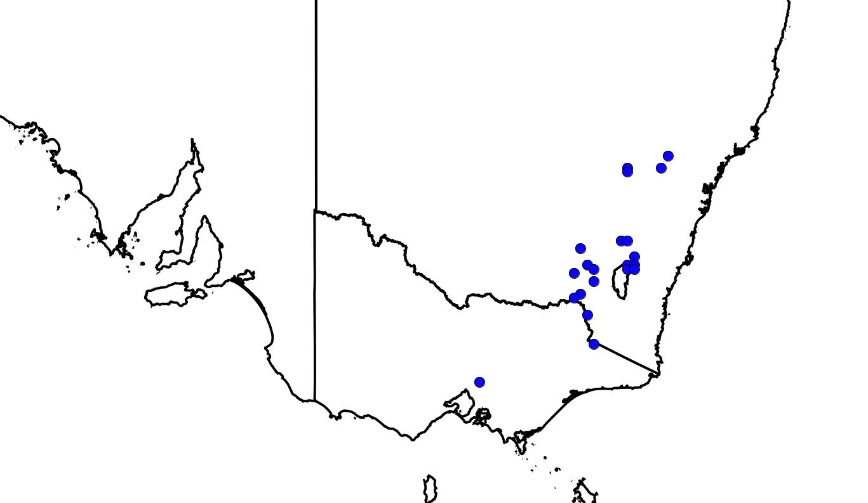
Figure 1: Hibbertia porcata occurrence records from ALA (2025a)

Population
The total population size for H. porcata is unknown and cannot be estimated given the lack of recent surveys in some regions of the historical distribution of the species and the fact the species has exhibited vegetative (asexual/clonal) reproductive tendencies in the extant subpopulation at the Bend of Islands site north-east of Melbourne which may be a distribution-wide phenomenon (see Biology and Ecology section).

Subpopulations
As of May 2025, there are c. 86 records representing the estimated lower bound of H. porcata occurrences – including confirmed specimen records, site records with photos and site records from areas where no other closely related taxa occur. This lower bound estimate of occurrences may represent an overestimate of the number of subpopulations as some records in New South Wales, for example near Tumut, Dalton and the Mullions Range, are clustered and may represent more-or-less continuous stands in continuous suitable habitat, however this requires targeted surveys.
Victoria
In Victoria, the two extant H. porcata subpopulations near Melbourne have been well studied. It is unknown whether the species persists at any of the three collection sites in the Ingeegoodbee, Towong and Walwa districts near the New South Wales border or whether these occurrences comprised a single clone or multiple clones. If any of these occurrences persist and comprise multiple clones or non-clonal plants, then the total Victorian population may exceed 50 mature individuals. A summary of Victorian subpopulations and estimate of number of mature individuals is provided in Table 1.

Table 1: Victorian subpopulations of Hibbertia porcata.
Subpopulation location | Number of mature individuals (lower/mid/upper bound) | Comments
Boomers Nature Conservation Reserve | 40 (upper) | A count in 2021 found approximately 40 plants although a number of juveniles were included in the count and therefore, the total number of mature individuals may be overestimated and is considered the upper bound.
Bend of Islands | 1 (lower)  3-6 (mid)  200 (upper) | A total count of ramets has not been undertaken, however a survey of the boundary extent found the plants occupy an area of around 3,500m². Given the plant is thought to be clonal and not reproduce by seed, there may be only one true plant or genet with up to 200 ramets, some of which are likely to have become disconnected over the decades and may give the impression of a superficially larger subpopulation size. Whilst field observation suggests these ramets flower without successful seed set, therefore not displaying evidence of reproduction, should they set seed in the future, individual disconnected ramets could, potentially, be interpreted as mature individuals. The external boundaries of each discrete patch of more-or-less connected ramets were mapped in 2003 and again in 2022. These two surveys indicate that the boundary has scarcely changed in the last 20 years and that the absolute area of occupancy is stable. The two superimposed surveys (supplied by Frank Pierce 12 October 2023) support the interpretation that the entire stand may result from a single germination event in the distant past, subsequently subdivided by an old track, with a maximum of three large patches which may represent three germination events, and three very small outliers which may represent another three germination events.
Walwa | Not known | There is no record of population size for this occurrence which may have become locally extinct since the collection in 1980.
Towong | Not known | There is no record of population size for this occurrence which is very likely to have become locally extinct since the collection in 1874.
Ingeegoodbee | Not known | There is no record of population size for this occurrence which may have become locally extinct since the collection in 1939.
New South Wales
For New South Wales, there is a paucity of reliable subpopulation size estimates in any of the datasets reviewed, including specimen records in the Australasian Virtual Herbarium (AVH) and unvouchered site records in BioNet, the Atlas of Living Australia (ALA), iNaturalist and NatureMapr. This is undoubtedly because the species has only recently been segregated from broadly circumscribed taxa and because the species is not currently considered rare or threatened in New South Wales. A few records provide circumstantial evidence of minimum subpopulation sizes including two NatureMapr records from Gundaroo, which provide individual counts of 1 and 3, and one from Sutton, with an individual count of 15, and site records in BioNet from the Tarcutta Hills Reserve, which provide individual counts of 1-10. There is no record of subpopulation size in any collector's notes accompanying specimen records for New South Wales in the AVH. Farrow (2022) observed representative occurrences in New South Wales and noted at Broadway Travelling Stock Reserve that there were carpets of H. porcata in full flower. At other sites he reported the presence of seedlings among the flowering plants, indicating successful reproduction following the drought-breaking rains of 2020-2021.
From the scant available evidence, it is unclear whether any occurrences in New South Wales are clonal or whether all adult individuals are genetically distinct and arise from germination of seed in the seedbank. It is impossible, therefore, to estimate even a lower bound for population size for the species in New South Wales.

Cultural and community significance
The cultural, customary and spiritual significance of species and the ecological communities they form are diverse and varied for First Nations. Such knowledge may be held by First Nations peoples who have the rights to decide how this knowledge is shared and used.
The known distribution of Hibbertia porcata north-east of Melbourne occurs on the lands of the Wurundjeri People. The historic records in north-east Victoria near the NSW border are on land where Traditional Owners have not been formally recognised. In NSW, H. porcata occurs across the lands of the Gundungurra, Wiradjuri, Ngunnawal Yuin and Ngarigo peoples, marginally represented on lands of the Wonnarua, Darkinjung and Dharug peoples and potentially also marginally represented in the lands of the Yuin peoples (Horton 1996).
There is little published information on the cultural significance of Hibbertia porcata to Traditional Owners. However, given the acknowledged importance to First Nations peoples of Connection to Country and the widespread importance of Caring for Country (which includes biodiversity, ‘place’, custom and totemic elements), it is likely that the species has or is associated with some cultural and/or customary significance.

Biology and ecology

Habitat
Hibbertia porcata often occurs in eucalypt woodlands with heathy understoreys on various substrates with sandstone or other rocks (Hammer & Thiele 2021; Toelken 2013). Soils include sandy or clay loams or stony lateritic soil on shale or sandstone (AVH 2025).

In Victoria, H. porcata is recorded from dry sclerophyll forest (VicFlora 2018). Both extant Victorian subpopulations are within dry eucalypt woodlands classified as Box-Ironbark Forest and Grassy Dry Forest. The dominant canopy includes Eucalyptus polyanthemos (Red Box) and E. goniocalyx (Long-leaf Box or Bundy). The midstorey and understorey are relatively sparse, a response to previous disturbances and the north-facing aspect. At the Bend of Islands, H. porcata is recorded growing on rocky ground on a steep north-west facing hill in dry box forest dominated by E. goniocalyx, E. macrorhyncha (Red Stringybark) and E. tricarpa (Red Ironbark) with Acacia genistifolia, Pultenaea sp., Dillwynia sp. and Gompholobium sp. in the understorey. The Boomers Reserve subpopulation is found on disturbed ground, on and around mullock heaps. The dominant canopy is E. tricarpa and E. polyanthemos. The midstorey and understorey are diverse, owing to protection and restoration within a high value conservation reserve with ongoing management.
At Towong, H. porcata was collected “on granite rocks” (AVH 2025). In the Ingeegoodbee district, it was collected on a spur near the Berrima River. In the Red Bank Creek area, it was collected in a “mineral and stone area” (AVH 2025), suggesting the site may have been a gravel pit.
In New South Wales, H. porcata is recorded in dry sclerophyll forest or woodland dominated by E. blakelyi (Blakely's Red-gum), E. bridgesiana (But But or Apple Box), E. goniocalyx , E. macrorhyncha, E. melliodora (Yellow Box), E. polyanthemos, E. rossii (Scribbly Gum) or Callitris endlicheri (Black Cypress-pine) and occasionally in Themeda triandra grassland (likely to represent a woodland from which the overstorey has been eliminated through settlement activity at least at the very local scale) or heathland on a rocky sandstone ridge (AVH 2025). H. porcata is recorded on a range of aspects in dry elevated sites, often on rocky slopes, ridges or spurs or on undulating tablelands, occasionally on road cuttings, roadsides or travelling stock reserves.

Reproduction and dispersal ecology
Hibbertia porcata is inferred to be a long-lived procumbent perennial shrub. Field observations suggest the two confirmed extant Victorian subpopulations north-east of Melbourne may exhibit distinct reproductive strategies. The Bend of Islands subpopulation is reported to only reproduce vegetatively via prostrate stems, stolons or, potentially, root suckers. It has been suggested that this may result from chronic exposure to both native and exotic herbivores (Cam Beardsell and Dylan Osler personal communication, 2024). By contrast, the Boomers Reserve subpopulation, only 7.5 km to the north-west, is reported to produce viable seed with evidence of seed recruitment from the soil seedbank (FFG 2023).
From a subpopulation of H. porcata in the Dalton area in New South Wales, Roger Farrow (2022) reports “the presence of seedlings among flowering individuals of the species, indicating successful reproduction following the drought-breaking rains of 2020-2021”. Knight (2023) reports dry conditions in the Sutton district in NSW north-east of the ACT causing high mortality after which “the survivors are doing magnificently”. There are no other reports on H. porcata reproductive strategies from New South Wales.

Neville Walsh suggests that Hibbertia species tend to be very long-lived, rarely produce viable seed despite regular and often prolific seasonal flowering and only die in rare fire events after which they are inferred to be replaced by successful seedbank recruits (Neville Walsh personal observation 2024). From these observations, it is inferred that both extreme drought stress and wildfire can result in adult mortality and that recruitment from the seedbank can be promoted by optimal rainfall events. Hibbertia porcata is inferred to be a long-lived facultative resprouter with episodic recruitment from the soil-stored seedbank following rare intense fire events, supplemented by opportunistic and sporadic trickle recruitment following optimal rainfall events and other localized disturbance events.

From the scant available evidence, it is uncertain whether any occurrences other than the Bend of Islands subpopulation are clonal or whether all other adult individuals are genetically distinct and arise from germination of seed in the seedbank.

Hibbertia porcata has no specialised mechanism for long-distance dispersal. The only plausible vectors of seed are ants (myrmecochory) which operate at the metre scale. Berg (1975) considered the entire genus Hibbertia to be myrmecochorous. Hibbertias have prominent white fleshy elaiosomes and Berg states that “the best-developed Australian elaiosomes with regard to their effect upon ants seem from my experience to be those of Caesia, Bossiaea, Tetratheca, Hibbertia, Monotoca and Opercularia”. Rice & Westoby (1981) found that five of six Hibbertia species encountered in their study (all species of sclerophyllous vegetation) were undoubted myrmecochores and the sixth (a species of damp forests including rainforest ecotones) was considered likely to be myrmecochorous. Berg (1975) observed ant dispersal ranges from 0.4-4.0 m but did not provide an upper limit. In numerous Victorian assessments of myrmecochorous species, the plausible upper limit has been set at 10-100 m with the majority of seed assumed to be dispersed in the 1-10 m range.

Hibbertia porcata flowers mostly from October to December, occasionally also to May. Hibbertia flowers are known to be buzz pollinated, requiring a bee to vibrate the poricidal anthers to release pollen (Bernhardt 1986, Tucker & Bernhardt 2000, Doyle et al. 2023). Native bee pollinators recorded for Hibbertia include species in the genera Allodapula, Exoneura, Xylocarpa, Tetragonula, Leioproctus, Homalictus, Lasioglossum and Nomia (Armstrong 1979; Benson & McDougall 1995; Doyle et al. 2023), from which it can be inferred that effective pollination could occur at distances up to 1 km (Greenleaf et al. 2007; Biel et al. 2008; Smith et al. 2017).

Generation length
Generation length is difficult to estimate given the different reproductive strategies evident in the Victorian and NSW subpopulations.

The lower bound estimate of 10-24 years is based on a rationale suggested by Gavin Phillips (personal communication, 2025) applicable to non-clonal species of Hibbertia for which generation length can be calculated using the reproductive-lifespan proxy method in the IUCN Guidelines (IUCN Standards and Petitions Committee 2024), which is appropriate for plants that reproduce vegetatively and persist above-ground for long periods. This requires the primary juvenile period (PJP), lifespan and a coefficient. Many Hibbertia species have primary juvenile periods of 3-4 years (Benson 1985) or even longer, say at least 6 years (David Keith personal communication to Gavin Phillips and Gavin Phillips personal observation 20 June 2025). The lifespan can also range from as low as 10-20 years (DEH 2009) or up to 60 years (Benson & McDougall 1995) or even exceeding 60 years for the closely related H. serpyllifolia (Benson & McDougall 1995). The z coefficient estimated for selected woody shrubs falls into the 0.21-0.33 range (Fung & Waples 2017), but may underestimate values for Australian sclerophyll taxa. From this we can use the formula age of first reproduction + z * length of reproductive period to estimate generation length. For H. porcata and its ecology, Phillips suggests a maximum lifespan of 30-60 years, a PJP of 5-6 years and a z value of 0.21-0.33. This gives a generation length of 10-24 years. Phillips considers this a robust estimate consistent with most other Hibbertia assessments, however because the necessary demographic census and modelling has not been done for Hibbertias, this can’t be confirmed.

An alternative rationale based on ‘the turnover rate of breeding individuals in a population’ (IUCN 2012) can be used for species which recruit episodically following intense fire events capable of killing all or most adult plants in any one subpopulation. The mean interval between such events under pre-European settlement conditions in the dry sclerophyll forest or woodland habitat of the taxon is likely to have been in the 30-60 year range. On the assumption that H. porcata is likely to recruit episodically following intense fire or extreme drought events from a soil-stored seedbank, supplemented by some sporadic (trickle) recruitment in response to optimal seasons or localised disturbance events, a mid-bound estimate of generation length of 25-50 years is suggested.

The upper bound estimate of 150 years is suggested for clonal occurrences and reflects the field observation that the more extensive of the two confirmed extant Victorian stands at the Bend of Islands has been observed over four decades to persist only through vegetative spread by prostrate stems, stolons or, potentially, root suckering. This stand has remained stable for forty years and, in the absence of an all-consuming intense fire event or extreme and prolonged drought (it successfully survived the Millenium Drought), has the potential to survive indefinitely, particularly since fires are likely to be quite patchy and of variable intensity in open dry habitats such as at the Bend of Islands which has almost no understorey and mostly bare ground with litter, scarcely able to sustain even a low intensity ground fire in most seasons (David Cameron personal observation, 2001). Whether the reported lack of seedset, despite prolific flowering, is an artefact of browsing pressure, as suggested by Cam Beardsell and Dylan Osler (personal communication to David Cameron, 2024) is unknown.

Given the uncertainty regarding the balance between episodic recruitment following intense fire or extreme drought events and more continuous, sporadic or opportunistic recruitment in response to optimal rainfall or localised disturbance events, and the lack of field observations in New South Wales to determine whether any of these subpopulations exhibit clonality, the species is considered data deficient regarding generation length.

Threats

Catastrophic events such as severe and widespread wildfires, extreme and prolonged drought stress, habitat loss and degradation, accidental disturbance, herbivory (from Sambar (Cervus unicolor), rabbits, kangaroos and wallabies) or disease/pathogens are likely to represent the greatest threats to the persistence of H. porcata.

Climate change and fire

Climate change, resulting in more frequent fire events and increasing drought stress, operates across the entire range of the taxon, and is expected to have a greater impact than all other historic and current threats to its persistence.

Anthropogenic climate change is causing more extreme weather conditions in Australia based on observations (Dowdy 2018; Harris & Lucas 2019; Van Oldenborgh et al. 2021) and modelled projections (Clarke & Evans 2019; Dowdy et al. 2019). Round et al. (2024) report projected increases in percent time in drought, duration and intensity of drought for south-eastern Australia for the 21st century compared to the 20th century. A doubling of the time spent in extreme drought is projected. Warmer and drier conditions have increased the potential for large and severe fire seasons across south-eastern Australia (Collins et al. 2022). Furthermore, the mean annual Forest Fire Danger Index (a widely used indicator of fire weather) is projected to increase by up to 26% by 2080 in south-eastern Australia (Clarke & Evans 2019). A catastrophic fire event, especially under projected climate change conditions, could lead to a significant reduction in plant numbers or local extinction.

Fire regimes can threaten a species by either directly impacting aspects of its lifecycle (recruitment failure), or indirectly through disturbance of ecological interactions, ecosystem structure and function, or processes (degradation of habitat) (DAWE 2022). Hibbertia porcata is potentially threatened by anthropogenic fire regimes (including climate driven and local fuel management) and climatic warming and drying which, synergistically, increase the risk of recruitment failure following repeat, high intensity fire events followed by extreme drought stress and targeted browsing by native and exotic herbivores. These complex abiotic and biotic interactions can be disrupted and threats amplified under altered fire regimes (DAWE 2022). For example, fire herbivore interactions can suppress survival, growth and reproduction in a range of understorey plant species (Leigh & Holgate 1979; Leigh et al. 1991; Giljohann et al. 2017). This can be due to burnt landscapes becoming more easily accessible to herbivores who may be attracted to post-fire regrowth (DAWE 2022).

A severe or high intensity fire could degrade habitats, especially the dry slopes, and increase the likelihood of surface erosion and other habitat degradation which may disrupt or inhibit reestablishment of post-fire vegetation (DAWE 2022). Climate change threatens the habitat with increased solar radiation and reduced rainfall. It may lead to degradation of soils and protective cryptogamic crusts, with increased risk of storm events resulting in surface erosion (DAWE 2022).

These complex abiotic and biotic interactions with fire regime and climate change are described in more detail under the Environmental Protection and Biodiversity Conservation Act 1999 listed Key Threatening Process for ‘Fire regimes that cause declines in biodiversity’ (DAWE 2022).

Neville Walsh suggests that Hibbertia species tend to be very long-lived, rarely produce viable seed despite regular and often prolific seasonal flowering and only die in rare fire events after which they are inferred to be replaced by successful seedbank recruits (Neville Walsh personal observation 2024). From these observations, it is inferred that both extreme drought stress and wildfire can result in adult mortality and that recruitment from the seedbank can be promoted by optimal rainfall events. Hibbertia porcata is inferred to be a long-lived facultative resprouter with episodic recruitment from the soil-stored seedbank following rare intense fire events, supplemented by opportunistic and sporadic trickle recruitment following optimal rainfall events and other localized disturbance events.

Habitat loss and degradation
Historically, H. porcata is likely to have suffered severe decline in response to land clearing for agriculture, particularly in the Towong and Walwa districts in north-eastern Victoria where the taxon may now be locally extinct. Additional localised historic threats include mining or prospecting activity at several sites in both Victoria and New South Wales such as at Boomers Nature Conservation Reserve and possibly also near Walwa. During the Gold Rush era, Box-Ironbark forests, such as those in the Queenstown (now St Andrews) and Christmas Hills districts, were targeted for tunnel support and firewood (David Cameron personal observation 2025). Localised timber harvesting may have also degraded the habitat of the species in a few districts in New South Wales.

With only two known extant Victorian subpopulations located 7.5 km apart and occupying a relatively small area, the potential for stochastic events to disturb both subpopulations is high. The subpopulation at Boomers Nature Conservation Reserve, managed by Parks Victoria, would be considered relatively protected from threats related to land use change. The Bend of Islands subpopulation occurs on private land and has a conservation covenant with Trust for Nature. This protects the land in perpetuity and commits the land for conservation. The owners are committed to protection of the land and to undertake significant management for conservation. However, for both subpopulations, which occupy small areas, the potential for accidental damage from management works is a significant threat. Additionally, for both subpopulations, secure land tenure may not be able to mitigate the threats of changing climate conditions or fire events.

Herbivory
The subpopulation at Boomers Nature Conservation Reserve is protected by an herbivore exclusion fence, which excludes most large herbivores (Sambar, rabbits, kangaroos and wallabies). The subpopulation at the Bend of Islands is largely unfenced and likely browsed. A fence has been installed to protect a small part of the subpopulation and would likely exclude most herbivores. Plants in the fenced exclosure were noticeably larger on a visit in June 2022 (Frank Pierce personal communication, 12 October 2023). The Bend of Islands subpopulation is reported to only reproduce vegetatively via prostrate stems, stolons or, potentially, root suckers. It has been suggested that this may result from chronic exposure to both native and exotic herbivores (Cam Beardsell and Dylan Osler personal communication, 2024). The impact of trampling and browsing by Sambar (Cervus unicolor) is likely to be the greatest long-term threat to the Bend of Islands subpopulation since population density of Sambar has been undergoing an explosive increase in the last twenty years throughout the region. Sambar densities are greatest in the forested districts east of Melbourne, extending to the NSW border, with lower densities between Khancoban, Tumut and the ACT in NSW (ALA 2025). Sambar are effectively unrecorded throughout the remainder of the range of Hibbertia porcata in NSW.

Disease susceptibility
The species may also be threatened by the pathogen Phytophthora cinnamomi since some Hibbertia taxa have demonstrated susceptibility to P. cinnamomi (Reiter et al. 2004). Given the recent segregation of H. porcata and numerous other taxa in the genus, susceptibility of individual taxa has yet to be observed in the field or tested in laboratory trials. The response to P. cinnamomi varies dramatically across this genus, however Hibbertia has multiple species considered to be at high risk of extinction from P. cinnamomi (McDougall et al. 2024, Wan et al. 2019). McDougall et al. (2024) note that “Many new species of Hibbertia have been named in recent decades, and several have very limited distributions. One of these, Hibbertia circinata, is regarded as being at a very high risk of extinction because it is usually killed in the presence of P. cinnamomi and its single population is infested. Prior to its recent recognition as a species, it was part of Hibbertia linearis R.Br. ex DC., which we identified as being at low risk of extinction. Glasshouse testing of rare, newly described Hibbertia species, occurring in habitat suitable to P. cinnamomi, is recommended.”
The Strategic Management Prospects spatial tool scores the threat of P. cinnamomi as between 30-40 (1 being low and 100 being high) for the areas containing the two known extant Victorian subpopulations (DEECA 2025).
The significance of the observation by Cliff Beauglehole, when collecting the species at Red Bank Creek near Walwa in 1980, as having “sessile flowers all galled” (AVH 2025) is unknown.

Adequacy of survey

The two extant Victorian subpopulations of H. porcata have been monitored regularly but no known monitoring has occurred in NSW. The currently available information does not allow an estimation of the number of mature individuals. The data used for the assessment against the IUCN criteria provides sufficient scientific evidence to support the assessment.

Assessment against the IUCN Criteria

Key assessment parameters
Table 2 includes the key assessment parameters used in the assessment of eligibility for listing against the criteria. The definition of each of the parameters follows the Guidelines for Using the IUCN Red List Categories and Criteria.

Table 2: Key assessment parameters
Metric | Estimate used in the assessment | Minimum plausible value | Maximum plausible value | Justification
Number of mature individuals | Data deficient | unknown | unknown | The total population size for H. porcata is unknown and cannot be estimated due to the lack of recent surveys. Some subpopulations are apparently small and localised.
Trend | Unknown but inferred to be declining |  |  | Past decline in population size can be inferred from habitat loss which itself can be inferred from a comparison of 1750 and current vegetation mapping.  Future decline in population size can also be inferred from the projected impact of an increase in fire risk, increasing drought and herbivory (see Threats section for more detail).
Generation length (years) | Data deficient | 10-24 | 150 | Generation length is difficult to estimate, given the different reproductive strategies evident in the Victorian and NSW subpopulations. In addition, different calculation methods give vastly differing values, so the species is considered data deficient regarding generation length (see Reproduction and dispersal ecology section).
Extent of occurrence (EOO) (km²) | 80,608 | 80,608 | 104,916 | The lower bound estimate is based on the number of confirmed and extant occurrences. The upper bound estimate also includes less confident and unvouchered site records, some of which are historic and may no longer persist.
Trend | Unknown |  |  | It is unclear whether the identified threats are currently operating with sufficient intensity to result in a current or imminent risk of local extinction of a significant proportion of outlying occurrences such that EOO is in significant current decline.
Area of occupancy (AOO) (km²) | 280 | 260 | 420 | The lower bound estimate is based on the number of confirmed and extant occurrences. The midpoint estimate also includes some records interpreted as having intermediate reliability, locational accuracy or implied persistence. The upper bound estimate also includes less confident and unvouchered site records, some of which are historic and may no longer persist.
Trend | Unknown but estimated to be declining |  |  | Continuing decline is based on the high current or imminent risk of local extinction of at least some small and isolated occurrences in response to the current or projected impact of the identified threats.
Number of subpopulations | 86 | 86 | 134 | Geographically isolated occurrences are interpreted as distinct subpopulations since they occur at separations that are likely to exceed the dispersal range of the taxon, which has no specialised mechanism for long-distance seed dispersal, and its likely pollinators. The only plausible vectors of seed are ants (myrmecochory) which operate at the metre scale and effective pollination by native bees could occur at distances up to 1 km.  The lower bound estimate is based on the number of reliably determined, discrete and extant occurrences.  The upper bound estimate also includes less confident and unvouchered site records, some of which are historic and may no longer persist.
Trend | Unknown but likely declining |  |  | Continuing decline in subpopulation number is based on the high current or imminent risk of local extinction of at least some small and isolated subpopulations in response to the current or projected impact of the identified threats.
Basis of assessment of number of subpopulations | At the time of writing there are c. 86 records representing the estimated lower bound of H. porcata occurrences – including confirmed specimen records, site records with photos and site records from areas where no other closely related taxa occur. This lower bound estimate of occurrences may represent an overestimate of subpopulation number since some records in New South Wales, for example near Tumut, Dalton and the Mullions Range, are clustered and may represent more-or-less continuous stands in continuous suitable habitat, however this is not certain.
Number of locations | 3 | 3 | 4 | The Interim Biogeographic Regionalisation for Australia (IBRA) (DCCEEW 2023) supports the recognition of 3-4 threat-based locations:  - The majority of stands in New South Wales fall within the NSW South Western Slopes IBRA region. Records in NE Victoria in the Walwa district also occur in the NSW South Western Slopes IBRA region, as does the historic Towong record which is presumed long extinct and located either side of the state border on the Upper Murray River.  - A smaller proportion of New South Wales stands fall within the South Eastern Highlands IBRA region. The extant Victorian records northeast of Melbourne also fall within the South Eastern Highlands IBRA region.  - One stand (Pagoda Lookout in Wollemi National Park) falls within the Sydney Basin IBRA region.  - The Berrima River record near the NSW border in the Suggan Buggan district in East Gippsland, if it persists, falls within the Australian Alps IBRA region. Based on a 1939 specimen, in the absence of targeted searching, it is unknown whether H. porcata survives in this remote and relatively intact landscape. This location contributes only to the upper bound estimate of location number.  All records fall within the Temperate Köppen climate zone (Bureau of Meteorology 2024).
Trend | Unknown but likely to be declining |  |  | There is a significant likelihood that the only confirmed record within the Australian Alps IBRA region has already become extinct since a collection was taken in 1939. There is also a significant risk that the only confirmed record within the Sydney Basin IBRA region may become locally extinct in response to the projected impact of the identified threats. This suggests a long-term trajectory of 4 locations declining to 2 locations.
Basis of assessment of location number | The most serious plausible threat that results in the lowest number of locations for H. porcata is considered to be prolonged and extreme drought stress, which may act synergistically with the increasing risk of repeat fire events, which results in the species having 3-4 threat-defined locations. These locations can be defined across the distribution of the species using the Interim Biogeographic Regionalisation for Australia (IBRA) (DCCEEW 2023), and Köppen climate classes (Bureau of Meteorology 2024). This is because the IBRA bioregions are defined by common climate, geology, landform, native vegetation and species information (DCCEEW 2023), and attributes that influence the effects of drought and fire events such as productivity and natural drought frequency are known to differ across ecoregions. The complex interaction between extreme and prolonged drought stress and increasing fire risk, both driven by climatic drying and warming, results in an increasing risk of adult mortality and recruitment.
Severe fragmentation | Hibbertia porcata is inferred to be fragmented naturally (prior to large-scale clearing) and anthropogenically at both the landscape and regional scales with most extant occurrences at separations greatly exceeding the dispersal range of the taxon, which has no specialised mechanism for long-distance dispersal. The only plausible vectors of seed are ants (myrmecochory) which operate at the metre scale. The only known extant Victorian occurrences are separated by 7.5 km and the closest historic records in north-east Victoria are 290 km away, precluding any possibility of recolonisation in the event of local extinction. Similarly, all extant occurrences in New South Wales are fragmented at the landscape or subregional scales, often because of historic habitat loss due to agricultural intensification or land clearance. However, subpopulation sizes across the NSW range of the species are essentially undocumented and one could argue that severe fragmentation is therefore data deficient across the full range of the species. Circumstantial evidence suggests, however, that individual occurrences are small and isolated with no evidence of very large subpopulations. Anecdotal reports of ‘carpets of plants’ at one site are noted, but that was in a travelling stock reserve which are usually quite small, so likely indicative of high local density but not necessarily a large subpopulation.  For this assessment, it is considered that Hibbertia porcata is data deficient regarding its qualification as severely fragmented.
Extreme fluctuations | There is no evidence to suggest H. porcata is subject to any significant fluctuation in population size, EOO, AOO or number of subpopulations. It is a long-lived perennial which is inferred to have maintained stable populations under undisturbed pre-European settlement conditions.

Criterion A. Population size reduction
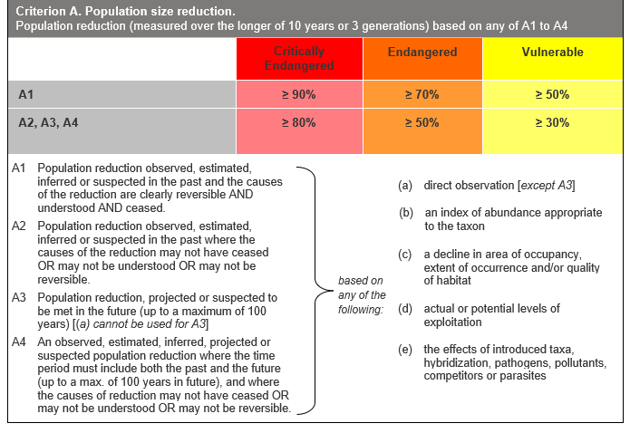
Insufficient data to determine eligibility
Generation length
With a minimum plausible bound of 10-24 years and a maximum plausible bound of 150 years, H. porcata is considered data deficient regarding generation length (see Reproduction and dispersal ecology section).

Past reduction
Past reduction cannot be estimated with any confidence since it is unknown whether H. porcata persists at sites where historic records have not been recently confirmed and since there is insufficient longitudinal monitoring data to indicate whether extant occurrences are in significant long-term population decline in response to the impact of the identified threats. Although the comparison of current vegetation extent with inferred pre-European extent suggests historic habitat loss across the range of the species has been considerable, in the absence of a reliable description of habitat range and accurate mapping of pre-settlement and current vegetation types, historic habitat loss cannot be quantified.

Future reduction
A projected future reduction cannot be quantified with any confidence although the projected impact of climate change resulting in a dramatically increasing risk of prolonged and intense drought and intense and repeated wildfire across the range of H. porcata is likely to be significant.
The future impact of other identified threats is equally difficult to quantify and their contribution to future reduction cannot be estimated with any confidence since the identified threats operate stochastically and with unpredictable intensity. In addition, the persistence of the two Victorian extant occurrences is conservation dependent and therefore dependent on the success or otherwise of applied management regimes. The impact of the exotic herbivore Sambar is expected to increase as this species continues to fill out its full projected habitat range. Infection by the water-borne pathogen Phytophthora cinnamomi in warm moist conditions conducive to its transmission represents another potential threat.

Past and future reduction
Past and future (moving window) decline is likely to be significant given the impact of historic and projected threats, but as the three-generational time frame is unknown, the degree of reduction cannot be quantified with any confidence.

Criterion B. Geographic range
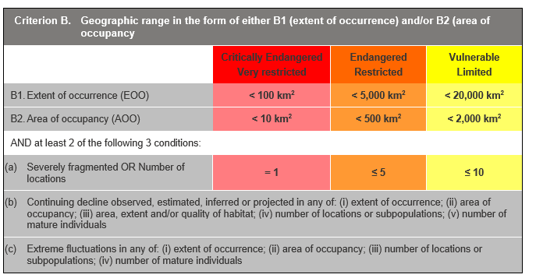
Eligible as Endangered under Criterion B2ab(ii,iii,iv,v)
Extent of Occurrence
The lower bound estimate of 80,608 km² is based on the number of reliably determined, locationally accurate and extant occurrences. The upper bound estimate of 104,916 km² also includes less confident and unvouchered site records, some of which are historic and may no longer persist.

Area of Occupancy
The lower bound estimate of 260 km² is based on the number of reliably determined, locationally accurate and extant occurrences. A midpoint estimate of 280 km² also includes some records interpreted as having intermediate reliability, locational accuracy or implied persistence. The upper bound estimate of 420 km² also includes less confident and unvouchered site records, some of which are historic and may no longer persist. These estimates meet the threshold for Endangered under B2.

Severely fragmented
Hibbertia porcata is inferred to be fragmented naturally (prior to large-scale clearing) and anthropogenically at both the landscape and regional scales with most extant occurrences at separations greatly exceeding the dispersal range of the taxon, which has no specialised mechanism for long-distance dispersal (as discussed above). However, subpopulation sizes across the NSW range of the species are essentially undocumented, and therefore severe fragmentation is data deficient across the full range of the species. For this assessment, it is considered that Hibbertia porcata is data deficient regarding its qualification as severely fragmented.
Number of locations
Three to four locations can be identified based on the overriding threat of climate change which operates across the entire geographic and ecological range of the taxon and results in an increasing risk of adult mortality and recruitment failure in response to prolonged and extreme drought stress which may act synergistically with the increasing risk of repeat and extreme fire events.

Continuing decline
Continuing decline in (ii) area of occupancy, (iii) area, extent and quality of habitat, (iv) number of locations and subpopulations and (v) number of mature individuals is inferred or projected based on the current and projected impact of the identified threats, and risk of local extinction of at least some small and isolated occurrences in response to those threats.
Climate change is causing an increase in fire risk and increased likelihood of high intensity fires, as well as increasing risk of drought (see Threats section). This leads to a projected decline, as more frequent high intensity fires, especially if followed by drought stress and herbivory of post-fire recruitment, are likely to lead to the loss of individuals and subpopulations.
In assessing the vulnerability of Victoria's Central Highlands forest to climate change, Nitchke & Hickey (2007) predict that all tree species in the region, including Acacia dealbata (Silver Wattle), A. mearnsii (Black Wattle), A. melanoxylon (Blackwood), E. dives (Broad-leaf Peppermint), E. globulus subsp. bicostata (Victorian Blue-gum), E. macrorhyncha (Red Stringybark), E. radiata (Narrow-leaf Peppermint) and E. rubida (Candlebark), will have almost nil or very low regeneration potential following stand replacing events such as wildfire by 2055 or 2085. Since all these trees, especially E. macrorhyncha, have significant geographic and ecological overlap with the range of H. porcata, the projected impact of climate change on its habitat cannot be ignored. Although there is circumstantial evidence that the taxon can persist in the absence of the canopy in forest or woodland landscapes, there is little doubt that landscape-scale decline of eucalypts and acacias in response to prolonged and extreme drought stress will permanently change the habitat of H. porcata across its entire range.

Criterion C. Small Population size and decline
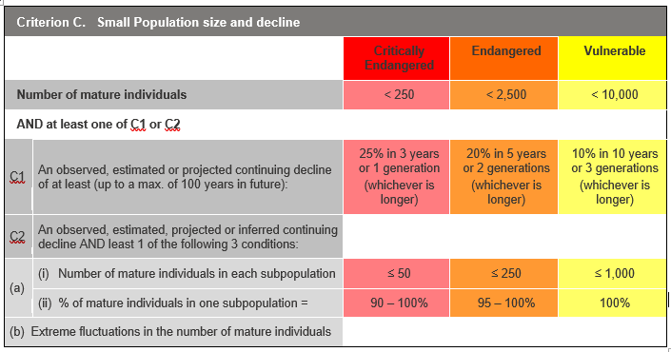

Insufficient data to determine eligibility
Hibbertia porcata is ineligible under Criterion C since there is no available estimate of population size, subpopulation size is unavailable for 84 of the 86 confirmed records, the percentage of mature individuals in any one subpopulation is confidently less than 90% and the population is not subject to extreme fluctuations.

Criterion D. Very small or restricted populations

Criterion D. Very small or restricted populations
– | Critically Endangered | Endangered | Vulnerable
D. Number of mature individuals | < 50 | < 250 | < 1,000
D2. Only applies to the Vulnerable category  Restricted area of occupancy or number of locations with a plausible future threat that could drive the species to Critically Endangered or Extinct in a very short time | - | - | D2. Typically: Area of Occupancy < 20 km² or number of locations ≤ 5

Insufficient data to determine eligibility
Hibbertia porcata is ineligible for listing under Criterion D since there is no available estimate of population size.
Hibbertia porcata may be eligible for listing as Vulnerable under subcriterion D2 since it has a restricted population with an estimated 3-4 locations such that this restriction may make it capable of becoming Critically Endangered or Extinct. However, with no reliable estimate of generation length, the short time frame (one to two generations) over which this decline needs to be considered is unknown.

Criterion E. Quantitative analysis
Insufficient data to determine eligibility
Criterion E (Quantitative Analysis) was not addressed as the taxon has not been subjected to a detailed Population Viability Analysis.

References
ACHRIS (2025). https://achris.vic.gov.au/weave/wca.html [accessed 8 May 2025].
ALA (2025a). Atlas of Living Australia website. Species page and occurrence map: Hibbertia porcata: Christmas Guinea-flower | Atlas of Living Australia. [accessed on 06 February 2025].
ALA (2025b). Atlas of Living Australia Hibbertia porcata occurrence download at https://doi.org/10.26197/ala.c9766db3-1fe8-45f4-847e-ba769cabf296 [accessed on 08 January 2025].
Armstrong JA (1979) Biotic pollination mechanisms in the Australian flora — a review. New Zealand Journal of Botany 17: 467-508.
AVH (2025). The Australasian Virtual Herbarium, Council of Heads of Australasian Herbaria, https://avh.chah.org.au [accessed 6 February 2025].
Beil M, Horn H, Schwabe A (2008) Analysis of pollen loads in a wild bee community (Hymenoptera: Apidae) - a method for elucidating habitat use and foraging distances. Apidologie 39(4): 456-467.
Benson DH (1985). Maturation periods for fire-sensitive shrub species in Hawkesbury Sandstone vegetation. Cunninghamia 1(3): 339-349.
Benson DH, McDougall L (1995) Ecology of Sydney plant species Part 3: Dicotyledon families Cabombaceae to Eupomatiaceae. Cunninghamia 4(2) 217-431.
Berg RY (1975) Myrmecochorous plants in Australia and their dispersal by ants. Australian Journal of Botany 32: 475-508.
Bernhardt P (1986) The pollination biology of Hibbertia stricta (Dilleniaceae). Plant Systematics and Evolution 147: 267–277.
Bureau of Meteorology (2024) Climate classification maps. Available at: http://www.bom.gov.au/climate/maps/averages/climateclassification/?maptype=kpngrp
Clarke HG, Evans JP (2019) Exploring the future change space for fire weather in southeast Australia. Theoretical and Applied Climatology, 136, 513–527.
Collins L, Clarke H, Clarke MF, McColl Gausden SC, Nolan RH, Penman T, Bradstock R (2022). Warmer and drier conditions have increased the potential for large and severe fire seasons across south-eastern Australia. Global Ecology and Biogeography 31(10): 1933–1948.
DAWE 2022, Fire regimes that cause declines in biodiversity as a key threatening process, Department of Agriculture, Water and the Environment, Canberra.
DCCEEW (2023) Department of Climate Change, Energy, the Environment and Water: Australia’s bioregions (IBRA). Available at: https://www.dcceew.gov.au/environment/land/nrs/science/ibra.
DCCEEW (2025) Department of Climate Change, Energy, the Environment and Water, BioNet, Environment and Heritage Group, New South Wales Government.
DEECA (2025) Strategic Management Prospects, NatureKit, Available at: https://naturekit.biodiversity.vic.gov.au/
DEH (2009). Species information sheet for Hibbertia tenuis (Fleurieu Guinea-flower). South Australian Department for Environment and Heritage. Unpublished information provided to the Department of the Environment, Water, Heritage and the Arts. Canberra.
Dowdy AJ (2018) Climatological variability of fire weather in Australia. Journal of Applied Meteorology and Climatology, 57, 221–234.
Dowdy AJ, Ye H, Pepler A, Thatcher M, Osbrough SL, Evans JP, Di Virgilio G, McCarthy N (2019) Future changes in extreme weather and pyroconvection risk factors for Australian wildfires. Scientific reports 9(1), 10073.
Doyle CAT, Yap JYS, Bragg J, Rossetto M, Orme A, Ooi MJK (2023) Reproductive characteristics, population genetics, and pairwise kinship inform strategic recovery of a plant species in a fragmented landscape. Conservation Science and Practice 5(4): e12910.
Farrow, Roger (2022). A new plant for summer: Gail's Hibbertia. In Journal of the Australian Native Plants Society, Canberra Region Inc. 21(1): 1-3.
FFG (2023). Flora and Fauna Guarantee Act Nomination Nom 906: Hibbertia porcata Christmas Guinea-flower.
Fung HC, Waples RS (2017) Performance of IUCN proxies for generation length. Conservation Biology 31(4), 883–893.
Giljohann KM, McCarthy MA, Keith DA, Kelly LT, Tozer MG, Regan TJ (2017) Interactions between rainfall, fire and herbivory drive resprouter vital rates in a semi-arid ecosystem. Journal of Ecology 105, 1562–1570.
Greenleaf SS, Williams NM, Winfree R, Kremen C (2007) Bee foraging ranges and their relationship to body size. Plant Animal Interactions 153: 589-596.
Hammer, Timothy A & Thiele, Kevin R (2021). Hibbertia porcata, in P.G. Kodela (ed.), Flora of Australia. Australian Biological Resources Study, Department of Climate Change, Energy, the Environment and Water: Canberra. https://profiles.ala.org.au/opus/foa/profile/Hibbertia%20porcata [Date Accessed: 10 January 2025].
Harris S, Lucas C (2019). Understanding the variability of Australian fire weather between 1973 and 2017. PloS ONE 14: pp e0222328.
Horton DR (1996) The AIATSIS Map of Indigenous Australia. Australian Institute of Aboriginal and Torres Strait Islander Studies. URL: https://aiatsis.gov.au/explore/map-indigenous-australia (accessed 3 June 2025).
iNaturalist (2025). https://www.inaturalist.org/ [accessed 6 February 2025].
IUCN (2012). IUCN Red List Categories and Criteria: Version 3.1. Gland, Switzerland and Cambridge, UK.
IUCN Standards and Petitions Committee. (2024). Guidelines for Using the IUCN Red List Categories and Criteria. Version 16. Prepared by the Standards and Petitions Committee. Downloadable from https://www.iucnredlist.org/documents/RedListGuidelines.pdf.
Knight, Gail Ritchie (2023) Report from WWs (Wednesday Walkers) outing on 25 October. In Australian Native Plants Society, Canberra Region Inc. Bulletin November 2023.
Leigh JH, Holgate MD (1979) The responses of the understorey of forests and woodlands of the Southern Tablelands to grazing and burning. Australian Journal of Ecology 4: 25–45.
Leigh JH, Wood DH, Slee AV, Holgate MD (1991) The effects of burning and simulated grazing on productivity, forage quality, mortality and flowering of eight subalpine herbs in Kosciusko National Park. Australian Journal of Botany 39: 97–118.
NatureMapr (2025). https://naturemapr.org/ [accessed 6 February 2025].
Nitschke CR, Hickey GM (2007). Assessing the vulnerability of Victoria's Central Highland forests to climate change. Technical Report. Prepared for the Victorian Department of Sustainability and Environment.
Reiter N, Weste G, Guest D (2004). The risk of extinction resulting from disease caused by Phytophthora cinnamomi to endangered, vulnerable or rare plant species endemic to the Grampians, western Victoria. Australian Journal of Botany 52: 425-433.
Rice B & Westoby M (1981) Myrmecochory in sclerophyll vegetation of the West Head, New South Wales. Australian Journal of Ecology 6: 291-298.
Round V, Grose M, Macadam I, Bodman R, King M, Truong S, Heady C, Thatcher M, Clarke JM (2024) Victorian Climate Projections 2024 Technical Report. CSIRO, Melbourne.
Smith JP, Heard TA, Beekman M, Gloag R (2017) Flight range of the Australian stingless bee Tetragonula carbonaria (Hymenoptera: Apidae). Austral Entomology 56(1): 50-53.
Toelken HR (2013). Notes on Hibbertia subg. Hemmistemma (Dilleniaceae) 9. The eastern Australian H. vestita group, including H. pedunculata and H. serpyllifolia. Journal of the Adelaide Botanic Gardens 26: 57-58.
Tucker SC, Bernhardt P (2000) Floral ontogeny, pattern formation, and evolution in Hibbertia and Adrastaea (Dilleniaceae). American Journal of Botany 87(12): 1915-1936.
Van Oldenborgh GJ, Krikken F, Lewis S, Leach NJ, Lehner F, Saunders KR, van Weele M, Haustein K, Li S, Wallom D, Sparrow S (2021) Attribution of the Australian bushfire risk to anthropogenic climate change. Natural Hazards and Earth System Sciences 21: 941–960.
VicFlora (2018). Flora of Victoria, Royal Botanic Gardens Victoria: Hibbertia porcata. Retrieved from: https://vicflora.rbg.vic.gov.au/flora/taxon/fbd5fbbd-1e4b-4b96-b849-9659df056f2d [Date Accessed: 10 January 2025].


Acknowledgment
We acknowledge and respect Victorian Traditional Owners as the original custodians of Victoria's land and waters, their unique ability to care for Country and deep spiritual connection to it. We honour Elders past and present whose knowledge and wisdom has ensured the continuation of culture and traditional practices.
We are committed to genuinely partner, and meaningfully engage, with Victoria's Traditional Owners and Aboriginal communities to support the protection of Country, the maintenance of spiritual and cultural practices and their broader aspirations in the 21st century and beyond.
© The State of Victoria Department of Energy, Environment and Climate Action 2026
This work is licensed under a Creative Commons Attribution 4.0 International licence. You are free to re-use the work under that licence, on the condition that you credit the State of Victoria as author. The licence does not apply to any images, photographs or branding, including the Victorian Coat of Arms, the Victorian Government logo and the Department of Energy, Environment and Climate Action (DEECA) logo. To view a copy of this licence, visit http://creativecommons.org/licenses/by/4.0/
ISSN 1448-9902 (online)
Disclaimer: This publication may be of assistance to you but the State of Victoria and its employees do not guarantee that the publication is without flaw of any kind or is wholly appropriate for your particular purposes and therefore disclaims all liability for any error, loss or other consequence which may arise from you relying on any information in this publication.
Accessibility
If you would like to receive this publication in an alternative format, please telephone the DEECA Customer Service Centre on 136186, email customer.service@delwp.vic.gov.au or via the national Relay Service on 133 677 www.relayservice.com.au. This document is also available on the internet at www.environment.vic.gov.au

