Introduction
Biodiversity Response Planning (BRP) is a long-term area-based planning approach to biodiversity conservation in Victoria. It is designed to strengthen alignment, engagement and participation between government, Traditional Owners, non-government agencies and the community.
DELWP Regional staff have been working with stakeholders on actions to conserve biodiversity in specific landscapes, informed by the best available science and local knowledge.
These Fact Sheets capture a point in time, reflecting data and knowledge available in 2020. They provide information for many (but not all) landscapes across Victoria, containing general information on the key values and threats in each area, as well as the priority cost-effective actions that provide the best protection of biodiversity. Fact Sheets are intended to provide useful biodiversity information for the community, non-government and government organisations during project planning and development.
Further information and the full list of Fact Sheets is available on the Department’s Environment website.

Landscape description
This 740,000ha area is mostly native vegetation (75% cover) and has significant public land (91%). It follows the public land boundary and includes Murray Sunset National Park, and Berrook, Berribee and Boinka State Forests.
This landscape is buffered 1km from the public land boundary and has a minor overlap with Murray Scroll Belt landscape in the north, Hattah and Annuello landscapes in the east and Cowangie landscape in the south. You can find further information on these focus landscapes in the full list of Fact Sheets.

Cultural importance
We recognise that the entire landscape has high cultural value for Traditional Owners. Landscapes identified as having “notable” cultural importance is based on the density of recorded cultural heritage sites and knowledge shared by Traditional Owners. We also recognise that there are locations important to Traditional Owners not within these landscapes.
Notable cultural importance for the First People of the Millewa Mallee Aboriginal Corporation.

Stakeholder interest
As part of the Biodiversity Response Planning process, in October 2020 stakeholders were asked to nominate focus landscapes and actions of interest. First People of the Millewa Mallee, Parks Victoria, DELWP and Murrayville Landcare Group nominated Murray Sunset.
Possible future investment/project development in this landscape will be available to any interested stakeholders in addition to those who nominated this landscape.
Specific stakeholder interests identified through the engagement process within this landscape include:
- Parks Victoria Conservation Action Plan assets – Mallee Triodia, Sunset Plains and Swales, Semi-arid woodlands – (Taparoo, Raak, Pink Lakes), Inland saline soaks (Raak), Total Grazing Management, Semi-arid woodland restoration (rabbits, goats, kangaroos, revegetation, vegetation monitoring).
- Mallee Catchment Management Authority, Regional Catchment Strategy priority landscapes – 2. North west woodlands, 5. Murray Sunset National Park Dunefields, 6. Raak Plain, 8. Pink Lakes.
- Department of Environment, Land, Water and Planning – State Forest includes several large significant blocks – Berrook, Boinka, Lindsay point. Support fire management actions.

Community interest
There was no specific community interest in biodiversity conservation identified for this area through the consultation process.

 | Habitat Distribution Models identify 666 species with more than 5% of their Victorian range in this landscape area | Traditional Owners, stakeholders and community groups identified the following species of interest
 | 518 Plants, 20 species with more than 50% of Victorian range in area. Notably:  - Buttercup Pennywort (endangered, 88% of Victorian range in area)  - Horned Hop-bush (vulnerable, 89% of Victorian range in area) | - Buloke woodlands  - Semi-arid woodlands
 | 14 Mammals, 7 species with more than 10% of Victorian range in area. Notably:  - Mallee Ningaui (near threatened, 56% of Victorian range in area)  - Mitchell's Hopping-mouse (near threatened, 32% of Victorian range in area) | - Mallee Ningaui  - Red Kangaroo
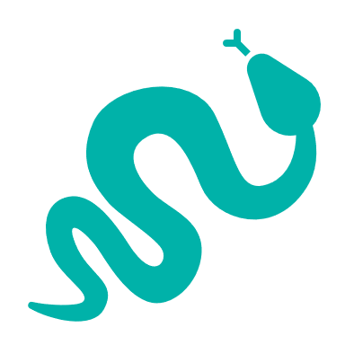 | 45 Reptiles, 7 species with more than 50% of Victorian range in area. Notably:  - Beaked Gecko (critically endangered, 70% of Victorian range in area)  - Yellow-faced Whip Snake (near threatened, 55% of Victorian range in area) | - Desert Skink  - Mallee Worm Lizard  - Murray-Darling Carpet Python
 | 89 Birds, 6 species with more than 50 of Victorian range in area. Notably:  - Black-eared Miner (criticallly endangered, 77% of Victorian range in area)  - Mallee Emu-wren (endangered, 76% of Victorian range in area) | - Threatened Mallee Birds – Mallee Emu-wren, Black-eared Miner, Red-lored Whistler, Striated Grasswren, Regent Parrot, Malleefowl  - White-browed Treecreeper

Strategic Management Prospects
Strategic Management Prospects (SMP) models biodiversity values such as species habitat distribution, landscape-scale threats and highlights the most cost-effective actions for specific locations. More information about SMP is available in NatureKit.

Additional threats
Threats identified (in addition to those modelled in SMP) through the consultation process were:
- alterations to hydrology
- land salinisation
- soil erosion
- habitat degradation due to extremes of climate and weather
- lack of regeneration in some vegetation communities
- recreational activities causing fragmentation
- loss of vegetation, and erosion
- legacy use of public land
- private land use impacting biodiversity
- inappropriate land use planning
- inappropriate fire regimes (planned burning and bushfires)

Which landscape-scale actions are most cost-effective in this landscape?
Some areas of this focus landscape (coloured areas on the map) have highly cost-effective actions which provide significant benefit for biodiversity conservation.
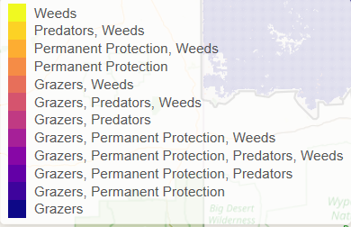
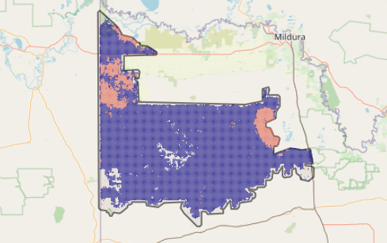
The SMP priority actions which rank among the top 3% for cost-effectiveness of that action across Victoria for much of the area (>25,000ha) are in order:
Control goats 646,471ha
Control pigs 172,874ha
Control overabundant kangaroos 95,145ha
Control weeds 56,751ha
Control rabbits 26,877ha
Of the top 10% of cost-effective actions, control goats provides the most cost-effective biodiversity benefits when considering all flora and fauna.
Actions suggested for this landscape through the nomination process are:
- control of weeds, goats, rabbits, pigs, overabundant kangaroos and foxes
- revegetation
The most cost-effective action for flora and fauna
Plants - Control weeds
Mammals, birds - Control goats
Reptiles - Control pigs

For a further in depth look into SMP for this landscape please refer to NatureKit.

