Introduction
Biodiversity Response Planning (BRP) is a long-term area-based planning approach to biodiversity conservation in Victoria. It is designed to strengthen alignment, engagement and participation between government, Traditional Owners, non-government agencies and the community.
DELWP Regional staff have been working with stakeholders on actions to conserve biodiversity in specific landscapes, informed by the best available science and local knowledge.
These Fact Sheets capture a point in time, reflecting data and knowledge available in 2020. They provide information for many (but not all) landscapes across Victoria, containing general information on the key values and threats in each area, as well as the priority cost-effective actions that provide the best protection of biodiversity. Fact Sheets are intended to provide useful biodiversity information for the community, non-government and government organisations during project planning and development.
Further information and the full list of Fact Sheets is available on the Department’s Environment website.

Landscape description
This 234,000ha area has a small amount of native vegetation (8% cover) and a small amount of public land (1%). It includes some small reserves, roadside and private land remnants in an otherwise cleared landscape.
This landscape has a major overlap in the east with the Lake Tyrrell landscape. For more information please refer to Lake Tyrrell in the full list of Fact Sheets.

Cultural importance
We recognise that the entire landscape has high cultural value for Traditional Owners. Landscapes identified as having “notable” cultural importance is based on the density of recorded cultural heritage sites and knowledge shared by Traditional Owners. We also recognise that there are locations important to Traditional Owners not within these landscapes.
Notable cultural importance within this landscape of interest has not been identified.

Stakeholder interest
As part of the Biodiversity Response Planning process, in October 2020 stakeholders were asked to nominate focus landscapes and actions of interest. South East Mallee Landcare Network, Hindmarsh Landcare Network, Trust for Nature and Mallee Catchment Management Authority nominated Birchip.
Possible future investment/project development in this landscape will be available to any interested stakeholders in addition to those who nominated this landscape.
Specific stakeholder interests identified through the engagement process within this landscape include:
- Trust for Nature; covenants and threatened species that are a key focus, for example, Buloke Woodlands, Grassy Woodlands, Grasslands (particularly remnants on road reserves).
- Mallee Catchment Management Authority; focus on the restoration (for example, regeneration within existing remnants) and protection (for example, grazing/competition impacts) of high value habitat (including WMP wetlands) for priority species outcomes.

Community interest
This area was identified by Landcare as being a priority area for woodland birds and connectivity of remnants and wetlands with gaps in biodiversity action.

 | Habitat Distribution Models identify 59 species with more than 5% of their Victorian range in this landscape area | Traditional Owners, stakeholders and community groups identified the following species of interest
 | 59 Plants, 7 species with more than 10% of Victorian range in area. Notably:  - Quambatook Mallee (endangered, 19% of Victorian range in area)  - Orange Darling-pea (endangered, 17% of Victorian range in area) | - ​Chariot Wheels  - Blue Bells  - Chocolate Lilies  - Buttons Daisy  - Eutaxias  - Needlewood Hakeas  - Sugar Woods  - Hopbush  - Mini daisies  - Quandongs  - Buloke and Mallee  - Buloke Mistletoe  - Camel Bush
 |  | - Carpet Python
 | Plains Wanderer known in the area (critically endangered, 2% of Victorian range in area) | - Plains Wanderer  - Grey Crowned Babbler  - Brown Tree Creeper  - Eastern Great Egret  - Hooded Robin  - Intermediate Egret  - Bush-stone Curlew  - Pink Cockatoo
 |  | - Bibron’s Toadlet

Strategic Management Prospects
Strategic Management Prospects (SMP) models biodiversity values such as species habitat distribution, landscape-scale threats and highlights the most cost-effective actions for specific locations. More information about SMP is available in NatureKit.

Additional threats
Threats identified (in addition to those modelled in SMP) through the consultation process were:
- alterations to hydrology
- land salinisation
- soil erosion
- habitat degradation due to extremes of climate and weather
- lack of regeneration in some vegetation communities
- recreational activities causing fragmentation
- loss of vegetation, and erosion
- legacy use of public land
- private land use impacting biodiversity
- inappropriate land use planning
- inappropriate fire regimes (planned burning and bushfires)

Which landscape-scale actions are most cost-effective in this landscape?
Some areas of this landscape (coloured areas on the map) have highly cost-effective actions which provide significant benefit for biodiversity conservation
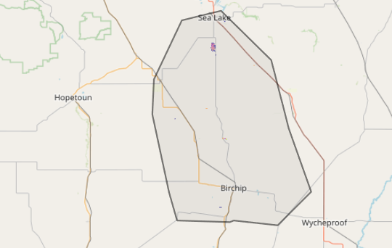
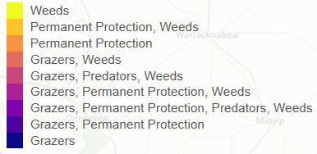
The only SMP priority action which ranks among the top 3% for cost-effectiveness of that action across Victoria is permanent protection.
The SMP priority actions which rank among the top 10% for cost-effectiveness of that action across Victoria are in order:

Control rabbits 304ha
Control overabundant kangaroos 278ha
Control weeds 218ha

Of the top 10% of cost-effective actions, control rabbits provides the most cost-effective biodiversity benefits when considering all flora and fauna.
Additional actions suggested for this landscape through the nomination process are:
- control of weeds and rabbits
- permanent protection
- environmental watering
- revegetation
- Noisy Miner control
- supplementary revegetation

The most cost-effective action for flora and fauna
Plants – Control rabbits
Mammals, birds, reptiles, amphibians – Combined cat and fox control

For a further in depth look into SMP for this landscape please refer to NatureKit.
