|  |
| --- |
| Roles and responsibilities: Native Vegetation Credit Register site assessors |
| Information sheet on the roles and responsibilities of those assisting landowners establish native vegetation credits. |

The site assessor can complete a gain scoring assessment and develop a security agreement to the standard of the NVCR that establishes native vegetation credits.

* 1. **What is a Site Assessor?**

A site assessor is an individual or organisation that charges a fee or commission for services including: assessments in native vegetation on proposed sites, developing site management plans and assisting landowners in offset site establishment.

A site assessor can also conduct a gain scoring assessment in accordance with the *Guidelines for the removal, destruction or lopping of native vegetation, 2017* (Guidelines) and developing a security agreement for a landowner to establish an offset site. The Department of Environment, Land, Water and Planning (DELWP) has a service provider Site Assessor Agreement that must be signed to establish a Native Vegetation Credit Register (NVCR) site assessor.

## Site assessor rights and obligations

The Site Assessor Agreement specifies how the site assessor must perform their duties, including that they ensure the highest quality of work with the utmost efficiency and that they keep the DELWP informed of matters it ought to be made aware of.

Site Assessors must work in accordance with and comply with the Guidelines, Rules of the NVCR and the Site Assessor Manual. They must:

* have knowledge of Victoria’s native vegetation removal regulations and offset policy, including the Guidelines, planning schemes and relevant policy and regulations as amended from time to time
* apply due diligence including assessing offset site eligibility and potential for long term security of potential offset sites
* have current registration on the Vegetation Quality Assessment Competency Register and have sound botanical and ecological management skills
* apply DELWP standards of management
* have GIS capability to develop aerial and zone plans to the standards described in the Site Assessor Manual
* contract a qualified surveyor to prepare site plans to Land Victoria’s specification and standard

A site assessor cannot possess property, or be engaged in businesses, that may create a Conflict of Interest.

The agreement specifies that the site assessor must not have any conflict of interest with their duties under the agreement, and when providing services to a landowner and a credit purchaser this must be disclosed to both parties and DELWP. The site assessor must maintain proper records and documents concerning any assessments and agreements and comply with privacy laws.

The Secretary to DELWP may terminate the Site Assessor Agreement if the site assessor acts dishonestly, breaches the agreement or does not act in good faith.

## Site assessor helps landowners and purchasers

In accordance with the Site Assessor Agreement, a site assessor can provide services to landholders to:

* undertake site assessments, develop site management plans and supporting information, calculate gain, undertake quality assurance checks and submit completed work to the standard of the NVCR;
* use the standard documents supplied by DELWP to assess potential native vegetation credit sites, provide information and advice to landowners and develop management plans; and
* develop Security Agreements between the landowner(s) and the Secretary to the DELWP.

The site assessor will have a strong knowledge of the offset market including market prices, demand and availability of native vegetation credits and must provide advice to landowners and purchasers in accordance with market trends.

The site assessor should not offer services that are expected to be outside the current or likely future offset market including market prices, demand and availability of native vegetation credits.

The site assessor should direct purchasers to the online *Search the Native Vegetation Credit Register* tool and the list of Brokers on the DELWP website.

The site assessor must advise the landowner that fees apply to the establishment, monitoring and compliance with a Security Agreement and ensure that landowners understand their ongoing commitments and obligations under the Security Agreement.

## Estimated timeframes to set up an offset site

|  |  |  |
| --- | --- | --- |
| Task description | Responsible party | Timeframe |
| Complete gain scoring assessment and prepares the security agreement (including management plan, maps and title plan) | Site Assessor and Surveyor | 1-3 months |
| Review the proposal to ensure all standards and rules are complied with and have been correctly applied | DELWP (site assessor may be required to address comments) | 3 weeks for each review |
| Approved proposal is executed, the security agreement is signed by the landholder and the Secretary to DELWP | Site assessor arranges landowner signature then provides to DELWP for signature | 1-2 weeks |
| Signed (executed) agreement is registered on the land title and provided to the landholder | DELWP (in parallel with the below step) | 1-2 weeks |
| Native vegetation credits are recorded on the NVCR | DELWP | 1 week from execution |

## More information

The DELWP native vegetation website has useful information for landholders and credit owners, it:

* explains the steps required to establish an offset site and has information sheets about this process
* contains a list of NVCR site assessors and brokers
* has the management standards that must be complied with when managing an offset site
* details the NVCR fees
* has information to help set a price for native vegetation credits, including all past trade prices.

<https://www.environment.vic.gov.au/native-vegetation/native-vegetation/offsets-for-the-removal-of-native-vegetation/i-want-to-establish-a-native-vegetation-credit-site>

You can email [nativevegetation.offsetregister@delwp.vic.gov.au](mailto:nativevegetation.offsetregister@delwp.vic.gov.au) for queries about trading and allocating native vegetation credits or [nativevegetation.offsetmanagement@delwp.vic.gov.au](mailto:nativevegetation.offsetmanagement@delwp.vic.gov.au) for queries about setting up a new offset site or managing an existing offset site.

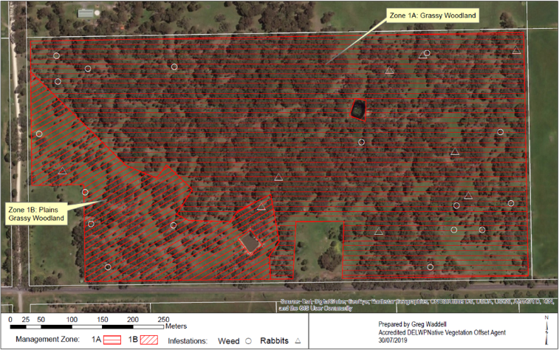

|  |  |
| --- | --- |
| © The State of Victoria Department of Environment, Land, Water and Planning 2020  LogoThis work is licensed under a Creative Commons Attribution 4.0 International licence. You are free to re-use the work under that licence, on the condition that you credit the State of Victoria as author. The licence does not apply to any images, photographs or branding, including the Victorian Coat of Arms, the Victorian Government logo and the Department of Environment, Land, Water and Planning (DELWP) logo. To view a copy of this licence, visit http://creativecommons.org/licenses/by/4.0/  ISBN 978-1-76105-305-4  Disclaimer  This publication may be of assistance to you but the State of Victoria and its employees do not guarantee that the publication is without flaw of any kind or is wholly appropriate for your particular purposes and therefore disclaims all liability for any error, loss or other consequence which may arise from you relying on any information in this publication. | Accessibility  If you would like to receive this publication in an alternative format, please telephone the DELWP Customer Service Centre on 136186, email [customer.service@delwp.vic.gov.au](mailto:customer.service@delwp.vic.gov.au), or via the National Relay Service on 133 677 [www.relayservice.com.au](http://www.relayservice.com.au). This document is also available on the internet at [www.delwp.vic.gov.au](http://www.delwp.vic.gov.au). |