Energy audit tool
ResourceSmart Schools

Contents
Using the energy audit tool 1
Energy consumption at schools 3
Tips for a successful audit 5
Teacher/facilitator checklist – basic audit 7
Worksheet: Basic energy audit – lighting 10
Worksheet: Basic energy audit – heating and cooling 12
Worksheet: Basic energy audit – appliances 14
Worksheet: Basic energy audit – windows and doors 16
Worksheet: Basic energy audit – discussion with relevant stakeholders 17
Appendix 1: Comprehensive energy audit 19
Appendix 2: Tools and calculations 23
Appendix 3: Extra activities 29
Appendix 4: Curriculum links 33
Glossary 35

Using the energy audit tool
Welcome to the ResourceSmart Schools (RSS) energy audit tool.
The audit tool helps you investigate and record information on energy use at your school, including lighting, heating, cooling and appliances. You will analyse this data to find ways to use less energy, reducing your energy bills and greenhouse gas emissions.
ResourceSmart Schools audit their energy use every year and upload results, photos and presentations to the RSS online system (secure.resourcesmartschools.vic.gov.au) as part of the energy module. The first audit provides baseline data and subsequent audits monitor your progress against baseline data.
The energy module is one of 5 modules in the RSS program. The other modules are core, biodiversity, water and waste. Schools must accomplish a set number of actions to complete each module and receive a certificate valid for 4 years.

What’s included in this tool?
An introduction to energy consumption at schools
Tips for completing the audit
Checklists to guide teachers/facilitators through the audit
Five basic energy audit worksheets
Information on completing a comprehensive energy audit (see Appendix 1)
Tools and calculations to help with your audit (Appendix 2), extra activities (Appendix 3) and advice on linking activities to the Victorian Curriculum (Appendix 4)
Glossary of energy terms

What does the audit involve?
Teachers and students will work together to assess energy use including measuring lighting levels and temperatures in rooms and reviewing how appliances and other equipment are used. Teachers will do some preparation and follow-up work (see the audit checklists) and students will complete the worksheets.

Who should do the audit?
The basic audit is suited to students in Years 5 to 10. The comprehensive audit is suited to students in Years 7 to 10 (see Appendix 1 for information on completing a comprehensive energy audit).

How long does the audit take?
Teachers will use their discretion to determine a realistic timeframe for each step of the audit investigation.

What school areas do we audit?
Audit at least one classroom for each year level, one hallway, one toilet and up to five other rooms in the school such as the school library, main office, teacher staffroom, IT room, hall/gym and science lab. When selecting other rooms, consider which ones are most likely to have higher energy use.

How does the audit link to the Victorian Curriculum?
Exploring the concept of energy, which includes an energy audit, contributes to several learning areas in the Victorian Curriculum (see Appendix 4: Curriculum links). Involving students in this audit also helps with:
Mathematics: Conducting an energy audit can incorporate using units of measurement, data collection and interpretation, chance, patterns, algebra, money, reading bills, financial mathematics, fractions, decimals and numbers.
History: Consider changes in energy technology and how we generate power, and the social changes that came about when electricity was supplied to households.
Download the curriculum guides from the website (sustainability.vic.gov.au/energy-efficiency-and-reducing-emissions/resourcesmart-schools/modules/curriculum).

Where can I find more information?
Visit the energy module pages on our Sustainability Victoria website (sustainability.vic.gov.au/energy-efficiency-and-reducing-emissions/resourcesmart-schools/modules/energy-module) for a module checklist and ‘how to’ guide packed full of ideas on how to work with students and your school community to reduce energy use.

Energy consumption at schools
Energy consumption is Victorian schools’ greatest impact on the environment. So, reducing your school’s energy consumption is the simplest way to reduce your school’s environmental impact.
In 2019, ResourceSmart Schools avoided creating 14,000 tonnes of greenhouse gas emissions – that’s equivalent to taking about 4,200 cars off the road for an entire year.

Types of energy typically considered in an energy audit
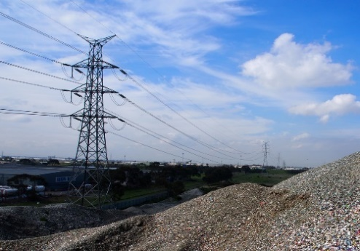 | Electricity for lighting, heating and cooling, appliances and other electrical equipment. Consumption is measured in kilowatt-hours (kWh).
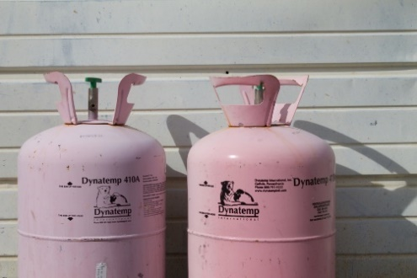 | Gas (natural gas or LPG ‘bottled gas’) for hot water, heating, cooking and other uses. Consumption is measured in megajoules (MJ), which is 1 million joules.
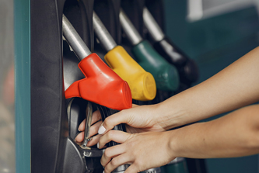 | Liquid fuels such as petrol and diesel for transport. Fuel is out of scope for this audit and is not required for ResourceSmart schools, but could be interesting for students to examine.

What are the biggest energy consumers in a typical Victorian school?
The biggest energy consumers in schools are lighting, computers and servers, and heating and cooling appliances. Electricity and gas bills provide a variety of information that can help schools understand their energy usage.

Measuring energy and electricity
Energy is a measurement of the ability of something to do work. Energy is measured in joules and kilojoules. Power is the rate of using energy and is measured in watts and kilowatts. Fuel bills show energy used in kilowatts per hour (kWh), and the cost of this can be calculated if the cost per kWh is known.
Energy is measured in kilogram, metres squared, per second squared (J = (kg m²)/s²). It takes 4.18 joules to raise the temperature of 1 gram of water by 1 degree Celsius.
Joule (J) | Standard unit of energy
Watt (W) | Unit of power (rate of energy usage)

Converting units
- 1 watt = 1 joule/second
- 1,000 watts = 1 kilowatt (kW)
- 3,600 watt-seconds = 1 watt-hour
- 1,000 watt-hours = 1 kilowatt-hours (kWh)

Tips for a successful audit
Follow these tips for a smoother audit:
Pick the right audit date
Select a date for your audit where you will see business-as-usual energy consumption, so not during the holidays for example. You may also want to consider how the school is used out-of-hours by community or sporting groups.
Estimate duration
Allow between 50 minutes and 2 hours to complete the walking assessment. For larger campuses, you may need to allocate student pairs or small teams to audit designated areas of the school, or get them to complete only one section of the audit (such as lighting or heating/cooling) across the school.
Select audit locations
To gather enough relevant data, you will need to audit at least one classroom for each year level, one hallway, one toilet and up to 5 other rooms in the school with a variety of energy levels or types.
Get your equipment ready
If your school does not have access to equipment such as a compass, lux meter or plug-in power meter, you can use phone and tablet apps as a compass and many local governments loan infrared thermometers and lux meters through their libraries or council offices. RSS facilitators may also have equipment you can use.

Choosing the right audit for your school
This audit tool includes 2 different energy audits to assess your school’s energy consumption depending on how much energy you currently use per student. The basic audit is a simpler tool for schools with lower energy consumption per student. The comprehensive audit is for schools with high energy consumption or with less energy-efficient infrastructure and behaviours in place.
Schools with large and energy-intensive infrastructure and high energy consumption would benefit from hiring a professional energy auditor to audit the school facilities.
To select the right energy audit for your school, compare your current energy use per student per year with the RSS benchmark:
Your RSS facilitator may be able to help with your energy audit and lend you the required tools.
- Primary school: 250 kilowatt-hours per student per year
- Secondary school: 400 kilowatt-hours per student per year
Use the table below to understand what level of audit you might need, then talk to your RSS facilitator to assess the best option for your school.

Teacher/facilitator checklist – basic audit

Before audit day

Step 1: Gather background energy information
- Upload 12 months of energy bills in the RSS online system (secure.resourcesmartschools.vic.gov.au) to set your baseline data (sustainability.vic.gov.au/energy-efficiency-and-reducing-emissions/resourcesmart-schools/get-started/baselines-and-benchmarks).
- Print a floor plan and aerial map of your school. If your school does not have an aerial map, you can use Google Maps.
- Select which areas to audit.
- Allocate areas to be audited to pairs or small groups.

Step 2: Organise equipment
Each pair/small group will need:
- Lux meter to record lighting levels.
- Infared thermometer to record temperatures.
- Plug-in power meter to record appliances energy consumption.
Note: See Appendix 2: Tools and calculations for advice on using these tools.
- Compass or aerial map of school buildings to determine orientation of windows.
- Paper strips or feathers to detect air drafts and gaps around windows and doors.
Note: If your school allows it, using incense smoke or an equivalent is an easier way to detect drafts.
- Student energy audit worksheets.
- Pens and clipboards.
- Camera to gather evidence for your RSS energy module, presentations and audit assessment.

On audit day

Step 3: Introduce energy audit tool
- Clarify understanding of terminology and timeframes with the class.
- Organise participants in pairs/small groups and define the areas to audit.
- Allocate equipment and responsibilities.
- Familiarise students with the school map and define the room(s) or locations that each pair/small group will audit.
- Review the method with the students (see Step 4).
- Show students how to use the equipment and record data on their worksheets.
Note: Begin with all pairs/groups auditing the room you are in, so they know how to use equipment and complete worksheets. Compare their results and discuss any discrepancies.

Step 4: Collect data
- Students visit their allocated rooms/locations to record energy information and complete worksheets.
- Collate results of each audited room
  - Lighting worksheet.
  - Heating and cooling worksheet.
  - Appliances worksheets.
  - Windows and doors worksheet.
- Interview school staff and collate results in the Basic energy audit – discussion with relevant stakeholders worksheet.

Step 5: Complete energy action plan and prioritise actions
- Discuss results and findings with students.
- Discuss what you do well and what you can do better or differently to improve energy efficiency at your school.
- Populate the energy action plan with findings and recommendations. List actions in priority order (highest to lowest) and allocate timeframes and responsibilities. The RSS School Environmental Management Plan (SEMP) is available on the Core Module page (sustainability.vic.gov.au/energy-efficiency-and-reducing-emissions/resourcesmart-schools/modules/core-module) and offers an action plan template for each module.
Note: Check Appendix 3: Extra activities to get insights into energy bills, standby consumption and other energy-saving activities and ideas.
- Upload energy audit results, photos and presentations to RSS energy module in the RSS online system as support and evidence.

After the audit

Step 6: Communicate and implement
- Encourage students to present findings and recommendations to the principal, assistant principal and school council (buildings and grounds subcommittee).
- Communicate to the wider community through:
  - presentations during whole school assembly
  - stories and hints in the school newsletter, school blog and your social media channels
  - stall at school fair
  - Student conferences
  - teacher and principals’ conferences.
- Upload presentations to RSS online system as support and evidence.
- Get the energy action plan approved by the principal, assistant principal and business manager.
- Upload the approved action plan to the energy module in the RSS online system and incorporate it into your SEMP.

Step 7: Monitoring for continued engagement
Ongoing monitoring will tell you how effective you have been in implementing changes and reducing energy use.
- Complete yearly energy audit.
- Analyse your smart meter, electricity supplier energy dashboard or Schools Water Efficiency Program (SWEP) energy dashboard.
- Update energy bills in the RSS online system to monitor seasonal trends. Use the reporting function to compare energy use over time and with other Victorian schools.
- Write stories about your energy audit and savings to share in newsletters or on your school’s intranet, website and social media channels.
- Compare impact and achievements with baseline (reflect on where you started). Look at kWh, MJ and CO2e saved and translate CO2e saved to equivalent numbers (see Appendix 2: Tools and calculations).
- Communicate and celebrate your success with your school community!

Worksheet: Basic energy audit – lighting
Name(s)__________________________________________________Date _________
Name of room being audited _______________________________________________
Tools required: Lux meter
For information on using a lux meter, refer to Appendix 2: Tools and calculations.

Light globes
What types of light globes are used in this room? Circle the globe type below. Note that these are not the only style of each kind of light. Some LED downlights can look similar to the halogens light pictured here.
 | Incandescent light | Compact fluorescent light |  | LED light | Halogen light
Globe type | 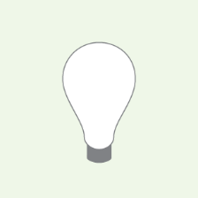 | 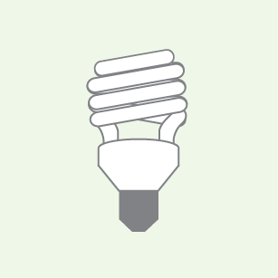 |  | 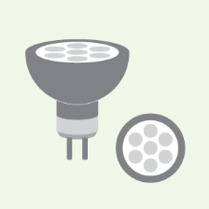 | 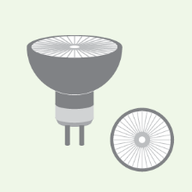
No. of globes
Fluorescent light tubes
T12s are the old fluorescent light tubes. T8s are thinner than T12s. T5s are thinner than T8s  The thinner they are the more energy efficient they are. |  |  | 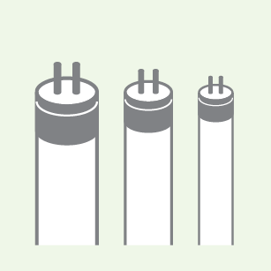
Other globe types
If your light globe is not listed here, draw it in the box to the right. Try to find out what it is. LEDs are preferred as they are most efficient.

Light signage
Are there signs reminding people to turn off lights? | Yes No
Are the signs easy to see and read? | Yes No
Do you have any other comments?

Australian Standard lighting levels
What is the light level (lux) in the middle of the room?
What level of lighting is needed in this room? Australia has a list of Standards with recommended lighting levels based on the activity in the room. Circle the type of activity you would expect to see in the room you are auditing and see how the light level in the room compares to the recommended standard. Is the room too dark or too bright?
Australian Standard (lux) | Location or task
40 | Hallways, corridors
80 | Change rooms, storage rooms
160 | Areas for occasional reading of printed materials e.g. entrance hall
240 | Food preparation areas, counters for transactions
320 | Classrooms with desks, offices
400 | Classrooms with specialist activities e.g. fine woodwork
600 | Libraries and areas for proofreading, fine painting
1200 | Graphic art inspections
1600 | Watchmaking and fine jewellery making
How does the light level in your room compare to the Australian Standard?

Worksheet: Basic energy audit – heating and cooling
Name(s)__________________________________________________Date _________
Name of room being audited _______________________________________________
Tools required: Infrared thermometer
For information on using an infrared thermometer, refer to Appendix 2: Tools and calculations.
Record the room temperature and answer the questions below.

Room temperature
The RSS guide for temperature settings for optimum indoor thermal comfort are:
Winter: 18–20ºC
Summer: 24–27ºC
What is the temperature of the room in degrees Celsius (ºC)? | ºC
How does the room feel (thermal comfort)? | Too cold / Okay / Too hot

Seasons
What season is it? (Circle one)
  Winter |   Spring |   Summer |   Autumn
Aboriginal groups have their own seasonal cycle depending on where they live, with 6 to 8 seasons each year. Find out who are the Traditional Owners where you live and what season is it.
Traditional Owners of my region
What Aboriginal season is it?

Heating and cooling appliances in the room
 | Yes/no | How many? Use a tally (IIII)
Does this room have air conditioners (AC)?
Does this room have heaters?

What temperature are appliances set at?
Heating and cooling appliances | AC or heater (circle one) | Location | Set temp (ºC)
Unit 1 | AC / heater
Unit 2 | AC / heater
Unit 3 | AC / heater
Unit 4 | AC / heater
Unit 5 | AC / heater
Unit 6 | AC / heater
Unit 7 | AC / heater
Unit 8 | AC / heater

Heating and cooling signage
Do you have signs reminding people to turn off air conditioners and heaters?
Do you have signs showing correct temperatures for air conditioners and heaters?

What other observations did you make?

Worksheet: Basic energy audit – appliances
Name(s)__________________________________________________Date _________
Name of room being audited _______________________________________________
Optional tool required: Plug-in digital power meter to capture the real-time energy consumption of each appliance. Energy consumption for each item can be added but is not necessary for a basic audit.
For information on using a plug-in power meter, refer to Appendix 2: Tools and calculations.

Appliances in the room
List all appliances in the room, such as fridges, dishwashers, air conditioners, heaters, televisions, computers, and so on.
If the appliance has an energy rating label, record the star rating and yearly energy consumption. The more energy efficient a model, the less energy it will use and the less it costs to run.
If the appliance has no rating label, it should have an electrical rating plate where you can see the power rating of the appliance in watts (W) (see example below).
An example of an energy rating label | An example of a rating plate
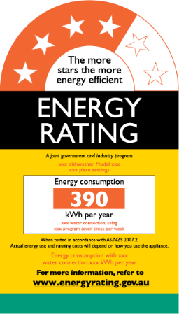 | 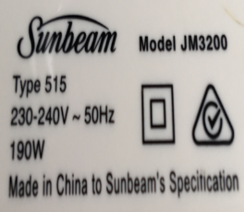
This appliance has a four-star rating and uses 390 kWh per year. More stars equal more energy savings. | This appliance uses 190 W of energy (190 J per second) when in good working order. This is also called the power rating.
Note that energy star ratings have changed over the years. Appliances like fridges tend to lose efficiency over time so the energy use listed on the star rating label cannot be taken as true for older appliances. To find out more about energy rating labels, visit energyrating.gov.au/label
If you have a power meter, you can measure the real-time energy consumption of each appliance and compare it to the power rating listed on the rating label or plate.
Appliance | Is the power on?  (Yes/No) | Is it being used? (Yes/No) | Energy rating label stars  (1–7 or no rating) | Energy consumed per year (kWh per year on the Energy Rating Label) | Power rating listed on rating plate  (W or kW) | Real-time energy use measured with power meter  (kWh)

What other observations did you make?

Calculating greenhouse gas emissions
The formula for calculating carbon or CO2e emissions from your electricity and gas consumption can be found in Appendix 2: Tools and calculations.

Worksheet: Basic energy audit – windows and doors
Name(s) __________________________________________________Date_________
Name of room being audited _______________________________________________
Tools required: Paper strips

Assessing windows and doors for energy efficiency
Complete the table below.
What direction are the windows in the room facing? (Note: Most north and west-facing windows need shading or shelter) | North East South West
Are there any curtains or blinds on the windows? | Yes / No
Are the curtains or blinds open and windows clear of artworks, etc. to let in natural light? | Yes / No
Do the curtains or blinds work? (Do they reduce sunlight? Do they keep the heat or cold in the room?) | Yes / No
Are there trees or an awning outside the window? | Yes / No
Can windows be opened to allow natural airflow or cross-ventilation? | Yes / No
Is there any draughtproofing on the doors? | Yes / No
Test the windows and doors for leaks or draughts (use a strip of paper or feather to detect air movement). List the ones that leak.

List three actions in this room that will save energy at your school:
1.
2.
3.

Worksheet: Basic energy audit – discussion with relevant stakeholders
Organise to meet with (or invite to your class) your principal, business manager, IT person and maintenance team to gather more information. Use these questions as a guide to understand more about energy in your school. This information will be useful when completing the RSS energy module checklist.
What insulation does our school have? For example, ceiling, walls, double-glazed windows. Which rooms have insulation?

How do we know the lights, air conditioners and heaters are working properly and that the reflectors (lights) and air filters (air conditioners) are clean?

Do our tea/coffee and hot water systems boil water 24 hours a day or do they have timers? If we have timers, what times are they programmed for?

What is our shutdown process to save energy overnight, and for holidays and weekends?

Are the school’s computers and printers programmed with sleep and/or shutdown modes and what times are these set for?

Do we have any energy generation at our school, such as solar panels and wind turbine?

Are our school facilities used by community users? If so, has the school calculated their energy usage? Does the hire agreement include energy-saving clauses?

Appendix 1: Comprehensive energy audit
The RSS comprehensive energy audit tool is for schools with high energy consumption or for schools wanting greater understanding of their energy use to better inform actions and reduce energy consumption.

Using the Comprehensive Energy Audit Excel Tool
Use the RSS Comprehensive Energy Audit Excel Tool to record information from locations across the school such as classrooms, offices, kitchen, toilets, hall, corridors and specialist rooms. The tool is available on the energy module page (sustainability.vic.gov.au/energy-efficiency-and-reducing-emissions/resourcesmart-schools/modules/energy-module).
The worksheets have embedded calculations and formulas based on industry averages for electricity and gas use for each listed appliance. To find the power rating for any item not listed, search online for the user manual or look on appliance label.

What’s in the Excel tool?
Light levels (lux)
Temperature (°C)
Electricity consumption (kWh)
Electrical appliances by location (e.g. classroom, office, corridor)
Gas heating (the worksheets for gas appliances are prepopulated with common brands of gas heaters in schools. Students may need help from maintenance staff to derive gas consumption from some gas appliances, for example gas equipment in boiler rooms)
Summary table, by building
Summary table, by type (for schools that would like to know the school’s consumption by type of appliance, for example IT, lighting or heating and cooling)
Appendix 2: Tools and calculations explains how to use the different audit measuring tools and how to calculate emissions.

Teacher/facilitator checklists – comprehensive audit

Before audit day

Step 1: Gather background energy information
- Upload 12 months of energy bills in the RSS online system (secure.resourcesmartschools.vic.gov.au/) to set your baseline data (sustainability.vic.gov.au/energy-efficiency-and-reducing-emissions/resourcesmart-schools/get-started/baselines-and-benchmarks).
- Print a floor plan and aerial map of your school. If your school does not have an aerial map, you can use Google Maps.
- Select which areas to audit and if the task will be divided by room or by tasks such as light levels and temperatures.
- Allocate areas to be audited to pairs or small groups.

Step 2: Organise equipment
Each pair/small group will need:
- Portable electronic device with access to Excel worksheets or paper equivalent if handwritten data is to be added to spreadsheet later.
- Lux meter to record lighting levels.
- Infared thermometer to record temperatures.
- Plug-in digital power meter to record appliances energy consumption.
Note: See Appendix 2: Tools and calculations for advice on using these tools.
- Compass or aerial map of school buildings to determine orientation of windows.
- Paper strips or feathers to detect air drafts and gaps around windows and doors.
Note: Students will need to complete the windows and doors worksheet from the basic energy audit to assess drafts and window orientation.
- Camera to gather evidence for your RSS energy module, presentations and audit assessment.

On audit day

Step 3: Introduce energy audit tool
- Clarify understanding of terminology and explain why you are doing the audit.
- Organise participants in pairs/small groups and define the areas to audit.
- Allocate equipment and responsibilities.
- Familiarise students with the school map and define the room(s) or locations that each pair/small group will audit.
- Review the method with the students (see Step 4).
- Show students how to use the equipment and record data on their worksheets.
Note: Begin with all pairs/groups auditing the room you are in, so they know how to use equipment and complete worksheets. Compare their results and discuss any discrepancies. For more information on standby consumption, refer to Appendix 3: Extra activities.

Step 4: Collect data
- Students visit their allocated rooms/locations to record energy information and complete Excel worksheets.
- Complete the Basic energy audit – windows and doors worksheet.
- Interview school staff and collate results in the Basic energy audit – discussion with relevant stakeholders worksheet.

Step 5: Complete energy action plan and prioritise actions
- Discuss results and findings with students.
- Discuss what you do well and what you can do better or differently to improve energy efficiency at your school.
- Populate the energy action plan with findings and recommendations. List actions in priority order (highest to lowest) and allocate timeframes and responsibilities. The RSS School Environmental Management Plan (SEMP) is available on the Core Module page (sustainability.vic.gov.au/energy-efficiency-and-reducing-emissions/resourcesmart-schools/modules/core-module) and offers an action plan template for each module.
Note: Check Appendix 3: Extra activities to get insights into energy bills, standby consumption and other energy-saving activities and ideas.
- Upload energy audit results, photos and presentations to RSS energy module in the RSS online system as support and evidence.

After the audit

Step 6: Communicate and implement
- Encourage students to present findings and recommendations to the principal, assistant principal and school council (buildings and grounds subcommittee).
- Communicate to the wider community through:
  - presentations during whole school assembly
  - stories and hints in the school newsletter, school blog and your social media channels
  - stall at school fair
  - Student conferences
  - teacher and principals’ conferences.
- Upload presentations to RSS online system as support and evidence.
- Get the energy action plan approved by the principal, assistant principal and business manager.
- Upload the approved action plan to the energy module in the RSS online system and incorporate it into your SEMP.

Step 7: Monitoring for continued engagement
Ongoing monitoring will tell you how effective you have been in implementing changes and reducing energy use.
- Complete yearly energy audit.
- Analyse your smart meter, electricity supplier energy dashboard or Schools Water Efficiency Program (SWEP) energy dashboard.
- Update energy bills in the RSS online system to monitor seasonal trends. Use the reporting function to compare energy use over time and with other Victorian schools.
- Write stories about your energy audit and savings to share in newsletters or on your school’s intranet, website and social media channels.
- Compare impact and achievements with baseline (reflect on where you started). Look at kWh, MJ and CO2e saved and translate CO2e saved to equivalent numbers (see Appendix 2: Tools and calculations).
- Communicate and celebrate your success with your school community!

Appendix 2: Tools and calculations

Calculating carbon emissions
The formula for calculating carbon or CO2e emissions from your electricity and gas consumption is provided below. If you are using the Comprehensive Energy Audit Excel Tool, the formula is built into the spreadsheet and you only need to enter your consumption data (your total kWh and MJ usage). For the basic audit, use the calculations below.
Greenhouse gas emissions (CO2e also called CO₂ equivalent)
Measuring greenhouse emissions as CO₂ equivalent (CO2e) allows us to calculate and present emissions from various greenhouse gases using one unit. For example, when we burn gas, carbon dioxide, methane and nitrous oxide are all released.
Methane and nitrous oxide have a much higher global warming potential than carbon dioxide. Their CO2e value is calculated as the amount of CO₂ that would need to be released to have an equivalent global warming impact.
The following emissions are based on figures from the Department of Industry, Science, Energy and Resources industry.gov.au/data-and-publications/national-greenhouse-accounts-factors-2020)

Calculating CO2e emissions for electricity consumption
In Victoria in 2020, 1.09 kg CO2 was released for each 1 kWh consumed. This factor includes emissions from the loss of electricity during transmission from the power supplier to the end user, and emissions from the electricity used. For example:
A school that consumes 100,414 kWh of electricity over 12 months emits 109.45 tonnes of CO2e:
Emissions of greenhouse gases in tonnes of CO2e are estimated as follows:(100,414 x 1.09) ÷ 1,000 = 109.45 tCO2e

Calculating CO2e emissions for gas consumption
In Victoria, each gigajoule (GJ) (1,000 MJ) of gas burned emits 55.43 kg CO2e. For example:
A school, which consumes 77,760 MJ (77.76 GJ) of natural gas over 12 months emits 4.31 tCO2e:
Emissions of greenhouse gases in tonnes of CO2e are estimated as follows:(77,760 ÷ 1,000) x (55.43 ÷ 1,000) = 4.31 tCO2e

Comparing a school’s emissions to petrol use
CO2e emissions can seem quite abstract, so it helps to compare it to something people understand. For example, you could try comparing your school’s CO2e emissions to petrol use:
A school emits 107,443 kg of CO2e over 12 months. Burning 1 litre of petrol emits 2.51 kg CO2e. This means emitting 107,443 kg of CO2e is the same as burning 42,806 litres of petrol (i.e. 107,443 ÷ 2.51)
You could drive 406,657 km with this petrol – that’s like circumnavigating Australia 28 times.
Figures based on 2018 ABS car data and an average fuel efficiency of 9.5 km per 1 litre petrol: 42,806 L × 9.5 = 406,657 km
To drive round Australia, you follow Highway 1 – the longest national highway in the world. It’s about 14,500 km in length: 406,657 km ÷ 14,500 km = 28.

Using energy tools

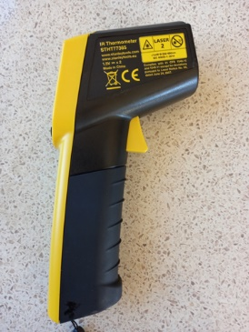
Infrared thermometer
Temperature is measured in degrees Celsius (°C). An infrared thermometer allows you to measure temperature from a distance. For example, students can measure the temperature of windows that are out of reach and draw conclusions about heat transfer through the windows.
When using an infrared thermometer, explain to students that the infrared beam must not to be aimed at people, not even at themselves:
- Aim the beam to the floor, wall or ceiling where there is no chance of someone walking in front of the beam.
- Press the button and the temperature reading will appear on the screen. Sometimes the red dot (showing the beam) does not work – refer to the instruction manual to fix this.
The RSS guide for temperature settings for optimum indoor thermal comfort are:
Winter: 18 to 20°C
Summer: 24 to 27°C
Note: Heating and cooling account for about one-third of total energy costs. As a guide, in summer for every 1°C you lower your air conditioner setting, you add 10 per cent to the running costs of your cooling appliance. The same is true for every 1°C you turn up your heater settings in winter.

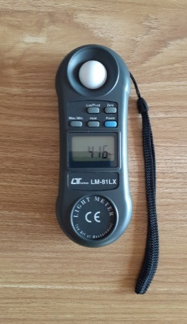
Lux meter
Like the way temperature is measured in degrees, light is measured in lux. A lux meter measures the light in a room and identifies locations that are over lit (using too much energy) or under lit.
When working with a lux meter:
- Uncover the white circular lux sensor (the white dome in the picture above).
- Turn the lux meter on. The lux sensor is extremely sensitive and registers how much light an area is receiving. The reading can be affected by small changes that will affect light levels such as a tree branch moving outside the window, people moving around the lux meter and changes in cloud cover. Take the reading from the lux meter where the reading is most stable.
- If the lux result is reading one, you need to switch the measurement up to the next reading. Most readings will be 2,000 or less but if you have a higher reading, move the control up to the next notch (results will now be x10).

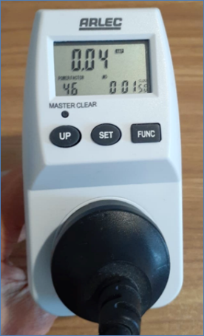
Plug-in digital power meter
Power output is measured in watts (W). A plug-in digital power meter measures the power output of appliances.

Option A: Measuring individual appliances
The teacher and students gather around the chosen appliance(s). This can be a kettle, a hairdryer, a vending machine, a computer or an iPad (see photo). With a plug-in power meter, students can monitor the kettle as it boils water, and see how the energy use changes over time when going from cold water to boiling water. They can then compare their data to the energy rating listed on the appliance. Similarly monitoring a hairdryer on various speeds will show how the plug-in power meter measures different levels of energy consumption.

Option B: Measuring power output over time
You can monitor appliances for longer periods to work out your daily, monthly and annual consumption. Monitoring an appliance for 24 hours will give you your daily energy consumption, which you can multiply by 365 to get your yearly energy use. This is useful for old white goods, old hot water urns or vending machines as these appliances can each consume over 2,000 kWh per year.
Together with monitoring, reviewing the school’s requirements for refrigeration and vending machines can lead to big electricity savings. If you buy a single plug-in power meter, you could repeat the 24-hour monitoring over one or perhaps 2 weeks, depending on how many bits of equipment you are interested in measuring. A plug-in power meter check could also form part of the school’s yearly maintenance schedule.

Smart meters
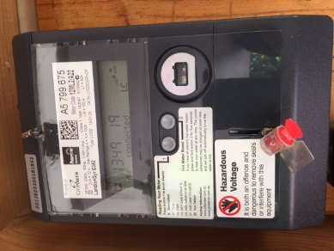
A smart meter measures electricity flowing in and out of your home at 30-minute intervals. It communicates your school’s energy use to the meter service provider, usually on a daily basis.
In Victoria, smart meters are already installed in most schools. Your electricity retailer will summarise your energy data on your electricity bill as a peak kWh consumption number and an off-peak kWh consumption number.
Your retail provider should be able to give your school smart meter data over 12 months (or more) by 30-minute intervals. The data is usually in Excel (.xls) or a comma delimited file (.csv), which once opened you can save as Excel. The dataset is large and will need to be organised before summarising the data.

What if your school has more than one smart meter?
A National Meter Identifier (NMI) is a unique 10 or 11-character reference that's associated with the electricity connection point at your school. Request your smart meter data by NMI. This way you control the size of the dataset and the output becomes smart-meter specific (which covers a specific part of your school). When you summarise your smart meter data, you can extract output similar to the following table:

Time period | kWh | Percentage
Every single day of the year | 165,163 | 100%
9.00 am – 3.30 pm, weekdays during term | 62,512 | 38.5%
8.00 am – 5.00 pm, weekdays during term | 79,707 | 48.3%
5.00 pm – 8.00 am, any day of the year | 68,346 | 41.4%
11.00 pm – 7.00 am, any day of the year | 34,669 | 21.0%
Saturday and Sunday, any week of the year | 28,394 | 17.2%
Term breaks, public holidays and weekends | 44,862 | 27.2%
The data in this table comes from a Victorian school and supports the analysis by the Victorian Department of Education and Training that half to two-thirds of a school’s total energy usage is consumed outside of school hours.

Energy dashboards
An energy dashboard is available through one of the five distribution networks in Victoria. Find your school network at energy.vic.gov.au/electricity/electricity-distributors. To logon to your specific portal you will most likely need your NMI number, smart meter number(s) and your principal’s approval to do so.
For schools covered by Citipower and Powercor, visit website (powercor.com.au/our-services/myenergy)
For schools covered by United Energy Distribution, visit website (unitedenergy.com.au/your-electricity)
For schools covered by Ausnet Services, visit website (ausnetservices.com.au/myHomeEnergy/Login)
For schools covered by Jemena,visit website (jemena.com.au/electricity/monitor-my-electricity-usage)
The Schools Water Efficiency Program (SWEP) initiative also supports schools with energy tracking dataloggers which track water and energy consumption side-by-side.

What information is available in a dashboard?
Seasonality
What costs the most – peak or off-peak when we apply our respective tariffs
Which time / day / week / month do we use the most electricity and why?
Which time / day / week / month do we use less electricity and why?
Have we used more this week compared to last week and why?
How much electricity do we use when we are not at school and why?
Can we justify off-peak consumption when we are not at school and why / why not?
How can we improve on better quality electricity data and keep on top of our reporting so we can make decisions that we trust are accurate?
How are we trending for the future?

Appendix 3: Extra activities

Standby consumption
Task: Analyse the difference between your audit results and utility bill data to see if they show different consumption rates.
Different consumption rates could be due to:
underestimating standby consumption (the energy used by an appliance when not in use)
omitting appliances in the audit
underestimating the number of hours appliances are being used or are on.
Standby consumption can vary from less than 1 watt per hour to hundreds or even thousands of watts per hour. The Victorian Department of Education and Training (DET) estimate that improved shutdown and switch-off behaviour can result in savings of up to 20 per cent.

Power use of common appliances
Appliance | Power use | Explanation
PC and laptops  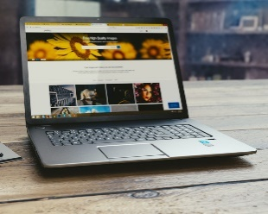 | 120–40 watts | A PC draws 120 watts when actively used. It draws 40 watts when not used but still turned on. Adding up the hours when a PC is idle (breaks, afterwork hours, weekends, public holidays and term breaks) adds up to more hours than when it is being actively used. This means a PC in some cases consumes more electricity when it is not used than when it is.
Printers and copiers  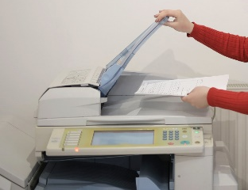 | 1.5–90 watts | Having energy efficiency features on printers and copiers can save the school hundreds and sometimes thousands of watts per day. New printer/copier equipment uses as little as 1.5 Watts per hour in standby, compared to some older equipment that uses 90 watts per hour in standby, especially if energy efficiency features are not activated.
Chargers for laptops  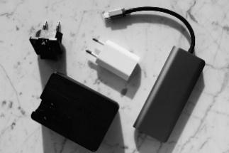 | 5–43.8 watts | Laptops are 90 per cent more energy efficient than PCs, but some chargers continue to use electricity even when they are not plugged into the laptop but are still plugged into an electricity outlet or the laptop is fully charged. A consumption of 5 watt for a charger is common and being left on 24 hours a day, 365 days a year adds up to 43.8 kWh or more than 46 kgCO2e over a year per charger.

IT equipment standby consumption
IT equipment uses a large percentage of any school’s energy. Even a small reduction in energy use like 10 per cent will produce a large saving. Talk to the school’s IT staff about this regularly as IT is constantly improving. Things to consider:
Find out which systems need constant access to DET servers and which systems can be turned off when not in use.
Battery backup
Student PC standby
Sleep times on printer and copier equipment.
Make sure you have turned on energy efficiency features of machinery.

Heat flows
Task: Investigate how the school can manage heat flows better by identifying current strategies.
Stopping a building from becoming too hot in summer or too cold in winter is more energy efficient than relying on heating and cooling systems to make a room comfortable. Some of the strategies to manage the temperature in a building include, but are not limited to:
natural vegetation to shade windows and walls
artificial shades (blinds, awnings, etc.)
draft proofing
window tinting
insulation
natural ventilation.
Natural ventilation – opening windows, doors and roof vents – can be used to cool rooms. Natural ventilation can also help students’ concentration and reduce drowsiness by managing the temperature and reducing carbon dioxide levels in the room.

Natural light
Task: Investigate if the school makes good use of natural light by working out what direction the school windows face and how trees and plants contribute to creating shade.
The lighting in many school rooms is controlled by a single switch. This limits our ability to control electric lighting demand by zoning within an area. Zoning allows you to take advantage of natural light and only switch on lights in the zone(s) furthest from the windows as needed. Discuss the possibility of installing multiple switches to create zones with the school electrician.
The sun also provides heat. Sometimes we get too much sun in north and west-facing classrooms/offices and sometimes we do not get enough in south-facing rooms. We can help manage this by:
adding shade to stop excessive light and heat entering the building on the north and west sides
planting trees outside the north and west sides.

Renewable energy
Task: Investigate possibilities to use renewable energy.

Solar energy
How does it work?
What’s the best location at the school for a photovoltaic (PV) installation?
How many panels do we need to cover our daylight electricity consumption?
Investigate how to transport energy from one place to another.
Investigate battery backups.
Can the school buy green electricity from its current provider and if so, is it convenient?
If the school can cover energy consumption by PV installation, can it send energy to a grid or share it with the community through new technologies?

Wind energy
Are wind speeds in the school area enough to set up a turbine?
How much electricity can the school produce with a small turbine compared to a large industrial turbine?
What is the cost–benefit of the following sources: solar, wind, waves or coal?

Appendix 4: Curriculum links
Exploring the concept of energy contributes to several different learning areas in the Victorian Curriculum F–10. The table below lists examples of how an energy audit can contribute to student learning outcomes in Years 3 to 10.
For more inspiration, read about sustainability as a cross-curriculum priority on the Victorian Curriculum website or download the RSS curriculum guides from sustainability.vic.gov.au/energy-efficiency-and-reducing-emissions/resourcesmart-schools/modules/curriculum.

Linking energy audits with the Victorian Curriculum
Levels | Learning area | Content description
Years 3 and 4 | Science | - Science knowledge helps people to understand the effects of their actions (VCSSU056)
Years 3 and 4 | History | - A significant example of change and a significant example of continuity over time in the local community, region or state/territory (VCHHK073)
Years 3 and 4 | Health and physical education | - Describe strategies to make the classroom and playground healthy, safe and active spaces (VCHPEP095)
Years 5 and 6 | Science | - Scientific understandings, discoveries and inventions are used to inform personal and community decisions and to solve problems that directly affect people’s lives (VCSSU073)
Years 5 and 6 | Economics and business | - Identify the types of resources (natural, human and capital) and explore the ways societies use them in order to satisfy the needs and wants of present and future generations. (VCEBR003)
Years 5 and 6 | Ethical capability | - Discuss how ethical principles can be used as the basis for action, considering the influence of cultural norms, religion, world views and philosophical thought on these principles. (VCECU010)
Years 7 and 8 | Science | - Some of Earth’s resources are renewable, but others are non-renewable (VCSSU100)  - Science and technology contribute to finding solutions to a range of contemporary issues; these solutions may impact on other areas of society and involve ethical considerations (VCSSU090)
Years 7 and 8 | Geography | - The challenges of managing and planning Australia’s urban future (VCGGK126)
Years 7 and 8 | Health and physical education | - Plan and use health strategies and resources to enhance the health, safety and wellbeing of their communities (VCHPEP130)
Years 7 and 8 | Ethical capability | - Investigate criteria for determining relative importance of matters of ethical concerns (VCECU016)
Years 9 and 10 | Geography | - Environmental worldviews of people and their implications for environmental management (VCGGK146)
Years 9 and 10 | Health and physical education | - Plan, implement and critique strategies to enhance the health, safety and wellbeing of their communities (VCHPEP149)

Glossary
Carbon dioxide equivalent (CO2e) is a metric measure used to compare the emissions from various greenhouse gases on the basis of their global-warming potential.
Giga (G) is a thousand million units, so a gigawatt (GW) is 1,000,000,000 watts.
Joule (J) is the standard unit of energy.
Kilo (k) is 1,000 units, so a kW or a kJ is 1,000 watts or 1,000 joules.
Light emitting diode (LED) is a semiconductor light source that emits light when current flows through it.
Liquefied petroleum gas (LPG) is used for hot water, heating, cooking and other uses.
Mega (M) is 1,000,000 units, so a megajoule (MJ) is 1,000,000 joules
National Meter Identifier (NMI) is a unique 10 or 11-character reference that's associated with the electricity connection point at a location.
Photovoltaic (PV) system is an energy technology that uses semiconductors to produce an electric current when exposed to sunlight – often called solar cells or solar panels.
Tonne (T) is 1,000 kilograms.
Watt (W) is the standard unit of electricity (a joule per second). It is a measure of the rate at which energy is being used.
Watt-hour (Wh) is the amount of electricity used in an hour. As electricity is a measure of the rate of use rather than an amount, measuring electricity use in watt hours, or more commonly kilowatt-hours (kWh), allows you to know the amount of electricity used.

