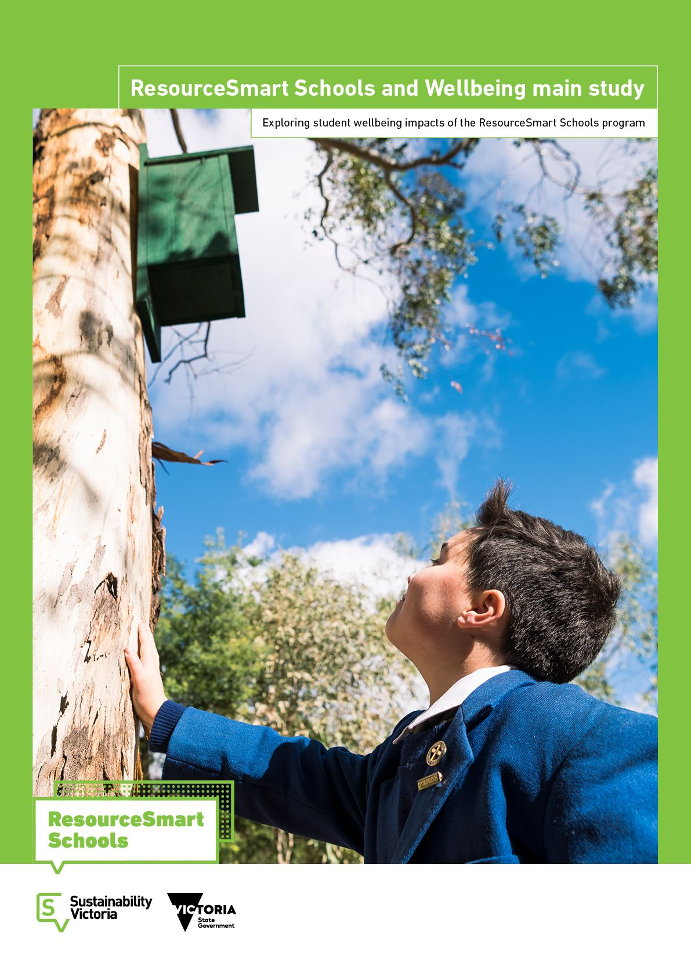

Sustainability Victoria:
ResourceSmart Schools and Wellbeing - Main Study

This project was undertaken by a team from the Australian Council for Educational Research (ACER) lead by Dr Katherine Dix.
Sustainability Victoria and ACER would like to extend our thanks to the Victorian school communities involved in the study – the students, teachers and partnership organisations.

ResourceSmart Schools and Wellbeing main study
© Sustainability Victoria 2020
Authorised and published
by Sustainability Victoria,
Level 28, Urban Workshop
50 Lonsdale Street Melbourne
Victoria 3000 Australia
Accessibility
This document is available in PDF
and Word format on the internet at
www.sustainability.vic.gov.au

While reasonable efforts have been made to ensure that the contents of this publication are factually correct, Sustainability Victoria gives no warranty regarding its accuracy, completeness, currency or suitability for any particular purpose and to the extent permitted by law, does not accept any liability for loss or damages incurred as a result of reliance placed upon the content of this publication. This publication is provided on the basis that all persons accessing it undertake responsibility for assessing the relevance and accuracy of its content.
ResourceSmart Schools and Wellbeing main study should be attributed to Sustainability Victoria.
ResourceSmart Schools and Wellbeing main study (excluding all trade marks and logos) is licensed under a Creative Commons Attribution 4.0 Australia licence. In essence, you are free to copy, distribute and adapt the work, as long as you attribute the work and abide by the other licence terms. Go to http://creativecommons.org/licenses/by/4.0/ to view a copy of this licence.


CONTENTS
Executive Summary 3
Key findings 3
1. Introduction 7
Background 7
Aims of this project 9
Literature search approach 10
Survey development 11
Ethics 15
Survey administration 15
2. Review of Literature 18
Wellbeing within sustainability 18
Sustainability within wellbeing 20
Evidence from ResourceSmart Schools 23
School improvement frameworks 23
3. Survey Results 26
About the participating RSS schools 26
Students’ awareness of environmental sustainability 27
Student wellbeing 32
Whole-school wellbeing 36
Factors influencing student wellbeing 38
ResourceSmart activities and wellbeing 39
How RSS is helping to promote whole-school wellbeing 41
Making the RSS-wellbeing link explicit 49
Impact beyond the school 49
Opportunities for improvement 57
Views from the RSS delivery partner organisations 62
4. Evaluation framework 64
Learning and teaching 65
Workplace/operational 65
Whole-school community engagement 65
Embedding measurement 66
References 69
Appendix A: Summary of literature reviewed 75
Appendix B: Principal Invitation and Consent 79
Appendix C: Partner Invitation 80
Appendix D: Parent and student information AND CONSENT 81
Appendix E: Surveys 83
Appendix F: Interim Pilot Report 88

Executive Summary
As a very large school, it's taken years for teachers here to get on board and support it. Most teachers support the ResourceSmart Schools program and see the benefits. I think it's added an incredible value to our staff's perspective of how we treat our environment. Every school should have this program in place. We're educators and need to promote sustainable practices that also promote wellbeing.
(Primary RSS Leader)
This report presents the findings of a study into the wellbeing impacts of the ResourceSmart Schools (RSS) program in Victoria, Australia. The findings are based on a literature review and a state-wide survey of program schools to inform the development of RSS-wellbeing evaluation framework, as a first step in the ongoing monitoring of the program’s wellbeing impacts in RSS schools.

Key findings
The review of literature identified several important documents that guided the development of the RSS-Wellbeing Evaluation Framework, outlining the intersection of environmental sustainability and wellbeing in schools.
- Evidence of impact of sustainable schools (Barratt-Hacking et al., 2010)
- FISO school improvement model (Victoria State Government, 2018)
- Five Ways to Wellbeing (Aked et al., 2008) and A haven of green space (Chiumento et al., 2018)
- Australian Student Wellbeing Framework (ESA, 2018)
- ResourceSmart Schools Research Project Final Report (Rickinson et al., 2014)

The RSS-Wellbeing Evaluation Framework presents opportunities at the whole-school level and at the student-level that could be refined into a set of observable behaviours or outcomes to form the basis of an assessment. For example, the Five Ways to Wellbeing could form the basis of an additional RSS Module that recognises five-star student-level engagement in RSS.
This main study and the initial pilot (see Appendix F) provided evidence, both in the literature and in the results, of links between RSS activities and wellbeing. Reports collected from 117 RSS leaders and over 2200 students in 123 Victorian government and non-government, primary and secondary schools, along with insights from the nine delivery partners, provided evidence of a small significant relationship between the RSS program and student wellbeing. Moreover, there was strong alignment in the three points of view, between the students, their RSS leader and the regional delivery partners.
- Students’ views about environmental sustainability in their schools were highly positive.
- Students’ attitudes about school and self, declined with age.
- 83% of students agreed or strongly agreed that their school cares about the environment. This ranged between 94% in primary and 64% in upper secondary.
- Students in highly engaged RSS schools were more likely to agree that their school was environmentally sustainable and that they actively engaged in sustainability activities.
Being at a RSS school made students feel:
- happy that their school cares about helping the environment.
- proud that their school cares about the future.
- safe and healthy, knowing that their school maintains a clean green environment.
- motivated to care for nature, wildlife and the environment beyond school.
- engaged and connected to nature by being outdoors.
- empowered by having a voice, taking action, and making a difference.
In their words:
Being a ResourceSmart School has given us opportunity to make the world a better place and safer to live in. (Year 7 student)
This makes me feel so proud of what I am doing and this school appreciates all the things we do to save the environment. So thanks for this survey it really shows how I feel about the environment. (Year 6 student)
It makes me feel a bit more certain about my future because sometimes I worry. If all schools did what we did it would make a huge difference. (Year 8 student)
Overall, student’s responses suggest that having the RSS program in their school had a positive impact on their wellbeing and the wellbeing of their community.
The findings suggest that students who felt that their school cared about the environment and embraced sustainability, were also more likely to exhibit higher levels of wellbeing in terms of:
- happiness (r=0.48, p<0.01)
- optimism (r=0.43, p<0.01)
- perseverance (r=0.39, p<0.01)
- engagement in learning (r=0.65, p<0.01)
- connection to and pride in school (r=0.64, p<0.01)
In addition to implementing the RSS program, schools were also engaged in promoting whole-school wellbeing (e.g. Cybersafety, be you). All schools were implementing at least one wellbeing program, and several schools were implementing up to six programs in addition to RSS. However, the extent of these efforts appears to be relatively independent of schools RSS activities. This suggests that RSS activities are having positive impact on student wellbeing, independent of other whole-school wellbeing activities. The following RSS leader insights suggest how.

RSS leaders in 99 schools reported that the Waste and Biodiversity modules were the strongest contributors to promoting whole-school wellbeing: 62% reported moderate to major impact – that clean, green environments support wellbeing. Moreover, high-implementing RSS schools reported greater levels of impact on wellbeing due to their sustainability activities. This was true for each RSS module and supported by a significant positive correlation between overall module impact and whole-school wellbeing.
The RSS program develops confidence, responsibility, maturity, and practicalities not found in classroom based 'feel good' sessions. It relates to real life, real issues, and our very real planet. (Primary RSS leader)
In addition, of the participating RSS leaders:
- 86% agreed that RSS helped schools to develop a positive school community.
- 79% agreed that RSS supported the social and emotional development of students.
- 72% agreed that RSS helped schools to engage with parents and families.
- 59% agreed that RSS helped to support students experiencing difficulties.
- 68% believed that there was a moderate or major direct link between RSS activities and the wellbeing of the students and teachers in their school.
- 61% reported that whole-school wellbeing was, to a moderate or major extent, due to ‘hidden’ benefits in the RSS program.
- 87% believed that it was of moderate to major importance that the RSS program also explicitly promoted student wellbeing.
The RSS-wellbeing conceptual model below, summarises the findings in terms of relationships between the RSS program and indicators of wellbeing, at the school and student levels. Significant relationships (correlations in bold) were found between the schools’ RSS status and students’ views about environmental sustainability, which in turn related to their views about school connection, learning engagement and self-reported wellbeing.
RSS-WELLBEING CONCEPTUAL MODEL
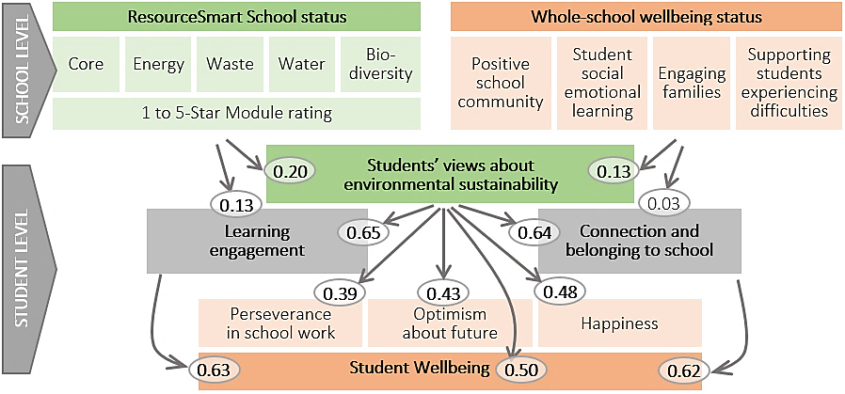

However, one of the most important findings of this study was the extent to which the RSS program was having impact beyond the school-gate. Three in five students (62%) said that they regularly talked to their family about caring for the environment, and two in five students (42%) did things differently at home to care for the environment because of the RSS activities at school. There was good agreement between RSS leaders and students about how the RSS ‘message’ was being embraced at home and in the wider community, reflected in the following insights.

In their words:
We had a Earth Day at school for an hour and we did an activity for keeping the world clean and one of my promises where to turn off power points in my home if there was no use having it on. I also convinced my mum to start recycling. (Year 6 student)
After joining the Sustainability Committee, I started to make an effort to recycle more often at home. (Year 9 student)
My mum was doing gardening and I decided to help her which I normally don't do and that act was all from my role in the biodiversity team, to do kitchen garden. (Year 6)
One parent whose son was bullied at another school has been overwhelmed at the difference the RSS program has made for her boy. After 12 months he is now a school leader and has totally turned around his life. He is our 'shining example' of what the RSS program can do for students and their families. (Primary RSS leader)

1. Introduction
Student wellbeing can be defined as the ability to successfully, resiliently, and innovatively participate in the routines and activities important in a school-context (Weisner, 1998, p.75) and as consisting of five domains: physical, psychological, cognitive, social, and economic wellbeing (Pollard & Lee, 2002, p.1). Children spend thousands of hours at school and hence the school environment plays an important part in students’ social and emotional wellbeing. There is, moreover, growing evidence that wellbeing also has a significant impact on students’ academic performance (Berger et al., 2011; Elias & Arnold, 2006; Izard, 2009).
While a supportive sustainability-aware school environment is a resource for students that will help them flourish and perform, a non-supportive environment may pose risks to their wellbeing and performance. Teacher and peer support for example are known to be protective factors (e.g. Suldo et al., 2009; Cohen, 2004). By contrast, school-related demands may induce stress that is known to negatively affect students’ wellbeing and academic performance (e.g. Currie et al., 2012).
What seems to be less well known is how specific school programs, such as the ResourceSmart Schools program, might contribute to students’ wellbeing. It is unclear what the indirect influence is on student wellbeing of altering the school environment as schools undergo a transformation process as they become more environmentally aware. Such programs may have additional benefits that, for example, develop pertinent knowledge, skills or attitudes in students that help them cope with their life inside and outside of school and enable them to develop behaviours that might be beneficial to their wellbeing longer term.

Background
The Victorian Government’s ResourceSmart Schools (RSS) program (formerly ResourceSmart AuSSI Vic), administered by Sustainability Victoria, aims to assist primary and secondary schools in minimising waste, saving energy and water, improving biodiversity, and reducing greenhouse gas emissions. RSS adopts a whole-school approach that endeavours to deliver measurable environmental, financial, educational and social outcomes through improvements in the management of resources and integrating education for sustainability into participating schools’ curriculum and daily operations. The overall objective of RSS is to “help schools benefit from embedding sustainability in everything they do”.
Schools are required to complete a series of modules (one core followed by four resource-specific modules in the areas of biodiversity, energy, waste, and water) as part of a certification program ranging from 1-star (sustainability ‘awakening’ schools) to 5-stars (sustainability ‘leadership’ schools). The modules are detailed in Figure 1. Participating schools also have access to a consortium of service providers across nine regions who are contracted to deliver the modules, as well as the ResourceSmart Schools Awards that give recognition to schools for outstanding achievements in sustainability.
Furthermore, the program embraces a vision that sustainability actions and learnings within school can be transferred to home and local community settings. Key features of the program include:
- Recognition: Sustainability Certification for participating schools and schools can also enter the RSS Awards to be recognised and rewarded for school activities and achievements.
- Facilitation and support: Support from sustainability experts is provided to schools on their journey to embed sustainable activities in their schools.
- Savings: Schools make savings by becoming more sustainable through reduction in electricity and water usage and reducing waste to landfill, among other activities.
- Flexibility: Schools use the RSS program and create a tailored environmental management system based on their needs.
- Curriculum: Schools are aided to implant sustainability into all learning areas and levels of the Victorian Curriculum.
Figure 1. ResourceSmart Schools (RSS) at a glance – Modules and key areas
Sustainability Modules |  | Workplace/Operational | Learning and  Teaching | Whole School  Community Engagement
Core | Create a snapshot of how the school is approaching sustainability by gathering baseline data, reviewing curriculum, infrastructure and daily operations and recognising prior achievements and opportunities for improvement. Plan how to embed sustainability principles throughout the school and to set up a framework to track the school’s progress and achievements. |  | Create a plan to build sustainability into teaching and learning to embed sustainability into the curriculum. | Communicate with the school community about the fantastic work and share learnings to demonstrate leadership in sustainability.
Biodiversity | Schools assess the way they use natural resources through a biodiversity audit. From this, create a biodiversity improvement plan and manage habitats in your grounds. |  | Explore curriculum activities that engage students in learning and take action to conserve and increase biodiversity in schools. | Engage the whole school to work on biodiversity by engaging teachers, students, parents and the wider community.
Energy | Complete a school energy use audit and create an energy plan to manage energy use in the school grounds through retrofitting, new technology and maintenance. Changing individual behaviour also plays a critical role (e.g. switching lights off). |  | Explore curriculum activities that engage students in learning how to be more sustainable users of energy. | Engage the whole school in energy smart behaviour and liaise with your community, government, energy networks and/or other schools.
Waste | Assess how waste is managed in school by using audits and litter assessments. Create a waste and litter reduction plan, learn to manage litter in school grounds and yard (e.g. food and garden waste) and improve management of recyclables. |  | Explore curriculum activities that engage students in learning to manage waste and resources more effectively. | Encourage the whole school to work on waste by engaging teachers, students, parents and the wider community.
Water | Save water by assessing the way water is used in the school through audits, creating a water plan, managing water usage in your grounds and school yard, retrofitting and new technology as well as maintenance. |  | Explore curriculum activities that engage students in learning to be more sustainable users of water. | Embed sustainability and being water smart into the life of the school and wider community.
Source: Sustainability Victoria, 2018

The linking of these modules to the curriculum is significant. Within the Victorian curriculum, sustainability is clearly connected to the learning areas of Maths, English and Science, as well as History, Geography, Economics, Civics and citizenship, Digital technologies, Design and technologies, Ethical capability, and Health and PE (VCAA, 2017; SV, 2016). Largely, education for sustainability develops the knowledge, skills, values and world views necessary for students to act in ways that contribute to more sustainable patterns of living (Australian Education for Sustainability Alliance, 2014). At the systems-level, “all life forms, including human life, are connected through ecosystems on which they depend for their wellbeing and survival” (VCAA, 2017, p.1). Beyond the clear links of wellbeing within the Health and PE curriculum, shown in Table 1, what is less apparent is how wellbeing is developed in other ways through a school environmental sustainability program.
Table 1. Sustainability related content descriptions for the Health and Physical Education curriculum
Foundation to Level 2 | Levels 3 and 4 | Levels 5 and 6 | Levels 7 and 8 | Levels 9 and 10
Explore actions that help make the classroom a healthy, safe and active place (VCHPEP078)  Identify and explore natural and built environments in the local community where physical activity can take place (VCHPEP079)  Participate in play that promotes engagement with outdoor settings including aquatic and the natural environment (VCHPEP063) | Describe strategies to make the classroom and playground healthy, safe and active spaces (VCHPEP095)  Participate in outdoor games and activities to examine how participation promotes a connection between the community, natural and built environments, and health and wellbeing (VCHPEP096) | Explore how participation in outdoor activities supports personal and community health and wellbeing and creates connections to the natural and built environment (VCHPEP113) | Investigate and select strategies to promote health, safety and wellbeing (VCHPEP126)  Plan and implement strategies for connecting to natural and built environments to promote the health and wellbeing of their communities (VCHPEP131)  Plan and use health strategies and resources to enhance the health, safety and wellbeing of their communities (VCHPEP130) | Plan, implement and critique strategies to enhance the health, safety and wellbeing of their communities (VCHPEP149)  Plan and evaluate new and creative interventions that promote their own and others’ connection to community and natural and built environments (VCHPEP150)
Health and Physical Education - explores how people connect and interact with natural, managed and built environments, and with people in different social groups within their social networks and wider communities. They consider how these connections and interactions within systems play an important role in promoting, supporting and sustaining the wellbeing of individuals, the community and the environment as a whole, now and into the future. Students develop their world view by exploring concepts of diversity, social justice and consumerism as these relate to the promotion and maintenance of health and wellbeing. Through movement experiences, students are provided with opportunities to develop a connection in and with environments and to gain an appreciation of the interdependence of the health of people and that of environments.
Source: VCAA Learning about Sustainability (2017, p.7)

Aims of this project
In 2014, a team of researchers from Monash University was commissioned by Sustainability Victoria to undertake an evaluation of the ResourceSmart Schools program (Rickinson, Hall & Reid, 2014; 2016), in order to understand more about the impact and influence of the RSS program within participating schools. This ongoing interest in improving the program was against the backdrop of a number of previous evaluations of the program (Corbett, 2010; Sustainability Victoria, 2011; 2012; Guevara & King, 2012; Pitt & Sherry, 2013).
In August 2018, Sustainability Victoria (SV) commissioned a pilot study into the wellbeing impacts of the ResourceSmart Schools (RSS) program (Dix, Ahmed, & Carslake, 2019). The main objective for this pilot was to investigate the potential links between the wellbeing of schools and their ResourceSmart engagement, in order to inform the main study and, in turn, future design and planning for the ResourceSmart Schools program. While SV maintained detailed records about schools’ engagement in the RSS program, little was known about the social-emotional climate of schools and to what extent RSS might contribute. The pilot confirmed the validity of the approach and indicated promising results.
Building on the pilot, the Australian Council for Educational Research (ACER) was contracted by SV in March 2019 to investigate the intersection between wellbeing and sustainability by conducting a review of wellbeing literature and undertaking a survey of Victorian schools actively implementing RSS during 2019. Within this overarching aim, the goals of the project were to:
- understand broader wellbeing policies and programs related to sustainability education;
- explore and record the wellbeing impacts from implementing RSS; and
- provide an evaluation framework for the ongoing measurement of the program’s wellbeing impacts in RSS.

Literature search approach
There appears to be limited literature explicitly looking at the impact of school-based environmental sustainability programs on student wellbeing, beyond school garden programs. Accordingly, the search was expanded to also include articles which might have some relevance to wellbeing frameworks.
Employing the resources of the ACER Cunningham Library, the following formal search was undertaken using the ERIC database:
ERIC
SU Well Being OR SU Quality of Life
AND
SU ( Sustainability OR conservation OR wildlife OR ecology OR biodiversity OR climate OR recycling OR sanitation OR ) OR SU Sustainable Development OR SU natural resources OR SU environmental education OR SU energy education OR SU pollution OR SU ( gardening OR horticulture ) OR SU outdoor education
AND
SU primary OR secondary OR elementary OR school* OR Children OR Adolescents
NOT DE higher education
Similar searches were undertaken on PsycInfo database, SCOPUS, British Education Index, and Education Research Complete. In addition, we explored the grey-literature through Google Scholar and followed up on bibliography and reference lists from related reports and articles that were identified. Furthermore, a Google search for all Australian school wellbeing/sustainability frameworks and school improvement frameworks was also undertaken.
The studies and reports then passed through an appraisal process by examining titles and abstracts to remove documents that were deemed irrelevant or out of scope for the current work. The list of 41 included studies, which were used in the literature review in Chapter 2, are summarised in Appendix A. The key findings from each of the studies were extracted and have been presented in Appendix A, along with the country in which the study took place.

Survey development
In order to explore and record wellbeing impacts from schools implementing the RSS program, three purpose-designed surveys were developed during the pilot, guided by the conceptual model presented in Figure 2.
Figure 2. RSS-wellbeing conceptual model
SCHOOL LEVEL
STUDENT LEVEL
ResourceSmart School status |  |  |  |  |  | Whole-school wellbeing status
Core | Energy | Waste | Water | Bio-diversity |  | Positive school community | Student social emotional learning | Engaging families | Supporting students experiencing difficulties
1 to 5-Star Module rating

Students’ views about
environmental sustainability
 |  | Learning engagement |  |  |  |  | Connection and  belonging to school
 |  |  | Student Wellbeing
 |  |  | Perseverance in school work |  | Optimism  about future |  | Happiness

While a lot was known about these schools in terms of their level of engagement with the RSS program, nothing was known about to what extent schools also promoted wellbeing or how they might already be linking these two domains together. The main purpose of the surveys was to gather an understanding of how being a sustainable school was reflected in and actioned through wellbeing activities and policies at the student level and at the whole-school level. Two surveys were developed:
- RSS Leader survey – to capture the extent to which schools promote the social-emotional wellbeing using the Survey of School Promotion of Emotional and Social Health (SSPESH: Dix et al., 2018); elicit examples of where schools link wellbeing to their sustainability activities.
- RSS Partner survey – to gather system-level perspectives from the sustainability industry that work with their cluster schools to support the implementation of sustainable practices in schools.
- RSS Student survey – middle school Years 5-10 – A brief assessment of student wellbeing, school climate, and how students feel when they do environmental activities.
Where possible, pre-existing validated scales and items were identified during the review of literature and used in the three surveys, presented in Appendix E.

The RSS leaders survey
Reflecting on Barratt-Hacking et al.’s (2010) analysis of the educational and social benefits to young people of learning in a sustainable school, we used established scales and developed new items that might connect with ‘modelling sustainability practices, thinking and planning’ within a broader context of enhancing wellbeing and advancing community cohesion.
The extent to which schools promoted social-emotional wellbeing was assessed using the SSPESH (Dix et al., 2018), which is designed around a four-component health-promoting-schools model. Thirteen items were assessed on a four-point scale of Not yet in place (0), Introducing (1), Taking hold (2), and Completely in place (3).
A. Positive school community
- Our school has specific policies and practices that promote inclusion and a safe environment
- There is an effective leadership team in our school that has responsibility for student mental health and wellbeing (this may be one key person in very small schools)
- Our policies, processes and procedures are reviewed annually to ensure they meet the needs of the school community
B. Student social emotional learning
- Student mental health and wellbeing is a regular item in our staff meetings
- Social, emotional and resilience skills are taught at all year levels to all students in formally structured sessions
- Our whole staff participate in opportunities to discuss child and adolescent development and the typical challenges they face
C. Engaging families
- Activities that specifically engage parents, particularly those from diverse backgrounds, are regularly offered (e.g. multi-cultural events)
- Activities for families that promote school-wide mental health and wellbeing are regularly offered (e.g. parent education evenings, grandparents day)
- We promote a wide range of information on student mental health to all parents and carers in a variety of ways (e.g. newsletters, website, forums)
D. Supporting students experiencing mental health difficulties
- Our school has clear referral pathways with local mental health services and supports families to access these services
- Our school runs specific programs for students with additional needs
- There is a budget allocation for supporting student mental health and wellbeing (e.g. for staffing, resources, parent information sessions)
- Staff participate in training that develop their skills for communicating with students they are worried about, and their parents
ResourceSmart and wellbeing activities
In addition to these items, two sets of items were developed to capture:
- how current sustainability activities across the five RSS modules (Waste, Biodiversity, Water, Energy, Core) might contribute to whole-school wellbeing, and visa-versa
- how the four whole-school wellbeing components (listed above) might be helped by the RRS program.

The RSS delivery partners survey
To support the triangulation of views, the RSS Partner survey (see Appendix E) contained many of the same items as the RSS Leaders survey in terms of how sustainability partners viewed:
- how current sustainability activities across the five RSS modules (Waste, Biodiversity, Water, Energy, Core) might contribute to whole-school wellbeing, and visa-versa
- how the four whole-school wellbeing components (listed above) might be helped by the RRS program.

The student survey
The EPOCH Measure of Adolescent Wellbeing (Kern et al., 2016) was identified as an appropriate general indication of student wellbeing, and preferred over the deficit approach used in Goodman’s Strengths and Difficulties Questionnaire (Goodman, 1997). The EPOCH typically contains five domains (Engagement, Perseverance, Optimism, Connectedness, and Happiness). However, for the purposes of this study, the more relationship-oriented Connectedness items were not used, opting for the more school-oriented items of School Connectedness (discussed later) to capture student sense of belong to school. Likewise, results from the pilot indicated that the Engagement scale contributed little, and was better served by an indication of Social Engagement (discussed later).
Across the three domains, each item was scored on a 1 to 5 scale (almost never/ not at all like me = 1; almost always/ very much like me = 5). Scores were computed for each domain as the average of the four items. SPSS was used to assess the internal consistency using reliability analysis and construct validity using confirmatory factor analysis. The outcomes were in line with those established in studies from Australia, the United States and elsewhere (Gregory & Brinkman, 2015; Kern et al., 2016).
Perseverance (average of 4 items) – scale had good internal consistency with Cronbach's Alpha of 0.83 across 2052 participants. All four items highly loaded on the perseverance domain with factor loadings ranging from .75 to .81 indicating adequate construct validity.
- I finish whatever I begin
- I keep at my schoolwork until I am done with it
- Once I make a plan to get something done, I stick to it
- I am a hard worker
Optimism (average of 4 items) – scale had good internal consistency with Cronbach's Alpha of 0.81 across 2070 participants. All four items loaded on the optimism factor with factor loadings ranging from .58 to .84 indicating adequate construct validity.
- I am optimistic about my future
- In uncertain times, I expect the best
- I think good things are going to happen to me
- I believe that things will work out, no matter how difficult they seem
Happiness (average of 4 items) – scale had good internal consistency with Cronbach's Alpha of 0.88 across 2038 participants. All four items highly loaded on the happiness factor with factor loadings ranging from .79 to .87 indicating adequate construct validity.
- I feel happy
- I have a lot of fun
- I love life
- I am a cheerful person
School connectedness and a sense of belonging to school has been found to be a strong predictor of adolescent wellbeing and academic resilience and outcomes (Dix et al., 2017; Gonzalez & Padilla, 1997; McNeely, Nonnemaker & Blum, 2002). Moreover, school connectedness is a protective factor against student risk-taking behaviours (Catalano et al., 2004). The following five items have been typically used to provide an indication of student connectedness to school (Dix et al., 2017). Items were rated on a scale of strongly disagree (1), disagree (2), neither (3), agree (4), to strongly agree (5).
School connectedness (average of 4 items) – scale had high internal consistency with Cronbach's Alpha of 0.93 across 2036 participants. The four items highly loaded on the connectedness domain with factor loadings ranging from .83 to .86 indicating strong construct validity.
- I feel proud about being a student at this school
- I like this school
- I am happy to be at this school
- I feel like I belong at this school
Assessing social engagement and a sense of inclusion was based items sourced from the Young Minds Matter survey (Goodsell et al., 2017) and the ACWP (Lietz et al., 2015).
Learning engagement (average of 5 items) – scale had high internal consistency with Cronbach's Alpha of 0.93 across 1969 participants. The five items highly loaded on the social engagement domain with factor loadings ranging from .75 to .81 indicating strong construct validity.
- This school is a place where the things I learn are important to me
- This school is a place where I like learning
- This school is a place where I enjoy what I do in class
- This school is a place where I get excited about the work that we do
- This school is a place where the things I am taught are worth learning
In addition to these validated scales, items were developed in the pilot that aimed to find out more about what students thought about environmental sustainability in their school.
Environmental sustainability (average of 7 items) – scale had good internal consistency with Cronbach's Alpha of 0.88 across 1950 participants. The seven items loaded on the environmental sustainability domain with factor loadings ranging from .54 to .82 indicating adequate construct validity.
- This school is a sustainable school
- This school cares about the environment
- I like working in gardens and wetland areas
- At school we actively care for the environment (e.g. pick up rubbish)
- Being out-doors and experiencing nature is encouraged
- This school does audits for waste, energy and biodiversity
- School activities and excursions are often about helping the environment
Raising awareness at home
Emerging from the pilot was interest in how RSS practices and activities learnt at school, might raise awareness and influence behaviours at home. Two new items were included in the student survey.
- Do you ever talk to your family about caring for the environment?
ο Not really ο Sometimes ο Often
- Has anything that you have done at school about caring for the environment made you do things differently at home?
NO / YES: Can you give an example ____________________________
The small number of cases with missing data (< 2%) were replaced with the school’s average student scaled domain score, yielding a dataset comprising of 154 students across 17 schools.

Ethics
Prior to survey administration, ethics applications were submitted in September 2018 and approved by the ACER Ethics Committee (Ref: 311, 3 Sept 2018), the Victorian Department of Education and Training (Ref: 2018_003838, 18 Oct 2018), Catholic Education Melbourne (Ref: 0810, 21 Sept 2018), the Diocese of Sale Catholic Education (26 Sept 2018), and the Catholic Diocese of Ballarat Education (18 Sept 2018).
ACER used the Australian PeoplePulse platform for survey administration and live reporting. ACER staff adhered and compiled with the Australian Information Privacy Act 1988 in accordance with the Australian Government Department of Education and Training privacy requirements for data stored and used in Australia.

Survey administration
Surveys were administered online during Term 1 and 2 2019 via direct email inviation to partner organisations (untracked) and school leaders and RSS-lead-teachers (tracked). The student survey was administered online via a generic link (untracked) provided in the school invitation. The school RSS leader was encouraged to have students in Years 5-10 complete the anonymous survey. The data collection was online and could be accessed through mainstream mobile-friendly mediums, such as tablets and smart phones, as well as computer access. The student survey was anonymous and only the personal detail of Year-level was collected.
The initial invitation to participate was sent to 548 school principals (serving 1310 RSS-lead-teachers: see Appendix B) based on records held by SV as actively implementing the RSS program in 2019. Invites to complete the RSS Partner Survey (see Appendix C) were sent to a list of 30 RSS partners provided by SV.
Consent was received by 74 principals allowing their RSS-lead-teacher (see Appendix B) and students (see Appendix D) to participate. Twenty-two schools formally declined to participate. Typical reasons for declining included ‘school is too busy’, ‘involved in other research’, ‘too new to the RSS program’ and, ‘RSS teacher has changed schools’.
After receiveing the completed consent form from a school, ACER provided a link and password giving live access to the school’s online report, summarised their results from the Student survey. The report, only showing responses from the school, enabled schools to monitor their student responses to the survey and gain insight into their students’ wellbeing and opinions about sustainability in their school.
SV was given secure-access to the live online reports for the RSS-leader, Student, and Partner surveys during survey administration to monitor response-rates and view preliminary summarised results.

Survey reminders and administration tasks
Several reminders, listed in Table 2, to complete the surveys were sent to RSS-lead-teachers during the administration period. Status updates included details about a school’s participation in the surveys and provided links to both surveys.
Table 2. Administration timeline
Month | Date | Survey Administration tasks
April | 1 | Partner invites sent
April | 2 | Leader & Student invites sent (1858)
April | 6 | School Holidays 6-22 June
April | 19 | Easter 19-22 June
April | 23 | Term 2 begins
April | 30 | Partner Survey Closes
May | 2 | Student Survey reminders sent (48)
May | 9 | Leader & Student reminders sent (1460)
May | 13 | Call center open - operating 13-30 May
May | 17 | Leader & Student reminders (1360) and status updates (64) sent
May | 24 | Leader & Student reminders (1196) and status updates (81) sent
May | 30 | Call centre closed
May | 31 | Leader & Student surveys due to close - extended until June 5
June | 5 | Leader & Student surveys close

Call centre staff observations
In addition to sending reminders and updates, ACER established a dedicated call center to communicate directly with schools via telephone and email. Beginning on May 13, call centre staff focussed on contacting schools that had returned their consent forms but had not yet started either survey. Staff also contacted schools where the leader’s survey was complete but students had not started. Staff also followed up with schools that had completed their leader survey but had not yet returned their consent. The call centre operated until 30 May prior to the proposed close of the surveys.
Contact with schools was hampered in the first week by online NAPLAN testing and it was difficult to speak with RSS leaders as the majority were teachers and in class. Contact with schools was much more successful in the weeks after NAPLAN was complete. Direct telephone contact with schools was invaluable as it provided the opportunity to clarify misunderstandings about the project and the roles of the RSS-lead-teachers.
Most conversations with school staff covered:
- Who was to complete the leader’s survey
- How many students and what age group
- That it wasn’t too late to start
- Confidentiality requirements
- Length of survey
- Getting the invite letter to the right person (Re-emailing to another teacher, a new staff member, new principal, replacement principal)
The status updates sent on the 17th and 24th May via email elicited a great response in phone calls to schools and in increased survey response rates after those dates, as shown in Figure 3. The instructions and links included in the status updates provided clarity, motivation and made it easy for school staff to action the surveys. Figure 3 shows spikes in completions of leader and student surveys following reminders and updates. There was also a gradual increase around mid-May after the call center was operational.
Figure 3. Student and RSS Leader survey response
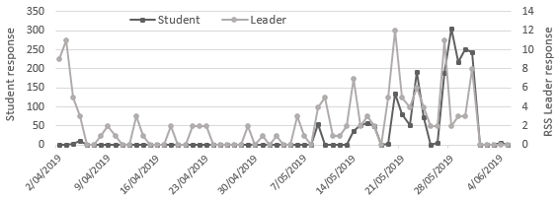

Administration issues
Some issues were evident with the accuracy/recency of the contact list provided by SV. Out of the initial 1858 principals and RSS-lead-teacher emails that were supplied, 234 were no longer valid. In addition ACER received around 20 emails from teachers asking to be removed from the mailing list as they were no longer involved in the RSS program or had changed schools. Over 40 ‘out of office’ emails were also received. These types of issues suggested that the contact list provided by SV was completely current.
Call centre also provided feedback about innaccuracies of the contact list. When staff followed up with schools via telephone many reception/administration staff did not recognise the program and therefore struggled to identify the appropriate staff member to follow up with. For example, out of a sample of 20 calls to schools, seven had the incorrect principal or RSS-lead-teacher listed. The above discrepancies indicate communication issues between the RSS-lead-teacher and the wider school or poor maintainance of records between the schools and SV.

2. Review of Literature
Understand broader wellbeing policies and programs related to sustainability education.

Global environmental challenges and the recent impacts on climate have drawn attention from policymakers around the world with regards to introducing safer and sustainable practices and ensuring that the wellbeing of the future generations are protected. Countries such as Denmark, the UK and the US are among the first to prioritise the Education for Sustainable Development (ESD) goals and introduced formal sustainable schools and outdoor learning initiatives to promote sustainability, to improve outcomes for future generations (Bentsen et al., 2009; Malberg and Wistoft, 2018; Barton et al., 2016; Hignett et al., 2018; Phillips, 2014; Ruse, 2007; Waite et al., 2016; Fakharzadeh, 2015). Similar programs have also been undertaken in Australia (Rose et al., 2018; Rickinson, Hall and Reid, 2014; Salter, 2016; Maller 2004; Block et al., 2012).
This review aims to understand the concepts of environmental sustainability and wellbeing as a cause and effect for each other. We did this through two lenses, allowing the themes within these two sections to emerge from the literature. While wellbeing-within-sustainability looks at how subjective wellbeing can be improved through sustainable actions, sustainability-within-wellbeing looks at where the community’s actions for attaining wellbeing intersect with activities which pave the path for sustainable development.

Wellbeing within sustainability

Sustainable schools and wellbeing
With the growing international recognition of the Education for Sustainable Development (ESD) Target 4.7 of Sustainable Development Goal (SDG 4) the focus on sustainability in schools is quickly gaining popularity. A sustainable school is one that that applies sustainability to everything - governance, operation, community engagement and relationship, curriculum, teaching and learning processes (Compass Education, 2015). The focus is on educating students with a clear drive towards getting them to effectively participate and contribute to a better and more sustainable future for humanity. The World Health Organisation recommends that schools should take up a whole school approach when trying to promote health and wellbeing (WHO, 2003) and sustainable schools fully support this goal.
According to an evidence paper developed in the UK by the Department of Children, Schools and Families there is significant evidence which supports the claim that incorporating sustainability in a school’s development plan improves teaching and learning by providing a meaningful, real-world focus that enables the development of capabilities for living and working sustainably, now and in the future (Barratt-Hacking et al., 2010). The same paper suggests that a sustainable school provides a positive context for supporting teachers’ work, and young people’s learning and wellbeing, and for developing group cohesion. Sustainable actions also improve the quality of school buildings and surroundings leading to an enrichment of young people’s physical and mental health and safety, and their overall development, learning, enjoyment and behaviour (Barratt-Hacking et al., 2010). Other studies have also linked students’ health and wellbeing to a school environment that promotes sustainability (Bell & Dyment, 2008; Bentsen, et al., 2009; Berger, 2006; Chen, 2014; Dyment & Bell, 2008; Kerret et al., 2014, Konu, 2002; Malberg & Wistoft, 2018; Phillips, 2014; Rose, 2018; Waite et al., 2016). John-Akinola and Gabhainn (2014) found that student’s general health and wellbeing outcomes are influenced by the socio-ecological environments of the schools. Konu et al. (2002) identified links between subjective wellbeing of students (such as perceptions of life), school related factors (such as, school environment, school subjects and organisation, and services and health care provided at the school) and social relationships (such as, school climate, teacher-pupil relationship, peer relationships and group dynamics). Additionally, Sellstrom et al. (2006) found that school health policies had a positive influence on pupils’ health behaviour and the school social environment was associated with pupils’ wellbeing. Moreover, positive feelings of connectedness to school, good communication, and perceptions of adult caring led to positive mental health outcomes in children (Patton et al., 2000). Sustainable schools achieve this sense of connectedness and belongingness by promoting group cohesion, community engagement, and using the curriculum and this in turn creates a positive climate that promotes wellbeing for all (Block et al., 2012; Hignett et al., 2018; Rose et al., 2018).
A key study undertaken by the National College for Leadership of Schools and Children’s Services in 2009 suggested that a focus on sustainability in a school had a beneficial impact on student behaviour (Birney & Reed, 2009). The study did not report any instances of bullying and most pupils were well adjusted individuals (Birney & Reed, 2009). Students’ participation and voice was also encouraged during the sustainable projects which improved educational outcomes through increased motivation (Birney & Reed, 2009).

Nature and wellbeing
A major share of the sustainability initiatives in schools focus on ecological activities and results in positive health outcomes. This relationship between experiencing nature and wellbeing is highlighted in the Catholic Education Melbourne’s Sustainability Framework (2015) and also in the Catholic Education Sandhurst’s Kinship with the Earth Education for Sustainability Framework (2012). Both the frameworks suggest that links to nature through outdoor play and shared activities boosts community values, develops and strengthens relationships and provides stronger support networks (CEM, 2015; Catholic Education Sandhurst, 2012). At the same time, children who play outdoors have been found to be fitter, healthier with better immune system, and are more confident with higher subjective health and emotional wellbeing scores (Maller, 2004; Pasanen et al., 2014; Adams & Savahl, 2017). An outdoor education project (Thurston Family Project) undertaken with disadvantaged youths and their families found that many of the participating children had more positive attitudes towards school and their home and their teachers observed reductions in anxiety and disruptive behaviour, and overall improved pro-social behaviours (McManus, 2012). More recently, an Australian study has also established that developing a relationship with nature is positively linked to two indicators of child wellbeing – self-satisfaction and prosocial behaviour (Whitten, et al., 2018). In 2014, Capaldi and colleagues conducted a meta-analysis which confirmed that a relationship with nature promotes happiness and hence improves wellbeing. Several other studies have also suggested a positive association between connection to nature and both eudaimonic (i.e. functioning well and realizing one’s full potential) and hedonic (i.e. feelings of shorter-term pleasure and happiness) wellbeing (Cervinka, Roderer & Hefler, 2011; Mayer et al., 2009; White, Alcock, Wheeler & Depledge, 2013).

Several other articles have suggested a positive link between physical activity and experiencing nature (Pasanen et al., 2014; Dyment & Bell, 2007) and how it promotes ecological knowledge, foster social bonds and influence positive behavioural changes leading to better health and wellbeing outcomes for present and the future (Pretty et al., 2009; Maller, 2005). Studies have also suggested that if the school grounds offer diverse natural settings, children are more active, more civil to each other, and more creative (Dyment & Bell, 2007; Dyment & Bell, 2008; Bell & Dyment, 2008). Similarly, involvement in horticultural activities improves students’ self-concept, sense of control, self-satisfaction, sense of achievement and social skills (Chen et al., 2014).
Additionally, engagement with natural environments and outdoor play contribute to the continuing development of skills crucial to higher-order thinking, creativity, problem-solving and self-discipline (CEM, 2015). Spending time outdoors and connecting with nature have been linked to higher resilience to stress, increased positive affect, and greater overall wellbeing (Capaldi et al., 2014; Mayer et al., 2009; Nisbet et al., 2011). Another study on views from Icelandic teachers found that even under extreme climatic conditions (where children may be exposed to the potential dangers of the outdoors) teachers strongly believed that outdoor environment provides an opportunity for children’s learning, stimulating their play, health, and wellbeing, and influencing their views and action regarding their environment in a sustainable way (Norðdahl & Jóhannesson, 2016).
More than two decades ago, Hattie and colleagues (1997) suggested that outdoor learning supports student growth and development. Others have suggested more recently that complementing the traditional school with an outdoor school program is the way to move forward to support sustainable education (Bentsen et al., 2009; Fägerstam, 2014). The evidence suggested here all indicate that contact with nature is vital for their positive mental health.

Wellbeing for students with special needs
Activities in nature has been known to have positive influences on students’ wellbeing (Bell & Dyment, 2008; Dyment & Bell 2008; Berger, 2006) and studies have established that particularly students who fall in the spectrum such as, children with Attention Deficit Disorder (ADD) and Attention Deficit Hyperactivity Disorder (ADHD), benefit from a continued outdoor program, (Taylor, Kuo &Sullivan, 2001). Prior research also suggest that outdoor learning opportunities in nature support children’s imaginative play, promote positive relationships and allows for the playground to become a place of learning (Dowdell, Gray & Malone, 2011). Nature provides children with special needs an unbiased environment to develop skills and grow in ways which might not be possible in the indoor classroom environment (Berger, 2006). Another study focusing on the benefits of forest schools found that children with ADHD showed improved concentration when finishing a task after a 20-minute walk in a city park and this difference was comparable to results achieved with a standard ADHD medication (Taylor and Kuo, 2009).

Sustainability within wellbeing
While most research has focused on linking sustainable activities to wellbeing, schools that focus on wellbeing promotion often also place a high value on sustainability and take actions which further strengthen the collective wellbeing. Even though there is a plethora of literature on promoting social and emotional wellbeing in schools (e.g. Barry et al., 2017; Chilton et al., 2015; Kuosmanen et al., 2019; Langford et al., 2015; Wells et al., 2003), very little was found that explicitly made links to sustainability, beyond the notion of ‘program sustainability’.

School culture and leadership
A review of studies from developed countries have suggested that school health policies positively influence school culture and also the wellbeing of students (Sellstrom & Bremberg, 2006). There is also evidence that effective leaders in schools who focus on a whole school approach have created wellbeing for all parties involved in the process (Birney & Reed, 2009).

Respect for each other and the environment
Respecting the environment in schools has traditionally focussed on reducing vandalism and taking care of personal and school property. More recently, the focus has turned to school pride and caring for nature. It has also been suggested that safe, inclusive and respectful environments promote respect for each other and respect for nature (CEO Sandhurst, 2012; Chiumento et al., 2018). Care for and kinship with the earth creates a mindset for choosing a life which is more sustainable (CEO Sandhurst, 2012) and in turn this relationship with nature is further expected to improve one’s wellbeing (Maller, 2005; Berger, 2006; Adams & Savahl, 2017).

Social and therapeutic gardens
Research demonstrates that the quality of the natural environment positively affects the personal development of young people (Dungan, 2015; HPA, 2009; Wolf & Flora, 2010). Many schools establish initiatives to improve the wellbeing of their students and larger community through sustainability activities such as the ‘edible school yards’ program in New Orleans, the ‘Gardens for Bellies (Gfb)’ program in Denmark, and the ‘Good from Woods’ program in the UK. In Australia, there are programs like the Multicultural school gardens program (Cutter-Macenzie, 2009), the Stephanie Alexander Kitchen Garden (Henryks, 2011; Block, 2012), the Outreach School Garden Project (Viola, 2006) and Schools with vegetable gardens study (Somerset, 2005). Although the main goal of such programs is to create student wellbeing they also support sustainable practices by linking students to nature (Fakharzadeh, 2015; Malberg & Wistoft, 2018; Waite et al., 2016).
Ohly et al. (2016) undertook a systematic review of the health and wellbeing impacts of school gardening. Studies about physical or mental health or wellbeing were included if they reported on school gardens. They found that more robust quantitative research was needed to support the qualitative evidence of wide ranging benefits from school gardens.
One notable study aimed at school children aged 9–15 years experiencing behavioural, emotional and social difficulties in the UK (Chiumento et al., 2018), assessed the impact of the Haven Green Space intervention on mental wellbeing using the Five Ways to Wellbeing evaluation framework. The Five Ways actions seek to influence mental wellbeing by playing an essential role in satisfying needs for positive relationships, personal autonomy, competency and security (Aked et al., 2008). As an action-oriented approach, the Five Ways aim to promote behaviour change by creating feedback loops that encourage people to reflect upon and adopt behaviours that promote wellbeing.
Table 3 presents the Five Ways framework and its application in sustainability activities.
Table 3. Application of the Five Ways to Wellbeing Framework in Haven Green space intervention
Five Ways Action | Application in Haven Green Space and examples in action
Connect: to those around you and to the natural environment | - Children engaging in shared activities in pairs and full groups.  - Taking care of and connecting to the school’s green space environment, including recognising areas that lacked greenery and working to improve this.  - Connecting with others outside of the Haven Green Space group, for example engaging in activities such as planting or socialising in green spaces such as parks.  Example: Tea Ceremony: pupils were asked to explore the garden for herbs that could be brewed as herbal tea. The group came together to share tea and discuss issues they were facing in connecting with one another that had been raised when working in the green spaces.
Be active: engage in enjoyable physical activity | - Physical activity linked to horticulture e.g. digging, planting, watering etc.  - Painting and decorating the green space.  Example: All sessions offered the opportunity for physical engagement in gardening, although in line with STH engagement could be either active or passive. In one garden a large root was removed from the centre of the plot, necessitating considerable physical effort by a number of boys who noted satisfaction when the root was removed, including photographing each other holding it as a trophy.
Take notice: of the world around you and of feelings | - Being outside facilitates noticing changing seasons and growth of plants/development of the green space.  - Working with others in a shared green space necessitates team work and negotiation and is an interaction that encouraged awareness of one’s own and others feelings.  - Reporting positive and negative interactions with green spaces outside of the group, i.e. planting with family members or friends, or being unable to access green space due to their use by older children perceived as bullies.  Example: In one primary school, trees that had been planted were vandalised. This was identified by pupils involved in Haven Green Space who sought teacher support to re-plant them. The pupils led this activity, and discussed with teachers how this vandalism made them feel and why they thought it had been done.
Keep learning: to build confidence and have fun | - Opportunities for learning horticultural skills such as planting and nurturing plants.  - Learning about how to manage both success and failure when growing plants.  - Engaging in spontaneous play within the green space.  Example: All sessions offered learning opportunities, in particular nurturing plants and the natural environment. “Diggy Diggy”: in a primary school one corner of the garden space was devoted to digging. During this activity pupils engaged in creative play involving story telling.
Give: do something nice for a friend or stranger, linking with the wider community | - Developing a green space for others to enjoy.  - Planning for the future of the green space as a legacy for the school.  - Sharing what they have been growing in Haven Green Space group with teachers and fellow pupils including taking into class plants that had been grown or items discovered in the green space such as stones or broken pottery.  - Applying skills learnt in the green space to other opportunities for engagement with nature e.g. growing plants at home.  Example: This action was seen in giving time and energy to care for the green spaces, as well as giving plants or the green space itself as an asset to others including friends and family. In one primary school, pupils stated that they wanted to create an orchard for future generations of pupils to enjoy and to improve the school grounds for parents, pupils and teachers alike.
Source: Chiumento et al. (2018, p.3,8)

Evidence from ResourceSmart Schools
This section reviews the previous evidence from schools implementing RSS about the successful sustainability initiatives. Based on the literature reviewed the wellbeing links for each of the sustainable actions are explained further.
According to an evaluation study on ResourceSmart Schools in 2014 (Rickinson, Hall & Reid, 2014), schools that have been in the program for more than four years had by far the highest reported levels of significant progress towards their sustainability goals. Furthermore, a small number of staff interviewed as a part of this study also highlighted the role of students as positive influences on the sustainability practices at the family level (Rickinson, Hall & Reid, 2014). RSS also succeeded in bringing about cultural changes with regards to sustainability. Other benefits included getting the staff and leaders on board, coordinators getting protected time, students becoming major drivers, and school strategic documents being developed around sustainability. School programs also helped to forge new links with local sustainability groups and initiatives, and act as sustainability mentors for other schools. All of the benefits can be linked to the five wellbeing elements under the Australian Student Wellbeing Framework. Table 4 presents the evidence and wellbeing-sustainability links for the RSS initiatives.

School improvement frameworks
In order to achieve one of the aims of this project – to provide an evaluation framework for the ongoing measurement of the program’s wellbeing impacts in RSS – we also reviewed other school improvement frameworks used in schools in Victoria. It was important to ensure that the new RSS-wellbeing Framework could be embedded within current school policy and practice and support the understanding of the broader wellbeing policies and programs related to sustainability education. As presented in the literature review, it considers the indicators for ongoing measurement and reporting of student wellbeing in connection to the RSS program, by taking two directions of enquiry:
- Wellbeing-within-sustainability: looks for evidence of wellbeing linkage from within the five modules that achieve school sustainability goals (Core, Biodiversity, Energy, Waste, and Water).
- Sustainability-within-wellbeing: looks at the Framework for Improving School Outcomes (FISO) and other national wellbeing frameworks (e.g. be you, KidsMatter), where the community’s wellbeing intersect with sustainable activities.
In our review of schooling frameworks, both in the government and non-government sectors, we found significant overlap in the core ideas and guiding principles. Two major frameworks emerged that were used as the foundations for the RSS-wellbeing framework: The Framework for Improving Student Outcomes (FISO) and the Australian Student Wellbeing Framework.
The broad goal was to triangulate wellbeing and RSS activities, evidence and indicators, onto FISO as the central guiding framework used by Victorian schools towards improving student outcomes. The FISO model depicts the six high-impact Improvement Initiatives, namely Building practice excellence, Curriculum planning and assessment, Building Leadership Teams, Empowering Students and Building School Pride, Setting Expectations and Promoting Inclusion and Building Communities, is provided in Figure 4.
Table 4. Evidence from RSS on wellbeing-sustainability
RSS Modules | Evidence from Schools | Wellbeing Link
Waste Management | Schools are charged for waste disposal so reducing waste is a relatively easy way to begin saving the school money. The audits on waste management and data collection revealed high costs of removing waste without recycling. Strategies included, recycling and establishing a policy for sustainable buying, and involving student action teams/ parent volunteers to take away the recycle. | Improves student participation e.g. through formation of Student Action Groups.  Promotes awareness and improves sustainability culture e.g. data collection at one independent school showed that rubbish removal was costly. The awareness created through data collection helped them realise the benefits of recycling.  Involve families e.g. one participating independent school mentioned how they are a part of the “Nude Food” lunches program.  Students eating together, sometimes outdoors, strengthens social bonds and improves litter management, which creates tidier, cleaner school grounds.  Wellbeing Elements: Partnerships, Student Voice, Inclusion
Biodiversity | Examples include setting up vegetable gardens, native planting and indigenous gardens with a specific aim of creating outdoor learning spaces. Schools often use the garden to manage waste (food scraps) and as water saving measures (e.g. rainwater collection). An effective way to involve other adults, including other school staff and parents. | Builds connections and links to the wider community e.g. one rural government secondary school felt that it provided them an opportunity to work with other community organisations such as, Waterwatch and Landcare, which is very important for schools in isolated areas.  Involve families e.g. one government school found that the vegie-garden project has brought parents on board and information was exchanged with parents about caring for plants and parents often shared plants from their home gardens with the school vegie-garden.  Wellbeing Elements: Partnerships, Student Voice, Inclusion
Energy | Schools reduce energy use by switching appliances off when not in use, using more energy efficient equipment, generating their own power using solar and wind, and dress appropriately for the weather. | Save resources e.g. according to Pitt and Sherry’s 2013 study of SETS data, energy use per student decreased in participating schools – between 2008 and 2012- by 20.3%.  Positive influences on the sustainability practices at home e.g. children would go home and talk about turning water off when brushing teeth or turning lights off.  Wellbeing Elements: Student Voice, Inclusion, Leadership, Support
Water | Examples include installation of water tanks, placing buckets under taps, and recycling water to use in vegetable garden which led to significant savings in water use. | Save resources e.g. one government school went from being reliant on normal supply water to having a water tank installed and flushing the toilets with this water, which made significant savings in water use.  Wellbeing Elements: Student Voice, Partnerships, Inclusion, Leadership, Support
Core | RSS develop whole school policies and management plans around sustainability, such as School Environmental Management Plan (SEMP). Other activities include PD sessions by the program facilitators, and higher staff time allocation for focusing on sustainability issues. | Develop school policies and management plans around sustainability e.g. one government secondary school maintains a green procurement plan which is reviewed by the school council twice a year.  Wellbeing Elements: Leadership, Support
Source: Table constructed using information from the report by Rickinson, Hall & Reid (2014).

FISO promotes the understanding that the schooling system is more likely to deliver success for students if a common language, a common cycle of improvement and a common set of success criteria that define improvement, are used. From the classroom, to networks, to the system as a whole, FISO aims to support system-wide improvement. Much of the focus in this document has been built around FISO as it relates to the intersection between wellbeing and sustainability. Moreover, the FISO Model shows four state-wide priorities (1) Excellence in teaching and learning, (2) Professional leadership, (3) A positive climate for learning and (4) Community engagement in learning. These priorities are relevant for improving wellbeing in schools and for undertaking a sustainable school approach. Student Achievement, Engagement and Wellbeing are at the heart of the FISO framework.
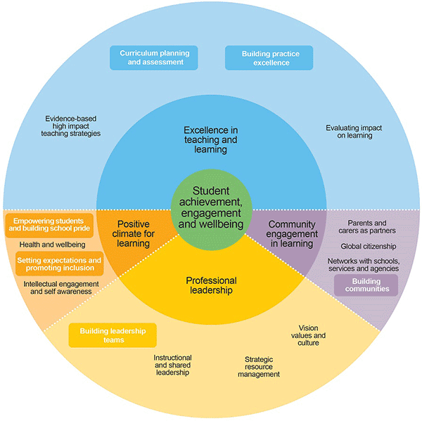
FISO also aligns to the Australian Student Wellbeing Framework, depicted in Figure 5, which includes the five elements of leadership, inclusion, student voice, partnerships and support. These elements together provide the base for the whole school community to promote student wellbeing, safety and learning outcomes.
Figure 4. The Framework for Improving
Student Outcomes (FISO, 2018)

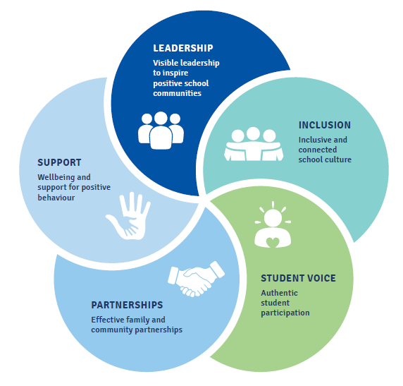

Figure 5. Australian Student
Wellbeing Framework (ESA, 2018)

3. Survey Results
Explore and record the wellbeing impacts from implementing the RSS program.

About the participating RSS schools
In total, 123 RSS schools participated in the study. Completed surveys were received from 117 RSS leaders and 2201 students, with almost half of the students (49%) in Years 5-6, as Figure 7 shows. The schools, profiled in Table 5, provided representation across primary, secondary and combined settings and across Government, Catholic and Independent sectors.
An indication of a school’s RSS status was derived based on progress across the five RSS Modules and Star-rating attainment (according to SV records as at March 2019). Across the 10 indicators, a school received score points if their status was: Available or Lapsed (0); Underway or Renewal required (1); Renewal underway or eligible for or being verified/certified (2); Certified (3). The total RRS score, which could range between 0 (starting) to 30 (fully certified), was used in subsequent analyses as a proxy for level of RSS engagement. As an indication of whole-school wellbeing, a score for was derived from the SSPESH items in the RSS leader survey (n=117). With scores ranging between 0 (low) to 39 (high), half the school (49%) were in the moderate range for promoting mental health and wellbeing, while very few schools (5%) scored in the low range. These contexts should be kept in mind when interpreting the results.
Figure 6. Year level profile of participating student
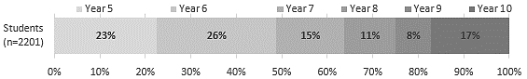
Table 5. Participating schools and their RSS-score and whole-school wellbeing status
Characteristics of schools |  | n | %
Surveys completed | RSS Leader survey only | 46 | 37% | 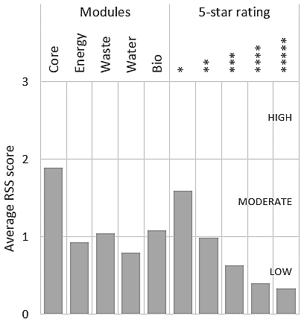
Surveys completed | Student survey only | 22 | 18%
Surveys completed | Both surveys | 55 | 45%
Type | Primary | 79 | 64%
Type | Combined K-12 | 12 | 10%
Type | Secondary | 28 | 23%
Type | Special | 4 | 3%
Sector | Government | 82 | 67%
Sector | Catholic | 34 | 28%
Sector | Independent | 7 | 6%
RSS status | Low (0-9) | 69 | 56%
RSS status | Moderate (10-19) | 34 | 28%
RSS status | High (20-30) | 20 | 16%
Whole-school wellbeing | Low (0-20) | 6 | 5%
Whole-school wellbeing | Moderate (21-32) | 57 | 49%
Whole-school wellbeing | High (33-39) | 54 | 46%

In addition to the participation of school RSS leaders and students, nine delivery partner organisations also completed a survey. The representation of schools in each Victorian region included: 11% in Barwon South Western Region, 17% in Eastern Metropolitan, 11% in Gippsland, 6% in Grampians, 3% in Hume, 6% in Loddon Mallee, 12% in Northern Metropolitan, 27% in Southern Metropolitan, and 7% of schools were in Western Metropolitan.

Students’ awareness of environmental sustainability
As a first step, it was important to validate that the RSS score was a reliable and valid indication of a schools’ level of engagement with and implementation of the RSS program. We hypothesised that if a school was highly engaged in implementing the RSS program, then this may be reflected in student’s views about their school.
Students’ responses to seven items about environmental sustainability in RSS schools are presented Figure 7, ordered from most to least agreement. Four in five students (83%) agreed or strongly agreed that their school cares about the environment. Three-quarters of students agreed that they went to a sustainable school (77%), that they actively cared for the environment (74%), and that being out-doors and experiencing nature was encouraged (75%).
Two-thirds of students (65%) agreed or strongly agreed that their school does audits for waste, energy and biodiversity and half the student cohort agreed that they liked working in gardens and wetland areas (53%) and that school activities and excursions were often about helping the environment (52%).
Figure 7. Students’ views about environmental sustainability at school
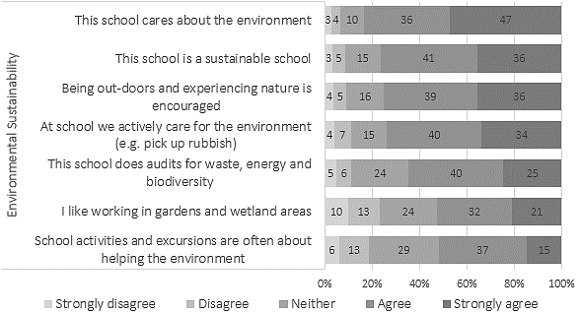

Overall, students’ views about environmental sustainability in their schools were positive and potentially provided an independent indication of a school’s level of RSS engagement. Students’ average score across seven items, forming a scale of environmental sustainability, was compared to the school’s RSS score. A small positive relationship (Spearman correlation r = 0.20, p < 0.01) was found. This suggests that students in highly engaged RSS schools were more likely to agree that their school was environmentally sustainable and that they engaged in sustainability activities in their school. Figure 8 demonstrates this relationship by comparing the spread of student responses grouped by schools that were low-implementing (RSS score below 10), moderate implementing (RSS score between 10 and 20) or high-implementing (RSS score 15 or above). Accordingly, the RSS score was used in subsequent analyses to examine relationships between sustainability and wellbeing.
Figure 8. Students’ views about environmental sustainability at schools, by RSS status
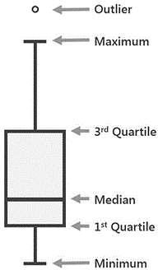
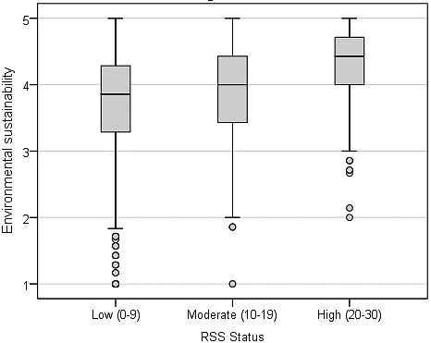
Strongly agree

Agree

Neither

Disagree

Strongly disagree

In addition to better understanding students’ awareness of environmental sustainability in their school, students were also asked more explictly about how being at a RSS school and caring for the environment made them feel. Over 1800 student comments were received and thematically analysed into 13 emergent concepts, shown by frequency of response in Figure 9.
Figure 9. Students’ emergent themes about how being at a RSS school makes them feel
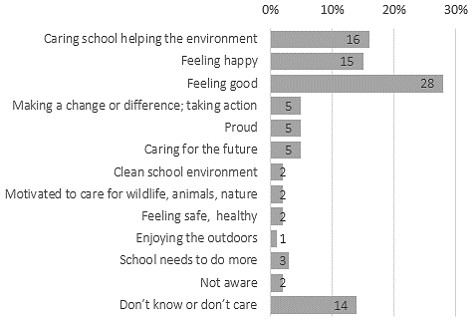

Students’ comments that were insightful and provided a typical example, with the frequency of response in brackets, are presented by the emergent themes in Table 6.
Table 6. Students’ views about how being at a RSS school makes them feel
Themes | Exemplar comments from students
Caring school helping the environment  (16%) | - It makes me feel happy that we're preserving the environment and not wasting natural resources. (Year 9)  - Good because I know that my school is caring for the environment and tries to make a difference. That they want to help the world and the environment. (Year 6)  - It makes me feel like I go to a school who thinks about the wellbeing of others and the environment. (Year 6)  - That this school is a really nice school and caring teachers. (Year 7)  - My school provides us with every possible thing they can and try to involve the kids in making decisions for the school. (Year 6)  - Great that we are starting to take care of the really important things. It’s great and fantastic that people come with a healthy and resource smart lunchbox. It’s really fantastic! (Year 5)  - I feel good at this school because they are caring for the environment and making earth a better place for people to live (Year 5)  - I feel happy that I am at this school. We have lots of trees and plants to help the environment. We also have a competition to bring rubbish free lunches. (Year 5)
Feeling happy  (15%) | - Being a ResourceSmart School and caring for the environment makes me feel happy. (Year 6)  - Great and happy. (Year 7)  - It makes me feel excited and happy. All the things we do for the environment makes me joyful. (Year 5)  - I feel good about this school because we are a sustainable school and it makes me feel happy. (Year 6)  - Happy that we put the time and effort to do good things to the environment and we care for it (Year 6)  - It makes me feel happy that I know that what I'm doing is helping the earth be more sustainable and making an impact in the world. (Year 6)
Feeling good  (28%) | - It makes me feel like I am being involved in helping the Sustainability levels of this planet, even if it is only a small act. The fact that so much is happening, things that revolve around the subject of sustainability, makes me feel as if we are actually contributing and making a change and that makes me feel really good. (Year 6)  - It makes me feel good for myself and for the environment! (Year 6)  - Pretty okay pretty fun pretty environmentally green (Year 9)  - Responsible and proactive about doing my part for the environment. (Year 7)  - Yeah it makes me feel good I love animals and feel good about helping other living things; when I grow up I would love to be a zookeeper for a job that’s a big dream (Year 5)  - Totally makes me feel great that we're doing everything we can for the environment. (Year 10)
Making a change or difference; taking action  (5%) | - Being a ResourceSmart School has given us opportunity to make the world a better place and safer to live in. (Year 7)  - It makes me feel as though I am making a difference in the way the things are run and really helping the environment. (Year 6)  - It makes me feel happy that I am going to a school that cares for the environment, and that I am doing something for the community. (Year 6)  - It makes me feel as if I have helped the planet! (Year 6)  - It makes me happy that my school care and that I have an opportunity to change the environment for good. (Year 7)
Proud  (5%) | - I feel proud of our school and caring about the environment because it is a big part of our school and I enjoy caring for the environment. (Year 6)  - Being part of a ResourceSmart School, makes me feel proud that I am in a school that cares for the environment. This definitely makes me think more about the environment and how we can improve it. (Year 5)  - It makes me feel proud of my school. (Year 6)  - This makes me feel so proud of what I am doing and this school appreciates all the things we do to save the environment. So thanks for this survey it really shows how I feel about the environment. (Year 6)  - Proud. There are schools that do nothing about the rubbish but we do something about it. Every year we try to reduce the amount of rubbish we have. We are encouraged often. (Year 6)
Caring for the future  (5%) | - Being in a resource smart school makes me feel good to know that the school I’m in cares for the environment and that the school I’m in is trying to make the world a better place. (Year 6)  - Caring for the environment makes me feel confident that in the future there will be a sustainable world to live in. The schools ok. (Year 6)  - I feel that the things we do at our school to try and help out the environment is a good way to pass on tips to the future generation about keeping our world tidy and not to litter as it does have an impact on the environment. (Year 6)  - I feel like it will save money and help the earth and for our future. (Year 7)  - It makes me feel good that I can come to school knowing that I will be helping the environment every day so the world will not exploded. (Year 6)  - Good because I believe caring for the environment is our future. We really have to take care of the Earth because it doesn't just belong to us it belongs to the animals and the plants. I feel proud to be a part of it. (Year 6)  - It makes me feel a bit more certain about my future because sometimes I worry. If all schools did what we did it would make a huge difference. (Year 8)  - Makes me feel like i will actually have a future and so will my kids (Year 6)
Clean school environment  (2%) | - Being part of a Resource Smart School makes me feel happy because I know that when I come to school it will be clean. When I care for the environment I fell a sense of pride because I know that my actions are impacting the environment. (Year 5)  - It’s pretty hard keeping it clean but when it is, it’s worth it. (Year 6)  - I feel that waking up every day with the feeling that I am going to a clean school with a clean environment is very important and my school has definitely achieved this. (Year 6)  - good because I feel that I am making a change in are school by making it more clean and I hope this happens over the world before it’s too late (Year 6)  - I think it’s great to be sustainable and I would really like to see more recycling in the bins as I am the recycling monitor (Year 6)  - It makes me feel like I go to a great school and a safe rubbish free school (Year 5)
Motivated to care for wildlife, animals, nature  (2%) | - Being a sustainable school makes me feel happy and healthy because our school is surrounded by nature. (Year 5)  - I feel very enthusiastic about saving our environment and caring for our wildlife. (Year 6)  - It makes me feel proud of myself because I am doing something that will not only help the environment but to help all living things on the Earth. I love it when my school and I are complemented on how much we do to help save the environment because it means that other people are recognizing what I'm doing. (Year 6)  - It makes me feel like animals are more safe from waste/rubbish and I'm proud of that! (Year 6)
Feeling safe, healthy  (2%) | - I feel safe knowing that our school protects and likes nature I believe it is a way to encourage people to do smart things for creatures. (Year 10)  - It makes me feel safe and we are helping earth. (Year 6)  - It makes me feel safe since people here care about each other and the environment. (Year 6)  - Very nice, and healthy. (Year 8)
Enjoying the outdoors (1%) | - I love the outdoors. (Year 6)  - It makes me feel connected and I always enjoy going out with my friends outdoors (Year 6)  - very happy because I like to be outside and help with all gardening and environment things (Year 7)  - happy and calm because I’m in the environment and exploring (Year 10)
School needs to do more (3%) | - Sometimes the school is fun but other times its really boring the one thing I want the school to do is look after others plants animals more then what it does (Year 7)  - I am happy about being a ResourceSmart School though I know my school has a long way to go. I wish we would learn more about how to do gardening and protect the environment but we just learn a lot of the same thing in environment classes. (Year 6)  - We have a group that does environment stuff but no one listens (Year 10)
Not aware (2%) | - I’m not very aware of us being a resource smart school but I see students helping the environment and picking up rubbish every now and then. (Year 8)  - I didn't even know my school was resource smart. I mean we have an alley at the school which is just always filled with rubbish (Year 7)  - I do not know much about ResourceSmart School but I feel like they will have a positive impact to Australia. (Year 10)
Don’t know or don’t care (14%) | - I don’t know at the moment I haven’t given it any thought. (Year 9)  - I don’t know. You can’t stop climate change. (Year 5)  - Not really sure (Year 10)  - Nothing special I feel the same as I do when I go to a normal school (Year 9)  - I don’t really bother whether it is an environment friendly school or not (Year 7)  - I don't really care. (Year 6)  - I don't really know I don't really get involved in it because it doesn't really interest me so I don't get involved (Year 6)  - Bored and tired (Year 5)

The students’ responses presented in Table 6 were overwhelmingly positive about their school’s involvement in the RSS program. Many students (39%) reported that it made them feel ‘happy’, ‘good’ or ‘proud’ that their school was encouraging environmental sustainability. Students’ also reported positive feelings about the importance of caring for the environment, making a difference or taking action in their schools and contributing to a sustainable future. They also described their own motivation to care for nature and wildlife. Some students felt that having a clean school was important to them and contributed to their pride for the school. A small number of students also mentioned that their school’s involvement in the RSS program made them feel safe and healthy.
The comments around the different themes illustrate the level of awareness on environmental topics particularly regarding the impact of global warming from waste dumping and other unsustainable practices. Many students were rather concerned about future generation’s wellbeing and lobbying for sustainable actions from all.
Some students believed their school’s involvement in the RSS program implied that their school and teachers cared about the environment and their future. The comments also suggest that the RSS program has been successful in demonstrating the importance that the school places on good environmental practices and influences how students feel about their schools. However, based on their feedback, around 8% of students were not as engaged (not happy or didn’t care) with the program as the others and a few failed to recognise the RSS activities undertaken at their schools (2%).
Overall, students’ responses suggest that having the RSS program in their school had a positive impact on their wellbeing and the wellbeing of their community.

Student wellbeing
The main aim of this pilot was to establish to what extent the RSS program may influence student wellbeing. Items from the widely-used EPOCH instrument were accompanied by a selection of other validated scales to provide a general profile of student wellbeing in terms of a sense of optimism, perseverance and happiness, along with engagement in learning and connection to school.
Figure 10 presents an overview of student wellbeing (n = 2201) in RSS schools, ordered from most to least positive. In terms of general happiness, most students reported that they feel happy (61%) and love life (63%) very often or almost always. Two-thirds of students very often or always felt that they were a cheerful person (63%) and had a lot of fun (63%).
Figure 10. Student wellbeing in school
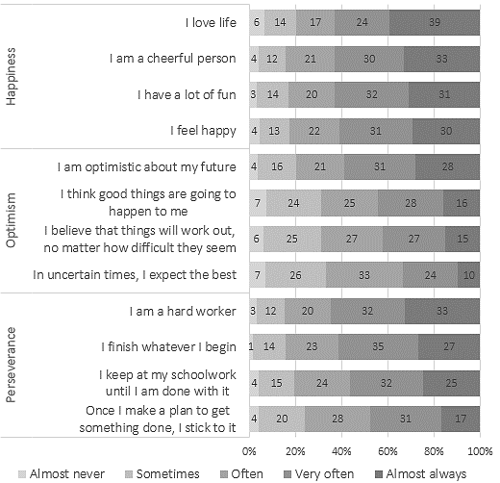
Three out of five students were very often optimistic about their future (59%), while almost a half believed that good things would happen to them (45%) very often or almost always. Fewer students very often believed that things will work out, no matter how difficult they seem (42%) and one-third of students very often expect the best in uncertain times (33%).
Students’ level of perseverance was strong. Two-thirds of students very often or always felt that they were a hard worker (65%). Three in five students very often finished whatever they began (61%) and kept at schoolwork until it was done (57%). However, making plans to get something done and sticking to it, always or very often, was reported by less than half the students (48%).
Overall, most students were happy learners who persevered at their work and had a strong sense of optimism about their future.

Connection to school and engagement in learning
As noted earlier, the RRS program is a program implemented at the school-level, with students only indirectly involved in it through sustainability-focused learning opportunities. Accordingly, as further elements of broader wellbeing, it was important to also understand how students engaged with school and how connected to school they felt.
Figure 11 presents an overview of students’ attitudes about school connectedness and learning engagement, ordered from most to least agreement. In terms of school connectedness, most students really liked their school (77%), felt proud about being a student at their school (76%), were happy to be at school (76%) and felt like they belonged (71%). Nevertheless, around a quarter of students (25%) were uncertain or did not feel a connection with the school.

The majority of students (75%) agreed or strongly agreed that school is a place where the things I learn are important to me. Most students also agreed that they like learning (74%) and thought that the things they were taught were worth learning (74%) at their school. For many, school was also a place where they enjoyed what they did in class (70%) and got excited about the work that they did (57%).
Figure 11. Student learning engagement and connection to school
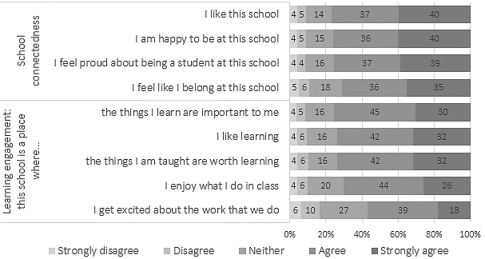

The influence of age
The reseach literature on student attitudes towards school frequently reports a decline in attitudes with age (e.g. Tobia et al., 2019; Redmond et al., 2016). To what extent a student’s age influenced their views about environmental sustainability and attitudes about school and themself, was also of interest.
Using the wellbeing dimensions discussed above, five scales were formed by taking the average score across the items in each of the dimensions. Accordingly, the derived scales provided measures of student optimism, perseverance, happiness, learning engagement, and school connectedness. Along with the scale of school environmental sustainability, these dimensions were compared by student Year level.
Supporting previous research, Figure 12 shows a general decline in attitudes and beliefs with age. Moreover, a moderate negative relationship (Spearman correlation r = 0.49, p < 0.01) was found between students’ attitudes about school environmental sustainability and their Year level. It suggests that younger students were more likely to hold highly postive views about working in the garden, actively caring for the environment and reporting their school as being environmentally sustainable, compared to their older counterparts.
Similar typical declines in attitude with age were also evident across the other measures of school connectedness and learning engagement, and across the wellbeing measures of perseverance, happiness and optimism.
Figure 12. Students’ views about environmental sustainability at schools, by Year level
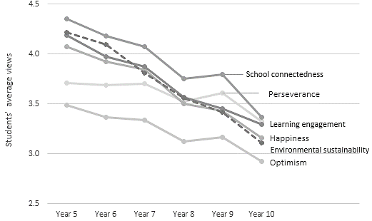

The influence of being an environmentally sustainable school
Of greater interest, however, were students’ views about themselves and about school also a reflection of the school environment? The five wellbeing scales (optimism, perseverance, happiness, learning engagement, and school connectedness) were compared to the independent school RSS scores in order to examine the relationships between a student’s wellbeing and the RSS status of their school. Figure 13 presents the relationships by comparing the responses of students in RSS schools that were in the low, moderate or high implementing ranges.
Figure 13. Student wellbeing and connection to school, by school RSS status
School status:
Strongly agree

Agree

Neither

Disagree

Strongly disagree
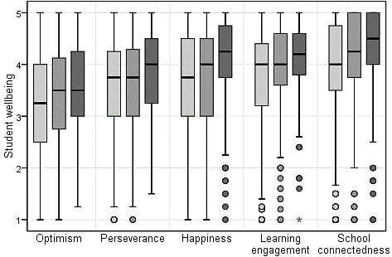
Almost always

Very often

Often

Some-times

Almost never

School  RSS score | 0.08  (0.00) | 0.06  (0.01) | 0.11  (0.00) | School  level | 0.13  (0.00) | 0.11  (0.00) | Spearman Correlation r  (p)
Environmental sustainability | 0.43  (0.00) | 0.39  (0.00) | 0.48  (0.00) | Student level | 0.65  (0.00) | 0.64  (0.00) | Spearman Correlation r  (p)
Visual inspection of Figure 13 suggests a very weak relationship between student wellbeing and school RSS score, in terms of optimism (r=0.08), perseverance (r=0.06) and happiness (r=0.11). What small differences there were between groups, were only statistically significant (p<0.05) due to the large sample size, as the correlation (r) tabulated beneath Figure 13 reflects.
Similarly, students’ views about learning engagement (r=0.13) and school connectedness
(r=0.11) indicated very small relationships with school-level RSS status, such that students in high-implementing RSS schools were somewhat more likely to feel proud about being a student at their school and like the school, compared to students in low implementing RSS schools.
As a further point of comparison, the five student wellbeing domains were also assessed against the student environmental sustainability scale (introduced in Figure 8 above). Also tabulated at the bottom of Figure 13, the results indicate small to strong significant relationships between students’ views about themselves and about the sustainability of their school. The findings suggest that students who felt that their school cared about the environment and embraced sustainability, were also more likely to exhibit higher levels of wellbeing in terms of optimism (r=0.43, p<0.01), perseverance (r=0.39, p<0.01) and happiness (r=0.48, p<0.01).
Moreover, the relationships were stronger with regard to students’ learning engagement (r=0.65, p<0.01) and school connectedness (r=0.64, p<0.01). The findings suggest that students who felt that their school was a sustainable school, were also more likely to learn things that were important and worthwhile to them, get excited about the work that they did, and feel proud about being a student at the school.

Whole-school wellbeing
Turning to the RSS School Leader survey, it was of interest to understand to what extent schools implementing the RSS program were also actively engaged in promoting whole-school wellbeing. By doing so, would help put the results emerging from students, into context.
RSS leaders were asked if their school was implementing any whole-school wellbeing programs or frameworks, presented in Figure 14. Half the schools were implementing Cybersafety and School Wide Positive Behaviour. All schools were implementing at least one program, and several schools were implementing up to six programs.
Figure 14. Whole-school wellbeing frameworks implemented in RSS schools
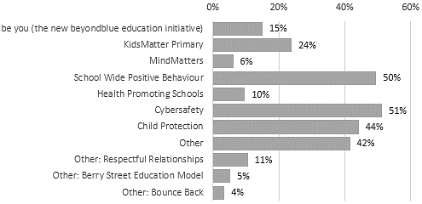

The top three programs mentioned in ‘other’ were Respectful relationships (11%), Berry Street Education Model (5%) and Bounce Back (4%). In addition, the following 32 programs were mentioned by one or two schools: Achievement Program, Alternative play times, Better Buddies, Body Safe, Catching on early, Child Safe, Circle Time, DRUMBEAT, eSmart Achievement Program, Faith and Well-being Curriculum, Friendly Schools Plus, Imagination club, Jigsaw, Mentor Framework, Mindfulness, Nathan Burke wellbeing program, Pastoral care, PATHS, Peaceful kids, Play is the way, Positive Education, Real School, Resilience and Respect, Restorative practices school, Rights, Safe Schools, Smiling minds, Social Skills programs, The rite journey, You Can Do It!, Zones of regulation, or their own framework.

The influence of whole-school wellbeing implementation
In addition to finding out specific wellbeing programs in schools, a set of 13 generic items asked leaders about aspects of their school that have been identified as being important indicators in promoting whole-school social-emotional wellbeing (Dix et al., 2018). Figure 15 presents an overview of leader’s views (n=113) about their school’s capacity to promote a Positive school community, develop students social emotional skills, engage with families, and support students experiencing difficulties.
Figure 15. Whole-school promotion of wellbeing (SSPESH)
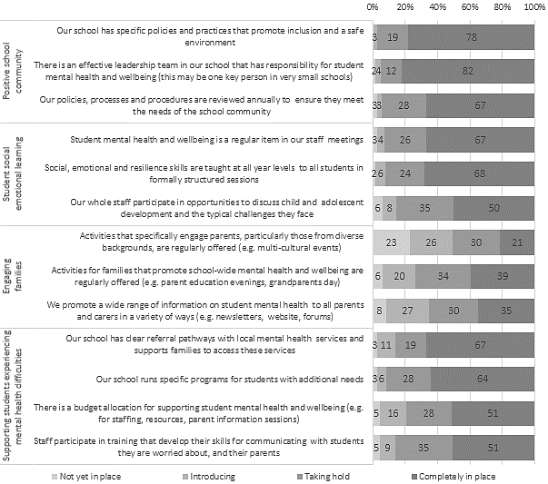

RSS schools presented a typical profile on the four SSPESH domains, as shown in Figure 16. Leaders reported that their school was well positioned to promote a positive school community (average score 7.97/9). They were nearly equally as effective in teaching student social emotional learning (average score 7.35/9). Leaders reported that their school was still introducing better ways to engage with families (average score 5.41/9), but were further along the way in terms of supporting student at risk (average score 9.56/12). With total SSPESH scores ranging from 11 to 39 (out of a possible 39), 5% of RSS schools fell into the low band, 49% were in the moderate band, and 46% were scored into the high bands of promoting whole-school wellbeing (see Table 5 above). Visual inspection of Figure 16 of a school’s RSS score and SSPESH score in each of the four domains, indicates no relationship. That is to say, while there was evidence of RSS schools also focusing on whole-school wellbeing promotion, the extent of these efforts appear to be independent of schools RSS activities, confirmed by a non-significant correlation (r=0.00, p=0.99).
By disaggregating the schools’ SSPESH score onto the student-level data, analysis was undertaken using Spearman’s correlation to test for any relationships between SSPESH and the student wellbeing measures. Table 7 presents the results and indicates no relationships of practical significance, noting that significance is an effect of the large sample. These results suggest that RSS schools’ whole-school wellbeing efforts were having a very small positive association with student wellbeing, and also students’ views about the school as being an environmentally caring place. There was no relationship at the school-level between the SSPESH and RSS scores.
Figure 16. Comparison of school RSS score and SSPESH score
School RSS status:
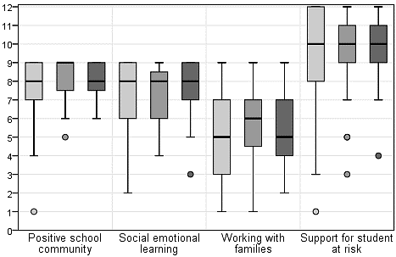
Whole-school wellbeing (SSPESH) score
Table 7. Relationship between whole-school wellbeing (SSPESH) and student wellbeing
Student-level  SSPESH | Student wellbeing |  |  | Learning engagement | School connectedness | Environmental sustainability | RSS status
Student-level  SSPESH | Optimism | Perseverance | Happiness
r  (p) | 0.06  (0.01) | 0.03  (0.17) | 0.08  (0.01) | 0.05  (0.04) | 0.03  (0.23) | 0.13  (0.01) | 0.00  (0.99)

Factors influencing student wellbeing
Figure 17 presents a summary of the main relationships between school-level factors and student-level outcomes, mapped onto the RSS-wellbeing conceptual model. While there were small significant relationships between a school’s RSS status and students’ views about environmental sustainability, the strongest relationships were evident within the student-level, between a student’s views about their schools environmental activities and their wellbeing.
Figure 17. RSS-wellbeing conceptual model with main relationships (significant correlations in bold)
ResourceSmart School status  SCHOOL LEVEL |  |  |  |  |  | Whole-school wellbeing status
Core | Energy | Waste | Water | Bio-diversity |  | Positive school community | Student social emotional learning | Engaging families | Supporting students experiencing difficulties
1 to 5-Star Module rating
STUDENT LEVEL
Students’ views about
environmental sustainability
 |  | Learning  engagement |  |  |  |  | Connection and  belonging to school
 |  |  | Perseverance  in school work |  | Optimism  about future  0.13  0.20  0.03  0.651  0.641  0.481  0.431  0.391  0.13 |  | Happiness
Student Wellbeing
0.501
0.63
0.62

ResourceSmart activities and wellbeing
Examining wellbeing within sustainability to explicitly draw out any possible links, RSS leaders were asked to think about their school and indicate to what extent current sustainability activities might contribute to whole-school wellbeing. Figure 18 presents the results.
In terms of engagement with the RSS program, most schools had commenced the Core module (95%) and the Waste module (94%). Around a quarter of schools were yet to start the Energy (22%) and Water (26%) modules, and 13% of schools had not started the Biodiversity module.
Of the schools who had commenced a module, the Waste and Biodiversity modules were rated as the strongest contributors to promoting whole-school wellbeing, with three out of five leaders (62%) reporting moderate to major impact. Although these findings are based on the data from 99 schools, the results are supported by findings from the literature review – that clean, green environments support our wellbeing.
Figure 18. Contribution of RSS activities to whole-school wellbeing
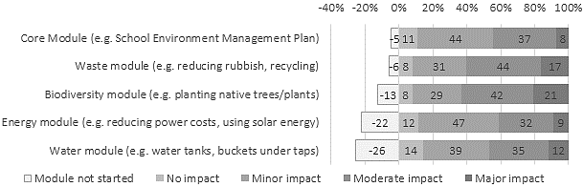

This link was further tested by examining the relationship between RSS module impact (average score) and RSS status. Figure 19 shows a clear relationship between extent of impact on student wellbeing attributed to each RSS module, depending on the school’s RSS implementation status of low, moderate or high. Significant positive correlations were found between school RSS status and the impact on wellbeing due to the Core module (r=0.32, p<0.05), Waste module (r=0.33, p<0.05), Biodiversity module (r=0.25, p<0.05), and Energy module (r=0.27, p<0.05). A smaller non-significant positive relationship was found between RSS Status and the Water module (r=0.20, p>0.05).
Figure 19 also shows the average response by regional partner organisations, who were also asked the same question, but thinking about the schools in their network and the extent that sustainability activities might contribute to wellbeing. Partner views were similar to leader views.
The results suggest that environmentally sustainable schools in the high range reported greater levels of impact on wellbeing due to their sustainability activities, compared to schools in the low range of RSS status. This was true for each RSS module, and supported by a significant positive correlation (r=0.23, p=0.02) between overall RSS impact on wellbeing and SSPESH whole-school wellbeing status.

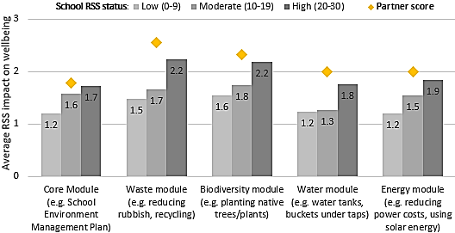
Figure 19. Relationship between RSS status and RSS module impact on wellbeing
Major impact

Moderate impact

Minor impact

No impact

RSS status |  |  |  |  |  | RSS impact on SSPESH  Wellbeing
r  (p) | 0.32  (0.002) | 0.33  (0.001) | 0.25  (0.02) | 0.20  (0.07) | 0.27  (0.001) | 0.23  (0.02)

In an effort to explore sustainability within wellbeing – that is, how whole-school wellbeing might benefit from RSS activities – RSS leaders were asked if the RSS program also helped their school to develop the four areas of whole-school wellbeing. On average, 86% of leaders agreed that the RSS program also helped schools to develop a positive school community, and 79% agreed that it supported the social and emotional development of students. Almost three-quarters of teachers agreed that the RSS program also helped schools to engage with parents and families (72% agreed). Only three in five RSS leaders agreed that the RSS program also helped support students experiencing difficulties (59% on average). Importantly, a breakdown of the results by RSS status, presented in Figure 20, suggests that highly engaged schools gained greater benefit towards promoting whole-school wellbeing, compared to low implementing schools. This result is further support by postive significant correlations between RSS status and leaders’ agreement that RSS have also helped to support wellbeing activities in their school (r=0.30 to 0.36, p<0.01).
Figure 20. Leader agreement that RSS has also helped to …
School RSS status:
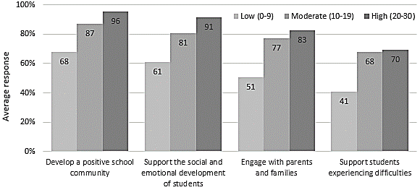

Correlation r
RSS status | 0.30** | 0.36** | 0.36** | 0.32**
RSS module impact | 0.42** | 0.39** | 0.32** | 0.36**
SSPESH wellbeing | 0.20* | 0.29** | 0.15 | 0.16
**. Spearman Correlation is significant at the 0.01 level (2-tailed). *. Spearman Correlation is significant at the 0.05 level (2-tailed).
RSS delivery partner organisations were also asked if they thought the RSS program could also help their network schools to develop a positive school community, support the social and emotional development of students, encourage parent and family engagement, and support students experiencing difficulties. All partners agreed (100%) in all four domains.

How RSS is helping to promote whole-school wellbeing
RSS school leaders and RSS partner organisations who agreed that the RSS program was also helping their school to promote wellbeing, were also asked to explain in what ways the program was making a difference. The emergent themes and some exemplar comments in each of the four wellbeing domains are presented in the following tables and summarised in Figure 21 below.
The majority of RSS leader’s comments were about the increased inclusion of parents, staff and families and the positive contribution that their involvement had on the school community. Leaders also felt that that students benefitted from their involvement in the program, with some leaders reporting that students were empowered to lead RSS initiatives. Some of the ways that leaders felt their students were supported by the RSS program included their increased involvement in outdoor activities and leading sustainability initiatives in the school. Leaders felt that parents engaged through various school activities such as ‘Nude Food’, assisting throughout the school, especially with garden programs and with the school grounds. Leaders also acknowledged that parent engagement was strengthened via students taking home the sustainability message as well showcasing the schools efforts directly to parents.
Figure 21. How RSS is helping to promote whole-school wellbeing

Importantly, schools identified the benefits of have a school garden or keeping chooks as an effective calming strategy for students experiencing social, emotional or behavioural difficulties, by providing a safe place. As the tables of comments presented in the following sections indicate, having a clean, safe and green school did appear to contribute to developing whole-community wellbeing.

Developing a positive school community
The 80 RSS leaders who agreed that the RSS program was also helping their school to develop a positive school community, were also asked to explain in what ways the program was making a difference. The emergent themes of bringing the community together, care for the environment, connected to nature, empowering students to lead, enhancing and strengthening the school, and expert support, along with exemplar comments are presented in Table 8.
Table 8. RSS leaders’ insights into how the school community benefits from the RSS program
Themes | Exemplar comments from RSS leaders: Positive school community
Bringing the community together  (40%) | - Biodiversity audit by all 5/6 students was bonding and fun for students and staff - common goal achieved. (Primary)  - Engaging with parent body to develop and implement projects. Give a greater sense of belonging and connect to the school for participating students. (Primary)  - Involvement of interested parents with links to other community environmental programs e.g. Landcare and Junior Landcare. (Primary)  - It brings people from diverse backgrounds together. (Primary)  - It brings the community together especially when we have planting days. The implementation of Green Team leaders and their roles have helped create positive relationships with everyone. (Primary)  - Our 4 (soon to be 5) star certification has brought great pride to our community. We recently had a community market which was certified as a Waste Wise event (2star certification. We are a finalist in the ResourceSmart school of the year. These have brought our community together in celebration. Our sustainability practices unite our student population. Our new initiative as a soft plastic waste depot will further enhance whole school & community positivity. (Primary)
Care for the environment  (20%) | - Awareness and urgency to keep our local environment healthy. (P-12)  - Being more aware of the environment and our impact. (Secondary)  - Caring for the environment. (Primary)  - Thinking and behaving more environmentally friendly. (Primary)  - Understanding of Stewardship. (Primary)
Connected to nature (3%) | - Students are in touch with nature, their environment and feel ownership of their learning. (Primary)
Empowering students to lead  (21%) | - It has prompted us to establish a part time position of sustainability coordinator and a student action group. (Secondary)  - Some students now have an outlet for their passion for sustainability. (Secondary)  - Student lead activities and increased student leadership involvement as well as increased parental involvement. Students are happy to lead programs that show how proud they are of their school which in turn develops positivity in our school community. (Primary)  - We encourage students to participate in whole school events that encourage mindfulness in reducing waste particularly - as well as taking an active role in participating in tree days, schools clean up days and representing our school in local environmental sustainable initiatives. Students are also invited to be actively involved in gardening and promoting our achievements towards becoming a 5 star sustainable school. eg murals painted by students for modules achieved. (Primary)
Enhancing and strengthening the school  (14%) | - As a community we have undertaken many projects to promote and care for our local environment which has developed our sense of community and belonging within our school. (Primary)  - Children feel proud of their environment due to less rubbish on ground. Clean, Safe School. (Primary)  - New whole school initiatives implemented such as clean up schools day. (P-12)  - Sense of pride, responsible citizenship. (Primary)
Expert support (3%) | - Access to facilitator's knowledge and expertise. (Primary)  - Expertise support. (Secondary)
The nine RSS partners also offered the following ways in which they thought the RSS program helped schools to develop a positive school community.
Absolutely. Better operational processes and sharing the school stories with the community.
By bringing people together to work towards a common goal around an incredibly important and relevant issue.
Empowering actions, collaboration, celebration, working together.
Helping the school to gain skills, knowledge and engagement in taking action to improve the school environmental footprint and educate staff, students and wider community about environmental issues. These are positive steps a school can make and the ResourceSmart Schools program can help schools to do this.
Increases school pride and sustainability.
Teachers in different areas/year levels working together; students working in teams; ideas from everyone being incorporated into the curriculum and the infrastructure of the school.
The program promotes positive action and exposes students to outcome based activities linked to the immediate environment.
Through a greater awareness and actions on their local environment and being able to translate that to the broader environment.
Yes. Students actively involved in improving school grounds and community. Engaging with parents and other community.

Supporting student social and emotional development
The 72 RSS leaders who agreed that RSS was also helping their school to support student social and emotional development, were asked to explain how the program was making a difference. Table 9 presents comments about impacts to students’ social and emotional developments. Themes emerged in the following areas: community building, student leadership and agency, school garden and connectedness to nature, developing pride in school and empathy, and providing alternative learning activities.
Table 9. RSS leaders’ insights into how the social and emotional development of students benefits from the RSS program
Themes | Exemplar comments from RSS leaders: Student social and emotional development
Community building, student leadership and agency (60%) | - Allowing students to work in mixed ability groups to get to know different students throughout the school. Also through student leadership opportunities. (Primary)  - Some of the sustainability programs (eg. True Food has directly enabled shy, isolated students to take leadership positions and develop self-efficacy. (P-12)  - Student agency, student voice, respect for environment, connectedness. (Primary)  - Student collaboration. (Secondary)  - Student leadership student voice, responsibility, community focus, teamwork, making a difference. (Primary)  - The students in the Green Teams are required to work together and relationships are developed. Also the leaders are required to make speeches and these students grow in confidence in having been given responsibilities. Students feel they are doing something positive for everyone. (Primary)
School garden and connection to nature (19%) | - Connecting them with the earth and making them feel useful in an unusual area of the school. (Secondary)  - Encouraging a connection with the natural environment through planting etc. (P-12)  - Gardening and working with the chooks has helped students develop collaborative and social skills and provided opportunities for students. (Primary)  - More connected to nature and general wellbeing. (Primary)  - Promoting healthy life habits and home habits that provide sustainable futures. (Primary)  - Students are very hands on in our school grounds, learning about the environment. We have a Kitchen Garden Program that students engage in. (Primary)  - Those students who struggle socially are able to participate in organised group activities such as gardening. This promotes a sense of belonging. (Primary)
Pride in school and empathy  (7%) | - Connection to school and local environment. (P-12)  - Empathy. (Primary)  - Greater buy-in and ownership and pride. (Primary)  - Pride in school. (Secondary)  - Understand other's needs and build empathy. (Secondary)
Providing alternative learning activities (14%) | - Enabled Hands On Learning program to target specific areas of Biodiversity unit. (Primary)  - Outdoors, teamwork, problem solving. (Primary)  - Through PD opportunities with CERES, students have been exposed to information that help them to understand the world around them, and what they can do to help the world and its inhabitants. (Primary)  - Various learning opportunities. (Primary)  - Engaging a small cohort of interested students and giving them a focus within the school separate from the normal academic and cultural experiences on offer. (Primary)  - It engages students at risk of disengagement, it provides an outlet for some students who don't cope with 'classroom' well, it provides distraction for students suffering from trauma. (Primary)  - Many lunchtime and during normal class time have been organised for students for students who enjoy the outdoors. (Primary)  - Support of events - pedal cinema. (Secondary)

The nine RSS partners also offered the following ways in which they thought the RSS program helped schools to support the social and emotional development of students.
Absolutely. Student need the support and visual evidence of having on ground support relating to sustainability.
By reconnecting students with nature.
Connection with nature is an important part of our life and particularly for children as they grow up.
Empowers students to act on things that concern them. Has opportunities to develop, practice and use communication skills. Encourages group work on issues.
Having a variety of tools to support the social and emotional development of students is always useful. RSS is another one of those tools that can be used to engage some students.
Team work - collective goals.
The program can support students to develop critical and creative thinking skills and ethical capabilities, as well as develop and foster social and emotional skills and positive experiences through working in nature-focussed activities and settings.
The program supports a range of activities and initiatives that enable greater tactile and social/emotional based topics that broaden students’ experiences.
This is not implicit in its current form, but it could.
Working in team on meaningful actions/projects, developing sense of belonging and ownership/responsibility.

Engaging parents and families
Ways that the RRS program helped to engage families were evidenced through comments received from 62 RSS leaders. Themes arising from the comments presented in Table 10 included demonstrating and communicating the school’s focus on sustainability to parents, parents getting involved with the school for example helping with the school garden or working bees, reducing food waste through embracing nude food and inspiring students to talk about sustainability with their parents.
Table 10. RSS leaders’ insights into how engaging with families benefits from the RSS program
Themes | Exemplar comments from RSS leaders: Engaging with families
Demonstrating and communicating the school’s focus on sustainability to parents  (26%) | - Encouraged parents to discuss with their children how they can be sustainable at home. (P-12)  - Newsletters and various initiatives have been communicated with parents. (Secondary)  - Parents and families are regularly updated on what is happening with regards to RSS. We have enlisted the help of parents with our Biodiversity module, including completing the Audit, participating in Tree Planting Day, and having one of our family's businesses help redesign our school gardens. (Primary)  - Sustainability page on intranet. (P-12)  - We showcase what we do at school (sustainability who have also taking on the responsibility to look after the environment (recycling, composting, not wasting water, energy etc. (Primary)
Garden programs, helping out with the school grounds  (32%) | - Calling upon families to support and consult on projects. Also inviting parents to share in produce from School garden has helped to promote a welcoming feel to the school and sense of connect to parent community. (Primary)  - Families assist in looking after our gardens, aviary and chickens and goats on a regular basis. The goats are always a great talking point. (Primary)  - Parent Club support for purchase of recycled seating, reusable crockery & provision of lunch containers for new prep students each year. Parents involved in term working bees. (Primary)  - Parents Club buy food containers for new students each year to reduce waste. They provide funds for our Kitchen Garden Program & support the school to purchase recycled seating, native plants and fruit trees. Parents are involved with tree planting and cooking. (Primary)  - Vegetable gardens are involving parents, worm juice is sold to parents, vegetables are sold to parents, working bees to maintain the school grounds. (Primary)
Nude food and food waste reduction  (8%) | - Garden program, farmers zero waste market, nude food days. (Primary)  - More kids talking about Nude Food and wanting to come to workshops. (Primary)  - Preparing and prompting Nude food lunches. (P-12)  - Some parents have hopped on board and supported the 'Nude Food' program with the food not being wrapped, but many don't bother to support it. We also have a colleague that runs a vegetable store after school and parents have donated money to buy the vegetables. The vegetables are grown here at school. (Primary)  - Through Nude Food lunches. (Special)
Parents engage and collaborate with the school (31%) | - A core group of parents meet with me on a regular basis to assist me with module requirements; contribute ideas and resources for the program; assist with the uploading of bills; and help spread the message of what we are doing at the school to our parents and families. They also plan working bees and open evenings to highlight the work we and our students are doing. (Primary)  - Families participate in school events and consider waste, water use, etc. (Primary)  - Interested parents have given input to sustainability. (Secondary)  - Parents and wider community engage in practical activities in the school grounds, working bees, excursions and other programs for example, sports. (Primary)  - Parents association drive waste activities such as boomerang bags, reusable produce bags, green events including Twilight Fair. (Primary)  - Twilight bushwalk night. (Secondary)
Students take the message home  (3%) | - Message is taken home. (Primary)  - Parents are influenced by the sound environmental messages our children are taking home. (Primary)

The nine RSS partners also offered the following ways in which they thought the RSS program helped schools to engage with parents and families.
It give parents and families to be more involved with activities at the school. Helping out in the garden, working bees, raising money to go towards sustainability projects
It is assumed that program content will be shared with parents. This is also dependent on the level of engagement the school has with parents and families
Parents who have skills or knowledge in the sustainability field may be able to assist with some projects. Parents may attend assemblies or special celebrations and see their child speaking in public about their sustainability achievements in the school and community; parents and families may become interested in the subject matter the child is being taught in schools, and find out more about it.
Planting days, clean ups, sustainability sub-committees.
Recycling hubs at schools, parents helping schools project, school helping parents.
Students makes the perfect facilitators of sustainability in their own homes and with family and friends.
The program can engage parents and families by including them in getting feedback when developing environmental policies and activities, communicating regularly to parents and families about students and staff efforts to become a more environmentally friendly schools as well as providing tips and support to parents and families to become more environmentally friendly at home and support the learning of the young person.
This is encouraged across all of schools and is one of the main reasons for the success of the program.
Unites community in actions. Improves lives of students and the greater community. Opportunities to learn together.

Supporting students experiencing difficulties
Comments collected from 55 RSS leaders indicated how the RRS program impacted students experiencing difficulties. As Table 11 presents, these included creating a safe and calm space, offering students alternative opportunities to experience success, providing a chance to connect with like-minded students, strengthening connections with their school and the environment, and developing their independence and student agency.
Table 11. RSS leaders’ insights into how students experiencing difficulties benefit from RSS
Themes | Exemplar comments from RSS leaders: Students experiencing difficulties
A safe and calming place (16%) | - A place to feel safe at. (Secondary)  - Allowing Students to have attention on other subjects allowing them to reflect and relax. (P-12)  - Assists calming down through planting and watering the garden. (Special)  - Decreases in anxiety in some students when given new leadership roles. (Primary)  - It provides relief for students who suffer from disengagement and trauma, it develops empathy and compassion towards animals which in turn fosters empathy towards each other. (Primary)  - Several of our students use gardening or working with the chickens as a ‘time out’. (Primary)
Alternative opportunities to experience success  (36%) | - Activities in sustainability and environment issues give alternate opportunities for students to learn, to learn in other styles and to make connections. (Primary)  - Being outside more regularly with garden programs and developing outdoor areas. Also broadening ideas of what school can be and what can be achieved to gain a sense of success at school. (Primary)  - Enabled students to work and produce work in alternate settings with increased differentiation. Helping to formulate goals for Hands on Learning initiative. (Prim.)  - Inclusion at lunchtime for students who may be struggling socially. Giving them a new subject to focus on and learn new strategies. (Primary)  - We have found that children who might have academic challenges, can engage in the ResourceSmart program through the variety of experiences and activities it has provided. (Primary)  - We have had some students who have assisted in the garden when classroom activities become too much for them. Often these hands on skills allow the children to feel success they may not be feeling in the classroom in an academic way. (Prim.)  - We include special needs students with many of the sustainability activities which they generally enjoy. (Primary)  - Year 10 Introduction to Environment Studies for learning support students. (Sec.)
Collaborate with like-minded students  (9%) | - Green Team allowing students to work together and give them purpose. (Primary)  - Linking them with like-minded students and positive actions. (Primary)  - Many students with disabilities or social isolates have found a home in the Green Team. (Secondary)  - Opportunities to work with peers. (Primary)  - Providing an opportunity for those students who don't normally engage with others a chance to work with students who have the same beliefs as them in a very open and neutral space. (Primary)
Connectedness to environment, and animals (9%) | - By getting them outside in the fresh air. (Primary)  - Difficult to judge. Could be enhanced connection to local space. (P-12)  - Gets them in to connect with the environment and connect with adults in a relaxed and sensory nature. (Primary)  - Spending time with the chickens when lonely at play times. Observing bugs in the Bug Hotel, working with other on projects to improve the school. (Primary)  - The vegetable garden and chickens give some children another avenue to explore their passions at school. (Primary)
Connectedness to school (11%) | - Connectedness to school with Kitchen - garden program, gardening, development of school areas including frog bog, lizard lounge, mud kitchen, tree planting. (Primary)  - It has given students something to do at lunch time and a greater role in the school community. (Primary)  - ResourceSmart Schools Program has encouraged opportunities to be provided for ALL students to participate and feel they can make a difference to their wellbeing each day - diet , exercise and appreciating the positive environments and relationships life can bring . (Primary)  - There are opportunities for all students to belong to a Green Team and students who have difficulties or have challenges quite often relish their roles once in the Green Teams. They feel they belong and are acknowledged. (Primary)  - They can see positive things being done to improve the school. (Secondary)
Develop independence and student agency (18%) | - Gives students a purpose. (Secondary)  - It gives them an outlet and encourages students with different strengths to shine. (Primary)  - Our environment team is very inclusive and encourages students to take on a role of responsibility they may not otherwise get to experience. (Primary)  - Some students who experience difficulties find comfort in our Kitchen Garden, our cooking classes, taking care of the chickens, and being given jobs like tallying rubbish free lunches, and distributing grey water on garden beds. (Primary)  - Students who have lacked confidence or as senior students, are not involved in any other leadership role within the school have been given the opportunity to be a part of the Planetaters which has given them a voice and a purpose, which has helped to develop their skills and confidence, and also allowed them to shine in front of the whole school community. (Primary)  - Yes - empowering and encouraging students who have learning difficulties, socially excluded, etc, are given positions of leadership and are boldened and equipped with confidence. (P-12)

The nine RSS partners also offered the following ways in which they thought the RSS program helped schools to engage with parents and families.
By giving them a purpose, connecting them with nature and contributing to society in a positive way.
Can engage students who ordinarily miss out on extra tasks. More hands on than most tasks. Lots of physical tasks.
Hands on learning and use of natural enviro/materials.
Opportunities for outdoor activities - break from the classroom. Feel empowered that they can make a difference.
RSS can provide solutions in cooperation with teachers.
The program can support students who are experiencing difficulties through providing opportunities to get students working in an outside setting, on excursions to settings in nature, with hands-on projects, and through student leadership opportunities.
The RSS program offers opportunities for all students to get involved and can help - we had a situation with 2 students whose father committed suicide and being involved with RSS and with their mother, that involvement helped enormously during a very difficult period in their lives.
We've observed and been made aware by schools that disengaged students respond positively to RSS initiatives. The tangible nature of the program often sets it apart from traditional curriculum.

Making the RSS-wellbeing link explicit
RSS leaders were asked three questions that directly connected their RSS activities with wellbeing in their school, as shown in Figure 22. For all three questions, the majority of leaders indicated that there was at least some connection between RSS activities and wellbeing outcomes in their school. Two-thirds of leaders (68%) believed that there was a moderate or major direct link between RSS activities and the wellbeing of the students and teachers in their school. Three out of five leaders (61%) reported that whole-school wellbeing was, to a moderate or major extent, due to ‘hidden’ benefits in the RSS program. Lastly, the majority of leaders (87%) believed that it was of moderate to major importance that the RSS program also explicitly promoted student wellbeing. The RSS partners were even more positive in their views (8 out of 9 selected major).
Figure 22. RSS leaders’ views about the RSS-wellbeing link
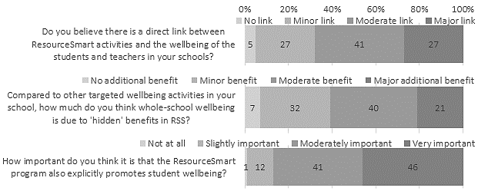

Impact beyond the school
In a final line of inquiry, the extent to which the RSS program might be having impact beyond the school-gate was investigated. RSS leaders and students were asked several questions about whether the ResourceSmart 'message' was being taken home, and if so, how. Figure 24 presents a summary of the activities that were happening beyond the school, due to the RSS program, as reported by RSS leaders and students.
Figure 23. Summary of how the RSS program may be having impact in the home

RSS leaders were asked how often their school explicitly encourage students to take the ResourceSmart 'message' home, and to what extent did they think the ResourceSmart 'messages' that were being embraced by students were having impact in the home. Figure 24 presents the results. Half the leaders (51%) reported that they often or very often explicitly encouraged students to take action at home. Moreover, almost half the leaders (47%) also believed that the RSS activities at school were being embraced by students and having a moderate to major impact in the home.
Figure 24. RSS leaders’ views about the impact of RSS in the home
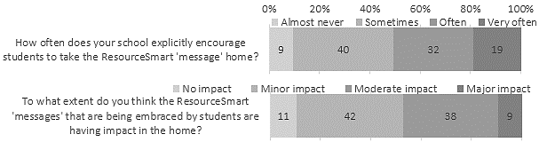

Comments received from leaders about how the RSS program has impacted students embracing sustainability messages, were classified into the following themes: Actions at home including composting, veggie gardens and worm farms, increased recycling and talking about sustainability with their parents. RSS leaders also reported that they had a direct impact with what happens at home by communicating with parents through newsletters and social media, demonstrating sustainable practices at school and talking with parents directly. Many comments focussed on the ways that students had embraced sustainability and how they had taken the ‘message’ home, such as students and families embracing ‘nude’ food and other sustainability initiatives at the school, and at home. Table 12 presents a selection of exemplar comments which underpin each emerging theme.
Table 12. RSS leaders’ views about the RSS ‘message’ reaching homes
Themes | Exemplar comments from RSS leaders
Actions at home - compost bins, worm farms, veggie gardens, recycling  (34%) | - 1. Year 7RE lettuce seed planting. Students plant lettuce seed to care for at school and then take home for families to enjoy. 2. Beeswax Wrap activity to replace plastic wraps. 3. Eco bricks activity to take home bricks for BBQs and fireplaces.  4. Water testing sampling at local creek, students apply this to local waterways.  5. Habitats and Interactions bushland incursion to understand relationship and to look out for species habitats at home. 6. Zoos Vic fighting extinction/Wipe for Wildlife/Don't Pal Us off campaigns promoted at college to discuss with family and create positive habits. 7. Energy - home audits. 8. Carbon footprint - how do they and their family live?. (Secondary)  - A survey of parents showed that about 30% of our families have implemented environmental actions in the home as a consequence of school action. (Primary)  - Children are cooking at home because of the produce they are able to source from our school garden. They talk about food miles and seasonal produce. Students take sick or injured animals home to be cared for by their families and teach their parents how to look after birds of different types. They develop confidence outside of the school because of how they manage and see themselves inside of the school confines. One parent whose son was bullied at another school has been overwhelmed at the difference the RSS program has made for her boy. After 12 months he is now a school leader and has totally turned around his life. He is our 'shining example' of what the RSS program can do for students and their families. (Primary)  - Children wanting to plant vegie gardens at home.  One family installed solar panels on their home.  Less wrappers coming to school due to recycling efforts. (Primary)  - Kids forcing their parents to recycle at home or put their food in containers-not to bring wrappers to school. (Primary)  - Many students have got their own chickens reports of students initiating better waste management in their homes observation of students having a greater understanding of biodiversity and the need to protect habitat for native animals birds insects. (Primary)  - -Nude Food to reduce waste at school  -Vegetable Gardens (parent helpers)  -Saving water. (Primary)  - Parents exploring the idea of toothbrush collection to go to Terra-Cycle soft plastics collection discussion. We are trying to work out how to implement this without being too time consuming. (Primary)  - Students have made compost bins and worm farms from the program. (P-12)  - Students are thinking about the way their lunch is brought to school and they actively follow a nude food approach where ever possible to help reduce our school waste. More families are following our lead by sorting their rubbish recycling soft plastics a local supermarkets and have set up composting bins at home. Having chickens at school. Teaching students to care for them and about the benefits they have in reducing our organic waste as well as getting eggs to sell and hatching & raising chicks ourselves has lead to many families setting up coops of their own. With school community support we have also re-established our school garden and celebrated our achievements in creating a great learning space for and with our students by holding a hugely successfu garden fair which will now be an annual school community event. (Primary)  - Students encouraging their parents to re-duce waste (water food packaging) re-use where possible recycle what they can and compost food scraps. Some parents have also been encouraged to grow vegetables and keep chickens just like we do at school. (Primary)  - Students occasionally share news about their veggie patches at home - show new snack containers receive likes on our school social media page . Dojo . (Primary)  - Students regularly discuss recycling at home and growing their own vegetables. (Primary)  - Students who tell us they do recycling at home as a result of learning about it at school. (Secondary)
Directly communicating sustainability messages with parents/carers (20%) | - At Solway we incorporate a lot of what is on ResourceSmart into our students' home learning tasks where students work on a fortnightly grid. Every fortnight a new sustainability focus activity is send home for students to investigate and discuss with their families. We also provide links activities and discussion starters in our weekly newsletter under the sustainability section. We regularly seek feedback from families on how this has been transported to home life and we have had very positive feedback. When organising school events e.g. Mother's Day Breakfast we encourage families to bring their own keep cups for coffees and inform them of how to dispose of their waste at these events. Families are very used to our sustainable event management and support our school on our sustainable journey. (Primary)  - Discussion with parents and students at home time pick up and morning delivery. (Primary)  - Home school impact is most evident with special days such as Earth Hour, Clean Up Australia Day, Recycling Week. Our newsletter often also contains news of current initiatives such as working on a module. (Primary)  - Home veggie gardens nude food lunch boxes discussions at home about what we are doing at school promotion of events through our Facebook and good uptake by parents. (Primary)  - I have had conversations with parents in our school who have stumbled across the CERES blog posts written by myself and they were very impressed that our school is so active and that the information is out there for everybody to see!  I have also heard from members of the community (who didn't know that I worked at the school) that they have heard that Monbulk PS is doing great things with RSS and sustainability. It's great to hear that members of the Monbulk community who don't necessarily have strong link to the school are hearing about our work and achievements.  Our rubbish free lunch initiative has also seen the majority of our parents get on board and many of these parents have said that having rubbish free lunches and buying in bulk saves them a lot f money!. (Primary)  - No but I am confident that on the odd occasion a student will discuss with his family what we have been promoting at school. Also on the odd occasion a parent may read our newsletter article and this may have some impact on their lifestyle habits. One student attended a pro-renewables rally on a weekend with his family. (Secondary)  - Our ethically sustainably sourced food program directly impacts the food choices that school families make at home by purchasing through school. (P-12)  - We are currently working to shift ideas about waste by promoting Nude Food lunches and having waste return home in lunch boxes. We are hoping this assists families to become more aware of the waste that is brought to school and develop more conscious decision making in families about what is wanted and what is needed and how waste can be reduced at the point of purchase. (Primary)  - We still have a long way to go but the message of compost and saving our natural resources is slowly getting through. (Primary)  - We tend not to use the 'ResourceSmart' brand rather the concepts of sustainability as embedded in our vision and logo https://www.cornishcollege.vic.edu.au/sustainability/ are explicitly taught and connected to students and their homes. For example Year9 Science Inquiry looking at Energy Efficiency. (P-12)  - Weekly newsletters recommend ways that the children and parents/guardians can get involved in sustainability practices and initiatives at school. Such as growing vegetables in our school gardens children sitting and walking around the frog habitat children respecting their school grounds by placing rubbish in the correct bins. (Primary)
Nude food and reducing lunchbox rubbish (13%) | - For home learning students were asked to design a nude food lunch they could have at home or at school. The following week more students came to school with lunchboxes containing minimal to no packaging. (P-12)  - Lunches gradually becoming more nude food following massive campaign Students are becoming more aware not to leave lights on taps running etc. This term is our RE Term we have discussed re-using re-purposing refashioning and recycling. I am sure some of these messages will be travelling home. (Primary)  - Nude food day encourages families to think about waste. Students when they hear Resource smart messages discuss these with their families. (P-12)  - Rubbish free lunch boxes that contain as many ""naked"" or ""healthy"" foods. Using reusable containers rather than zip lock bags or cling wrap.  Experimenting with a variety of vegetables due to growing them at school therefore increasing the options for their lunch boxes. (Primary)  - We are promoting waste minimisation through Nude healthy food.  Energy monitoring through turning off lights and heating and using clothing. (Primary)
Student buy-in and taking the sustainability message home (25%) | - By utilising the data in Geography fieldwork booklet and comparing home use to school use. (Secondary)  - Just this week at school Council one of the dads was talking about how they had to introduce another bin to capture soft plastics. He told how he was growled at by his 9 year old daughter for putting items in the wrong recycling bin. (Primary)  - Many students have their own vegetable gardens in the home. Several families have installed solar and other sustainable practices due to the students insistence and knowledge around human impact on the environment. (Primary)  - Students are talking about sustainability at home and bringing sustainability initiatives that are in place at home to school. (Secondary)  - Students at our school for the most part are taking on the messages within the ResourceSmart program. They are often seen taking initiative and action at our school to promote sustainability and looking after our environment. Students have come up with initiatives to reduce water usage by putting buckets under water bubblers created water saving tips to be placed around the school and are quite mindful of the importance of minimising waste and packaging to keep local waterways clear from rubbish contamination. They are actively involved in regular rubbish pick-ups to 'Love our Streets 3184' by collecting rubbish from the canal and the bay. (Primary)  - Students treat environmental issues as important. They respond well to discussions regarding sustainability and issues around the environment. Students volunteer for projects such as the Sustainability Action Group and their projects (volunteer to complete energy and waste audits readily). Students volunteer in good numbers for events such as tree planting. Students predominantly utilise our 4 stream waste system better than adults. (Secondary)  - Through the science and sustainability program the RS modules are focused on. I tie sustainability in with the Vic Curriculum so if the topic is Chemical Science we would look at waste in our school local area and around the world. This unit coincided with the plastic bag ban last year so students had the background knowledge they needed to help justify why single use plastic bags were being phased out. (Primary)  - We try to extend the learning to home - competition to design recycling posters surveys around energy consumption students presenting at assembly etc. (Prim.)
Minor or no impact (5%) | - At this early stage I believe that it only has a minor impact. (Primary)  - For example there is no impact on the quality of lunch box content or the amount of waste and plastics used by families even after much content and associated curriculum is delivered and activities done. (Primary)  - Hard to gauge as no real feedback has been sought. (Primary)
Just started RSS program (3%) | - We are only just starting out on the Resource Smart journey. I'm sure these questions will have more positive results in months to come. (Primary)  - We have only just started using ResourceSmart schools and we haven't yet promoted it to the wider school community / students. (Primary)

The extent to which the school’s efforts in encouraging students to take the RSS ‘message’ home, was evidenced in the responses from students to two questions.
Students were asked if they ever talk to their family about caring for the environment. Almost two in five students (38%) did not really talk about environmental sustainability at home. However, a similar number of students (41%) did sometimes, and one-fifth of students often discussed the environment with their family. Figure 25 presents the results, and also shows that two in five students (42%) did things differently at home to care for the environment because of the RSS activities that they did at school.
Figure 25. Students’ actions outside of school to care for the environment
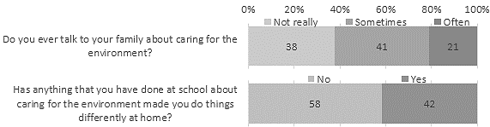

However, as Figure 26 shows, student’s environmental activities were influenced by age. Younger students were significantly more likely to do things differently at home (r=-0.33, p<0.01) and talk to their family about caring for the environment (r=-0.21, p<0.01) because of the RSS activities at school.
Figure 26. Students’ actions by Year level
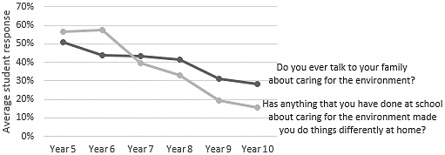

Over 700 students also provided examples of the kinds of things they did differently at home. These comments were thematically analysed and the emerging themes and exemplar comments are summarised in Figure 27 and presented in Table 13. What emerged was evidence of a wide range of activities aligned across the five modules and efforts towards living more sustainably, with many student directly attributing their actions at home to what they were doing at school.
Figure 27. Overview of what students’ are now doing differently at home, due to RSS
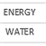
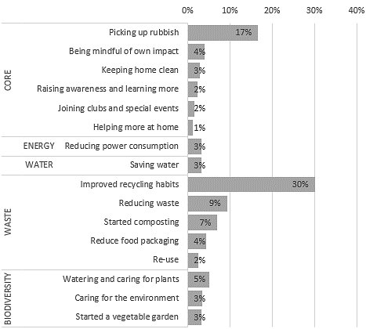

Table 13. Students’ examples of what they are now doing differently at home, due to RSS
Themes | Exemplar comments from students
Core related (cross-dimensional)
Being mindful of own impact | - cleaning up after myself and putting rubbish in the right bin (Year 5)  - Talking about cleaning up the environment (Year 9)  - purchasing products that benefit the world environmentally (Year 8)  - Some students talked to us in assembly and that helped me realise that even I can make a small difference. (Year 8)  - we bought bamboo toothbrushes for the family (Year 10)  - We don't really eat anything with palm oil in it. (Year 6)  - We got told that platypuses are dying because of the rings from bottles and jars are getting stuck on them and they die from other wild life so I started cutting them in half so they wouldn't get stuck (Year 6)  - Eat more vegetables (Year 9)  - We tried no meat Mondays (Year 8)  - I ride to school every day (Year 5)
Helping more at home | - I do it at home and I learn more (Year 5)  - I was the environmental leader at my old school so we have made changes around the house to benefit the environment (Year 7)  - Making room and house tidy (Year 9)
Joining clubs and special events | - Clean up Australia Day - we go down the street and clean up at the caravan park so I went home and did the same around my street (Year 6)  - eco warriors (Year 6)  - i am part of a sustainability team to pick up rubbish (Year 6)  - I have joined clean-up groups and made my home more sustainable (Year 5)
Keeping home clean | - Cleaning up my room (Year 6)  - i cleaned up some of the rubbish around my house (Year 9)  - Picking up the rubbish in our yard (Year 8)  - Cleaning (Year 10)
Picking up rubbish | - I cleaned up the beach with my friend (Year 6)  - I now clean up after myself and when I see rubbish anywhere I will always pick i up and put it in the bin. (Year 6)  - I pick up rubbish after school everyday and put it in the bin so it doesn't go to rivers and the ocean (Year 5)  - Picking up rubbish and being a good example for others and my sisters (Year 5)  - We turn of all lights when exiting a room, we don't dry clothes in a machine. We also do rubbishy pick ups around the shops. (Year 7)  - Yes because I have dogs and they make a mess and our rabbits eat all the rubbish so I pick all of the rubbish up for my family and friends. (Year 5)
Raising awareness and learning more | - In media, my friends and I often talk about the affects of climate change, picking up rubbish, recycling, compost, plastic removal, ect, but we do that in normal conversation, I feel as though if it was brought up in class, lot's of people would have an opinion and learn so much. (Year 10)  - I have learnt about the environment and use my nolage (Year 5)  - I try but my parents don't want a bar of it (Year 7)  - make posters (Year 5)  - Me &my friend are trying to raise awareness about climate change (Year 5)  - Tell people to put their rubbish in the bin. (Year 7)  - When I get learned at school I like to talk to my parents about it. (Year 5)
Energy related
Reducing power consumption | - Heating and air conditioning use (Year 10)  - I have a power monitor on the fridge watching our power usage. (Year 7)  - I have lights off as much as possible and I limit my water use, like shower time (Year 9)  - turn off lights when there is no 1 in the room (Year 8)  - Turning of the powerpoints (Year 5)  - Using renewable electricity (Year 5)  - We had a Earth Day at school for an hour and we did an activity for keeping the world clean and one of my promises where to turn off power points in my home if there was no use having it on (Year 6)
Waste related
Improved recycling habits | - After joining the Sustainability Committee, I started to make an effort to recycle more often at home. (Year 9)  - I convinced my mum to start recycling (Year 6)  - I have a rubbish and recycling bin. I craft things that I can use again (Year 5)  - I learnt what thing go in what bin and the different types of recycling. (Year 8)  - I recycle as much as I can before we put it in the recycling bin (Year 9)  - I've started washing my milk cartons and taking the lids off to recycle (Year 6)  - we bring recycled bags to the shops (Year 6)  - We now use the recycling bin properly and we've donated to a lot of animal-based charities (Year 10)  - I don't use plastic as much and I don't have rappers on my food. (Year 6)  - I talk to my siblings and tell them to put rubbish in the right bin (Year 6)  - Making waste audits and monerting the waste we create. (Year 5)
Reduce food packaging | - Our school incourges nude food, and no food waste. This has changed the amount of waste we produce as a family, we have bought nude food for all picnics, and work lunches. We have also created a compost bin to not contribute to food waste, and landfill. (Year 6)  - Yes because I tell my parents to give me and my sisters nude food (Year 5)  - I usually bring Plastic Reusable Containers to School. The Environment is very important to me. (Year 8)  - Whenever I learn about the environment at school I like to tell my parents about it and then at home we start to try and not collect that much plastic frame the shops. We also collect rubbish sometimes. (Year 5)
Reducing waste | - I started using butter containers and we would buy more butter like the ones in golden wrappers and put them in to the butter containers. We also use much less compost and much less rubbish (Year 5)  - changing a plastic drink bottle to a other one, not using plastic bags for lunch ( sometimes (Year 9)  - Do waste free Wednesday (Year 5)  - Reducing my waste and use less electricity and water. (Year 8)  - we don't use single use plastic (Year 7)  - We, try to use reusable bags when we go shopping and try to use less plastic (Year 7)
Re-use | - Reusing curtains as grocery bags. And recycling. (Year 9)  - reusing containers (Year 6)  - Use old things to make new things. (Year 5)  - Bought metal straws (Year 8)
Started composting | - Encouraged my family to get a compost and we are thinking about it (Year 6)  - have a compost bin and make sure that everything is in the right bin (Year 6)  - Yes, l've made a compost bin with my family (Year 5)
Water related
Saving water | - I turn off the tap if it is leaking (Year 6)  - I used to leave the tap on when I brushed my teeth but I started not to because of this school (Year 5)  - In geography we are learning about the sustainable development goals and the millennium development goals. I am trying to have shorter showers because I learnt that even though Australia is one of the driest places in the world, and yet we have a very high water consumption rate. (Year 10)  - saving water and electricity (Year 6)  - Shorter showers, no straws (Year 9)  - water tank (Year 7)
Biodiversity related
Caring for the environment | - in class we went down to the school gardens and the way the people who talked to us about the environment made me see the environment differently in a good way (Year 6)  - It helps learn about plants and helps me learn (Year 5)  - just thinking about the environment and thinking about our affect on the world (Year 7)  - learning about humanity's impact on the planet and our effect on ecosystems in biology 1/2 (Year 10)  - make animal habitat (Year 6)  - Wanting to stop global warming (Year 5)
Started a vegetable garden | - I started a veggie patch and I went to go pick up rubbish along the street. (Year 6)  - At school we a vegetable garden and now at home I do (Year 5)  - My mum was doing gardening and I decided to help her which I normally don't do and that act was all from my role in the biodiversity team, to do kitchen garden. (Year 6)  - We made a vegie patch and have seeds from school in our garden (Year 5)
Watering and caring for plants | - Caring for plants at home and watering them (Year 6)  - looking after the garden and life among it (Year 6)  - Trying to help grandpa garden (Year 5)  - Water the garden (Year 7)  - When I started gardening at school, I started caring for my garden so much more. (Yr 6)

Opportunities for improvement
The student wellbeing aspect is played down too much. The RSS program develops confidence, responsibility, maturity, and practicalities not found in classroom based 'feel good' sessions. It relates to real life, real issues, and our very real planet.
(Primary RSS leader)
As a final opportunity, RSS leaders were asked how the RSS program could be improved to value-add to whole-school wellbeing and student wellbeing. Ideas that almost 60 staff had for improvement to the program fell into three main areas – promotion (9%), development (76%), and outcomes (16%) – summarised in Figure 28, with exemplar comments provided in Table 14.
Figure 28. Overview of how the RSS program can be improved

Comments about promotion centred on creating further branding opportunities by partnering with large events or sharing school success stories. Other ideas collected were about creating a range of RSS branded products and utilising creating student brand ambassadors who can champion the message further in the community.
Many comments were received around further development of the RSS program. The majority were around more support for teachers through providing resources such as lesson plans, modules and example activities that teachers can implement with their class. Leaders also felt that templates that they can complete to help them tell their story. Other leaders thought that support through offering further training for teachers or whole school promotion of the program would benefit the program and the schools.
Another common theme for further developing the program was reducing the administrative burden of the program. Teachers felt that improvements to data uploads would result in more efficient use of teachers time and translate into more usage of the program. Some leaders felt that financial support offered to schools would be beneficial to program outcomes.
Leaders also shared the outcomes that the program has had on them and their school community. Some teachers felt that the program encouraged school staff to model sustainable behaviours and actions to students which demonstrates that teachers care for the environment. Other outcomes shared included the positive impacts on teacher and student wellbeing as well as strengthened connections in the school community.
Table 14. RSS leader view about how the program could be improved
Themes | Exemplar comments from RSS leaders
PROMOTION (9%)
Targeting and rewarding student champions of the program | - There are a small number of students who care very much about Resource Smart issues and they benefit significantly from finding ways they can make a difference to their environment. By targeting these students and rewarding/promoting their efforts to the wider community as well as giving them leadership opportunities they will benefit significantly. (Secondary)
More promotion and cross-promotion. Create SV branded resources | - Add value through promoting Resource Smart through signature events (think Melbourne Water Kids Teaching Kids National Conference) with heaps of product and brand promotion. Kids will pick up on this. Also cash for schools to employ / pay a stipend to volunteers / helpers. Access to materials ie garden gear / seeds /pots and pot plants / water wise items all connected with Sustainability Victoria / RSS and Wellbeing branding. (Primary)  - Promoting more whole school events such as Recycling Week where all students and staff are encouraged to get on board. (Primary)
Share success stories | - It would be great to see ResourceSmart to celebrate schools who show evidence of focusing on whole-school wellbeing to share ideas to other schools. (Primary)  - Have templates available for schools to follow in evidencing their programs and sharing progress. (Primary)
More student voice | - Giving greater student voice. (Secondary)
DEVELOPMENT (76%)
Make the wellbeing-sustainability link explicit | - Direct links and examples to mental health and positive education curriculum materials and support. (Primary)  - Perhaps making links between reduced energy use and improved sleep.  Perhaps linking reducing waste to encouraging the consumption of foods that aren't wrapped - e.g. fruits and vegetables.  Perhaps making links between saving water using tap water and ensuring that people are drinking large amounts of water.  Perhaps making links between the relationships between native plants insects and birds and what this means for our food production. (Primary)  - Perhaps resources or links on your site that Sustainability Vic has found or identified as useful to schools regarding wellbeing. Current research or article to share with staff on this matter available on your website. (Primary)  - Targeted literacy materials. Linking in with frameworks/programs such as Be You Respectful Relationships (with our environment) positive relationships and feelings. (Primary)  - The student wellbeing aspect is played down too much - the RSS program develops confidence, responsibility, maturity, and practicalities not found in classroom based 'feel good' sessions. It relates to real life, real issues, and our very real planet. (Primary)
Provide more support to teachers, training and activities | - Continue to advise teachers and offer support in content activities visits to the school. (Primary)  - Easy hands on activities for students and teachers that can be completed in a shorter time frame. Linking what is grown to Nutrition and Cooking programs. (Special)  - Enable us to document and be rewarded for wellbeing activities in our schools in all the modules not just Core which most of us have already completed. Workshops run to show leaders how to link ResourceSmart with Rs education to enable our sustainability programs to be seen as more important and relevant. I did one with Victorian Schools gardening and it was great. (Primary)  - I think providing the programme gives young people an opportunity to bring about change in their world in areas that they already know are going to impact on them significantly throughout their lives. Maintaining the programme would be very beneficial to young people's mental health as it provides them with opportunities to both belong to the school and wider community. (Secondary)  - I tried to organise a guest speaker to speak to staff. As time is very limited I told the speaker (can't remember his name) that we cannot allocate an hour for him to discuss the core module. I suggested can he do a half an hour. He was inflexible with that so we ended up doing nothing. This dispirited me because any opportunity to address sustainability needs to be taken. Also much of the program is very text heavy and time dependent for staff as we receive no time allocation to implement the program. This to me shows a disconnect between teachers and policy makers. That said we now have 2 environmental captains who are in year 12 who could potentially take on some of this responsibility. (Secondary)  - More explicit training for whole of staff. (Secondary)  - More support in terms of providing the cross-curricular implementation of the resource smart activities. (Primary)  - Offering supports more frequently within schools. Teachers are busy people and can't do it all. (Primary)  - Perhaps more teaching activities and ideas for teachers to implement making the links with wellbeing more explicit. (Primary)  - Perhaps the impact on how the steps and initiatives covered will positively impact on their own lives - rather than it just being something they do. Perhaps having some lessons that teachers can follow? (Primary)  - Providing more information at a whole staff level so that teachers know what opportunities there are for students. Specific student wellbeing module? (Primary)  - The interconnectedness of sustainability and action supports health and wellbeing. Eg; sustainable development goals type framework - health eating respect care responsibility action and awareness. (Primary)  - The ResourceSmart program is a great program for not only encouraging students and schools to take action to protect and care for our environment but it also holds them accountable for their actions through the continuous module updating and needing to provide evidence etc. I know at our school one of our challenges is getting staff and some parents on board. Perhaps if there was further information about building up teacher confidence in sustainability this could help tackle this problem. (P)  - I think this would be very difficult. Every school approaches it differently and there is a different level of support at each school. We do not currently have a groundswell of staff who have time to make this a priority and therefore are limited in what we can achieve. If more can be achieved perhaps a greater sense of community will be established thereby increasing student wellbeing... (Secondary)
Integrate RSS into the curriculum | - In my school the RSS program is not given value or seen as an integral part of the curriculum. I believe it is viewed by leadership at this school as an addition to the curriculum taught and it is not yet imbedded as a part of the schools culture or development of the whole child.  As a "leader" for RSS I am allocated 40 mins a fortnight outside of my teaching time to work through RSS modules and set up whole school practices.  A team was not set up of interested staff however 2 teams of students have come forward to lead the way in was waste reduction and correct disposal in our school. The school was a part of this initiative a few years ago. Sadly once the RSS staff member left the program was not continued and another staff member was not appointed to take over. Many sustainable practices that were put in place ceased. I feel I am now back at the same place in this journey as was 5 years ago. This is frustrating for all the students who would like to enact change in our school. Together the students involved and myself are hoping to replant the seed. (Primary)  - It can be given a higher priority in the school. It can be embedded in our curriculum more thoroughly which we are currently working on. (Primary)  - Class room resources (lessons and activities linked to the Victorian curriculum)  across Foundation to Year 12 which meld the RSS module objectives and instil the value of Earth based/focussed well-being practices. (P-12)  - Engage the classroom teachers more with the program rather than just once or twice a week. Document which home group is responsible for which component of our ResourceSmart focus areas. (Primary)
Reduce administrative burden of the program | - To reduce the administration - uploading onto RSS. (Primary)  - Encourage schools to give more time allowance so we have more time to write and implement integrated programs. (Secondary)  - Less administrative work to be accredited for obtaining and retaining stars.  More allocated funds for schools to run programs (pay for CRT days etc. (Primary)  - Make the inputting of data more efficient. Facilitators available to speak to children more often. (Primary)  - Modules often ask for tracking of information (eg monitoring of bills) that really do not impact students wellbeing. Staff find it difficult to obtain gold stars as competing demands for time within a school mean that key information is difficult to collet. (P-12)  - The administrative demands of Resource Smart can be a hurdle that classroom teachers find difficult to manage with the workload of teaching. Any ways of reducing this would support schools. The most effective way to improve the program would be to have funding for the teacher who leads the sustainability initiatives to be a part of all wellbeing whole school meetings with the leadership team. A core group of staff (one from every team at least) would need to be part of a Sustainability Group that would also meet at least twice a term to allow for implementation of initiatives. All teams could consider timetabling of Sustainability activities into their weekly program. At present there is only timetable allocation for Grade 5 classes for a semester per class. Opportunities for passionate students and those requiring extra support for involvement could also attend as part of a ""Club"" before/ after school or during break times. The children are extremely passionate and dedicated to the Environment. They repeatedly state how much they love KGT and how they wish they could do more. They educate their families and are endlessly positive and enthusiastic to make the school and the world a better place. (Primary)  - We already receive great support from our facilitators and assessors from RS.  I suppose it comes down to having time to gather evidence and record it. For us I know that we have the evidence for another module but I haven't had the time to work on it. It' probably up to individual schools to allow time for us to complete modules. (Primary)  - We are beginning to engage with the program again after several years with little or no involvement. I think it does need to be streamlined as it is rather a large body of work to keep on top of. (Primary)
Include more students in RSS activities | - More students ACROSS the school actively participating in ResourceSmart activities rather than Grade 6 leadership students. (Primary)  - More involvement in garden program. (Secondary)  - We have plans for sub-committees and community connections which will work toward pride in the school, pride in themselves, and in their knowledge and strengths. (Primary)  - Have only been in this role for just over a term but as the previous Wellbeing Co-ordinator I am targeting many of our at-risk students to take responsibility for jobs such as watering emptying bins taking apple cores to chickens etc. (Primary)
Include wellbeing activities in the modules | - Develop some sort of way to measure this and incorporate it into the modules. (Primary)  - Include wellbeing tasks in modules including the teaching of wellbeing and linking this with environmental activism in section B of each module. (P-12)  - RRS could be involved in the planning of the wellbeing program. The college program involves all classes having a 70 minute session per week to complete a range of wellbeing programs. If the Sustainability and Environment Team could be part of the initial planning then a whole school approach could embrace major environment calendar events rather than just interested teachers promoting it individually. (Secondary)
Financial support to schools | - One of the issues is $$$. Schools have to fund the implementation of the program and this can be expensive and time consuming. Perhaps financial support for the implementation of specific elements would be beneficial. For example to bring in experts to work with children in gardening composting etc. some lesson plans that explicitly link wellbeing strategies to RSS work would also help. Let me know if you want to employ me to write some!!. (Primary)  - The program overall is sufficient. The issues with implementing the program is time available to staff to run and resources to cover these costs. More financial support would assist in being able to implement the program more successfully. (Primary)
OUTCOMES (16%)
Helps to model sustainability behaviours to students | - Importance of healthy environments for individual student/staff and school community wellbeing across ALL areas - energy biodiversity water waste. (Secondary)  - It can show the students that we are trying to do our part for caring for the environment. (Secondary)  - Seabrook PS is very large school. It's taken years for teachers here to get on board and support it. Most teachers support it and see the benefits. Others don't get involved.  I think it's added an incredible value to our staff's perspective of how we treat our environment. Every school should have this program in place. We're educators and need to practise sustainable practices. (Primary)
Impacts teacher and student wellbeing | - It helps my wellbeing as an RSS leader as the current state of the world really deflated me and gets me down. I hope that this is passed onto the children. (Primary)  - I would hope to see the students feeling positive about their futures as many of these activities promote sustainability and a healthy planet overall. (Primary)  - It empowers students to make a difference to the environment by changing their behaviour and encourage someone else to change their behaviour. This gives them confident. We also going to a property in country side and plant trees there. This activity is especially contributes to the students wellbeing since they can connect to the nature and learn how to plant trees. (Secondary)
Connecting with others | - Our wellbeing ultimately depends on a healthy ecosystem/s. RS program is about preserving healthy ecosystems. In addition the sense of empowerment and the opportunities to mix with others helps build a sense of community empowered to make a difference. The resource smart program encourages different parts of the school to work together (maintenance finance teaching etc). This helps to develop community and wellbeing is a by-product of this. (Secondary)  - Working in groups, Feeling connected with others. (Primary)  - As we are a special developmental school and our students have got a moderate IQ it is more difficult to implement the Resource Smart program. (Special)
Anticipating impact on wellbeing | - We are just starting out. It will definitely contribute to whole-school wellbeing and student wellbeing in months to come. (Primary)  - As we are in the process of rebooting our involvement with Resource Smart Schools we are confident that as we move through the upcoming year we will be in a better position to comment upon his question. (Primary)  - Having just started our journey with the program it is hard to gauge the full impact it is having and will have on the well-being of students and the wider school community going forward. Being a small school our journey is going to take time but the students are incredibly keen and full of enthusiasm to contribute ideas establish programs across the school and utilise the expertise of the school community to promote the importance of being resource smart individuals for our planet now and in the future. The program, as it is, can only have a positive impact on the wellbeing of all students not just the Sustainability Team so it doesn't really need to be changed in any way as an improvement in student wellbeing is a natural by-product of the program anyway. (Primary)  - I am not sure i think at this time. My school is just starting, so as we continue, I am sure wellbeing by doing things and getting students involved will take over. (Secondary)  - When we get further into the ResourceSmart program we anticipate that the program as is will provide great benefits to our entire school community. (Primary)

Views from the RSS delivery partner organisations
An important aspect of the RSS program involves partner organisations that support and mentor schools to improve their environmental sustainability.
As an endorsement of their importance, a RSS leader from a primary school provided this comment.
I think there have been great improvements with the staff from CERES who are so wonderful. I also like the connection between council and CERES. Please look after your resource smart people pay them well etc because right now they are GOLD. They make my job much easier. Also reducing the burden on teachers is important as we are time poor. I love looking after sustainability at the school but too much admin can get in the way. (Primary RSS leader)
The delivery partners who work with local network schools were in a position to provide unique insights about ways in which to improve the RSS program to value-add to whole-school wellbeing. The nine RSS partners offered the following suggestions for improvement, which pick up on similar comments made by RSS leaders.
Build the core module into the other modules as it does not represent great value for students or the school on its own.
The program to have more student-centred approach/framework (for example with the audits, action plans...).
Edit all module checklists to include actions which can be undertaken by students.
Increase flexibility of certification so schools are acknowledged for wide variety of student led actions / school initiatives.
Case studies promoting solutions and outcomes.
Could include statements from government and curriculum documents - FISO; education as a cross curriculum priority; critical and creative thinking; included in wellbeing discussions, not just sustainability discussions. Links to health research that supports sustainability and wellbeing links.
Greater integration in curriculum tailored for particular school needs/priorities. Some consistency in programs/professional development/curriculum (lesson plans) may also aid teachers and schools fully leveraging the benefit in this area.
The ResourceSmart program can be improved by making it more practical and hands-on for students. I believe the biggest improvements to wellbeing are when students are actively engaged in the whole process from developing to implementing projects, being immersed in nature and being able to see that the changes they make do have a positive impact.
Reduce the administration load of the program and the current framework takes away from the wellbeing of teachers which in turn can affect a school taking up the program or sticking with the program - and therefore students are not having access to a program which has the potential to value-add to the whole-school well-being and student wellbeing. The program needs to reduce the emphasis on certification and all of the extensive actions that go with each module and instead put the emphasis on creating engaging support materials for teachers and students to inspire and inform on how to be a more environmentally friendly school. These resources need to be as largely visual as well as being demonstrative e.g videos showing how schools are greening their grounds, auditing their energy needs and designing a project on renewable energy, and becoming a waste wise school through steps along the way. Student and teacher worksheets to go with visual, engaging materials need to be concise and not lengthy. So much of the information that is designed for this program labours over details and teachers do not have the time nor the desire to read this.

4. Evaluation framework
Provide an evaluation framework for the ongoing measurement of the program’s wellbeing impact.
Based on the literature and evidence discussed in the previous chapters, the links between wellbeing and sustainability in sustainable schools have been drawn together and conceptualised in Figure 29. The model depicts how wellbeing and learning are enhanced when the students feel connected to the school community and forge positive relationships through active participation, collaboration, modelling sustainable practices and contributing to the school and community. The link is further strengthened by a safe and positive environment that promotes engagement and school connectedness and fosters student wellbeing.
Figure 29. Wellbeing in ResourceSmart Schools
 | Sustainability Areas |  |  |  |  | Positive School Community |  | Five ways to Wellbeing for Students
ResourceSmart Schools | Biodiversity | Energy | Waste | Water
ResourceSmart Schools | Core target area: Learning and Teaching  Activities in the curriculum focus on each of these sustainability areas and focus on engaging students in learning how to be more sustainable. Within the Victorian curriculum most learning areas already include links to sustainability (see VCAA, 2017; SV, 2016). |  |  |  |  | Social & Emotional Learning
  Connect
  Give
  Take Notice
  Keep Learning
  Be Active
ResourceSmart Schools | Core target area: Workplace/Operational  Workplace/operational policies that are sustainable and supports each of the sustainability areas. Collect and use data to plan how to embed sustainability principles throughout the school and to set up a framework which includes wellbeing indicators, to track the school’s progress and achievements. |  |  |  |  | Young people’s participation through collaborative partnerships, communication & support
ResourceSmart Schools | Core target area: Whole-school community engagement  The whole school works on all areas of sustainability by engaging teachers, students, parents and the wider community, including working with and helping out students with special needs. |  |  |  |  | Contributing to the community & modelling sustainable practices

Sustainable schools achieve this wellbeing outcome through an understanding of the skills, principles and world views essential for students to act in ways that contribute to more sustainable ways of living in order to create a positive environment. This is achieved through a ‘whole-school approach’ that integrates learning and teaching with the organisational and economic and social/community engagement aspects of a school’s practice. In attaining this goal, the schools also create wellbeing by promoting social and emotional learning, encouraging student participation by building a balanced, positive working/learning environment, and fostering relationships with the community.
The themes mentioned here also align to all the FISO priority areas: Excellence in teaching and learning, Professional leadership, Positive climate for learning, and Community engagement in learning. The section discusses the Core target areas for RSS in detail and illustrates how they help to improve student wellbeing.

Learning and teaching
Teachers ensure effective teaching practice by optimising the opportunity for students to be actively engaged in learning for better academic and social success. In ResourceSmart Schools, the curricula focuses on each of these sustainability areas – core, biodiversity, energy, waste and water. The goal is to engage students in learning how to be more sustainable. The focus is on:
- Creating a stimulating learning environment.
- Promoting positive behaviour.
Enhancing student’s learning and bringing their learning experiences together is the key which will improve their social, emotional, relationship skills and also learning. Students who are engaged in learning will essentially actively participate in decisions that affect them and create a safe environment that is free from bullying, abuse and thus strengthen the collective wellbeing in the schools.

Workplace/operational
Apart from quality teaching and learning, school improvement is about strengthening a wide range of factors that underpin the way the school views itself and its student body and community. Schools focus on:
- Having the right people to lead and become the change agents.
- Providing staff with the necessary tools and trainings.
- Ensuring that there are supportive policies/procedures, and social and physical environment that promote safety, inclusiveness and sustainability.
- Continually seek opportunity for school improvement.
- Actively build school pride and confidence that resonates a good school ethos.
Together, all of these help foster a positive environment for teaching, learning and in turn improve the collective wellbeing in a school.

Whole-school community engagement
A whole school approach is vital where staff, parents, carers, and community are also engaged in attaining sustainability. As a result, students achieve better outcomes from their education and feel a greater connection to their school. Parents and caregivers who are involved in their child’s learning and are engaged in the community of the school are able to support their child better at school. The first step to ensure this engagement is through positive and effective communication between school staff and parents. Schools focus on:
- Finding opportunities for engagement in the school community.
- Foster parent involvement in their child’s learning.
- Ensuring staff are approachable and respond in ways that are sensitive to student and family needs.
- Having effective communication channels in place.
- Ensuring that the needs of the most vulnerable students are being met through quality services and support.
Engaging communities, parents and students effectively helps to get the support that is required to achieve student learning, safety and wellbeing in schools. Moreover, creating an inclusive culture through their involvement further improves the school ethos and enhances wellbeing for all.

Embedding measurement
After a systematic analysis of the themes and ideas from the various frameworks such as the Framework for Improving Student Outcomes (FISO), Australian Student Wellbeing Framework, and the Five ways to Wellbeing Framework, the measurement frameworks presented in Figure 30 (School level) and Figure 31 (Student level) have been developed. The ideas developed by Chiumento et al. (2018) in their application of the Five Ways to Wellbeing Framework to the Haven Green space intervention was a key resource for developing a model at the student level, while the evidence paper developed by the UK Department of Children, Schools and Families (Barratt-Hacking et al., 2010) has provided guidance in linking these frameworks and ideas at the school level. The action points for schools and students have also been outlined based on the literature review and prior evidence from schools (Rickinson, Hall & Reid, 2014) with examples to provide a good understanding of how each element of this model is linked to the next.
At the school level (see Figure 30), all the RSS activities work towards achieving the FISO objectives while aiming for a positive school climate by delivering the results in the sustainability target areas. Additionally, links to the Five Ways to Wellbeing are clearly articulated with examples on how to achieve the wellbeing goals at the student level (see Figure 31). Importantly, the ideas and examples provided are presented using a check-box approach to suggest that these could lead to a set of observable behaviours or outcomes that could form the basis of an assessment. For example, the Five Ways to Wellbeing could be developed into an additional RSS Module that recognises five-star student-level engagement.
This study was mainly undertaken to provide evidence, both in the literature and on the ground, that there were indeed links between RSS activities and wellbeing. Although we have developed the RSS-wellbeing framework, it has not be operationalised. Accordingly, we recommend that the RSS-wellbeing framework be refined and then field-tested, in order to ensure its effectiveness for the ongoing measurement of the program’s wellbeing impact.

Figure 30. RSS-wellbeing evaluation framework – School Level
RSS-Wellbeing Framework: School Level |  | RSS Core Target Areas: Whole-school wellbeing focus
 |  | Learning and Teaching | Workplace/Operational | Whole School Community Engagement
 |  | Promoting a positive school climate through …
Framework for Improving Student Outcomes (FISO) |  | Social & Emotional Learning | Young people’s participation through collaborative partnerships, communication & support | Contributing to the community & modelling sustainable practices
Framework for Improving Student Outcomes (FISO) | Excellence in teaching and learning | Boost student’s learning and wellbeing.  - Look at sustainability in cross-subject ways and integrate sustainable initiatives with extracurricular and out-of-classroom activities  Bring student’s learning experiences together.  - Involve students in outdoor learning  - See the practices in school and community as learning resources | Encourage student’s participation.  - Develop inclusive school ethos using sustainability  - Make sustainability a strong focus of the school development plan  - Improve the quality of school buildings and surroundings  - Involve students in thinking about and responding to issues | Get students to contribute to school, community and family and encourage everyone to participate in sustainable activities.  - Listen to students and take account of their environmental and community perspectives  - Provide students active experience of the wider world  - Involve students in developing and forming sustainable school practices
Framework for Improving Student Outcomes (FISO) | Positive climate for learning
Framework for Improving Student Outcomes (FISO) | Professional leadership
Framework for Improving Student Outcomes (FISO) | Community engagement in learning
 | Examples | Engage students to perform certain roles as part of the teaching learning modules, such as setting up a vegetable garden, looking after chickens, composting, and recycling.  Establish environmental studies programs which link closely with the activities to reduce resource use in the school or by using student inquiry projects and theme days. | Introducing a policy for recycling and sustainable buying (such as for reducing paper waste).  Promotion of student leadership via the Student Action Teams provides students the opportunity to learn about sustainability in practice.  School initiated environment groups who met during lunch times. | Inviting parents to take part in various initiatives such as “nude food lunches”, school vegetable garden etc.  Students setting up the school vegetable garden with native plants. The School used the garden to manage waste (such as food scraps). The vegie-garden is also an opportunity for involving parents and exchanging information about caring for plants. Students/Parents bring in plants from their home gardens for the school vegie-garden.  Staff and students get to work with local community organisations, such as Landcare on biodiversity programs.

Figure 31. RSS-wellbeing evaluation framework – Student Level
RSS-Wellbeing Framework: Student Level |  | RSS Core Target Areas: Student wellbeing focus
 |  | Learning and Teaching | Workplace/Operational | Whole School Community Engagement
 |  | Promoting a positive school climate through …
Five Ways to Wellbeing Framework |  | Social & Emotional Learning | Young people’s participation through collaborative partnerships, communication & support | Contributing to the community & modelling sustainable practices
Five Ways to Wellbeing Framework | Connect | - Work on learning tasks in groups or pairs to foster connections among fellow students. | - Identify ways to improve sustainability such as plan areas where greenery could be added and work with others in the school (i.e. peers and staff) to improve the green spaces and care for them. | - Work with community groups in and out of school.  - Connect with others outside the school, e.g. take part in activities such as planting or socialising in parks or other communal green spaces.
Five Ways to Wellbeing Framework | Give | - Make connections between ideas and work with others to develop sustainable lifestyles. | - Participate in sustainable actions as a way of doing well for others, e.g. by building a green space for others to enjoy.  - Develop a plan for the future of the school garden as a legacy for the school. | - Share produce from the school gardens with others, e.g. peers, school staff or shelter homes in the local community or pick plants that had been grown to the class.  - Create recycled garden-art.  - Use and apply the skills learnt in schools in other scenarios, e.g. growing plants at home or helping out at local community green spaces such as botanic gardens.
Five Ways to Wellbeing Framework | Take Notice | - Through outdoor learning opportunities take notice of the outside world such as developing an understanding how the flora and fauna change with the seasons.  - Raise STEM awareness e.g. plant/animal life-cycles. | - Work with others in a team and improve negotiation skills. This also encourages awareness of one’s own and others feelings  - Be part of a Student Action Team to learn about the improvement opportunities on campus as well we encourages student voice and participation. | - Report any positive or negative interactions that take place when working on a sustainable project, e.g. a positive experience could be enjoying planting with family or friends; a negative could be students with physical disability not being able to access a garden patch.
Five Ways to Wellbeing Framework | Keep Learning | - Take every opportunity to learn, build confidence and have fun.  - Develop resilience, e.g. participating in the school garden project is about learning about plants, but also about how to manage both success and failure when growing plants.  - Engage in unstructured play with others to boost confidence and creativity, e.g. playing in outdoor spaces builds deeper connections with fellow students and nature.
Five Ways to Wellbeing Framework | Be Active | - Participate in activities that provide opportunities for physical workout, e.g. gardening, recycling, looking after resident animals in the school. | - Participate in constructive and meaningful group activities for example painting and decorating the school grounds.  - Student Action Teams meeting regularly to discuss sustainable initiative and taking lead in collecting and disposing recycle items from the school.

References
Adams, S., & Savahl, S. (2017). Nature as children's space: A systematic review. The Journal of Environmental Education, 48(5), 291-321.
Aked, J., Marks, N., Cordon, C., & Thompson, S. (2008). Five Ways to Wellbeing: A report presented to the Foresight Project on communicating the evidence base for improving people’s well-being. London: New Economics Foundation. http://neweconomics.org/ 2008/10/five-ways-to-wellbeing-the-evidence/?_sf_s=five+ways+to+wellbeing&_sft_ latest=research.
Australian Education for Sustainability Alliance. (2014). Education for sustainability and the Australian curriculum project: Final report for research phases 1-3. Melbourne: Australian Education for Sustainability Alliance.
Australian Student Wellbeing Framework (2018). Education Services Australia, Melbourne. https://studentwellbeinghub.edu.au/docs/default-source/aswf_flyer-pdf.pdf?sfvrsn=0
Barratt-Hacking, E., Scott, B., & Lee, E. (2010). Evidence of Impact of Sustainable Schools. Bath, UK: University of Bath. Center for Research in Education and the Environment.
Barry, M. M., Clarke, A. M., & Dowling, K. (2017). Promoting social and emotional well-being in schools. Health Education, 117(5), 434-451.
Barton, J., Bragg, R., Pretty, J., Roberts, J., & Wood, C. (2016). The wilderness expedition: An effective life course intervention to improve young people’s well-being and connectedness to nature. Journal of Experiential Education, 39(1), 59-72.
Bell, A. C., & Dyment, J. E. (2008). Grounds for health: The intersection of green school grounds and health‐promoting schools. Environmental Education Research, 14(1), 77-90.
Bentsen, P., Mygind, E., & Randrup, T. B. (2009). Towards an understanding of udeskole: Education outside the classroom in a Danish context. Education, 3–13, 37(1), 29-44.
Berger, C., Alcalay, L., Torretti, A., & Milicic, N. (2011). Socio-emotional well-being and academic achievement: Evidence from a multilevel approach. Psicologia: Reflexao e Critica, 24(2), 344-351.
Berger, R. (2006). Using contact with nature, creativity and rituals as a therapeutic medium with children with learning difficulties: A case study. Emotional and Behavioural Difficulties, 11(2), 135-146.
Birney, A., & Reed, J. (2009). Sustainability and renewal: Findings from the leading sustainable schools research project.
Block, K., Gibbs, L., Staiger, P. K., Gold, L., Johnson, B., Macfarlane, S. ... & Townsend, M. (2012). Growing community: The impact of the Stephanie Alexander Kitchen Garden Program on the social and learning environment in primary schools. Health Education & Behavior, 39(4), 419-432.
Capaldi, C. A., Dopko, R. L., & Zelenski, J. M. (2014). The relationship between nature connectedness and happiness: A meta-analysis. Frontiers in Psychology, 5, 976.
Catalano, R. F., Oesterle, S., Fleming, C. B., & Hawkins, J. D. (2004). The importance of bonding to school for healthy development: Findings from the Social Development Research Group. Journal of School Health, 74(7), 252-261.
Catholic Education Melbourne (2016). Education for Sustainability in the Archdiocese of Melbourne.
Catholic Education Sandhurst (2012). Kinship with the Earth Education for Sustainability Framework.
Cervinka, R., Röderer, K., & Hefler, E. (2012). Are nature lovers happy? On various indicators of well-being and connectedness with nature. Journal of Health Psychology, 17(3), 379-388.
Chen, M. L., Lou, S. J., Tsai, W. F., & Tsai, C. C. (2014). A study of the impact of horticultural activities on primary school children's self-concept, well-being and effectiveness. Journal of Baltic Science Education, 13(5).
Chilton, R., Pearson, M., & Anderson, R. (2015). Health promotion in schools: a scoping review of systematic reviews. Health Education, 115(3/4), 357-376.
Chiumento, A., Mukherjee, I., Chandna, J., Dutton, C., Rahman, A., & Bristow, K. (2018). A haven of green space: Learning from a pilot pre-post evaluation of a school-based social and therapeutic horticulture intervention with children. BMC Public Health, 18(1), 836.
Cohen, S. (2004). Social relationships and health. American Psychologist, 59, 676–684 (2004).
Compass Education (2015). School Sustainability Self-assessment. AtKisson Group. http://www.compasseducation.org/sustainability-self-assessment-tool/
Corbett, L. (2010). Evaluation of ResourceSmart AuSSI Vic. Unpublished report, Sustainability Victoria.
Currie, C., Zanotti, C., Morgan, A. & Currie, D. (2012) Social determinants of health and wellbeing among young people. Health Behaviour in School-aged Children (HBSC) study: International report from the 2009/2010 survey. WHO Regional Office for Europe, 2012 (Health Policy for Children and Adolescents, 6), Copenhagen.
Cutter-Mackenzie, A. (2009). Multicultural School Gardens: Creating Engaging Garden Spaces in Learning about Language, Culture, and Environment. Canadian Journal of Environmental Education, 14(1), 122-135.
Dix, K. L., Fullarton, J., Ahmed, K, Carslake, T., Urbach, D. & Lietz, P. (2017). Evidence Report: Redesign of the Student Attitudes to School Survey. Unpublished report for the Victorian Department of Education. Australian Council for Educational Research, Melbourne.
Dix, K. L., Green, M. J., Tzoumakis, S., Dean, K., Harris, F., Carr, V. J., & Laurens, K. R. (2018). The Survey of School Promotion of Emotional and Social Health (SSPESH): A brief measure of the implementation of whole-school mental health promotion. School Mental Health, 1-15.
Dix, K. L., Ahmed, K. & Carslake, T. (2019). ResourceSmart Schools and Wellbeing – A Pilot Study. Unpublished interim report for Sustainability Victoria. Australian Council for Educational Research, Melbourne.
Dowdell, K., Gray, T., & Malone, K. (2011). Nature and its influence on children’s outdoor play. Australian Journal of Outdoor Education, 15(2), 24-35.
Dyment, J. E., & Bell, A. C. (2007). Grounds for movement: Green school grounds as sites for promoting physical activity. Health Education Research, 23(6), 952–962. Retrieved 27 June 2019 from https://doi.org/10.1093/her/cym059.
Dyment, J. E., & Bell, A. C. (2008). Our garden is colour blind, inclusive and warm: Reflections on green school grounds and social inclusion. International Journal of Inclusive Education, 12(2), 169-183.
Elias, M., & Arnold, H. (2006). The connections between academics and social-emotional learning. In M. J. Elias & H. Arnold (Eds.), The Educator's Guide to Emotional Intelligence and Academic Achievement: Social-Emotional Learning in the Classroom (Chap. 1). Thousand Oaks, CA: Corwin.
ESA. (2018).The Australian Student Wellbeing Framework. Education Council, Carlton South, Victoria.
Faber Taylor, A., & Kuo, F. E. (2009). Children with attention deficits concentrate better after walk in the park. Journal of Attention Disorders, 12(5), 402-409.
Fägerstam, E. (2014). High school teachers’ experience of the educational potential of outdoor teaching and learning. Journal of Adventure Education & Outdoor Learning, 14(1), 56-81.
Fakharzadeh, S. (2015). Food for Thought: The Intersection of Gardens, Education, and Community at Edible School Yard New Orleans. Children, Youth and Environments, 25(3), 175-187.
FISO improvement model (2018). Framework for Improving Student Outcomes. Victoria State Government Department for Education. https://www.education.vic.gov.au/school/ teachers/management/improvement/Pages/improvement-model.aspx.
Goodsell, B. T., Lawrence, D. M., Ainley, J., Sawyer, M., Zubrick, S. R., & Maratos, J. (2017). Child and Adolescent Mental Health and Educational Outcomes: An analysis of educational outcomes from Young Minds Matter: the second Australian Child and Adolescent Survey of Mental Health and Wellbeing.
Gonzalez, R., & Padilla, A. M. (1997). The academic resilience of Mexican American high school students. Hispanic Journal of Behavioral Sciences, 19(3), 301-317.
Goodman, R. (1997). The Strengths and Difficulties Questionnaire: a research note. Journal of Child Psychology and Psychiatry, 38(5), 581-586.
Gregory, T., & Brinkman, S. (2015). Development of the Australian Student Wellbeing survey: Measuring the key aspects of social and emotional wellbeing during middle childhood. Fraser Mustard Centre, Department for Education and Child Development and the Telethon Kids Institute, Adelaide.
Guevara, J., & King, B. (2012). ResourceSmart AuSSI Vic Most Significant Change Story Booklet 2012: From Delivery, to Facilitation, to Embedding Sustainability in Schools and Communities. Unpublished report for Sustainability Victoria.
Hattie, J., Marsh, H. W., Neill, J. T., & Richards, G. E. (1997). Adventure education and Outward Bound: Out-of-class experiences that make a lasting difference. Review of Educational Research, 67(1), 43-87.
Henryks, J. (2011). Changing the menu: Rediscovering ingredients for a successful volunteer experience in school kitchen gardens. Local Environment, 16(6), 569-583.
Hignett, A., White, M. P., Pahl, S., Jenkin, R., & Froy, M. L. (2018). Evaluation of a surfing programme designed to increase personal well-being and connectedness to the natural environment among ‘at risk’ young people. Journal of Adventure Education and Outdoor Learning, 18(1), 53-69.
Izard, C. E. (2009). Emotion theory and research: Highlights, unanswered questions, and emerging issues. Annual Review of Psychology, 60, 1-25.
John-Akinola, Y. O., & Nic Gabhainn, S. (2015). Socio-ecological school environments and children’s health and wellbeing outcomes. Health Education, 115(3/4), 420-434.
Kern, M. L., Benson, L., Steinberg, E. A., & Steinberg, L. (2016). The EPOCH measure of adolescent wellbeing. Psychological Assessment, 28(5), 586.
Kerret, D., Orkibi, H., & Ronen, T. (2014). Green perspective for a hopeful future: Explaining green schools’ contribution to environmental subjective well-being. Review of General Psychology, 18(2), 82.
Konu, A. I., Lintonen, T. P., & Rimpelä, M. K. (2002). Factors associated with schoolchildren's general subjective well-being. Health Education Research, 17(2), 155-165.
Kuosmanen, T., Clarke, A. M., & Barry, M. M. (2019). Promoting adolescents’ mental health and wellbeing: evidence synthesis. Journal of Public Mental Health.
Lietz, P., O'Grady, E., Tobin, M., Murphy, M., Macaskill, G., Dix, K., & Thomson, S. (2015). Australian Child Wellbeing Project Technical Report. ACER, Melbourne.
Langford, R., Bonell, C., Jones, H., Pouliou, T., Murphy, S., Waters, E. ... & Campbell, R. (2015). The World Health Organization’s Health Promoting Schools Framework: A Cochrane systematic review and meta-analysis. BMC Public Health, 15(1), 130.
Malberg Dyg, P., & Wistoft, K. (2018). Wellbeing in school gardens–the case of the gardens for bellies food and environmental education program. Environmental Education Research, 24(8), 1177-91.
Maller, C. (2004). The hidden benefits of environmental education: contact with nature and children's health and wellbeing. Echo: The Journal of the Home Economics Teachers Group, 43(1), 16.
Maller, C. (2005). Hands on contact with nature in primary schools as a catalyst for developing a sense of community and cultivating mental health and wellbeing. Eingana: A Journal of Environmental Education, 28(3), 17-22.
Mayer, F. S., Frantz, C. M., Bruehlman-Senecal, E., & Dolliver, K. (2009). Why is nature beneficial? The role of connectedness to nature. Environment and Behavior, 41, 607–643.
McManus, J., (2012). The Thurston Family Project: Working with families through outdoor activities and resiliency training. The Psychology of Education Review, 36(2), 40 - 45.
Nisbet, E. K., Zelenski, J. M., & Murphy, S. A. (2011). Happiness is in our nature: Exploring nature relatedness as a contributor to subjective wellbeing. Journal of Happiness Studies, 12, 303–322.
Norðdahl, K., & Jóhannesson, I. Á. (2016). ‘Let's go outside’: Icelandic teachers' views of using the outdoors. Education 3-13, 44(4), 391-406.
Ohly, H., Gentry, S., Wigglesworth, R., Bethel, A., Lovell, R., & Garside, R. (2016). A systematic review of the health and wellbeing impacts of school gardening: Synthesis of quantitative and qualitative evidence. BMC Public Health, 16(1), 286.
Pasanen, T. P., Tyrväinen, L., & Korpela, K. M. (2014). The relationship between perceived health and physical activity indoors, outdoors in built environments, and outdoors in nature. Applied Psychology: Health and Well‐Being, 6(3), 324-346.
Patton, G. C., Glover, S., Bond, L., Butler, H., Godfrey, C., Pietro, G. D., & Bowes, G. (2000). The Gatehouse Project: A systematic approach to mental health promotion in secondary schools. Australian and New Zealand Journal of Psychiatry, 34(4), 586-593.
Phillips, M. (2014). What is actually meant by 'learning for sustainability'? Environmental Education 106: 5-6. http://naee.org.uk/
Pitt & Sherry Consultants. (2013). Sustainability Victoria Resource Smart Australian Sustainable Schools Initiative – 2013 Data Analysis. Unpublished report for Sustainability Victoria.
Pollard, E. L., & Lee, P. D. (2003). Child well-being: A systematic review of the literature. Social Indicators Research, 61(1), 59-78.
Pretty, J., Angus, C., Bain, M., Barton, J., Gladwell, V., Hine, R., & Sellens, M. (2009). Nature, childhood, health and life pathways. Occasional Paper, 2.
Redmond, G., Skattebol, J., Saunders, P., Lietz, P., Zizzo, G., O'Grady, E., ... & Wong, M. (2016). Are the kids alright? Young Australians in their middle years. Final report of the Australian Child Wellbeing Project. Flinders University, University of New South Wales and Australian Council for Educational Research. www.australianchildwellbeing.com.au.
Rickinson, M., Hall, M., & Reid, A. D. (2014). ResourceSmart Schools Research Project Final Report. Melbourne: Monash University & Sustainability Victoria.
Rickinson, M., Hall, M., & Reid, A. D. (2016). Sustainable schools programmes: What influence on schools and how do we know? Environmental Education Research, 22(3), 360 - 389.
Rose, L., Williams, I. R., Olsson, C. A., & Allen, N. B. (2018). Promoting Adolescent Health and Well-Being through Outdoor Youth Programs: Results from a Multisite Australian Study. Journal of Outdoor Recreation, Education, and Leadership, 10(1), 33-51.
Ruse, S. (2007). Environmental education for 'healthy schools'. Environmental Education 85, 7-16.
Salter, N. (2016). Impact of whole-school education for sustainability on upper-primary students and their families. Environmental Education Research, 22(3), 436-437.
Sellström, E., & Bremberg, S. (2006). Is there a “school effect” on pupil outcomes? A review of multilevel studies. Journal of Epidemiology & Community Health, 60(2), 149-155.
Somerset, S., Ball, R., Flett, M., & Geissman, R. (2005). School-based community gardens: Re-establishing healthy relationships with food. Journal of the Home Economics Institute of Australia, 12(2), 25.
Suldo, S., Friedrich, A., White, T., Farmer, J., Minch, D. & Michalowski, J. (2009) Teacher support and adolescents' subjective wellbeing: A mixed-methods investigation. School Psychology Review, 38: 67–85.
Sustainability Victoria. (2011). ResourceSmart AuSSI Vic Initiative: Regional Network Pilot 2010-11: Key findings & future recommendations. Sustainability Victoria, Melbourne.
Sustainability Victoria. (2012). ResourceSmart AuSSI Vic Evaluation. School Commencement Survey Results: December 2012. Sustainability Victoria, Melbourne.
Sustainability Victoria. (2016). ResourceSmart Schools Curriculum Links: Linking sustainability into the Victorian Curriculum. Sustainability Victoria, Melbourne.
Sustainability Victoria. (2018). Resource Smart Modules. https://www.sustainability.vic.gov.au/ School/Modules
Taylor, A. F., Kuo, F. E., & Sullivan, W. C. (2001). Coping with ADD: The surprising connection to green play settings. Environment and Behavior, 33(1), 54-77.
Tobia, V., Greco, A., Steca, P., & Marzocchi, G. M. (2019). Children’s wellbeing at school: A multi-dimensional and multi-informant approach. Journal of Happiness Studies, 20(3), 841-861.
VCAA. (2017). Learning about Sustainability. Victorian Curriculum and Assessment Authority, Melbourne.
Viola, A. (2006). Evaluation of the Outreach School Garden Project: Building the capacity of two Indigenous remote school communities to integrate nutrition into the core school curriculum. Health Promotion Journal of Australia, 17(3), 233-239.
Waite, S., Goodenough, A., Norris, V., & Puttick, N. (2016). From little acorns..: environmental action as a source of well-being for schoolchildren. Pastoral Care in Education, 34(1), 43-61.
Weisner, T. S. (1998). Human development, child well‐being, and the cultural project of development. New Directions for Child and Adolescent Development, 1998(80), 69-85.
Wells, J., Barlow, J., & Stewart-Brown, S. (2003). A systematic review of universal approaches to mental health promotion in schools. Health Education, 103(4), 197-220.
White, M. P., Alcock, I., Wheeler, B. W., & Depledge, M. G. (2013). Would you be happier living in a greener urban area? A fixed-effects analysis of panel data. Psychological Science, 24, 920–928.
Whitten, T., Stevens, R., Ructtinger, L., Tzoumakis, S., Green, M. J., Laurens, K. R., ... & Carr, V. J. (2018). Connection to the Natural Environment and Wellbeing in Middle Childhood. Ecopsychology, 10(4), 270-279.
WHO. (2003). Creating an Environment for Emotional and Social Wellbeing. WHO, Geneva.
Wolf, K. L., & Flora, K. (2010). Mental Health & Function. Green Cities: Good Health.

Appendix A:
Summary of literature reviewed
First Author | Year | Country | Key Findings
Adams | 2017 | Many | The systematic review studied the benefits of engaging in nature throughout childhood. The main message is that childhood experiences in nature are crucial for children in their daily lives as it contributes to several developmental outcomes and various domains of their wellbeing.
Barratt-Hacking | 2010 | UK | Provides evidence from schools across UK. Regarding wellbeing the message is that: " sustainable schools improves teaching and learning by providing a meaningful, real-world focus which young people recognise as significant for their lives, thus enhancing school relevance, and supporting engagement and enjoyment. Young people gain understanding and skills that enable the development of capabilities for living and working sustainably, now and in the future."
Barton | 2016 | UK | This study suggests that participation in a wilderness expedition improves adolescent self-esteem. Also participation in wilderness expedition closed the gap between the differences in the self-esteem of boys and girls. Alongside the improvements in self-esteem, participants also experienced an increase in their connection to nature.
Bell | 2008 | Many | This paper highlights the growing body of evidence that green school grounds, as a school setting, can contribute to children's physical, mental, social and spiritual wellbeing.
Bentsen | 2009 | Denmark | The Danish outdoor school initiative called "Udeskole” could potentially contribute to students' academic, social, personal and physical education and development when used to complement mainstream schooling.
Berger | 2006 | Israel | Case study found that nature provided the participants with an alternative, sensuous environment, clean of human prejudice, and thereby allowed them to develop skills and expand personal issues in experiential ways which might not have been possible in the indoor and everyday environment. Nature’s important influence was also connected to living things, allowing them to perform as active media, a co-therapist perhaps, triggering specific issues, while shaping the process in various unexpected ways.
Birney | 2009 | UK | Evidence from this research suggests that the leadership in these schools has contributed substantially towards these schools becoming sustainable. The research also showed that when a school places sustainability at the core of its activity, it supports adults and young people’s learning, their contribution to and improvement of their community and the sustainability of our planet. The school leaders represented here have brought improvement, change, learning and leadership into a new relationship with each other and their community of practice for a different and bigger purpose.
Block | 2012 | Australia | Positive outcomes of the Stephanie Alexander Kitchen Garden (SAKG) program identified through qualitative research - increased student engagement and growth in student confidence, independence and self-esteem; improvements to the school learning environment; strengthening of social connections both within the school and between schools and their wider communities and greater connectedness between schools and communities to involvement in the program.
Capaldi | 2014 | Mixed | The relationship between nature connectedness and happiness appears to be positive and significant. (Europe, Asia, North America)
Cervinka | 2012 | Austria | Psychological wellbeing, meaningfulness and vitality were found to be robustly correlated with connectedness with nature.
Chen | 2014 | Taiwan | Engagement with horticultural activities, elementary school students’ self-concept, and sense of control, self-satisfaction, sense of achievement, social skills and horticultural skills were enhanced. Also, after participating in horticultural activities, elementary school students’ enhanced self-concept demonstrated that green plants helped them control their emotions. Their interpersonal relationships were improved and the students were happier had more friends, they were satisfied with themselves and their current lives.
Dowdell | 2011 | Australia | Case study comparing practices at two early learning centres. Access to the natural environment and a supportive teacher provides a richer environment for learning and influences children’s opportunities for social interactions and natural play.
Dyment | 2008 | Canada | The study suggests that green school grounds are more inclusive of people who may feel isolated on the basis of gender, class, race and ability, suggesting that these spaces promote, in a very broad sense, social inclusion. Study participants also commented on the important community connections fostered through greening projects by providing opportunities to meet new people, make new friends and strengthen old friendships.
Dyment | 2007 | Canada | This exploratory study clearly suggests that green school grounds can play a significant role in promoting physical activity.
Fägerstam | 2014 | Sweden | The study analyses teachers’ perceptions and experiences of school-based outdoor teaching and learning before and after a school-based outdoor teaching project. The benefits of outdoor learning included increased motivation, communication and participation among students and there was consensus that outdoor teaching could expand upon and strengthen indoor teaching.
Fakharzadeh | 2015 | USA | Highlights program's impact on the food security, environmental knowledge, and emotional and social wellbeing of the students involved in the program. Positive impact on children who have been affected by Hurricane Katrina.
Hattie | 1997 | Australia | The collective effects of the adventure programs is most comparable to typical in-class educational interventions on achievement and the results suggest that adventure programs can obtain notable outcomes and have particularly strong, lasting effects.
Hignett | 2018 | UK | The study studied the effects of an existing surfing intervention "Surf to Success programme" targeting young people either already excluded, or at risk of exclusion, from main stream school. Outcomes were greater satisfaction with appearance, connectedness with friends, positivity towards school and environmental knowledge.
John-Akinola | 2015 | Ireland | The results of this study suggest that pupils’ general health and wellbeing outcomes were associated with socio-ecological environments of the schools. Parental participation in school life was more positively associated with reported health and wellbeing outcomes than other dimensions of the school socio-ecological environment.
Kerret | 2014 |  | Green schools may be more likely to lead to students’ development of environmental behaviour by reducing the negative peer pressure placed on students to act in anti-environmental through creating values, behavioural  norms, and an overall positive school climate. This in-turn will have a positive influence on the students' subjective wellbeing.
Konu | 2002 | Finland | School context has a major influence on pupils' general subjective welt-being.
Malberg | 2018 | Denmark | Findings suggest that being outside in the Gardens for Bellies (GfB) gardens in an open, free environment as another setting for learning contributes to students’ emotional wellbeing and their interactions with one another. They handle conflict better and they feel happy and free. Wellbeing in the sense of interpersonal relations and self-esteem also seems to be enhanced by  the activities in the garden and facilitated by the garden educators.
Maller | 2004 | Australia | Preliminary findings from a study on children in Victorian Urban schools and anecdotal evidence suggest that contact with nature via environmental or nature-based programs does positively influence health and wellbeing, particularly in terms of mental health.
Maller | 2005 | Australia | Hands-on contact with nature in primary school is an important means of connecting with nature and can play a significant role in cultivating positive mental health and wellbeing.
Mayer | 2009 | USA | Three studies were undertaken and all three found that exposure to nature increased connectedness to nature, attentional capacity, positive emotions, and ability to reflect on a life problem.
McManus | 2012 | USA | Discussed the Thurston Family Project – a residential outdoor education project with disadvantaged youths and their families. Findings from the project include – more positive attitudes towards school and their home environment among participating students and their teachers observed reductions in anxiety, less disruptive behaviour, and higher levels of pro-social behaviours. Also, participating parents reported making positive changes in their family life.
Nisbet | 2011 | Canada | Three studies were undertaken and the overall findings are that individual differences in nature relatedness are associated with differences in wellbeing.
Norðdahl | 2016 | Iceland | The findings of the study indicate that the participants (Icelandic teachers) valued the educational potentials of the outdoors much more than they feared the possible dangers children could be exposed to. These teachers saw diverse opportunities of the outdoor environment for children’s learning, not only as a place for stimulating their play, learning, health, and wellbeing, but also as a place that could affect children’s views and action regarding their environment in a sustainable way.
Pasanen | 2014 | Finland | Repeated physical activity in nature in comparison with built locations seems to provide added benefits for subjective health and emotional wellbeing.
Patton | 2000 | Australia | The intervention promotes linkage between the school and broader community with a particular emphasis on the needs of young people at high risk of school drop-out.
Phillips | 2014 | UK | Case studies about initiatives in school that teach children how to behave sustainably/ responsibly and the author suggests that such actions promote physical and emotional wellbeing in students.
Pretty | 2009 | UK | Advocates contact with nature and physical activity as healthy lifestyle choices for both children and adults.
Rose | 2018 | Australia | Positive changes were observed on some indicators of emotional wellbeing (fear and self-efficacy), as well as peer and school connectedness. No camp effects were found for depression, aggression, wellbeing, friend connectedness, teacher connectedness, and nature connectedness. Results support the view that structured outdoor programs may have a beneficial effect on wellbeing.
Ruse | 2007 | UK | Examples of good practice from schools in Leeds that took up a "sustainable" approach as part of the Leeds Healthy Schools Programme (LHS). The initiatives were very unique at the time and very timely as they validated the Government's Sustainable Schools Framework 2006.
Salter | 2016 | Australia | Case study findings (primary schools in Perth, WA):  i) Whole-school sustainability education requires - visionary, committed school leadership; collaborative governance that invites participation from all staff; a few core staff to spearhead projects; contextualised professional learning opportunities; and engagement of student voice and leadership.  (ii) Sustainability programs can have a positive impact on students’ knowledge about ways they can care for the environment and attitudes towards school environmental activities.  (iii) Degree to which pro-environmental behaviours carry into students’ home lives is mediated by: complexity of the behaviour; the child’s willingness to act and action competence; parents’ encouragement of their child’s interest and school-parent relationships.  (iv) Close working relationships with sustainability facilitators increases positive outcomes.
Sellstrom | 2006 | High income countries | Review of studies suggests that school health policies had a positive influence on pupils’ health behaviour and the school social environment was associated with pupils’ wellbeing.
Taylor | 2001 | USA | Findings from this study suggest that contact with nature is systematically related to lessened attention deficit symptoms.
Taylor | 2009 | USA | The study established that twenty minutes in a park setting was sufficient to elevate attention performance relative to the same amount of time in other settings. These findings indicate that environments can enhance attention not only in the general population but also in ADHD populations. The difference was comparable to results achieved with standard ADHD medication.
Waite | 2016 | UK | Findings from a case study on the Good from Woods (GfW) programme where young people derived personal wellbeing from acting altruistically for humans and nature by planting a tree, in addition to enjoyable social interactions experienced at the time, demonstrating an ecological sense of wellbeing that acknowledges interdependence with others including nature. The feelings and experiences, such as, – ‘feeling confident/ capable/purposeful’ or ‘socially supported/supportive of others’ – contribute to student wellbeing in both psychological and social dimensions.
White | 2013 | UK | The study found that individuals living in urban areas with more green space have both less mental distress and better wellbeing.
Whitten | 2018 | Australia | Developing connection to nature has a relatively weak, albeit consistently significant, effect on wellbeing in middle childhood and is associated with two indicators of wellbeing: self-satisfaction and prosocial behaviour.

Appendix B: Principal Invitation and Consent
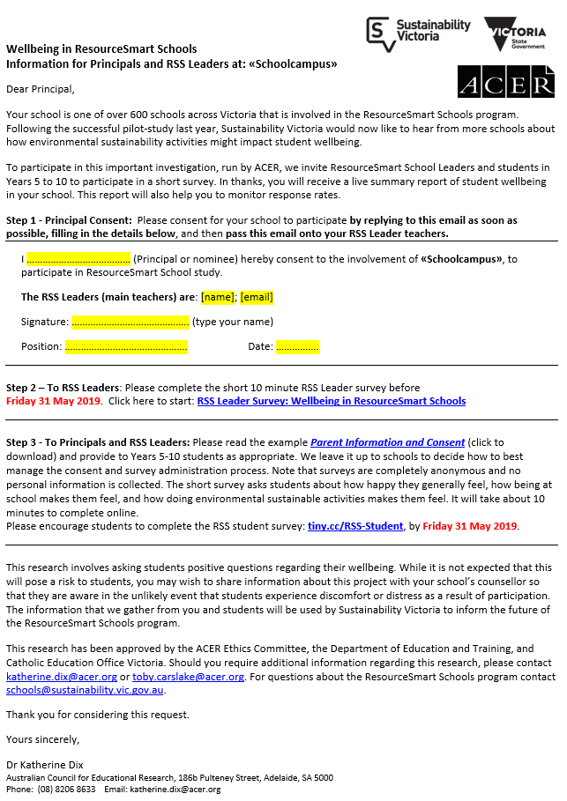

Appendix C: Partner Invitation
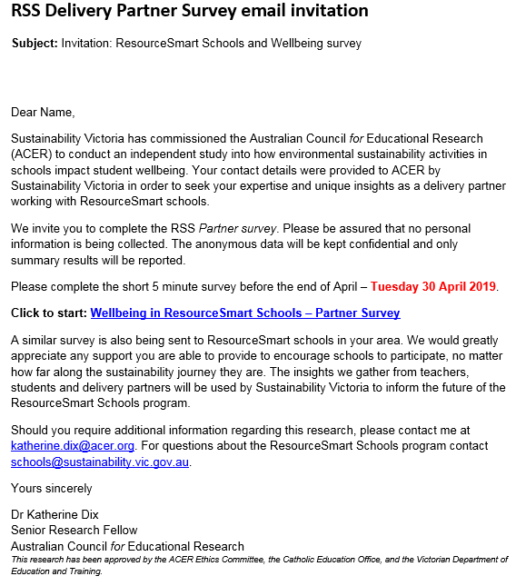

Appendix D: Parent and student information AND CONSENT
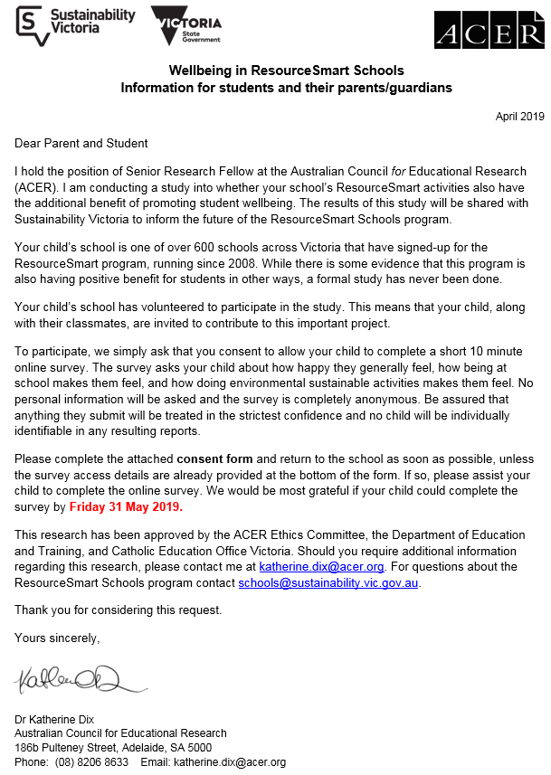

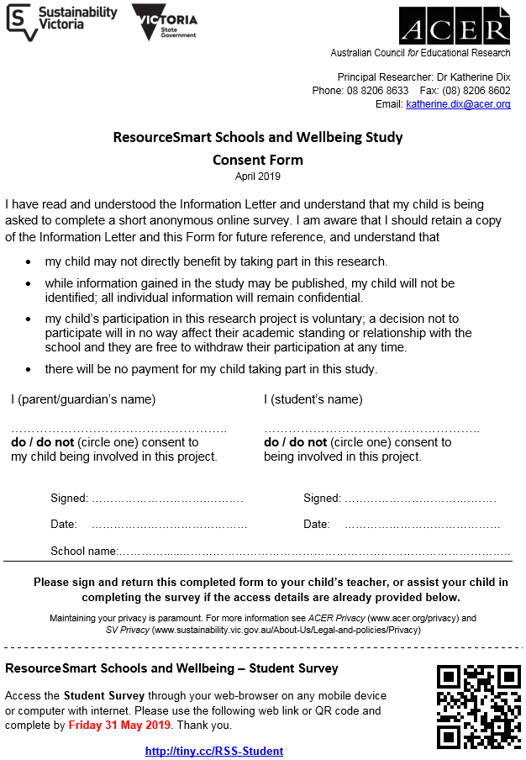

Appendix E: Surveys
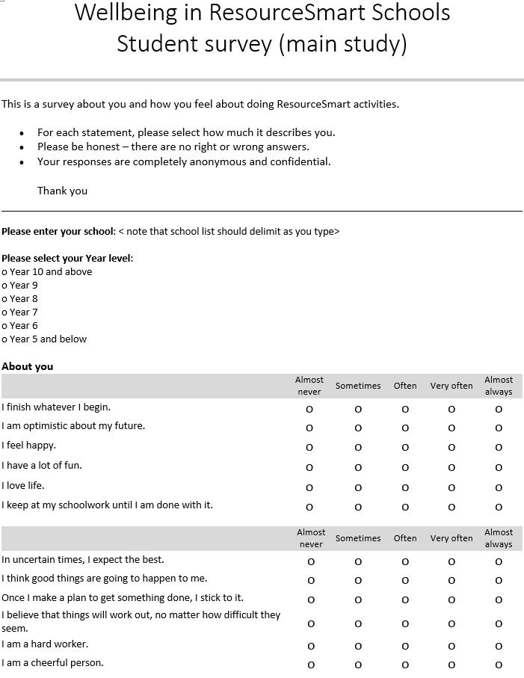
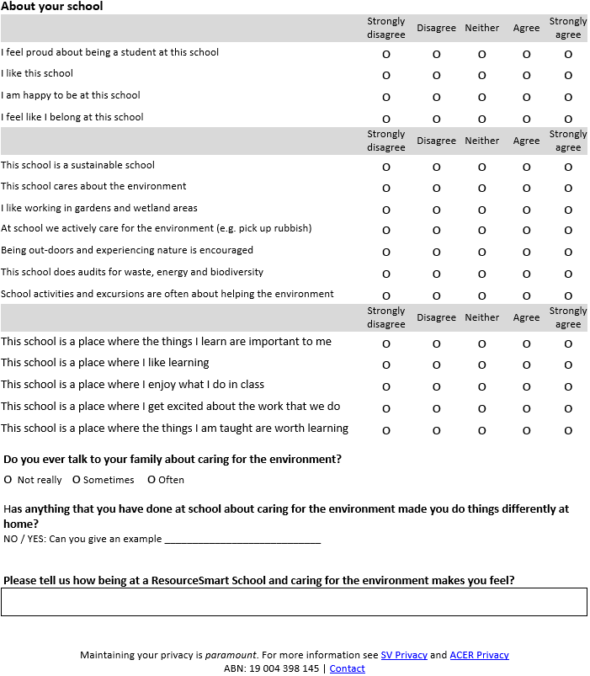

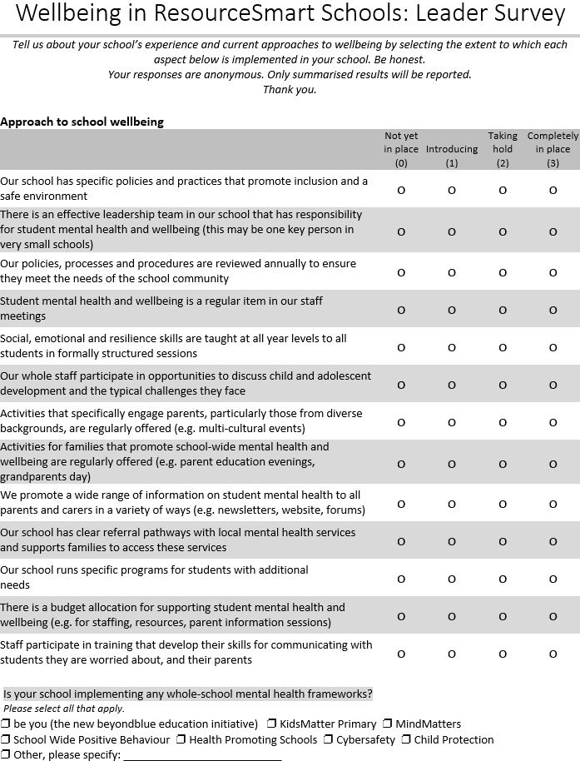
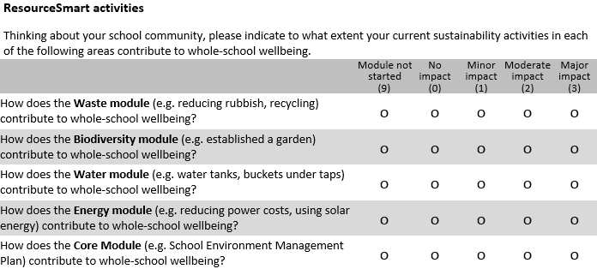
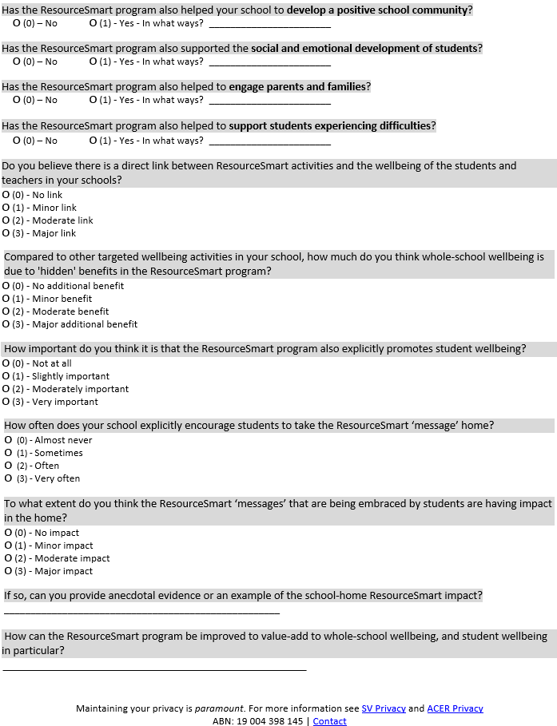

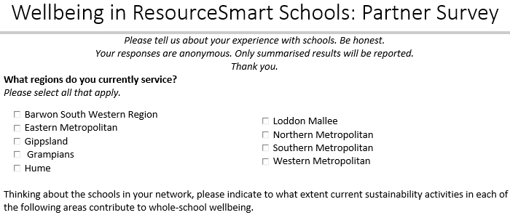
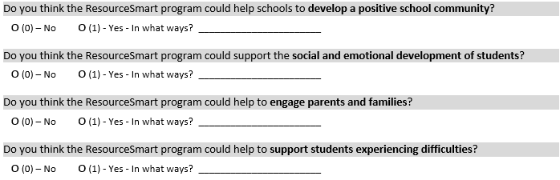
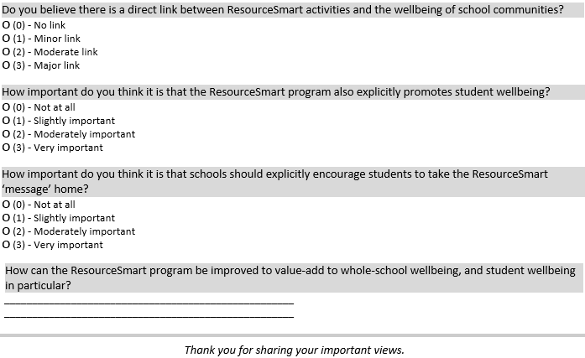

Appendix F: Interim Pilot Report

Sustainability Victoria
Level 28, Urban Workshop,
50 Lonsdale Street, Melbourne VIC 3000
Phone (03) 8626 8700
sustainability.vic.gov.au
Published by Sustainability Victoria.
ResourceSmart Schools and Wellbeing main study
© Sustainability Victoria, April 2020 CCC051



