Introduction
Biodiversity Response Planning (BRP) is a long-term area-based planning approach to biodiversity conservation in Victoria. It is designed to strengthen alignment, engagement and participation between government, Traditional Owners, non-government agencies and the community.
DELWP Regional staff have been working with stakeholders on actions to conserve biodiversity in specific landscapes, informed by the best available science and local knowledge.
These Fact Sheets capture a point in time, reflecting data and knowledge available in 2020. They provide information for many (but not all) landscapes across Victoria, containing general information on the key values and threats in each area, as well as the priority cost-effective actions that provide the best protection of biodiversity. Fact Sheets are intended to provide useful biodiversity information for the community, non-government and government organisations during project planning and development.
Further information and the full list of Fact Sheets is available on the Department’s Environment website.

Landscape description
At 126km in length, the King River flows north from the Alpine National Park through the King Valley and joins the Ovens River at the city of Wangaratta. This 111,317ha focus landscape encompasses much of the King River catchment, including Lake William Hovell. Approximately 22% of the landscape is public land and 36% of the area is covered with native vegetation.
Significant ecological features of this area include River Red Gum forests and woodlands considered one of the healthiest in the Murray-Darling Basin, as well as Ecological Vegetation Classes such as Endangered Plains Grassy Woodland and Floodplain Riparian Woodland which are considered Vulnerable. The King River and Lake William Hovell are renowned for trout fishing and other recreational pursuits.

Cultural importance
We recognise that the entire landscape has high cultural value for Traditional Owners. Landscapes identified as having “notable” cultural importance are based on the density of recorded cultural heritage sites and knowledge shared by Traditional Owners. We also recognise that there are locations important to Traditional Owners that are not within these focus landscapes. This area falls both within the Country of the Yorta Yorta and Taungurung Peoples respectively.

Stakeholder interest
As part of the BRP process, in October 2020 stakeholders were asked to nominate focus landscapes, values, threats and potential biodiversity actions. Representatives from DELWP, Parks Victoria, Trust for Nature, Goulburn Broken Catchment Management Authority, North East Catchment Management Authority, Taungurung Land and Waters Council, Yorta Yorta Nation Aboriginal Corporation, and the Alpine Resorts agreed on the boundaries and key aspects of this landscape.

Strategic Management Prospects
Strategic Management Prospects (SMP) models biodiversity values such as species habitat distribution, landscape-scale threats and highlights the most cost-effective actions for specific locations. More information about SMP is available in NatureKit.

Habitat Distribution Models identified 30 species with more than 5% of their Victorian range in this landscape area
There are 24 plants with more than 5% of their Victorian range in this landscape, notably:
- Concave Pomaderris (Pomaderris subplicata) which is Vulnerable and has a proportional distribution of 33%,
- Wedge Diuris (Diuris dendrobioides) which is Endangered and has a proportional distribution of 21%, and
- Delicate Leek-orchid (Prasophyllum aff. petilum (Wangaratta)) which is Endangered and has a proportional distribution of 20%

The consultation process identified the following species of interest: Hairy Anchor Plant, Northern Sandalwood, Spur-Wing Wattle
There is one amphibian with more than 5% of their Victorian range in this landscape:
- Rugose Toadlet (Uperoleia rugosa) which is Endangered and has a proportional distribution of 8%
The consultation process identified the following species of interest: Growling Grass Frog, Spotted Tree Frog
The landscape includes one mammal with more than 5% of its Victorian range
- Squirrel Glider (Petaurus norfolcensis) which is Endangered and has a 7% proportional distribution.
The consultation process identified Broad toothed Rat as another species of interest
There are 3 birds with more than 5% of its Victorian range within this landscape:
- Bar-shouldered Dove (Geopelia humeralis), with 12% proportional distribution,
- Superb Parrot (Polytelis swainsonii) which is Endangered with 6% proportional distribution, and
- Double-barred Finch (Taeniopygia bichenovii) with a proportional distribution of 5%
The consultation process identified the following species of interest: Egrets, shovelers, bitterns, geese and treecreepers, kingfishers, herons, White-Bellied Sea Eagle, spoonbills, Turquoise Parrot, Regent Honeyeater, forest woodland birds (e.g. robins, whistlers, warblers and flycatchers)
This landscape includes one reptile with more than 5% of their Victorian range:
- Southern Rainbow Skink (Carlia tetradactyla) which has a 5% proportional distribution.
The consultation process also identified Carpet Python as a species of interest
The consultation process identified the following aquatic species of interest in this landscape: Murray Cod, Trout Cod, Macquarie Perch

Additional threats
Threats identified through the consultation process (in addition to those modelled in SMP) are:
- Invasive weeds, particularly willows in the riparian zone
- Habitat destruction and fragmentation due to pressures from recreation and tourism, as well as urban boundary expansion
- Historical disturbances such as land clearing, de-snagging and waterway straightening, and more recent changes in stream geomorphology following the 1993 floods
Some individual threatened species may also require targeted intervention, beyond actions to manage landscape-scale threats, to improve their future prospects.

Which landscape-scale actions are most cost-effective in this landscape?
The coloured areas on the map indicate where landscape-scale actions are most cost-effective and will maximise biodiversity benefit across Victoria for multiple species.
The top 3 SMP priority actions which rank among the top 10% for cost-effectiveness of that action across the state for much of the landscape are:
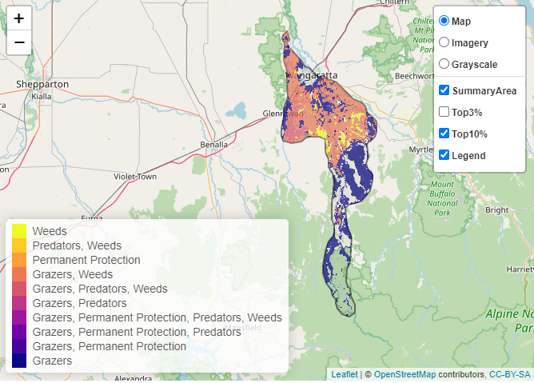

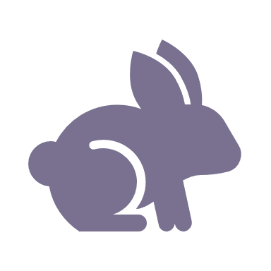 | Control Rabbits 50,660 hectares
 | Control Weeds 41,249 hectares
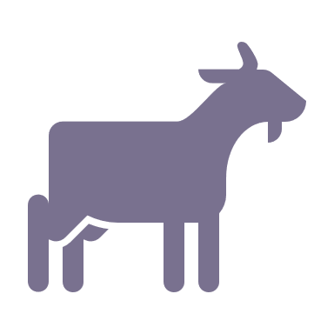 | Control Goats 14,423 hectares

Of the top 10% of all actions, controlling rabbits provides the most cost-effective biodiversity benefit when considering all flora and fauna.
Biodiversity management activities identified through the consultation process (in addition to those modelled in SMP) include:
- deer monitoring and control within elevated (hilly) areas, as deer are an emerging threat moving from higher areas down into the foothills and river flats;
- aquatic biodiversity enhancement through weed control, erosion control and providing instream habitat; and
- revegetation to create and enhance the landscape as a whole

The most cost-effective action for flora and fauna:
Plants, Birds Mammals Amphibians Reptiles – Control rabbits

For a further in depth look into SMP for this landscape please refer to NatureKit.

