Introduction
Biodiversity Response Planning (BRP) is a long-term area-based planning approach to biodiversity conservation in Victoria. It is designed to strengthen alignment, engagement and participation between government, Traditional Owners, non-government agencies and the community.
DELWP Regional staff have been working with stakeholders on actions to conserve biodiversity in specific landscapes, informed by the best available science and local knowledge.
These Fact Sheets capture a point in time, reflecting data and knowledge available in 2020. They provide information for many (but not all) landscapes across Victoria, containing general information on the key values and threats in each area, as well as the priority cost-effective actions that provide the best protection of biodiversity. Fact Sheets are intended to provide useful biodiversity information for the community, non-government and government organisations during project planning and development.
Further information and the full list of Fact Sheets is available on the Department’s Environment website.

Landscape description
This 160,000ha polygon has some native vegetation (15% cover) and some public land (10%). It includes the general linking area between Murray Sunset National Park and Wyperfeld National Park / Big Desert State Forest, encompassing public land blocks around Cowangie.
There is a minor overlap with the Murray Sunset landscape in the north and the Wyperfeld landscape in the south. You can find further information on these landscapes in the full list of Fact Sheets.

Cultural importance
We recognise that the entire landscape has high cultural value for Traditional Owners. Landscapes identified as having “notable” cultural importance is based on the density of recorded cultural heritage sites and knowledge shared by Traditional Owners. We also recognise that there are locations important to Traditional Owners not within these landscapes.
This landscape is an area of interest for both the First People of the Millewa Mallee Aboriginal Corporation (FPMMAC) and Barengi Gadjin Land Council Aboriginal Corporation but is not currently within either Registered Aboriginal Party boundary.
The landscape interests of the FPMMAC extends from Murrayville to Lake Tyrrell and includes the Mallee Research Station at Walpeup.

Stakeholder interest
As part of the Biodiversity Response Planning process, in October 2020 stakeholders were asked to nominate focus landscapes and actions of interest. First People of the Millewa Mallee, Murrayville Landcare Group, Mallee Catchment Management Authority and Trust for Nature nominated Cowangie.
Possible future investment/project development in this landscape will be available to any interested stakeholders in addition to those who nominated this landscape.
Specific stakeholder interests identified through the engagement process within this landscape include:
- Parks Victoria Conservation Action Plan assets – Mallee Triodia.
- Mallee Catchment Management Authority, Regional Catchment Strategy priority landscape – 8. Pink Lakes; Climate Change priority corridor 3: Western Central Mallee. Focus on the restoration (for example, connectivity of isolated remnants) and protection (for example, grazing/competition impacts) of high value habitat for priority species outcomes.
- Department of Environment, Land, Water and Planning, smaller areas of public land, for example, Boinka State Forest.

Community interest
There was no specific community interest in biodiversity conservation identified for this area through the consultation process.

 | Habitat Distribution Models identify 47 species with more than 5% of their Victorian range in this landscape area | Traditional Owners, stakeholders and community groups identified the following species of interest
46 Plants with more than 5% of Victorian range in area. Notably:
- Pale Myoporum (endangered, 19% of Victorian range in area)
- Desert Greenhood (vulnerable, 13% of Victorian range in area)
 | 1 Bird with more than 5% of Victorian range in area. Notably:  - Pink Cockatoo (vulnerable, 6% of Victorian range in area) | - Malleefowl

Strategic Management Prospects
Strategic Management Prospects (SMP) models biodiversity values such as species habitat distribution, landscape-scale threats and highlights the most cost-effective actions for specific locations. More information about SMP is available in NatureKit.

Additional threats
Threats identified (in addition to those modelled in SMP) through the consultation process were:
- alterations to hydrology
- land salinisation
- soil erosion
- habitat degradation due to extremes of climate and weather
- lack of regeneration in some vegetation communities
- recreational activities causing fragmentation
- loss of vegetation, and erosion
- legacy use of public land
- private land use impacting biodiversity
- inappropriate land use planning
- inappropriate fire regimes (planned burning and bushfires)

Which landscape-scale actions are most cost-effective in this landscape?
Some areas of this landscape (coloured areas on the map) have highly cost-effective actions which provide significant benefit for biodiversity conservation.
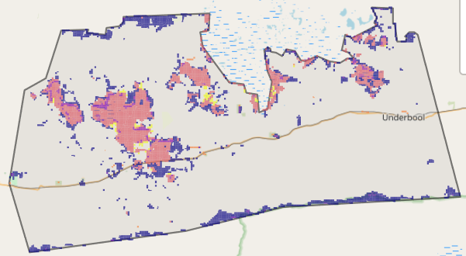
The SMP priority actions which rank among the top 3% for cost-effectiveness of that action across Victoria cover less than 1,000ha and are control goats and permanent protection.
The priority actions in the top 10% are in order:
Control rabbits 16,858ha
Control weeds 12,560ha
Control goats 10,307ha
Control overabundant kangaroos 9,102ha

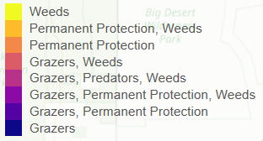

Of the top 10% of cost-effective actions, control rabbits provides the most cost-effective biodiversity benefits when considering all flora and fauna.

Actions suggested for this landscape through the nomination process are:
- control weed, rabbit, goat, over abundant kangaroo and fox
- revegetation
- permanent protection

The most cost-effective action for flora and fauna
 | Plants – Control rabbits
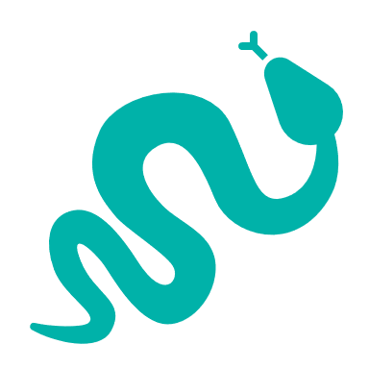 | Reptiles, birds – Control goats
 | Mammals – Combined cat and fox control

For a further in depth look into SMP for this landscape please refer to NatureKit.

