Background / preamble
The Cobberas Nunniong landscape was recognised during the 2019/20 Gippsland Biodiversity Response Planning (BRP) process as a focus area for future collaborative biodiversity action and investment.
Under the Victorian Government’s Biodiversity 2037: Protecting Victoria’s Biodiversity plan, the BRP process is a long-term area-based planning approach to biodiversity conservation in Victoria. It is designed to strengthen alignment, engagement and participation between government, Traditional Owners, non-government agencies and the community to benefit biodiversity by working together to identify, promote and tackle local biodiversity needs as part of an ongoing collective process.
In 2019/20, significant impacts from the bushfires in East Gippsland and coronavirus (COVID-19) on community, biodiversity stakeholders and agencies, and the environment, resulted in planned engagement with many local stakeholders in Gippsland about BRP being postponed to a future process. In the interim, a multi-agency Working Group of local staff in Gippsland came together to identify a series of potential strategic priority actions across the region, as well as 13 focus landscapes. Membership of this Working Group for Gippsland included staff from the Department of Environment, Land, Water and Planning (DELWP) coasts & marine policy and local forest, fire and biodiversity teams, East Gippsland and West Gippsland Catchment Management Authorities (EGCMA & WGCMA), Parks Victoria, Trust for Nature (TfN), the Bunurong Land Council Aboriginal Corporation (BLCAC) and the Gunaikurnai Land and Waters Aboriginal Corporation (GLaWAC).
As part of this process, the Gippsland BRP Working Group drew upon information available from the DELWP Strategic Management Prospects (SMP) tool as well as their own local knowledge to identify key biodiversity assets, threats and potential management actions across Gippsland. A subset of this information is presented in this Fact Sheet, reflecting a point in time assessment of some of the important biodiversity needs and landscapes for focus across the region.
These BRP Fact Sheets provide useful biodiversity information for the community, non-government and government organisations during project planning and development, including guidance for stakeholders interested to contribute towards some of the strategic priorities identified in these areas to date. Further information and the full list of Fact Sheets is available on the Department’s Environment website.

Landscape description
Landscape context: 188,760ha, 99% public land, 95% native vegetation cover
The Cobberas Nunniong landscape is dominated by alpine and sub-alpine mountains and tablelands (1000m+) with embedded valleys associated with the Cobberas and extending south to the Nunniong Plateau. This area includes alpine and sub-alpine vegetation types, with Montane Wet Forest and Montane woodland as well as areas of sensitive alpine grassland and bogs. A majority of this landscape falls within the Alpine National Park, however there is also state forest adjacent to the Nunniong Plateau area. This landscape is continuous with alpine and sub-alpine areas in Kosciuszko National Park in NSW, and contains the upper catchments of the Buchan, Tambo and Murray Rivers.

Biodiversity highlights and important places:
Extensive, continuous, remote and relatively undisturbed tracts of montane, sub-alpine and alpine ecosystems, featuring alpine bogs, montane forests, alpine grassland and woodlands. Nunniong Plateau in particular supports an assemblage of unique restricted plants.

Important vegetation communities in this landscape include:
*FFG listed | Alpine Bog / Fen Community
**EPBC listed | Alpine Bog / Fen Community
*Flora and Fauna Guarantee Act 1988 (Victorian)
**Environment Protection and Biodiversity Conservation Act 1999 (Federal)

Cultural importance
We would like to acknowledge the Traditional Owners and custodians of the land across this landscape. We pay our respects to Country, and to Elders past and present whose knowledge and wisdom has ensured the continuation of culture and traditional practices. We are committed to genuinely partner, and meaningfully engage, with Victoria’s Traditional Owners and Aboriginal communities to support the protection of Country, the maintenance of spiritual and cultural practices and their broader aspirations into the 21st century and beyond in the spirit of self-determination. The Gippsland BRP project team are seeking interest from traditional owners in this area to contribute towards biodiversity planning and conservation processes, including Biodiversity Response Planning.

Stakeholder and community interest
Local engagement for BRP in Gippsland in 2019/20 was postponed due to impacts from fire and coronavirus (COVID-19). If you would like to contribute local knowledge about this landscape in the future, find out more about BRP or add your name to the state-wide or Gippsland BRP stakeholder lists, you can find further information on the Department’s Environment website.

Species summary
An analysis of available Habitat Distribution Models* identified 391 species with more than 5% of their Victorian range falling within the Cobberas Nunniong BRP landscape, including 59 threatened species and 7 EPBC listed species.
*Note: While version 2.0 of the SMP model utilises HDMs for ~3,200 terrestrial species in its analysis, these models currently exclude aquatic, invertebrate, marine and non-vascular plant species. These HDMs and SMP will continue to be improved upon with ongoing input from species experts and natural resource management practitioners.
Species class | Species with a high proportion of their Victorian distribution in this landscape | Other notable species identified during the BRP process
383 plants, incl. 55 threatened species (5 EPBC) | 22 species with greater than 50% of their Victorian range within this landscape, most notably:  - Mt Stewart Wax-flower Philotheca myoporoides subsp. petraea (FFG listed, vulnerable, 62% of Victorian range, restricted to summit of Mt Stewart)  - Stringybark Tea-tree Leptospermum jingera (FFG listed, vulnerable, 60% of Victorian range, restricted to Nunniong Plateau & Snowy Range)  - Lemon-scented Zieria Zieria citriodora (EPBC listed, Vulnerable, 59% of Victorian range)  Nine species with greater than 75% of their Victorian range within this landscape, most notably:  - Wooly-bear Wattle Acacia lucasii (FFG listed, vulnerable, 85% of Victorian range)  - Marsh Leek-orchid Prasophyllum niphopedium (FFG listed, endangered, 83% of Victorian range, restricted to the Victorian alps)  - Kydra Dampiera Dampiera fusca (FFG listed, endangered, 81% of Victorian range)  - Olive Mallee Eucalyptus elaeophloia (FFG listed, vulnerable, 78% of Victorian range, restricted to the Nunniong Plain)  - Purple Eyebright Euphrasia collina subsp. diversicolor (FFG listed, vulnerable, 78% of Victorian range)  - Kosciuszko Grevillea Grevillea victoriae subsp. nivalis (FFG listed, endangered, 77% of Victorian range)  - Trailing Monotoca Monotoca rotundifolia (FFG listed, vulnerable, 77% of Victorian range)  - Monaro Fireweed Senecio lageniformis (76% of Victorian range) | - Congested Leek-orchid Prasophyllum retroflexum (FFG listed, endangered, Victorian range restricted to Nunniong Plain)  - Famine Wattle Acacia infecunda (FFG listed, vulnerable, restricted to north-east Gippsland)  - Wombargo Wattle Acacia tabula (FFG listed, vulnerable, restricted to north-east Gippsland)  - Brumby Sallee Acacia forresterae (FFG listed, endangered, Victorian range restricted to north-east Gippsland)  - Native Dog Hakea Hakea asperma (FFG listed, endangered, restricted to north-east Gippsland)  - Leafy Nematolepis Nematolepis frondosa (EPBC listed, Vulnerable, 38% of Victorian range, restricted to Gippsland)  - Blue-tongue Greenhood Pterostylis orephila (EPBC listed, Critically Endangered, 37% of Victorian range)
2 mammals, incl. 2 threatened species (2 EPBC) | Including:  - Broad-toothed Rat (EPBC listed, Vulnerable, 17% of Victorian range)  - Spot-tailed Quoll (EPBC listed, Endangered, 5% of Victorian range) | - Brush-tailed Rock-wallaby (historic sites)
5 reptiles, incl. 2 threatened species (0 EPBC) | Notable species include:  - Alpine Water Skink (FFG listed, critically endangered, 29% of Victorian range)  - Alpine Bog Skink (FFG listed, endangered, 13% of Victorian range) | - None raised
0 birds | No species with more than 5% of their Victorian range within this landscape. | (Landscape supports many common bird species)
1 frog, incl. 0 threatened species (0 EPBC) | Including:  - Dendy’s Toadlet (8% of Victorian range) | - None raised
Other species raised by the Working Group (e.g. fish, invertebrates etc):
Alpine Spiny Crayfish (FFG listed, endangered, restricted to the Victorian alps)

Strategic Management Prospects
Strategic Management Prospects (SMP) models species distributions, habitat importance, landscape-scale threats, and management costs. It then compares and highlights those places with the greatest opportunities for cost-effective action state-wide. Learn more about this tool on the SMP webpage.

Which landscape-scale actions are most cost-effective in this landscape?
The maps and information below show those places and actions modelled by SMP to provide the best opportunities for cost-effective action to benefit biodiversity across the state. Coloured areas in the maps below indicate opportunities for highly cost-effective actions that provide significant benefits to biodiversity in those places. If undertaken across Victoria, these collective actions should provide the greatest potential benefit to biodiversity by focusing on undertaking landscape-scale actions in places where they will provide the greatest benefit for cost across all species.
Map a) shows actions in the top 3% cost-effectiveness areas, and Map b) shows actions in the top 10% cost-effective areas.
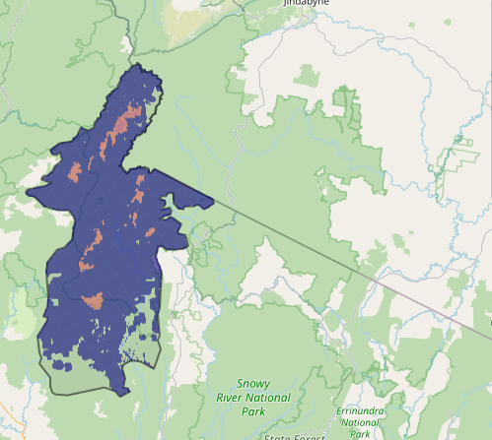
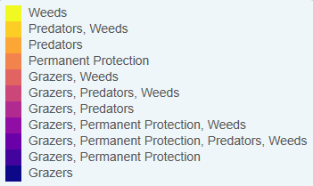
Map a) – SMP top 3% cost-effective actions
The following landscape-scale actions were ranked among the top 3% cost-effective opportunities for biodiversity action across the state by SMP:

Control horses 150,706ha
Control pigs 42,373ha
Combined horse and pig control 24,462ha
Control deer 18,438ha

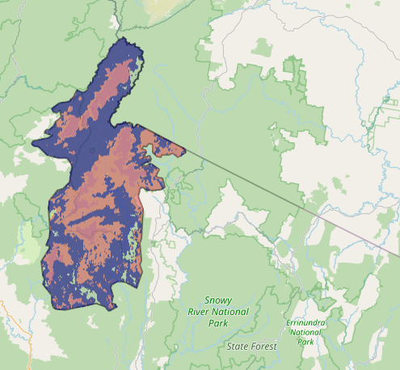
The following landscape-scale actions were ranked among the top 10% cost-effective opportunities for biodiversity action across the state by SMP:
Map b) – SMP top 10% cost-effective actions

Control horses 150,716ha
Control deer 98,830ha
Control weeds 79,415ha
Control pigs 18,438ha

The most cost-effective actions for flora & fauna according to SMP
 | Plants – Control horses and Control all grazers (particularly deer) |  | Birds – Control horses and Control deer
 | Mammals – Control horses, Control deer and Combined fox and cat control |  | Amphibians – Control deer
 | Reptiles – Control horses, Control deer, Control pigs and Combined fox and cat control (particularly cats)
For a further in depth look into SMP for this landscape please refer to NatureKit.

Additional threats raised by the Working Group
- None raised

Highest priority strategic actions
With consideration of the information available in SMP and local knowledge of this landscape, the Gippsland BRP Working Group identified the following priority actions for future collaboration and investment in this landscape:
The highest priority actions for the Cobberas Nunniong landscape include:
- Integrated large herbivore control (particularly horses, deer and pigs)
Other key actions highlighted by the Working Group include:
- Controlling transformer weeds
- Controlling / removing domestic stock

