DSE’s EcoMarkets team has built a strong partnership with the Bass Coast Landcare Network in recent years, resulting in a sizeable proportion of South Gippsland and Westernport native vegetation being conserved and managed.

BCLN also collaborated with the EcoMarkets team to develop and refine advanced tools to measure and predict the benefits of proposed conservation work. The environmental modelling tool ‘EnSym’ quantifies the benefits which result from environmental management actions and can prioritise natural resource investment.

Bass Coast Landcare Network’s Dave Bateman says the relationship with the EcoMarkets team has been a mutually beneficial one.

“When the EcoMarkets team was developing the EnSym tool, I worked with them to draft the manual. We then used EnSym in the Westernport Land Stewardship Project in which landowners tender for funds to manage and conserve their native vegetation. EnSym ranked the tenders according to our priorities so we knew it was going to be objective and we knew we were going to get the best outcome for the budget we had available,” he said.

“With EnSym, we can work out an environmental benefits score for a property, to benchmark that property and predict the environmental gains we could expect to achieve.
Bass Coast Landcare Network’s Dave Bateman


“We also use EnSym to produce a list of management actions, including a list of recommended plant species where revegetation work is planned. By using EnSym, we are more accountable. We then use the data to improve outcomes from our work.

“When DSE was running EcoTenders in this area, our staff conducted the site assessments. That worked well because our people have local knowledge and know most of the landholders: about 50% of farmers in this area are Landcare members. Also, if landholders missed out on EcoTender funding, they might be eligible for other opportunities and we could share the management plans that had been created by EnSym.

“It’s also helped us to receive more funding for projects. Funding bodies can see the value of what we do because we can quantify it and get clear feedback on what we’re doing.

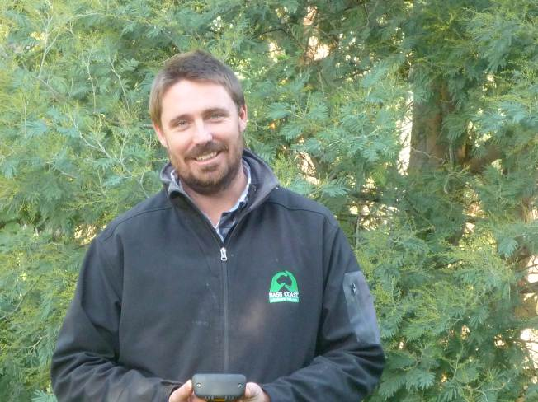
“Over time, additional tools have been added to EnSym and it will continue to be improved. In last year’s Powlett Project, we were the first organisation to use a new landscape preference tool, so that we could better identify the best bids for what we wanted to achieve.

“Now we’re working with the EcoMarkets team to develop a soil health gain calculator which will allow us to quantify improvements to soil on local properties. We’ll do a soil assessment, and factor in the impact of actions that might be done to improve it and generate a score to predict the gains that could be made.

“What we’re really doing is working together to measure farmers’ stewardship of their land and learn more about what makes the biggest difference,” he said.

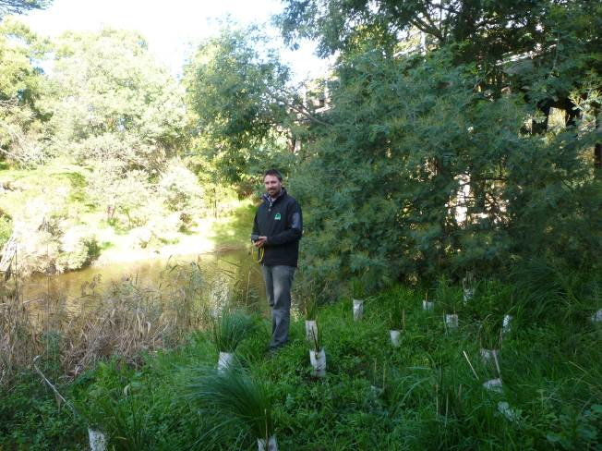

Dave Bateman beside the Bass River

