Goulburn Broken Catchment Management Authority (GBCMA) worked with the Department of Sustainability and Environment’s (DSE) EcoMarkets team and the local Landcare group to deliver a Wetlands Tender in 2010-11 which resulted in the conservation of 77 hectares of wetlands in the Strathbogie Ranges, and $227,000 being awarded to local landholders.
GBCMA’s Jenny Wilson said the Wetlands Tender was a highly successful project and she is already planning further tenders in the catchment.
“It was great to bring the community on board for this project. The spring soak woodlands, or bogs, as we call them, had been a focus for fencing works in the past, but that was mainly to keep stock out, not for the purpose of conservation or management. There was also a stage when a lot of farmers simply dug them out or turned them into a dam,” Jenny explained.
“We wanted to manage the bogs better because we know how important they are for the whole catchment.
“We got funding through NRIP – the Natural Resources Investment Fund – and used the EcoTender process for the project. That was really good: you’re given an outline of the steps, templates to use and support through the process. It’s great to share experiences, not reinvent the wheel.
“We worked with Janet Hagen from Landcare to do the site assessments. She’s a great local, does so much around this area.
“It was great because she could get the locals to support it; otherwise it would have been harder, they might have been a bit wary of something very new here.
“Janet was trained in EnSym – the environmental modelling program – and using the Index of Wetland Condition.
“She and her team managed the relationships with local landholders, did the site assessments and provided all of the data to our bid assessment team.
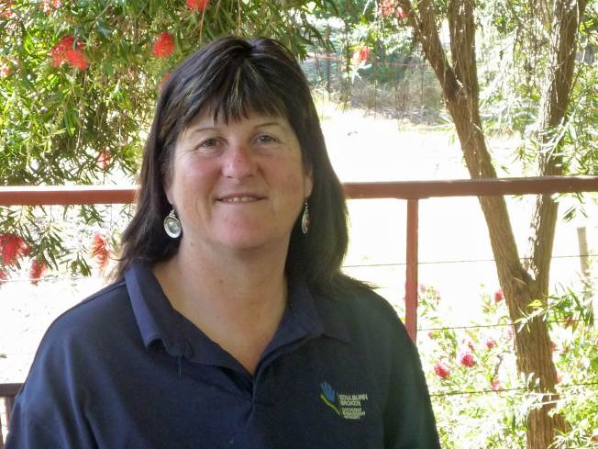
Jenny Wilson from Goulburn Broken Catchment Management Authority
“We then used EnSym to rank the bids and determine which bids would receive funding.
“It ran really smoothly. We had 16 landholders who were successful, and were able to provide funding for 77 hectares.
“The next step for the project will be conducting the annual site visits – that’s going to be really important, to keep up the momentum and see how the landholders are going.
“Also we’re planning another tender down on the plains. It’s a different landscape there but not far away so we expect word of mouth to have spread.
“What I love is that landowners see that they have an important asset that the public can support, through money and also through site assessments and visits.
“It’s a long term change towards getting community recognition for biodiversity conservation: they get to see that you’re interested year after year. That’s really important,” she said.

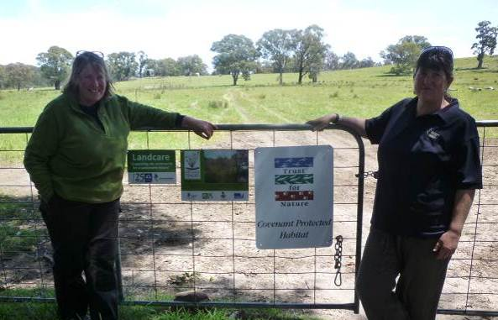
Jenny Wilson (right) and Landcare Coordinator, Janet Hagen

