|  |
| --- |
| Roles and responsibilities: Department of Environment, Land, Water and Planning |
| Information sheet on the roles and responsibilities of the department that administers the creation, trade and allocation of native vegetation credits. |

The Secretary to the Department of Environment, Land, Water and Planning (DELWP) can enter into a Security Agreement with a landholder to establish an offset site and is responsible for the administration of the Native Vegetation Offset Register (NVOR)

## Policy context

The *Guidelines for the removal, destruction or lopping of native vegetation, 2017* (Guidelines) is incorporated into all planning schemes in Victoria and sets the rules for establishing offset sites. This includes rules about eligibility requirements, security requirements, offset management, determining gains, and the registration of offsets and the trading of native vegetation credits.

The Guidelines specify the types of security agreements that can be used to establish an offset site. Third party offset sites create native vegetation credits that can be traded through the Native Vegetation Credit Register (NVCR).

**What is a security agreement?**

Security agreements are established with DELWP using an agreement under section 69 of the *Conservation Forests and Lands Act 1987* (section 69 agreement) or with Trust for Nature using an offset covenant under the *Victorian Conservation Trust Act 1972* (offset covenant).

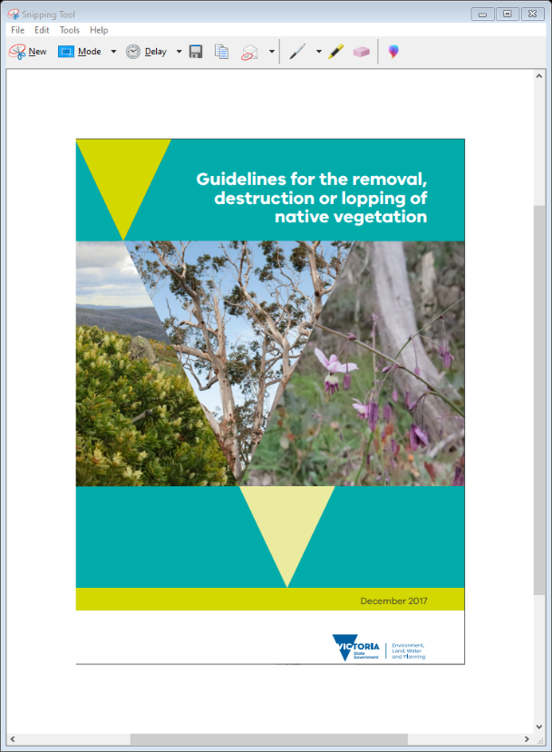First party offset sites can only be used by the property owner and can be established with either of the above agreements or an agreement under section 173 of the *Planning and Environment Act 1987*. First party offset sites must be recorded on the Native Vegetation Offset Register (NVOR) if they are to be used over time.

## What is the Native Vegetation Offset Register?

The NVOR contains information relating to existing offsets including the number of habitat units that an offset site generates and when these units have been used to offset the removal of native vegetation. The NVOR includes the NVCR that records the creation, trade and allocation of native vegetation credits to meet offset requirements.

The NVOR is operated by DELWP under cost recovery. Fees are reviewed annually and published on the DELWP website.

## Obligations of the Secretary to DELWP (regarding native vegetation credits)

Under a security agreement, the Secretary:

* must record all native vegetation credits established by a section 69 agreement or an offset covenant on the NVCR and assign them to the landowner
* can record any offset security agreement under section 173 of the *Planning & Environment Act 1987* on the NVOR
* maintains the NVCR as an accurate record of native vegetation credits and enable the available credits to be searched for by a person who wishes to purchase a native vegetation credit
* ensures the NVCR records the relationship between the native vegetation credits and the land on which the security agreement is registered
* records the sale of native vegetation credits in accordance with a credit trade agreement and the Rules of the NVCR
* records and maintains in the NVCR all pending trades, trades and allocations in accordance with the Rules of the NVCR.

DELWP may publish data in relation to the sale of any native vegetation credit trades on the DELWP website. This details the specific credits traded and the price but does not identify the credit owner or purchaser details or the specific location of the offset site.

When the Secretary enters into a section 69 agreement, the Secretary has an additional obligation to make payments to the landholder to the extent that native vegetation credits have been purchased through the NVCR and monies have been paid to the Secretary (the NVCR trust account). To enable this the Secretary will:

* invoice purchasers for the agreed amount (incl GST) as detailed in an executed credit trade agreement
* receive payment from the purchaser and hold this in the NVCR trust account
* pay monies to the landholder as detailed in the agreement when satisfied that the landowner is compliant with the agreement.

## Service providers: brokers and site assessors

The Secretary can enter into a Service Provider Agreement with a person or an organisation to operate as a broker or a site assessor. These broker and site assessors are listed on the DELWP website. These service providers assist in the operation of the native vegetation credit market and must operate in accordance with their agreement. Further information can be found the Roles and Responsibilities info sheets for brokers and site assessors.

## How are the obligations achieved?

The Native Vegetation Regulation team in DELWP includes two teams that administer the native vegetation credit market. The native vegetation offset management team and the native vegetation offset register team.

### The native vegetation offset management team

* performs quality assurance for all proposed offset sites
* facilitates the establishment of new offset sites under section 69 agreements, and develops templates and standards for Site Assessors to use
* monitors for compliance with the section 69 agreement, takes compliance action if required and ensures payments are made to landowners who are compliant with their agreement
* provides advice and responds to enquiries from landowners and Site Assessors.

### The native vegetation offset register team

* includes the registrar that operates the NVOR and the NVCR in accordance with the Rules of the NVCR
* makes the Rules of the NVCR available to relevant parties
* records potential sites in the NVCR so that potential credits can be searched for and initial trades facilitated
* maintains updated contact details of the credit owner and their Broker details (if relevant)
* performs quality assurance on all trade agreements and forms to ensure they meet the standards of the NVCR
* finalises the requested transaction in the NVCR (on proof of payment when applicable) and provides evidence of completed transactions to the submitter of the request
* facilitates the transfer of credits to new landowners when offset sites are sold – this ensures the new landowner receives any annual payments and can trade or allocate any remaining native vegetation credits
* facilitates the transfer of credits to new credit owners when there is a legal change in credit owner names to ensure the new credit owner can trade or allocate any remaining native vegetation credits
* provides native vegetation credit statements to credit owners or their Brokers (as relevant)
* respects privacy laws and only discloses information to the relevant credit owner, purchaser or their Broker or someone else that has been appropriately authorised in writing
* freezes the sale of credits when offset sites are non-compliant with their security agreement
* provides advice and responds to enquiries from credit owners and Brokers.

More information

The DELWP native vegetation website has useful information to support the credit market. The website:

* explains what an offset is
* explains how offset requirements can be met, including the steps to establish an offset site or purchasing a native vegetation credit
* has links to the *Search the Native Vegetation Credit Register tool* [https://nvcr.delwp.vic.gov.au](https://nvcr.delwp.vic.gov.au/)
* contains a list of Site Assessors and Brokers
* explains how gain is calculated at an offset site
* has the management standards that must be complied with when managing an offset site
* has information to help set a price for native vegetation credits, including all past native vegetation credit trade prices
* details the NVOR fees.
* Visit: <https://www.environment.vic.gov.au/native-vegetation/native-vegetation/offsets-for-the-removal-of-native-vegetation>

You can email [nativevegetation.offsetregister@delwp.vic.gov.au](mailto:nativevegetation.offsetregister@delwp.vic.gov.au) for queries about trading and allocating native vegetation credits or [nativevegetation.offsetmanagement@delwp.vic.gov.au](mailto:nativevegetation.offsetmanagement@delwp.vic.gov.au) for queries about setting up a new offset site or managing an existing offset site.

|  |  |
| --- | --- |
| © The State of Victoria Department of Environment, Land, Water and Planning 2020  LogoThis work is licensed under a Creative Commons Attribution 4.0 International licence. You are free to re-use the work under that licence, on the condition that you credit the State of Victoria as author. The licence does not apply to any images, photographs or branding, including the Victorian Coat of Arms, the Victorian Government logo and the Department of Environment, Land, Water and Planning (DELWP) logo. To view a copy of this licence, visit http://creativecommons.org/licenses/by/4.0/  ISBN 978-1-76105-303-0  Disclaimer  This publication may be of assistance to you but the State of Victoria and its employees do not guarantee that the publication is without flaw of any kind or is wholly appropriate for your particular purposes and therefore disclaims all liability for any error, loss or other consequence which may arise from you relying on any information in this publication. | Accessibility  If you would like to receive this publication in an alternative format, please telephone the DELWP Customer Service Centre on 136186, email [customer.service@delwp.vic.gov.au](mailto:customer.service@delwp.vic.gov.au), or via the National Relay Service on 133 677 [www.relayservice.com.au](http://www.relayservice.com.au). This document is also available on the internet at [www.delwp.vic.gov.au](http://www.delwp.vic.gov.au). |