Biodiversity audit tool
ResourceSmart Schools

Contents
Using the biodiversity audit tool 2
What is biodiversity? 4
Understanding habitats 5
Tips and tricks for a successful audit 8
Teacher/facilitator audit checklists 10
Worksheet: Habitat features 13
Worksheet: Native animal species list 16
Worksheet: Calculating your biodiversity score 18
Appendix 1: Resources 21
Appendix 2: Curriculum links 23
Glossary 26

Using the biodiversity audit tool
Welcome to the ResourceSmart Schools (RSS) biodiversity audit tool.
The audit tool helps you measure and record data on biodiversity in your school grounds by:
- recording habitat features such as indigenous/native trees, weeds and organic litter
- recording native animals in your school grounds
- calculating your school’s biodiversity score.
You can then analyse the collected data to find ways to improve your biodiversity score and record your ideas and next steps in your biodiversity action plan.
ResourceSmart Schools audit their biodiversity every year and upload results, photos and presentation(s) into the RSS online system as part of the biodiversity module. The first audit provides baseline data and subsequent audits monitor your progress against baseline data.
The biodiversity module is one of five modules in the RSS program. The other modules are core, water, energy and waste. Schools must accomplish a set number of actions to complete each module and receive a certificate valid for four years.

What’s included in this tool?
- An introduction to biodiversity and understanding habitats
- Tips and tricks for completing the audit
- Checklists to guide teachers/facilitators through the audit
- Three worksheets
- An appendix with resources to help with understanding biodiversity and advice on linking activities to the Victorian Curriculum
- Glossary of biodiversity terms

What does the audit involve?
Teachers and students work together to assess biodiversity on the school grounds and calculate a biodiversity score. There is some preparation and follow-up work for teachers (see Teacher/facilitator audit checklists) and worksheets for students to complete.

Who should do the audit?
The student worksheets are best suited to students in Years 3 to 10, with the supervision and guidance of a teacher.

How long does the audit take?
Teachers will use their discretion to determine a realistic timeframe for each step of the audit investigation. Consider the size and accessibility of the school grounds.

How does the audit link to the Victorian Curriculum?
Exploring the concept of biodiversity, which includes a biodiversity audit, contributes to several learning areas in the Victorian Curriculum (see Appendix 2: Curriculum links). Involving students in this audit will also help with:
- Critical and creative thinking: Responding effectively to environmental, social and economic challenges requires young people to be creative, innovative, enterprising and adaptable, with the motivation, confidence and skills to use critical and creative thinking purposefully.
- Mathematics: Conducting an audit can incorporate using units of measurement, data and interpretation, chance, patterns, fractions, decimals and numbers.
Download curriculum guides from sustainability.vic.gov.au/School/Modules/Curriculum

Where can I find more information?
See Appendix 1: Resources for help with understanding biodiversity in your local area.
Visit the Sustainability Victoria website for a module checklist and ‘how to’ guide packed full of ideas on how to work with students and the school community to improve your biodiversity score.

What is biodiversity?
Biodiversity comes from two words – bio meaning life and diversity meaning variability.
Also known as biological diversity, biodiversity is the term given to the variety of all life forms. This includes all the different plants, animals and microorganisms, as well as the genes they contain and the ecosystems they are part of.
Biodiversity conservation is an essential part of responsible environmental and natural resource management. It underpins our quality of life and supports our economy and productivity, now and in the future as plants capture carbon from our atmosphere.
More than 80 per cent of Australian plant and animal species are endemic, meaning they only occur naturally in our country. This makes it even more crucial for us to look after our rich land.

Biodiversity in schools
When schools commit to increase their biodiversity score, they support plants and animals that are endemic to the area, provide habitats for indigenous animals and reduce threats to local plants and animals. Regardless of school size, location or resources, every plant and effort counts.
Since 2008, ResourceSmart Schools have collectively planted more than 5 million plants.

Understanding habitats

Habitat layers
Vegetation can be classified into three separate layers, as shown in Figure 1. The three layers are:
- Canopy – the top layer of vegetation with plants taller than 6 metres
- Understorey – the layer of vegetation under the tree canopy with plants between 0.5 and 6 metres in height
- Ground cover or herb layer – layer of vegetation dominated by non-woody plants smaller than 0.5 m.
Students will record habitat features in these three main vegetation layers.
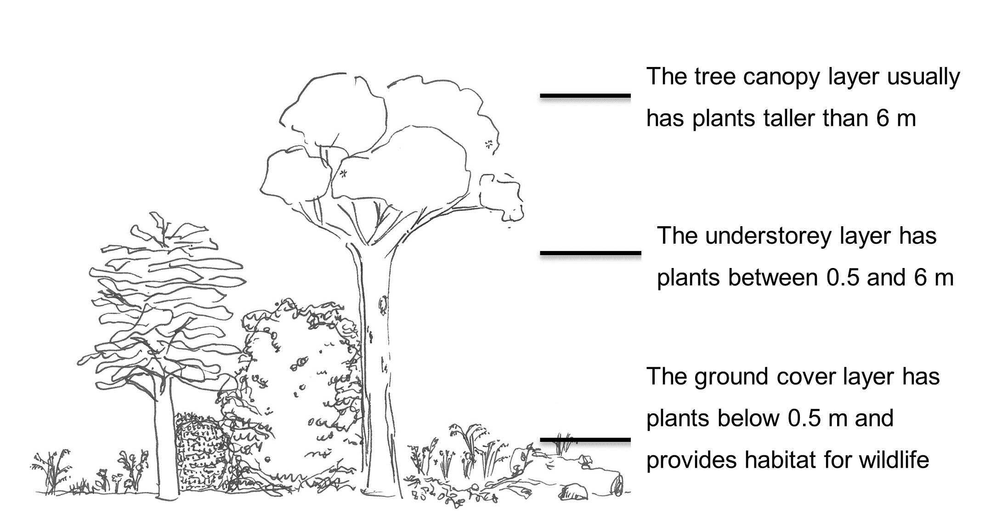
Figure 1: Vegetation layers (Source: April Seymore 2019)

Habitat value
Habitat value means the relative importance of various habitat types and conditions in sustaining socially or ecologically significant wildlife populations and biological diversity.
To increase biodiversity, it’s important to understand which habitat types and conditions are needed in your area to support endemic plants and animals.
Students will investigate the habitat types in the table below to help them get a better understanding of habitat values in your school grounds.

Habitat types and value
Habitat types | Description
Indigenous/native trees taller than 6 metres (dead and alive) | Large trees are natures’ skyscrapers. They provide food and shelter (habitat) for many kinds of animals. They are likely to have hollows that provide homes for reptiles, insects, mammals and birds. Brush-tailed phascogale, birds and the eastern pygmy-possum are some examples of the animals that use tree hollows for shelter.
Introduced / exotic trees taller than 6 metres | These trees also provide food and shelter but to a lesser value than indigenous/native trees. While they do support wildlife, these trees favour introduced wildlife. Examples include African Olive, palm trees and pine trees.
Understorey and ground cover | Trees are not the only types of vegetation that provide habitat for living things – many areas in Australia are naturally treeless and still provide habitat for plants and animals.  The greatest diversity of plant species is usually located in the understorey and ground cover or herb layer level. These plants, which include native grasses, are important because they provide food and shelter for other plants and animals.
Weeds | Some plants reduce the habitat value of an area by smothering other plants or by not providing food and shelter to animals. Agapanthus and holly are two examples.
Organic litter | Mulch, leaves, twigs provide homes and food for many small creatures such as worms, insects and spiders. These in turn are essential for healthy food chains. Organic litter also breaks down to recycle nutrients for plants and keeps the soil moist.
Logs and rocks | Old tree logs and big and small rocks provide habitat for small creatures.
Soil management/erosion | Bare and eroded areas tend to be detrimental to biodiversity.
Productive gardens and animals | These areas are important for pollinating insects and birds. Productive gardens and animal husbandry also have an important role to play in student engagement and wellbeing and allow students to connect with nature. Examples include veggie gardens, sensory gardens and flower gardens.
Extras | Extras covers any infrastructure and behaviours which contribute to increased biodiversity in school grounds.

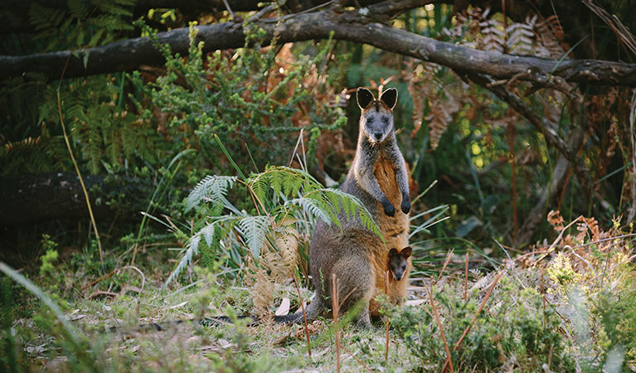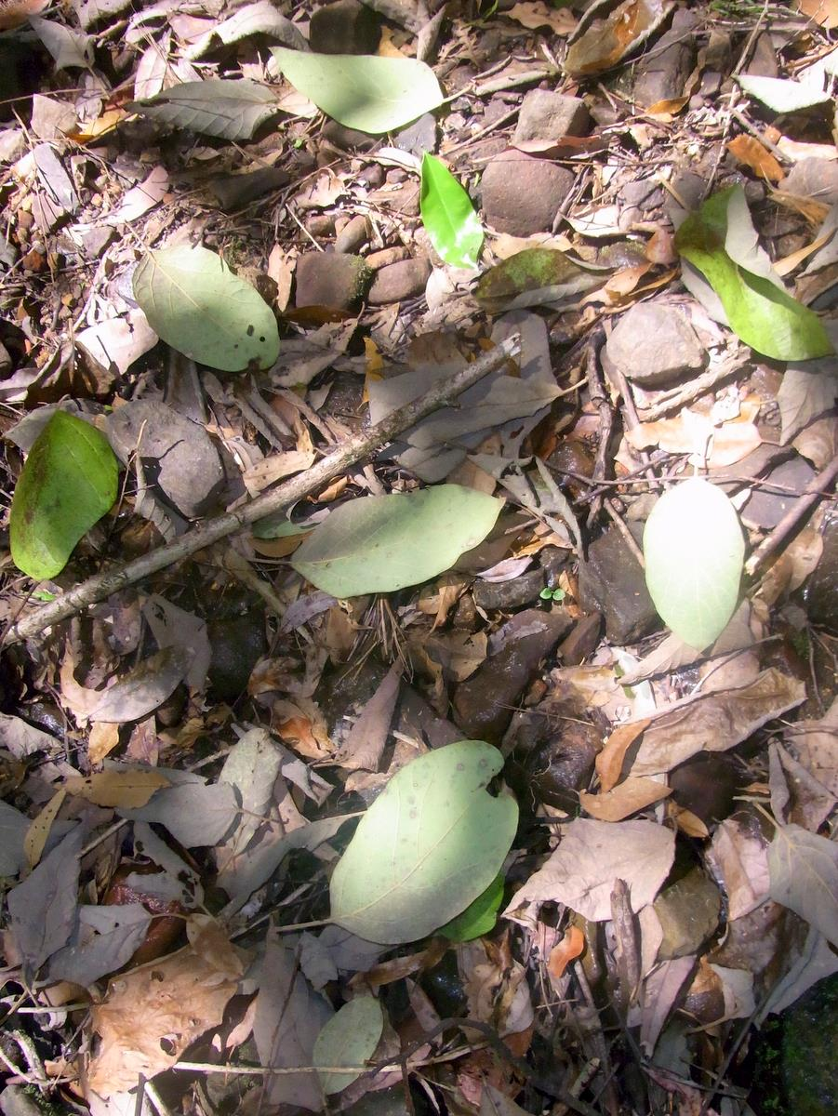
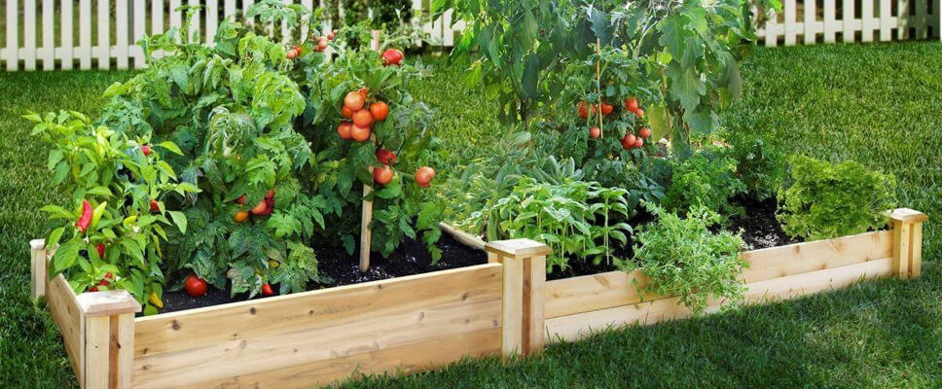T
Photos from top to bottom: Wallabies enjoying the vegetation; Organic litter makes a great home for makes a great home for invertebrate species such as worms, insects and spiders and helps maintain soil health; A veggie garden is a great way for students to learn about biodiversity.

Tips and tricks for a successful audit
Follow these tips for a smoother audit:

Pick a suitable date and notify school staff
Talk with maintenance staff about your planned audit so they can work around it. Check the forecast to avoid extreme weather events.

Decide how to divide the audit task
Students could work in small groups or pairs to assess specific designated areas or habitat features. Alternatively, a whole-class approach per worksheet may be possible if the number of students and/or size of the schools allows it. To calculate the biodiversity score, you will need to collate the data into one worksheet.

Use the audit checklist
The teacher/facilitator checklist takes you step-by-step through the audit and will help you get everything ready in advance.

Learn how to identify tree species
Within school grounds, the general rule of thumb for trees is:
- indigenous/native trees have leaves all year round
- exotic and deciduous trees lose their leaves during winter.
Note: A couple of exotic/deciduous tree species found on school grounds do not lose their leaves. Pine trees (Pinus spp.) are the most common example. Contact the experts listed in Appendix 1: Resources to help identify trees in your school ground. If you end up misidentifying only one or two species, it won’t have a major impact on your biodiversity score.

How to calculate tree height
To work out whether trees are in the canopy or understorey layer, you need to know if they are taller than six metres. The simplest way to calculate if a tree is taller than six metres is to compare its height to the height of a two-storey school building or a power pole. If the tree is the same height or taller, you can record it in as canopy vegetation.
Another method of calculating the height is the stick method for which you need a measuring tape and a stick, pencil or ruler. This method uses the principle of similar triangles to estimate tree heights.
The Gardenality website explains how to use the stick method.

Teacher/facilitator audit checklists

Before audit day

Step 1: Gather background biodiversity information
- Understand biodiversity and prepare pre-reading materials from the earlier section on understanding habitats and resources in Appendix 1 to enrich biodiversity content and understanding.
- Gather background information by talking with ground staff, principal, business manager about current landscape plans, trees planted, weed management, erosion and control strategies.
- Print out an aerial map and colour your school and surrounding area with vegetation and features of your school and local landscape. If your school doesn’t have an aerial map, you can use Google Maps.
- Calculate the size of your school in hectares (ha) using the Google Maps measuring tool or the measuring feature in the located schools settings page in the RSS online system.
Note: You need to know the size of your school in hectares to calculate your school’s biodiversity score. One hectare equals 10,000 m².
- If your school has biodiversity scores from previous years, note the scores and look for any trends.

Step 2: Organise your equipment
Each pair/small group will need:
- Pre-readings
- Aerial map of school grounds and surrounding neighbourhood
- Biodiversity audit worksheets
- Pens and clipboards
- Tape measure
- Camera to gather evidence for your RSS biodiversity module, presentations and audit assessment
- Calculator
- Watch or time-keeping device

On audit day

Step 3: Introduce biodiversity audit tool
- Share biodiversity pre-reading with students and check that students understand all the terms used.
- Review the method with the students (see Step 4).
- Establish student pairs or small groups and designate areas to audit.
- Calculate the size of your school with students if you haven’t done it already.
- Familiarise students with map of school and any designated areas as needed.
- Conduct safety briefing.
- Ensure all students understand their responsibilities, timeframe, equipment and tasks.

Step 4: Collect data and apply mathematics
- Walk around the school’s designated areas to audit and record biodiversity audit findings using the following worksheets:
  - Habitat features
  - Native animal species list
  - Calculating your biodiversity score

During or just after audit day

Step 5: Complete biodiversity action plan prioritise actions
- Discuss the students’ findings – what is the current state of biodiversity in your school?
- Discuss what you can do better or differently to improve your school’s biodiversity score.
- Populate the biodiversity action plan template with findings and recommendations. List actions in priority order (highest to lowest).
- Upload biodiversity audit results, photos and presentation(s) to RSS biodiversity module in the RSS online system as support and evidence.

After the audit

Step 6: Communicate and implement
- Encourage students to present findings and recommendations to the principal, assistant principal and school council (buildings and grounds subcommittee)
- Communicate to the wider community through:
  - presentation(s) during whole school assembly
  - stories and hints in the school newsletter, school blog and your social media channels
  - stall at school fair
  - letter-drop in local area
  - Kids teaching Kids conferences
  - teacher and principal’s conferences.
- Upload presentation(s) to the RSS online system as support and evidence.
- Get the biodiversity action plan approved by the principal, assistant principal and business manager.
- Upload the approved action plan to the biodiversity module in the RSS online system and incorporate it into your School Environment Management Plan (SEMP).

Step 7: Monitoring for continued engagement
Ongoing monitoring will tell you how effective you have been in implementing changes and improving your biodiversity score.
- Complete yearly biodiversity audit.
- Update the biodiversity score in the RSS online system every year.
- Take photos to monitor plant growth or when habitat extras are installed.
- Write stories and share these in school newsletters and intranet. Stories can be about school working bees that included mulching or nest box building or participation in National Tree Day.
- Compare impact and achievements with baseline (reflect on where you started).
- Communicate and celebrate your success with your school community!

Worksheet: Habitat features
Name(s):_________________________________________________Date_________ Section of school surveyed: _______________________________________________
Size of school: ________________hectares (1 hectare = 10,000 m²)
Note: Size can be found in the schools settings page in the RSS online system or calculated using ruler on Google Maps or equivalent.
Record the school habitat you observe in your school grounds.

Canopy count
Habitat feature | Tally (for example IIII) | Total number
Habitat trees – indigenous/ native trees taller than 6 m
Trees – exotic and introduced trees taller than 6 m

Understorey and shrub count
Habitat feature | Tally (for example IIII) | Total number
Shrubs and trees – indigenous/ native under 6 m
Shrubs and trees – exotic and introduced under 6 m

Indigenous/native trees and shrubs planted in the past 12 months
Habitat feature | Tally (for example IIII) | Location | Total number
Indigenous/native shrubs and trees planted in the past 12 months at your school
Indigenous/native shrubs and trees planted in the past 12 months offsite (in your community)

Ground cover/layer
Habitat feature | Tally (for example IIII) | Location | Total number
Indigenous/native ground-covering plants
Rocks and logs – large enough to provide habitat (minimum two teachers to lift)

Extras
Tick any extras you have at your school:
Extras |  | Extras
Exotic and introduced ground-covering plants |  | Native plants naturally regenerating | 
No chemical spray (for weeding, insecticides and fertilisers) |  | Fallen branches and leaf litter left in garden beds | 
Plants identified and labelled |  | Other features that contribute to increasing habitat for local native species such as creeks, lakes, swales, etc. | 
Overflow water from bubbler taps used on garden beds |  | Outside bins with lids or no outside bins | 
Compost area |  | Nest box (1 point for each different animal box) | 
Worm farms |  | Bat tubes | 
Bird bath |  | Insect hotel | 
Frog bog |  | Birds or possums’ boxes | 
Wetland |  | Other nest boxes | 
Rain garden |  | Lizard lounge | 
Note: Schools get one point for each different nest box installed at the school. For example, if you have five wood duck boxes you get one point. If you have one wood duck, one eastern rosella and one kookaburra box you get three points.

Soil management/erosion
Soil management
School not doing much to manage soil | 
School is doing some things to manage soil | 
School is doing a great job at managing soil | 

Mulch cover in garden beds
What percentage of your school’s garden beds are covered with mulch? Mulch ideally needs to cover the soil so you can’t see it and be 3–10 cm in thickness.
Percentage of mulch cover
Less than 25% | 
25–49% | 
50–74% | 
75–99% | 
100% | 

Productive gardens and animals
Tick each one you have at your school:
Productive gardens and animals |  | How are they progressing? (Started but could do more / Doing a great job)
Vegetable gardens | 
Herb gardens | 
Indigenous garden | 
Fruit trees or vines | 
Orchard (with more than 10 trees) | 
Chickens | 
Animal areas | 
Bush tucker garden | 

Weeds
Tick one of the following:
Weed action
No action to control weeds |  | No weeds present | 
Weeds present – some action to manage them | 

Worksheet: Native animal species list
Name(s):_________________________________________________Date_________
Record all the native animal species you can see or hear in your school grounds.

Native animal species at my school
Name and number of native animal | Type of animal* | Name and number of native animal | Type of animal*
E.g. Australian Magpie, 20 individuals | Bird | Gecko, 15 individuals | Reptile
1 |  | 21
2 |  | 22
3 |  | 23
4 |  | 24
5 |  | 25
6 |  | 26
7 |  | 27
8 |  | 28
9 |  | 29
10 |  | 30
11 |  | 31
12 |  | 32
13 |  | 33
14 |  | 34
15 |  | 35
16 |  | 36
17 |  | 37
18 |  | 38
19 |  | 39
20 |  | 40
* Bird, reptile, mammal, amphibian, fish, invertebrate

Worksheet: Calculating your biodiversity score
Name(s):_________________________________________________Date_________
Size of school grounds: _____________hectares (1 hectare = 10,000 m²)
Previous biodiversity score if available: ______________
Calculate and record your scores in the tables below. Circle your answer and write the score in the column on the right.
Remember to calculate the number of trees and shrubs per hectare rather than the total number. For example, a 2-hectare school with 17 habitat trees would be counted as having 5 to 10 large trees (17 trees divided by 2 ha). The school would score 10 points not 15 points.

Canopy score
 | School total | None (0) | <5 per ha | 5–10 per ha | >10 per ha | School score
How many habitat trees (indigenous/ native trees > 6 m) at your school? |  | 0 | 5 | 10 | 15
How many exotic and introduced trees (> 6 m) at your school? |  | 0 | 2 | 7 | 10

Understorey and shrub score
 | School total | <10 per ha | 10–20 per ha | >20 per ha | School score
How many indigenous/native shrubs and trees at your school? (< 6 m) |  | 0 | 5 | 10
How many exotic and introduced shrubs and trees at your school? (< 6 m) |  | 0 | 3 | 5

Ground cover and ground layer score
 | School total | None (0) | 3–5 per ha | >5 per ha | School score
How many indigenous/native grasses at your school? |  | 0 | 3 | 5
Rocks and logs – large enough to provide habitat (minimum 2 people to lift) |  | 0 | 3 | 5

Extras score
 | School total | Zero (0) | 1–3 | 3–6 | 7–10 | >10 | School score
How many extras do you have at school? |  | 0 | 3 | 7 | 11 | 15

Soil management score
 | School not doing much to manage soil | School doing some things to manage soil | School doing a great job at managing soil | School score
How well is soil being managed? | 0 | 3 | 5

Weeds score
 | Weeds present – no action | Weeds present – some management action | No weeds present | School score
How well are weeds being managed? | 0 | 3 | 5

Mulch cover in garden beds score
 | <25% cover | 25–49% cover | 50–74% cover | 75–99% cover | 100% cover | School score
What percentage of garden beds are covered with mulch? | 0 | 2 | 5 | 7 | 10

Productive gardens score
 | School total | No productive gardens | Started but could do more | Doing a great job | School score
Do you have productive gardens have and how are they progressing? |  | 0 | 3 | 5

Native animal species list score
 | School total | <10 species | 10 – 20 species | 20-30 species | 30-40 species | >40 species | School score
How many native animal species did you find? |  | 0 | 2 | 5 | 7 | 10

Total biodiversity score
Add together your scores in each of the end columns to get your school’s total biodiversity score, also known as your habitat quality assessment score.
Total biodiversity score: ______________

Measuring change over time
If you did an audit last year, what was your score: ______________
What is the change in your biodiversity score since last year:_____________

Questions
Where have you seen the biggest changes in biodiversity?

Do you have ideas for improving your biodiversity score?

Appendix 1: Resources

Mapping tools
Use mapping tools to link your school’s biodiversity into your local landscape and catchment.
- Use Google Maps or equivalent to show how vegetation at your school links to local nature and creek reserves. Use the ruler measurement tool to calculate how far away these indigenous areas are and how this could be an issue for animals to move across the landscape.
- Use Google Maps or equivalent to identify your local creek where water run-off from your school flows to. Identify which catchment your school is located in and who your local Catchment Management Authority is.
- NatureKit is the Victorian Government’s interactive GIS (geographic information system) biodiversity map and has layers for Ecological Vegetation Classes from pre-1750 and 2005. Find your school on the map and research what the vegetation was like before Europeans and what it is now.

Biodiversity information
- The health of your above-ground biodiversity relies on the health of your soils and below-ground biodiversity. Learn more about healthy soils through Agriculture Victoria healthy soils and Healthy Soils Australia.
- Weeds have many categories and impacts. Learn more about weeds through Identifying weeds and weed categories and management.

Biodiversity organisations
- The Department of Land, Environment, Water and Planning (DELWP) works in partnership with a range of agencies and stakeholders to protect and preserve Victoria’s native landscape through a range of biodiversity, wildlife, sustainability, climate change and community programs. Visit their website for more information.
- Catchment management authorities plan and coordinate land, water and biodiversity management in their region. Visit DELWP’s website to find your local catchment management authority.
- Coastcare consists of community volunteer groups who work to protect and enhance Victoria’s coastal and marine environments. Visit this website to find to find your nearest group.
- Landcare is a community-based volunteer movement that facilitates and coordinates actions to care for our environment. Visit their website for more information.
- Parks Victoria protects our state's natural and cultural heritage on behalf of all Victorians. Visit their website for more information.
- Victorian Water Authorities support community, education and involvement in sustainable water management. Find out more on the waterwatch website.
- Victorian Environment Friends Groups dedicate themselves to protecting and enhancing different landscapes. Visit their website for more information.

Guides and online resources
- Sustainability Victoria has a range of biodiversity module resources on its website, including a module checklist and a ‘how to’ guide with lots of useful resources.
- The former Department of Primary Industries produced a guide to auditing biodiversity in schools (Biodiversity Up Close). It’s still available from the Royal Botanic Garden Victoria website
- Birds in Backyards is a research, education and conservation program of BirdLife Australia focused on the birds that live where people live.
- Melbourne Water runs a community frog monitoring program and a waterbug census. Visit their website to see more on their environmental projects.
- Museums Victoria has a free Field Guide app to help you identify Victorian wildlife.
- Protecting Victoria’s Environment – Biodiversity 2037 is Victoria’s plan to stop the decline of our native plants and animals and improve our natural environment.
- Looking for a brochure? Ask for weed and native plant and animal brochures from your local council, catchment management authority or DELWP.

Appendix 2: Curriculum links
Exploring the concept of biodiversity, which includes a biodiversity audit, contributes to several different learning areas in the Victorian Curriculum F–10. The table below lists examples of how a biodiversity audit can contribute to student learning outcomes in Years F to 10.
For more inspiration, read about sustainability as a cross-curriculum priority on the Victorian Curriculum website or download the RSS curriculum guides

Linking biodiversity audits with the Victorian Curriculum
Levels | Learning area | Content description
Foundation to Level 2 | Science | - Earth’s resources are used in a variety of ways (VCSSU047)  - Living things have a variety of external features and live in different places where their basic needs, including food, water and shelter, are met (VCSSU042)
Years 3 and 4 | Science | - Science knowledge helps people to understand the effects of their actions (VCSSU056)  - Different living things have different life cycles and depend on each other and the environment to survive (VCSSU058)  - Collect and record relevant geographical data and information from the field and other sources (VCGGC074)  - Types of natural vegetation and the significance of vegetation to the environment, the importance of environments to animals and people, and different views on how they can be protected; the use and management of natural resources and waste, and different views on how to do this sustainably (VCGGK082)
Years 3 and 4 | Mathematics | - Use simple scales, legends and directions to interpret information contained in basic maps (VCMMG172)  - Select and trial methods for data collection, including survey questions and recording sheets (VCMSP178)
Years 3 and 4 | Geography | - Collect and record relevant geographical data and information from the field and other sources (VCGGC074)  - Types of natural vegetation and the significance of vegetation to the environment, the importance of environments to animals and people, and different views on how they can be protected; the use and management of natural resources and waste, and different views on how to do this sustainably (VCGGK082)
Years 3 and 4 | Health and physical education | - Describe strategies to make the classroom and playground healthy, safe and active spaces (VCHPEP095)
Years 3 and 4 | Ethical capability | - Explore the extent to which particular acts might be regarded by different people as good or bad, right or wrong, better or worse, and explain why (VCECU005)
Years 5 and 6 | Science | - Scientific understandings, discoveries and inventions are used to inform personal and community decisions and to solve problems that directly affect people’s lives (VCSSU073)  - Living things have structural features and adaptations that help them to survive in the environment (VCSSU074)
Years 5 and 6 | Mathematics | - Calculate the perimeter and area of rectangles and the volume and capacity of prisms using familiar metric units (VCMMG196)  - Describe and interpret different data sets in context (VCMSP207)
Years 5 and 6 | Economic and business | - Explore the concept of opportunity cost and explain how it involves choices about the alternative use of limited resources and the need to consider trade-offs. (VCEBR002)  - Identify the types of resources (natural, human and capital) and explore the ways societies use them in order to satisfy the needs and wants of present and future generations. (VCEBR003)
Years 7 and 8 | Science | - Some of Earth’s resources are renewable, but others are non-renewable (VCSSU100)  - Water is an important resource that cycles through the environment (VCSSU101)  - Science and technology contribute to finding solutions to a range of contemporary issues; these solutions may impact on other areas of society and involve ethical considerations (VCSSU090)  - Interactions between organisms can be described in terms of food chains and food webs and can be affected by human activity (VCSSU093)
Years 7 and 8 | Mathematics | - Identify and investigate issues involving numerical data collected from primary and secondary sources (VCMSP268)  - Distinguish between a population and a sample and investigate techniques for collecting data, including census, sampling and observation (VCMSP297)
Years 7 and 8 | Geography | - The challenges of managing and planning Australia’s urban future (VCGGK126)  - Strategies used to enhance the liveability of places, especially for young people, including examples from Australia and Europe (VCGGK115)
Years 7 and 8 | Ethical capability | - Discuss how ethical principles can be used as the basis for action, considering the influence of cultural norms, religion, world views and philosophical thought on these principles. (VCECU010)
Year 9 and 10 | Science | - Ecosystems consist of communities of interdependent organisms and abiotic components of the environment; matter and energy flow through these systems (VCSSU121)
Year 9 and 10 | Mathematics | - Identify everyday questions and issues involving at least one numerical and at least one categorical variable, and collect data directly from secondary sources (VCMSP324)
Year 9 and 10 | Geography | - Environmental worldviews of people and their implications for environmental management (VCGGK146)
Year 9 and 10 | Ethical capability | - Investigate criteria for determining relative importance of matters of ethical concerns. (VCECU016)

Glossary
Biodiversity is the term given to the variety of all life forms. This includes all the different plants, animals and microorganisms, as well as the genes they contain and the ecosystems they are part of.
Biological control is the control of pests and parasites using other organisms, often natural predators.
Canopy (or tree canopy cover) is the top layer of vegetation and is made up of trees taller than 6 metres.
Deciduous trees lose their leaves during winter and droughts. Most deciduous trees in Australia are introduced species. Australia has very few native deciduous trees.
Ecosystem refers to a community of plants and animals, how they interact and the physical environment they live in.
Endemic plants or animals are native or indigenous to only a specific smaller region. The advantage of using plants that are endemic to your area is that they grow best in your local conditions where a native species may not survive so easily. In Victoria, we have many endemic plant species that are only found in the Western Plains Grasslands. These plants do not occur naturally anywhere else in Australia or the world.
Erosion is soil lost through wind, water and compaction by humans. At schools, erosion tends to happen on grassed areas where students gather, such as near cricket pitches and football goals
Exotic trees are tree species growing outside of their natural geographical range.
Estimate is to roughly calculate the value, number or quantity of something.
Ground cover or herb layer is the layer of vegetation dominated by non-woody plants less than 0.5 m in height.
Habitat is the place or type of site where plants and animals like to live.
Habitat corridor, wildlife corridor or green corridor is an area of habitat connecting wildlife populations separated by human activities or structures like roads, houses or logging.
Habitat tree is an indigenous or native tree taller than 6 metres that provides nesting space or shelter for animals.
Habitat value is the relative importance of various habitat types and conditions in sustaining socially or ecologically significant wildlife populations and biological diversity.
Hectare is a unit of land measurement equalling 10,000 m². (100 m × 100 m in size).
Indigenous or native plants and animals naturally occur in a wide geographic range without having been introduced by humans. For example, kangaroos are indigenous to Australia and are found widely across Australia. Kangaroos do not occur naturally anywhere else in the world. Plants and animals can sometimes be naturally found in Australia but may not be local to your area (see Endemic).
Introduced flora and fauna are plants and animals that are not native and have been accidentally or deliberately been brought to Australia by humans. Introduced plants and animals might also be brought in by animals.
Invertebrates are animals lacking a backbone. The most common invertebrates include the protozoa, annelids, echinoderms, molluscs and arthropods. Arthropods include insects, crustaceans and arachnids.
Log is a tree branch on the ground which is larger than a cricket or baseball bat.
Mulch is the organic materials that are no longer attached to a plant and have fallen to the ground (includes leaves, twigs, and small branches less than 30 cm in diameter). Mulch ideally needs to cover the soil so you can’t see it and be 3–10 cm in thickness.
Nest boxes are designed and built to provide shelter for animals in areas where old trees and hollows are missing. Many Australian animals rely on tree hollows for shelter and nests. It takes many decades for a tree to create a suitable hollow – often more than 80 years. Different species need different types of nest boxes.
Organic litter is the mulch, leaves and twigs covering the ground. It provides homes and food for many small creatures such as worms, insects and spiders, which are essential for healthy food chains. Organic litter also breaks down to recycle nutrients for plants and keeps the soil moist.
Percentage is a part or portion expressed in hundredths.
Pollination is the transfer of pollen grains from one flower to another
Productive gardens and animals are areas for growing edible plants and raising animals like chickens. Students can learn about growing and caring for food plants, domesticated animals and Indigenous plants.
Provenance is based on the idea that local plants are genetically adapted to local environmental conditions. Knowing the provenance of your plants means you understand where they have come from.
Regeneration is the regrowth of plants.
Shrubs are a low-growing woody plant, usually with several major branches.
Soil management is the way soil is managed in the school grounds in relation to erosion.
Tally is a method of recording data by making a mark for each positive answer and then counting the number of marks.
Understorey is the layer of vegetation under the tree canopy and is usually between 6 and 0.5 metres.
Vertebrates are animals that have a backbone or spinal column. They include mammals, birds, reptiles, amphibians and fishes.
Victoria’s Grasslands are dominated by perennial, mostly tufted or tussock-forming grasses and occur on the vast, undulating western volcanic plains, the northern plains and in Gippsland.
Weeds can be species growing in the wrong place where it did not exist before. Many plants introduced into Australia in the last 200 years are now weeds.

