Introduction
Biodiversity Response Planning (BRP) is a long-term area-based planning approach to biodiversity conservation in Victoria. It is designed to strengthen alignment, engagement and participation between government, Traditional Owners, non-government agencies and the community.
DELWP Regional staff have been working with stakeholders on actions to conserve biodiversity in specific landscapes, informed by the best available science and local knowledge.
These Fact Sheets capture a point in time, reflecting data and knowledge available in 2020. They provide information for many (but not all) landscapes across Victoria, containing general information on the key values and threats in each area, as well as the priority cost-effective actions that provide the best protection of biodiversity. Fact Sheets are intended to provide useful biodiversity information for the community, non-government and government organisations during project planning and development.
Further information and the full list of Fact Sheets is available on the Department’s Environment website.

Landscape description
This 26,818ha area is a mostly cleared landscape (31% native vegetation cover) and is mostly private land (82%). The landscape is bordered by Northern Grampians in the west and Stawell in the east.

Habitat Distribution Models identify 6 species with more than 5% of their Victorian range in this landscape
6 Plants
- Tawny Spider-orchid (11% of Victorian range in landscape, endangered)
- Elfin Leek-orchid (10% of Victorian range in landscape, endangered)
- Pomonal Leek-orchid (9% of Victorian range in landscape, endangered)
- Veined Spider-orchid (9% of Victorian range in landscape, vulnerable)
- Rising Star Guinea-flower (5% of Victorian range in landscape, endangered)
- Dense Bent-grass (7% of Victorian range in landscape, endangered)

Strategic Management Prospects
Strategic Management Prospects (SMP) models biodiversity values such as species habitat distribution, landscape-scale threats and highlights the most cost-effective actions for specific locations. More information about SMP is available in NatureKit.

Which landscape-scale actions are most cost-effective in this landscape?
Some areas of this focus landscape (coloured areas on the map) have highly cost-effective actions which provide significant benefit for biodiversity conservation.
The SMP priority actions which rank among the top 10% for cost-effectiveness of that action across the state are in order:
Control rabbits 6,980ha
Control weeds 4,748ha
Control overabundant kangaroos 3,366ha
Control foxes 2,368ha
Control pigs 1,942ha
Revegetation 1,626ha
Control cats 831ha

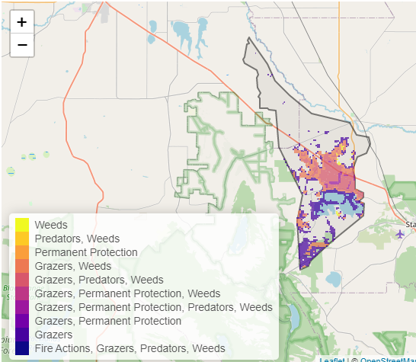
Of the top 3% of cost-effective actions, control rabbits, control weeds and control overabundant kangaroos ranked the highest.

The most cost-effective actions for flora & fauna
Plants - Control rabbits, control weeds, control kangaroos, control foxes
Birds - Control rabbits, combined fox and cat control, control weeds, control pigs, control kangaroos
Mammals, Reptiles - Control rabbits, combined fox and cat control, control kangaroos, control weeds
Amphibians - Control rabbits, combined fox and cat control, control weeds

For a further in depth look into SMP for this landscape please refer to NatureKit.
