Background / preamble
The Mullungdung Darriman landscape was recognised during the 2019/20 Gippsland Biodiversity Response Planning (BRP) process as a focus area for future collaborative biodiversity action and investment.
Under the Victorian Government’s Biodiversity 2037: Protecting Victoria’s Biodiversity plan, the BRP process is a long-term area-based planning approach to biodiversity conservation in Victoria. It is designed to strengthen alignment, engagement and participation between government, Traditional Owners, non-government agencies and the community to benefit biodiversity by working together to identify, promote and tackle local biodiversity needs as part of an ongoing collective process.
In 2019/20, significant impacts from the bushfires in East Gippsland and coronavirus (COVID-19) on community, biodiversity stakeholders and agencies, and the environment, resulted in planned engagement with many local stakeholders in Gippsland about BRP being postponed to a future process. In the interim, a multi-agency working group of local staff in Gippsland came together to identify a series of potential strategic priority actions across the region, as well as 13 focus landscapes. Membership of this working group for Gippsland included staff from the Department of Environment, Land, Water and Planning (DELWP) coasts & marine policy and local forest, fire and biodiversity teams, East Gippsland and West Gippsland Catchment Management Authorities (EGCMA & WGCMA), Parks Victoria, Trust for Nature (TfN), the Bunurong Land Council Aboriginal Corporation (BLCAC) and the Gunaikurnai Land and Waters Aboriginal Corporation (GLaWAC).
As part of this process, the Gippsland BRP working group drew upon information available from the DELWP Strategic Management Prospects (SMP) tool as well as their own local knowledge to identify key biodiversity assets, threats and potential management actions across Gippsland. A subset of this information is presented in this Fact Sheet, reflecting a point in time assessment of some of the important biodiversity needs and landscapes for focus across the region.
These BRP Fact Sheets provide useful biodiversity information for the community, non-government and government organisations during project planning and development, including guidance for stakeholders interested to contribute towards some of the strategic priorities identified in these areas to date. Further information and the full list of Fact Sheets is available on the Department’s Environment website.

Landscape description
Landscape context: 170,463ha, 38% public land, 40% native vegetation cover
The Mullungdung Darriman landscape lies in the rain-shadow area of the Strzelecki Ranges and incorporates the coastal lowlands on the sandy plains between the Strzelecki Ranges and the coast. The predominant vegetation types in this area include Shrubby Dry Forest, Heathy Woodland and Lowland Forest with some small areas of Damp Forest in gullies in the west (in Mullungdung and Boodyarn Forest and Holey Plains State Park) as well as Grassy Woodlands across the Darriman and Dutson Plains and Coastal Banksia Woodlands, Heathy Woodlands, heathlands and saltmarsh vegetation along the coast.
The area includes a mixture of land uses including state forests (Mullungdung and Boodyarn), conservation reserves (Holey Plains, Giffard Rifle Range Nature Conservation Reserve (NCR), and freehold land used for plantation forestry and grazing across the Darriman and Dutson Plains. Additional features include Toms Cap, Kangaroo Swamp, and Jack Smith Lake with main towns including Seaspray and Woodside.

Biodiversity highlights and important places:
Mullungdung and Won Wron State Forests and Holey Plains State Park comprise landscape-scale lowland forest and heathy woodland that has escaped clearing for grazing, rare in west Gippsland. These areas support representative flora and fauna for these types of forest as well as threatened species such as Powerful Owl, Masked Owl, Wellington Mint-bush, Dwarf Kerrawang, Trailing Hop-bush and Purple Diuris. This landscape also provides important habitat for the genetically diverse South Gippsland koala population and quality patches of native grassland remain between the Mullungdung forest to the coast.
Important vegetation communities in this landscape include:
*FFG listed | Plains Grassland (South Gippsland) Community
**EPBC listed | Subtropical and Temperate Coastal Saltmarsh Community  Natural Damp Grassland of the Victorian Coastal Plains
*Flora and Fauna Guarantee Act 1988 (Victorian)
**Environment Protection and Biodiversity Conservation Act 1999 (Federal)

Cultural importance
We would like to acknowledge the Traditional Owners and custodians of the land across this landscape, the Gunaikurnai particularly the Brataualung, Brayakaulung and Tatungalung people. We pay our respects to Country, and to Elders past and present whose knowledge and wisdom has ensured the continuation of culture and traditional practices. We are committed to genuinely partner, and meaningfully engage, with Victoria’s Traditional Owners and Aboriginal communities to support the protection of Country, the maintenance of spiritual and cultural practices and their broader aspirations into the 21st century and beyond in the spirit of self-determination.
The Gunaikurnai Land and Waters Aboriginal Corporation (GLaWAC) are the appointed Registered Aboriginal Party (RAP) and hold a Native Title Determination and Traditional Owner Recognition Settlement Agreement over this area. GLaWAC are an ongoing member of the Gippsland BRP working group.

Stakeholder and community interest
Local engagement for BRP in Gippsland in 2019/20 was postponed due to impacts from fire and coronavirus (COVID-19). If you would like to contribute local knowledge about this landscape in the future, find out more about BRP or add your name to the state-wide or Gippsland BRP stakeholder lists, you can find further information on the Department’s Environment website.

Species summary
An analysis of available Habitat Distribution Models* identified 71 species with more than 5% of their Victorian range falling within the Mullungdung Darriman BRP landscape, including 17 threatened species and 7 EPBC listed species.
*Note: While version 2.0 of the SMP model utilises HDMs for ~3,200 terrestrial species in its analysis, these models currently exclude aquatic, invertebrate, marine and non-vascular plant species. These HDMs and SMP will continue to be improved upon with ongoing input from species experts and natural resource management practitioners.
Species class | Species with a high proportion of their Victorian distribution in this landscape | Other notable species identified during the BRP process
65 plants, incl. 14 threatened species (6 EPBC) | Notable species include:  - Wellington Mint Bush Prostanthera galbraithiae (EPBC listed, Vulnerable, 74% of Victorian range, restricted to central Gippsland)  - Gippsland Lakes Peppermint Eucalyptus arenicola (49% of Victorian range, restricted to central Gippsland)  - Dwarf Kerrawang Commersonia prostrata (EPBC listed, Endangered, 44% of Victorian range, Victorian population restricted to swampy land and lake margins around Rosedale-Stradbroke-Providence Ponds areas)  - Small-leaf Star hair Astrotricha parvifolia subsp. 1 (FFG listed, vulnerable, 32% of Victorian range, restricted to Gippsland Lakes hinterland area) and Astrotricha parvifolia (30% of Victorian range, restricted to central Gippsland)  - Shy Sun-orchid Thelymitra planicola (23% of Victorian range)  - Golden Grevillea Grevillea chrysophaea (23% of Victorian range)  - Green-striped Greenhood Pterostylis chlorogramma (EPBC listed, Vulnerable, 13% of Victorian range)  - Blotched Diuris Diuris sp. aff. dendrobioides (Bairnsdale) (FFG listed, endangered, 8% of Victorian range, restricted predominantly to area around Bairnsdale)  - Thick-lip Spider-orchid Caladenia tessellata (EPBC listed, Vulnerable, 6% of Victorian range) | - Purple Diuris Diuris punctate (FFG listed, vulnerable, 4% of Victorian range)  - Matted Flax-lily Dianella amoena (EPBC listed, Endangered, 4% of Victorian range)  - Trailing Hop-bush Dodonaea procumbens (EPBC listed, Vulnerable, 2% of Victorian range, population at Dutsons Downs is an important site for this species and the only known existing site in Gippsland)
1 mammal, incl. 1 threatened species (1 EPBC) | Including:  - New Holland Mouse (EPBC listed, Endangered, 43% of Victorian distribution) | - Greater Glider (EPBC listed, Vulnerable, 1% of Victorian range)
0 reptiles | No species with more than 5% of their Victorian range within this landscape. | Landscape supports many common reptile species.  Lace Monitor also present (FFG listed, endangered, 1% of Victorian range)
1 bird, incl. 0 threatened species (0 EPBC) | Including:  - Beautiful Firetail (6% of Victorian range) | - Powerful Owl (FFG listed, vulnerable, 2% of Victorian range)
4 frogs, incl. 2 threatened species (0 EPBC) | Notable species include:  - Martin’s Toadlet (FFG listed, endangered, 35% of Victorian range)  - Southern Toadlet (FFG listed, vulnerable, 7% of Victorian range) | - Growling Grass Frog (EPBC listed, Vulnerable, 1% of Victorian range)
Other species raised by the working group (e.g. fish, invertebrates etc):
None raised

Strategic Management Prospects
Strategic Management Prospects (SMP) models species distributions, habitat importance, landscape-scale threats, and management costs. It then compares and highlights those places with the greatest opportunities for cost-effective action state-wide. Learn more about this tool on the SMP webpage.

Which landscape-scale actions are most cost-effective in this landscape?
The maps and information below show those places and actions modelled by SMP to provide the best opportunities for cost-effective action to benefit biodiversity across the state. Coloured areas in the maps below indicate opportunities for highly cost-effective actions that provide significant benefits to biodiversity in those places. If undertaken across Victoria, these collective actions should provide the greatest potential benefit to biodiversity by focusing on undertaking landscape-scale actions in places where they will provide the greatest benefit for cost across all species.
Map a) shows actions in the top 3% cost-effectiveness areas, and Map b) shows actions in the top 10% cost-effective areas.
The following landscape-scale actions were ranked among the top 3% cost-effective opportunities for biodiversity action across the state by SMP:
Map a) – SMP top 3% cost-effective actions
 | Control overabundant kangaroos 2,992ha
 | Control deer 253ha
 | Permanent protection 127ha
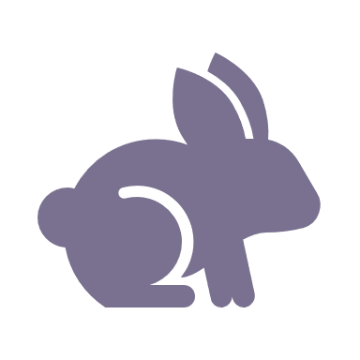 | Control rabbits 71ha
 | Control weeds 51ha

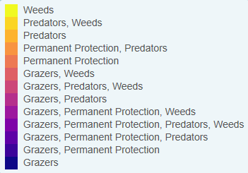

The following landscape-scale actions were ranked among the top 10% cost-effective opportunities for biodiversity action across the state by SMP:

Map b) – SMP top 10% cost-effective actions
Control deer 57,475ha
Combined cat and fox control 51,941ha
Control cats 38,181ha
Control rabbits 30,243ha
Control overabundant kangaroos 31,934ha
Control weeds 21,855ha

The most cost-effective actions for flora & fauna according to SMP
 | Plants – Control deer, Combined fox and cat control (particularly cats) and Control rabbits |  | Birds – Combined fox and cat control (particularly cats) and Control deer
 | Mammals – Combined fox and cat control (particularly cats) |  | Amphibians – Combined fox and cat control (particularly cats) and Control deer
 | Reptiles – Combined fox and cat control (particularly cats) and Control deer
For a further in depth look into SMP for this landscape please refer to NatureKit.

Additional threats raised by the working group
- Encroachment by native shrubs (e.g. Burgan Kunzea ericoides) into remnant grassland areas

Highest priority strategic actions
With consideration of the information available in SMP and local knowledge of this landscape, the Gippsland BRP working group identified the following priority actions for future collaboration and investment in this landscape:
The highest priority actions for the Mullungdung Darriman landscape include:
 | - Revegetation and permanent protection of remnant grassy woodland and fringing wetland areas
 | - Controlling deer
 | - Integrated predator control
 | - Ecological burning and controlling invasive shrubs (e.g. Burgan Kunzea ericoides) and transformer weeds
Other key actions highlighted by the working group include:
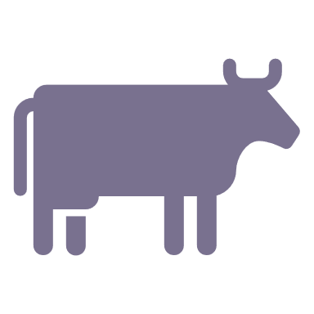 | - Localised control of native and introduced grazers, including rabbits, domestic stock and overabundant kangaroos and wallabies

