Introduction
Biodiversity Response Planning (BRP) is a long-term area-based planning approach to biodiversity conservation in Victoria. It is designed to strengthen alignment, engagement and participation between government, Traditional Owners, non-government agencies and the community.
DELWP Regional staff have been working with stakeholders on actions to conserve biodiversity in specific landscapes, informed by the best available science and local knowledge.
These Fact Sheets capture a point in time, reflecting data and knowledge available in 2020. They provide information for many (but not all) landscapes across Victoria, containing general information on the key values and threats in each area, as well as the priority cost-effective actions that provide the best protection of biodiversity. Fact Sheets are intended to provide useful biodiversity information for the community, non-government and government organisations during project planning and development.
Further information and the full list of Fact Sheets is available on the Department’s Environment website.

Landscape description
This 59,972ha area encompasses the coastline and wetland areas around Western Port Bay, from Point Leo to San Remo, the coast of French Island, and the mud banks of north east Phillip Island. The landscape has 45% native vegetation, and 15% public land.
This landscape has a minor overlap with the Mornington Peninsula and Westernport Flats landscapes along the coast. For more information, please refer to the Westernport Bay Ramsar Fact Sheet in the full list of Fact Sheets.
Note: the main land area of French Island is considered as a separate landscape.

Cultural importance
We recognise that the entire landscape has high cultural value for Traditional Owners. Some landscapes have notable cultural importance based on knowledge shared by Traditional Owners.
Westernport Bay Ramsar is a site of important cultural significance for the Bunurong Land Council.

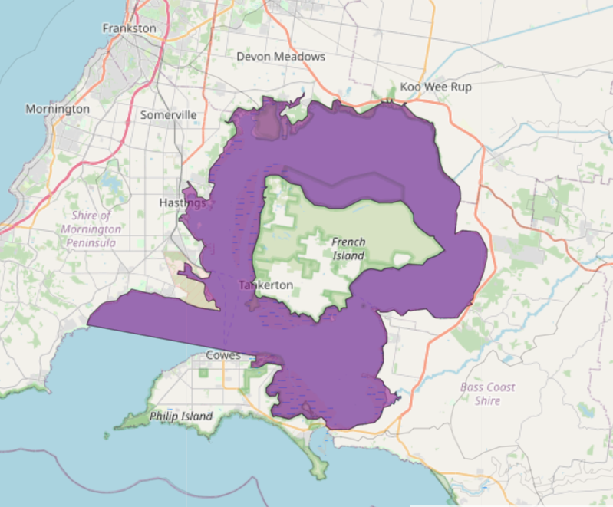

Figure 1: Map showing location of Westernport Bay Ramsar (purple).

Habitat Distribution Models identify 2 species with more than 5% of their Victorian range in this landscape
- 2 Plant species
- 1 species with more than 10% of statewide range in area
- Notable species: Tasman Grass-wrack (rare, 10% statewide range in area), Grey Mangrove (rare, 5.3% statewide range in area), Coast Saltwort (rare, 3.8% statewide range in area), Marsh Saltbush (rare, 3.5% statewide range in area)
- 0 Bird species with more than 5% of their Victorian range in this landscape
- Notable species: Sooty Oystercatcher (near threatened, 5.0% statewide range in area), Ruddy Turnstone (vulnerable, 4.9% statewide range in area), Lesser Sand Plover (critically endangered, 4.9% statewide range in area), Great Knot (endangered, 4.7% statewide range in area), Black-faced Cormorant (near threatened, 4.6% statewide range in area)

Strategic Management Prospects
Strategic Management Prospects (SMP) models biodiversity values such as species habitat distribution, landscape-scale threats and highlights the most cost-effective actions for specific locations. More information about SMP is available in NatureKit.
Actions with area in the top 3% and top 10%
Specific Action | Area in top 3% (ha) | Area in top 10% (ha)
Control Rabbits | 10 | 2,126
Control Cats | 0 | 1,907
Control Foxes | 0 | 1,722
Control Pigs | 818 | 1,701
Control Weeds | 1 | 1,037
Total Grazing Pressure | 47 | 580
Goat Control | 502 | 551
Control Overabundant Kangaroos | 52 | 524
Domestic Grazing Control | 0 | 433
Control Deer | 0 | 363
Permanent Protection | 0 | 95
Revegetation | 0 | 2
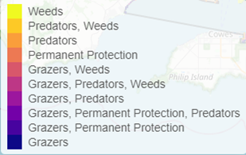
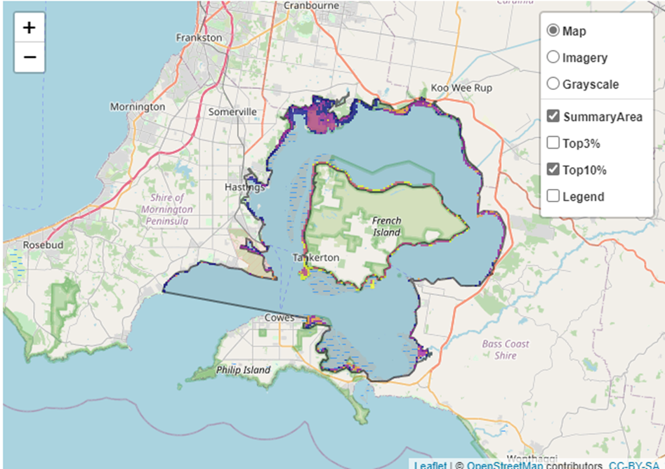
Areas of Westernport Bay Ramsar shown in Figure 2 have highly cost-effective actions (within the top 10% of cost-effectiveness for that action across the state) that provide significant benefit for biodiversity conservation.
Figure 2: The SMP priority actions which rank among the top 10% for cost-effectiveness of that action across the state. “Grazers” includes deer, domestic grazing, goats, horses, over-abundant kangaroos, pigs, rabbits and total grazing pressure

The most cost-effective actions for flora & fauna
Plants - Control rabbits
Birds, Mammals, Amphibians and Reptiles - Combined cat and fox control

For a further in depth look into SMP for this landscape, please refer to NatureKit.

Current actions in Westernport Bay Ramsar
Specific Actions | Current actions – top 10% (ha) | Current actions – outside top 10% (ha)
Pig Control | 637 | 20
Fox Control | 216 | 351
Rabbit Control | 102 | 193
Weed Control | 21 | 526

Current actions – top 10% = The area (ha) of the specific action currently occurring in locations identified by SMP as being in the top 10% for cost-effectiveness for that action across the state
Current actions – outside top 10% = The area (ha) of the specific action currently occurring in locations within this landscape that are not identified by SMP as being in the top 10% for cost-effectiveness for that action across the state

What you told us
SMP is just one tool to use in the process of defining focus landscapes. Feedback from our stakeholders is also vitally important and forms the basis of our understanding of knowledge gaps.

Westernport Bay Ramsar was identified by stakeholders as a focus landscape in the ‘medium’ category in Port Phillip region.

Stakeholder interest

Important landscapes
- Western Port Ramsar site
- Cannons Creek
- Warneet
- Blind Bight & Tooradin coastal area

Current activities/programs/partnerships
- Melbourne Water Priority Wetlands Region – Healthy Waterways Strategy
- Port Phillip and Westernport CMA Regional Catchment Strategy – Naturelinks – Ramsar Protection Program – Western Port coast
- Ecological burning
- Melbourne Water/Parks Victoria Spartina eradication partnership
- Biodiversity Response Planning project 020 – Building the Bass Coast biolinks
- Trust for Nature land covenanting program

Additional threats
Threats identified through the consultation process (in addition to those modelled in SMP):
- Unrestricted access increasing physical disturbance to vegetation, ad-hoc track formation and erosion.
- Predation from domestic dogs and cats as well as foxes
- Habitat modification and resource competition from European Rabbits
- Weed infestation, particularly resulting from unregulated slashing practices
- Climate change

