  - How to add a survey and species records to a project in the Victorian Biodiversity Atlas

This is a basic step by step guidance document to help you create a Survey and add your species records to a VBA Project. This guide uses the Survey Method of Translocation
Key Points:
- Use VBA Project ID 5838 only.
- Survey Method use Translocation;
- Extra Info details to note if it is Salvage site or the Release/Translocation site.

Share the data either via online VBA application or via dedicated upload template.

Direct Data entry Tips
Throughout the VBA each window has a ? in the top right hand corner – this is window-specific help that will provide further details about how to complete the fields. Make sure that you have allowed pop-ups from your browser (you will need to allow these from the VBA site)
Also, throughout the VBA fields marked with a red dot (●) are mandatory fields and must be completed. The fields marked with a yellow dot (●) are conditional - if you complete one you must complete the others.
- Visit VBA (https://vba.dse.vic.gov.au/vba/) and Login using your Login Name & Password (see VBA Registration Help Guide).
- Go to Data Entry in the top left screen, and select My Projects. Select Project 5834 from your list of Projects by clicking if this is not displayed you need to contact vba.help@delwp.vic.gov.au to be added
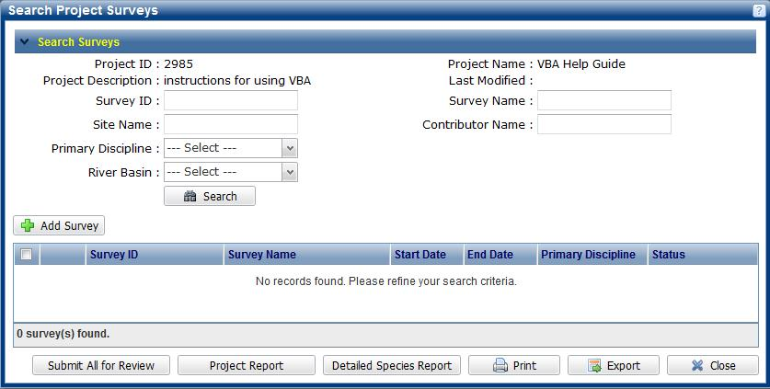
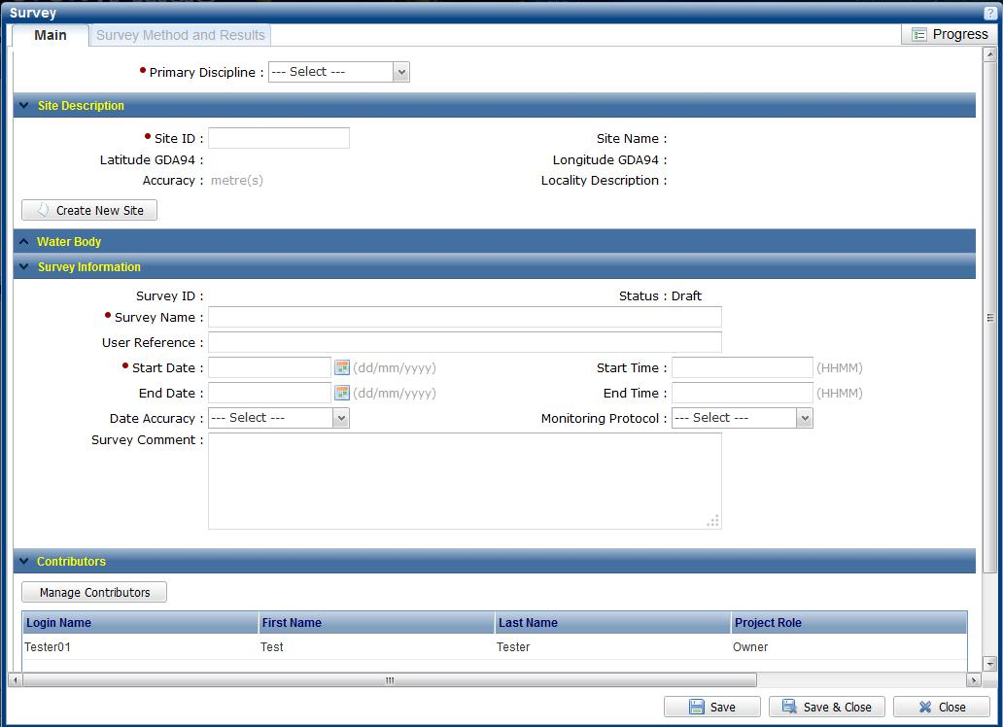

- Click Add Survey and fill in the mandatory fields (●): Primary Discipline, Survey Name & Start Date.
Survey Name should follow the format of ‘Species + translocation + fire area or park area + Salvage or Release. Specific identifiers you have can be added to the User Ref text (or in the species details later).
- You also need to record the location: select Create New Site (and follow the process described below in point 5) or if you know the VBA Site ID or are releasing to the same site that you salvaged from then add that SITE ID and press the Enter key on your keyboard and skip step 5.
- After Create New Site, you need to complete the mandatory fields: site Name, Locality and Accuracy (in metres). You can then either plot the position directly on the map as a point or polygon (zoom in to the location first), or you can type the coordinates into the Point Information section. Click Validate Location to confirm the point is plotting where you expect then Save. Once the Site ID has been populated Close this screen.

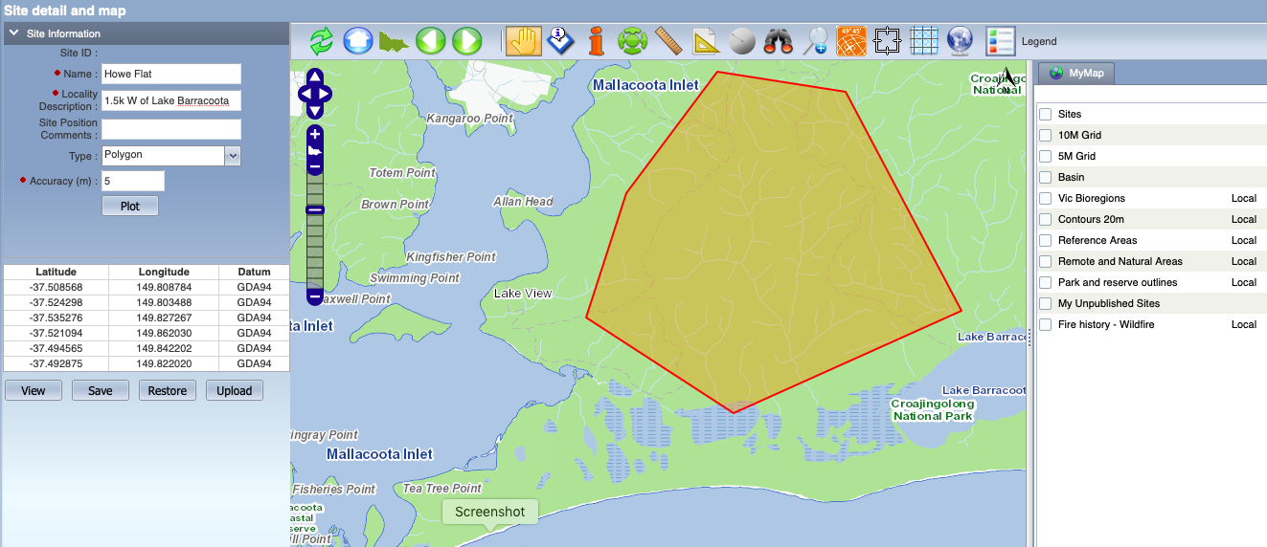

- Once all the Main information in the Survey has been completed click Save. The Survey Method & Results tab in the top left is now available for you to add your survey method and species records.
- Click Add Survey Method and select the TRANSLOCATION from Survey method from the drop-down list – The Method details can be updated to state the location where the individuals originated (Source of Taxa).
- After clicking Save, the Species Records tab in the top left becomes available and you can now add the species.
- Include the Type of Record as either: Capture for the salvage site OR Release for the translocation record.
- Extra Informaiton select: Salvage or Released/Translocation
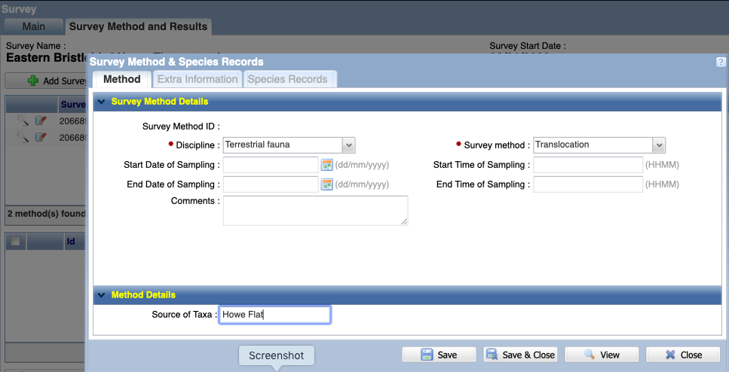
Select Translocation as the Method for both Salvage and Release surveys. Select Save to add Species Records
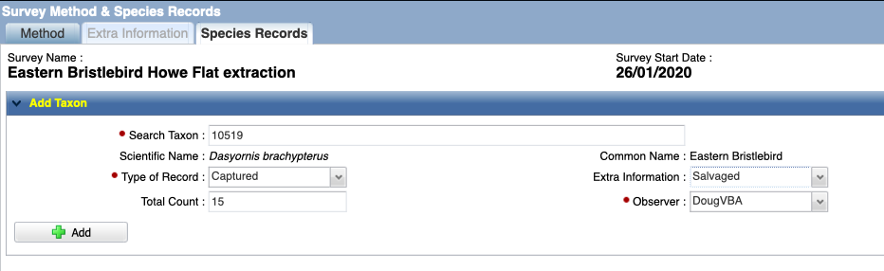
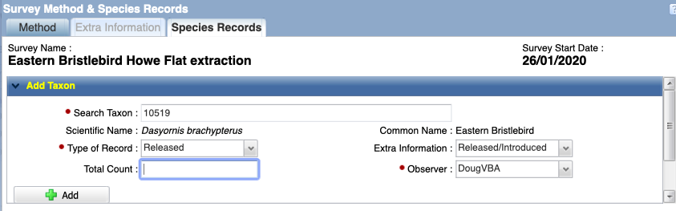
- Fill in the Type of Record and the Extra Information appropriate to the salvage and release activities – notes these will be in separate surveys. Include the number of individuals salvaged from this site on this date before selecting Add.

- If there are further details about the individulas (breeding status, tags and individual details) you can edit this after adding the observations and double clicking on the record. Save and Close when complete.
- You will have now returned to the Survey Method & Results window. Note: If you are returning to an existing survey make sure the window is in Edit mode before you make changes by clicking Edit.

- Before you submit the data for Expert Review and publication, the VBA requires the records to be validated. To do this go to the Validate and Submit in the bottom left corner – this gives a Rating indicating whether the species has been recorded in the vicinity before.
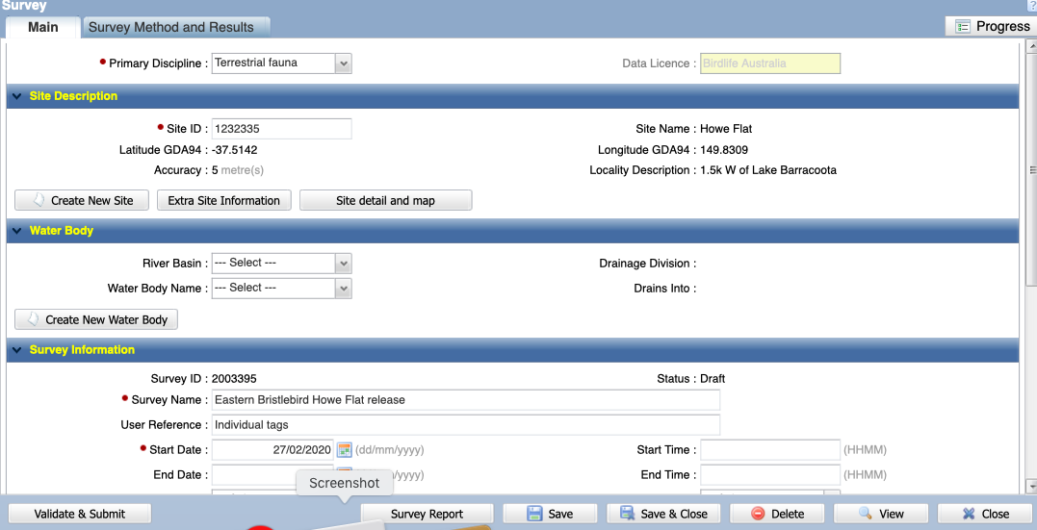

For each salvaged population there should be at least 2 surveys - one for extraction and one or more for release/re-introduction depending on where the individuals end up.

- Finally, Continue, and your whole survey will be submitted for Expert Review. Note: You will not be able to make any changes to this Survey until after the Review process has been completed.
- Once your records have been reviewed the Reliability field will be completed with either confirmed or acceptable which will lead to the records being published. If further evidence has been requested from you (via email from the VBA) the records will be classified as unconfirmed. Unconfirmed records will remain in draft and not visible to anyone other than the contributor until further evidence has been provided and the records can be re-assessed.

