|  |
| --- |
| Ecosystem services from forests in Victoria:  Assessment of Regional Forest Agreement regions |
| Fact sheet – December 2019 |

## Accounting for forest ecosystems

Victoria’s forests have unique intrinsic value and they are also vital to our economy and society. Forest ecosystems contribute to the generation of a variety of goods and services upon which people depend. These contributions are known as ecosystem services and they range from the provision of clean water, to the sequestration and storage of carbon, to opportunities for recreation and relaxation.

The Department of Environment, Land, Water and Planning has completed an assessment of ecosystem services from forests across Victoria’s five Regional Forest Agreement (RFA) regions using the United Nations System of Environmental-Economic Accounting.

The study is the first comprehensive assessment of forest ecosystem services across RFA regions. It highlights the diverse range of services that flow to Victorian communities and industries. It reveals the significant value forests contribute through these services.

Improving our ability to measure and value ecosystem services will help to increase understanding of the linkages between healthy forests and economies and communities, and ensure we manage forests so these important services can be provided into the future.

## What are ecosystem services?

Ecosystem services are the contributions ecosystems make to economic and other human activity. They are typically classified as provisioning, regulating or cultural services (see Table 1).

Ecosystem services can flow directly to people, and they can also be used by industries as inputs to the production of goods and services. Victorian industries that directly use forest ecosystem services include the tourism, water, timber, apiary and agriculture industries.

Although communities and industries benefit from ecosystem services, their value is often not captured in standard measures of economic activity such as gross state product or is not attributed to ecosystems. Environmental-economic accounting reveals this value.

|  |
| --- |
| The United Nations **System of Environmental-Economic Accounting** (SEEA) is a framework for capturing and organising information on the environment, including its contribution to economic and other human activity. It is based on internationally agreed accounting concepts.  Countries around the world are implementing the SEEA to better understand, monitor and report on the linkages between the environment and the economy and society. |

Table 1: Ecosystem services from forests in Victoria

|  |  |  |
| --- | --- | --- |
| Provisioning | Regulating | Cultural |
| Water provision  Biomass for timber  Biomass for firewood  Honey  Fodder | Water flow regulation  Soil retention  Carbon sequestration and storage  Pollination  Habitat for species  Air filtration  Pest and disease control | Recreation and tourism  Social and community connection  Cultural heritage connection  Amenity  Education and research |

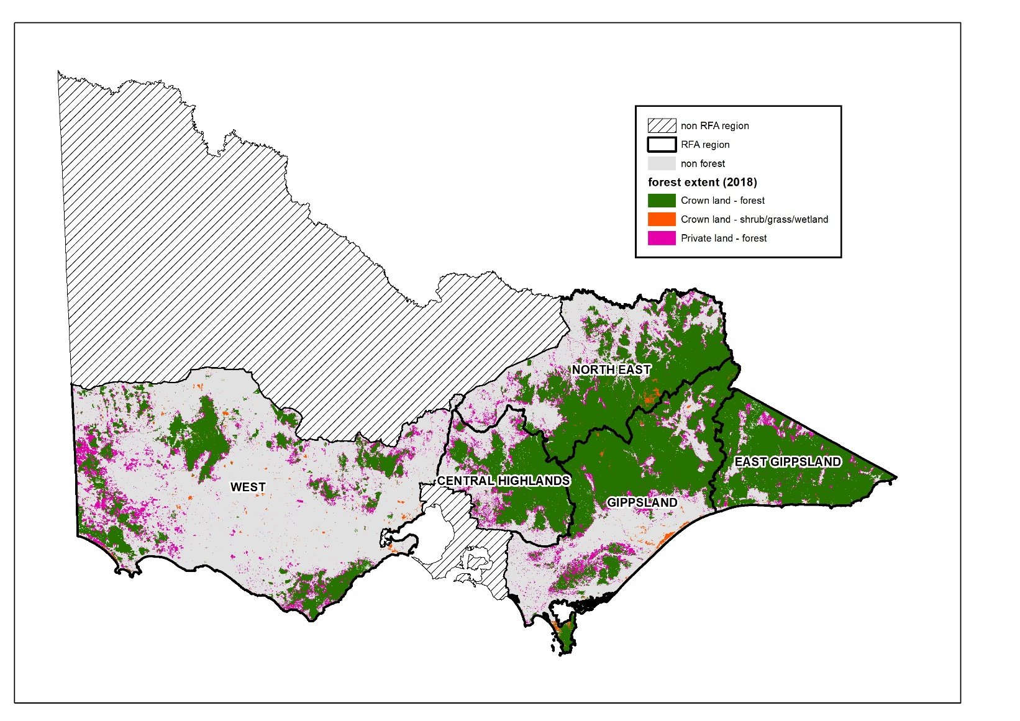

Figure 1: Forest ecosystem extent across the five Victorian RFA regions

## Valuing ecosystem services

Biophysical modelling and spatial analysis has been undertaken to quantify flows of ecosystem services from forests across Victorian RFA regions.

Ecosystem services can be challenging to value because they are often not traded in markets, meaning that prices are not readily observable. A range of market and non-market valuation techniques are used to estimate value.

Some ecosystem services are not quantified or valued in this study. This does not imply a lack of value and it is important that these services are recognised and considered in decision making processes.

Where ecosystem services are quantified or valued, the confidence around these estimates varies due to a range of factors including the availability and quality of data and methods that can be practically applied.

## Key findings

### Forest ecosystem extent

Five RFAs cover over 13 million hectares of land, which is more than half of Victoria (see Figure 1). They stretch from the southwest to the east of the state, covering all of Victoria except for the Wimmera-Mallee area in the northwest and the area east of Port Phillip Bay encompassing the Mornington Peninsula and Western Port Bay.

There are over 6 million hectares of forest across the RFA regions, which is around 80 per cent of Victoria’s forests. This includes native forests as well as softwood and hardwood plantations.

Most forests are on public land within state forests and parks (4.8 million hectares), with 1.2 million hectares on private land.

### Forest ecosystem services

#### Provisioning services

In 2018, an estimated 6,432 gigalitres of water flowed from forests in RFA regions, which has an ecosystem service value of $0.8–1.3 billion.

In 2018, around 9 million cubic metres of timber was harvested from plantation and native forests in RFA regions, which has an ecosystem service value of $82 million.

Forests also provide firewood directly to households. Around 45,000 cubic metres of firewood is collected from public land in RFA regions each year, which has an ecosystem service value of $3–7 million.

There are almost 2,500 beekeeping sites on public land across RFA regions. Between 1,000 and 1,500 tonnes per year of honey production is estimated to be dependent on forests, which has an ecosystem service value of $3–4.5 million.

Forests in RFA regions also provide fodder which is grazed by livestock within permitted areas.

#### Regulating services

Forests in RFA regions help regulate the flow of water, providing flood mitigation benefits to 646 localities across Victoria. This has a minimum estimated value of $97 million per year in avoided damages to property and infrastructure.

In 2018, forests in RFA regions prevented 382 million tonnes of soil erosion to major waterways. This has an estimated value of $3.1–8 billion based on the cost of artificially removing sediment from waterways.

Over 1,000 megatonnes of carbon is stored above ground in public forests in RFA regions. In 2017, an estimated 41 megatonnes was sequestered by these forests, which has an ecosystem service value of $3 billion. In the same year carbon losses due to fire, harvesting and natural factors were estimated at 15 megatonnes. The balance between carbon sequestration and losses equates to a net increase in carbon stored of 26 megatonnes.

Forests in RFA regions are estimated to contribute around $1 million per year to commercial pollination services through apiarists accessing floral resources. More broadly, commercial and wild pollination services are a crucial input to agricultural production.

Forests in RFA regions also provide important but unquantified regulating services of air filtration and natural pest control.

#### Cultural services

Forests provide unique opportunities for recreation and tourism, with an estimated 34 million visits per year to forests (state forests and parks) in RFA regions. The estimated value of this ecosystem service is $905 million per year.

Forests in RFA regions also provide important but unquantified cultural services and benefits including: health and wellbeing, social and community connection, cultural heritage connection, amenity, and education and knowledge.

## More information

The report *Ecosystem services from forests in Victoria: Assessment of Regional Forest Agreement regions* is available at:

### Accounting for the Environment

<https://www.environment.vic.gov.au/accounting-for-the-environment>

More information about forest management reform in Victoria is available at:

### Future of our Forests

<https://www2.delwp.vic.gov.au/futureforests>

|  |  |
| --- | --- |
| © The State of Victoria Department of Environment, Land, Water and Planning 2020  LogoThis work is licensed under a Creative Commons Attribution 4.0 International licence. You are free to re-use the work under that licence, on the condition that you credit the State of Victoria as author. The licence does not apply to any images, photographs or branding, including the Victorian Coat of Arms, the Victorian Government logo and the Department of Environment, Land, Water and Planning (DELWP) logo. To view a copy of this licence, visit http://creativecommons.org/licenses/by/4.0/  ISBN 978-1-76077-925-2 (pdf/online/MS word)  Disclaimer  This publication may be of assistance to you but the State of Victoria and its employees do not guarantee that the publication is without flaw of any kind or is wholly appropriate for your particular purposes and therefore disclaims all liability for any error, loss or other consequence which may arise from you relying on any information in this publication. | Accessibility  If you would like to receive this publication in an alternative format, please telephone the DELWP Customer Service Centre on 136186, email [customer.service@delwp.vic.gov.au](mailto:customer.service@delwp.vic.gov.au), or via the National Relay Service on 133 677 [www.relayservice.com.au](http://www.relayservice.com.au). This document is also available on the internet at [www.delwp.vic.gov.au](http://www.delwp.vic.gov.au). |