|  |
| --- |
| NaturePrint |
| Strategic Management Prospects inputs |

Strategic Management Prospects (SMP) is one of NaturePrint’s decision-support tools. SMP was developed to give Victoria a long-term, strategic approach to identifying cost-effective management actions that deliver an improved outlook for as many species as possible.

The inputs to the SMP analysis (Table 1) are fine-scale, state-wide spatial models based on extrapolation from different primary datasets. The SMP inputs include habitat distribution models, threat models, expert elicited response models for thousands of species for management actions, and cost estimates for management actions.

# Biodiversity values

Biodiversity values in Strategic Management Prospects are determined from species data. Habitat Distribution Models (HDMs) for over 4000 species are used in the first version of SMP analysis. HDMs predict the likely locations of habitat for species by comparing information on where a species has been recorded, and relate that data to environmental variables, such as soil, prevailing climate and topography. Sophisticated statistical and mathematical processes are then used to estimate the distribution of a species’ habitat.

HDMs have been created for most of Victoria’s vertebrate fauna, threatened vascular flora and some rare or threatened invertebrates.

Further detail about how HDMs were developed is in the *Habitat Distribution Models and Habitat Importance Models* information sheet.

# Threats

Fourteen threatening processes were chosen to be spatially mapped and modelled to inform the current version of SMP.

Threats need to be better managed across the landscape to ensure that species and ecosystems are conserved, and to give biodiversity the best chance to adapt to the effects of climate change and human population growth. Understanding where threats occur in different landscapes, is fundamental to making decisions about where resources are best directed to achieve the greatest conservation benefit.

Strategic management actions that focus on addressing threats to multiple species can prevent many vulnerable and common species from entering the endangered category, and provide co-benefits to endangered species.

## Modelling Threats

Threat models are one of the inputs used in the SMP analysis. The key threatening processes operating in Victoria can generally be placed into one of four categories based on the number of species they affect, their spatial scale and the type of action required to mitigate the threat:

* pervasive (e.g. climate change)
* broad (e.g. weed invasion, predation by foxes)
* narrow (e.g. chytrid fungus, loss of tree hollows)
* unique (e.g. inbreeding depression).

The threats modelled in SMP are in the ‘broad’ category. For each of NaturePrint’s thirteen modelled threats (Table 1), there is a spatial product or map. These maps are either binary or continuous, depending on the threat and how it was modelled.

The binary models indicate whether a threat is operating at a location or not (e.g. goats, pigs), while the continuous models (e.g. weed invasion, risk of land clearing, rabbit warrens) show the modelled likelihood of a threat occurring at a location. Figure 1 shows an example of a continuous model for rabbit warrens and indicates where rabbit warrens are more, or less, likely to occur across the state.

The threat models were built using a similar process to NaturePrint’s suite of Habitat Distribution Models (see the information sheet *NaturePrint:* *Habitat Distribution Models and Habitat Importance Models*). An overview of how each threat model was developed is provided in Table 1.

Generally, location information for a threat was related to a range of environmental variables (e.g. soil, climate, vegetation) and then extrapolated across the state.

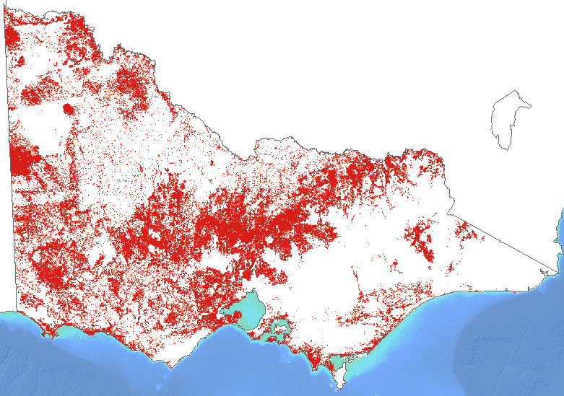

Figure 1: Threat model for rabbits – the darker red coloured areas indicate locations where there is a higher likelihood of rabbit warrens occurring.

# Indicative benefits

To plan and prioritise which biodiversity management actions we will do, and where, we want to know how particular management actions could benefit different species of plants and animals in different locations, and how that benefit may vary across species and locations.

For example, a fox baiting program might have a high benefit for small-medium sized mammals that are vulnerable to fox predation, but little or even a negative benefit to plant species in the area if rabbit numbers increase when foxes are controlled. A weed management program which highly benefits threatened plant species might have a negative impact on bandicoots if their blackberry refuge is removed and they are more vulnerable to foxes; but in another place where there are no bandicoots, there may be no negative impact.

## Estimating Benefit

To estimate benefit, SMP uses a best-practice, scientifically rigorous method that collects and analyses expert judgements on the potential success of management actions, or suites of actions. The expected benefit to a species of performing an action is represented spatially so we can see how much an action might benefit one (or many) species, and where.

Understanding how much improvement a species, or many species, is likely to receive because of a management action is an important step to inform decision making. A new measure – Change in Suitable Habitat – was developed to provide a consistent measure of the relative contribution of management actions to habitat quality and populations’ persistence across many different species (Figure 2).

This gives us a view of which actions improve a species’ trajectory the most, and in which places. Measuring Change in Suitable Habitat helps us to decide which actions will have the greatest benefit for a single species, or all of biodiversity, and where. Figure 3 shows the expected benefit to all biodiversity of conducting rabbit control across Victoria.

## Modelling Management Actions

The benefits of 17 management actions were spatially mapped and modelled to inform SMP version 1.2 (Table 1). These include: actions that target specific threats; and ‘actions’ which are a combination of actions required to address threats (control foxes and cats; remove domestic stock and manage weeds; control large invasive herbivores (pigs, goats and deer)), which assumes these best practice actions are done in combination. The last action is revegetation, which aims to address the impact of clearing or degradation that occurred in the past.

When devising suitable management actions to target threats, the following assumptions about best practice management standards and implementation were made:

* Only generic management actions are considered.
* Only on-ground actions are considered.
* Assume that landholders/managers are willing to undertake best practice management.
* Actions are undertaken by competent and skilled practitioners.
* Actions are undertaken humanely.
* Actions are persistent across the time horizon (50 years).

Table 1: Summary of NaturePrint’s modelled threats and management actions

*Note: some management actions are not included in the SMP analysis because at this stage they are difficult to cost and/or have legal or social ramifications that are beyond the scope of SMP. Benefit of Action models are available to view in NatureKit to inform management decisions and demonstrate the potential benefit of managing these threats.

| Threat | Description | Action | Description |
| --- | --- | --- | --- |
| Domestic Stock Grazing | A binary model indicating where grazing is an actual or potential threat based on public land and grazing licence information. | Control Domestic Stock | Domestic stock are controlled through their removal and fencing of parcels of land to prevent access by stock. |
| Transformer Weeds | A Maxent model was developed using presence-only data of transformer weeds, a range of environmental predictors including those reflecting invasion pathways and propagule pressure. Transformer weeds are a subset of invasive plants which have the capacity to change the character, condition, form or nature of ecosystems over substantial areas relative to the extent of that ecosystem. This model shows the likelihood that a transformer weed is present. | Control Weeds | Weeds are controlled through a coordinated program of methods depending on weed type, including mechanical, chemical, fire, heat smothering, grazing and scalping, as well as ongoing surveillance. |
|  | *Refer to each threat individually.* | Control Domestic Stock and Weeds | A combination of fencing out domestic stock and a weed control program. |
| Red Foxes | Apart from some off-shore islands foxes are ubiquitous in Victoria. The probability of foxes occurring at a location was deemed to be equal to 1. | Control Foxes | Foxes are controlled through a baiting program. |
| Feral Cats | Feral cats were assumed to be present across all of Victoria. The probability of cats occurring at a location was deemed to be equal to 1. | Control Cats | Cats are controlled through a baiting program. |
|  | *Refer to each threat individually.* | Control Foxes and Cats | A combination of fox and cat baiting programs. |
| Rabbits | A binary model derived from a continuous, ‘presence only’ model indicating the likelihood of the presence of rabbit warrens. Warren location data from Victorian and New South Wales government databases were related to a range of environmental predictors. | Control Rabbits | Rabbits are controlled through the removal of rabbit warrens through physical destruction (i.e. ripping). |
| Feral Horses | A binary habitat suitability model developed using presence-only data and a range of environmental predictors. Any habitat fragments less than 10,000 hectares were considered unsuitable. | Control Horses* | Horses are controlled through regular aerial shooting programs, in combination with mustering and ground shooting where aerial programs are not feasible. |
| Feral Deer | A continuous habitat suitability model developed using presence-only data of all four deer species that occur in Victoria and a range of environmental predictors. Any habitat fragments less than 10,000 hectares were considered unsuitable. | Control Deer | Deer are controlled through coordinated ground shooting programs by skilled shooters. |
| Feral Goats | A binary habitat suitability model developed using Victorian presence-only data related to a range of environmental predictors. Any habitat fragments less than 10,000 hectares were considered unsuitable. | Control Goats | Goats are controlled through the use of judas goats fitted with GPS collars, allowing the locating and aerial shooting of goat herds from helicopters. |
| Feral Pigs | A binary habitat suitability model developed using Victorian presence-only data and a range of environmental predictors. Any habitat fragments less than 10,000 hectares were considered unsuitable. | Control Pigs | Pigs are controlled through trapping and baiting programs. |
| Large Invasive Herbivores | Refer to each threat individually. This is a combination of the modelled likelihood of feral deer, goats and pigs. | Control Large Invasive Herbivores | Deer, goats and pigs are controlled in combination (where relevant). |
| Land Clearing (Habitat Loss) | Risk of land clearing over next 50 years calculated by determining the proportion of intact native vegetation, using historical clearing rates to predict future potential clearing. | Permanent Protection | The permanent cessation of land clearing at a location, with ongoing management. |
|  | *The action of Revegetation has no associated threat model.* | Revegetation | Combination of removal of grazing and tree planting. Cells closer to existing native vegetation and streams are weighted more heavily as connectivity and riparian condition are improved. |
| *Phytophthora cinnamomi* | Habitat distribution model created using presence of reported phytophthora-induced woody plant mortality coupled with the relative susceptibility of Victorian plants. | Control Phytophthora* | Phytophthora ‘control’ occurs through the restriction of vehicles and foot traffic from particular areas, as well as the provision of wash-down facilities. This action largely relates to minimising the rate of spread, rather than absolute control. |
| Fuel Reduction Burning < Tolerable Fire Interval (TFI) | Modelled by combining fuel management zones with the fire treatability classification of ecological vegetation classes and, where native vegetation exists, a ranking from 1 (greatest risk of planned burning at less than the Tolerable Fire Interval) to 5 (smallest or negligible risk). | Reduce fire frequency* | Best practice fuel reduction burning is that which is applied - in the context of the probability of future wildfire - at a spatio-temporal scale above the currently formulated tolerable fire interval. |
| Native Forest Harvesting | A binary model of areas that will potentially be subjected to forest harvesting (e.g. merchantable forest types) and those not subject to harvesting (e.g. reserve system, buffer zones etc.) | Stop harvesting* | The permanent cessation of native forest harvesting. |

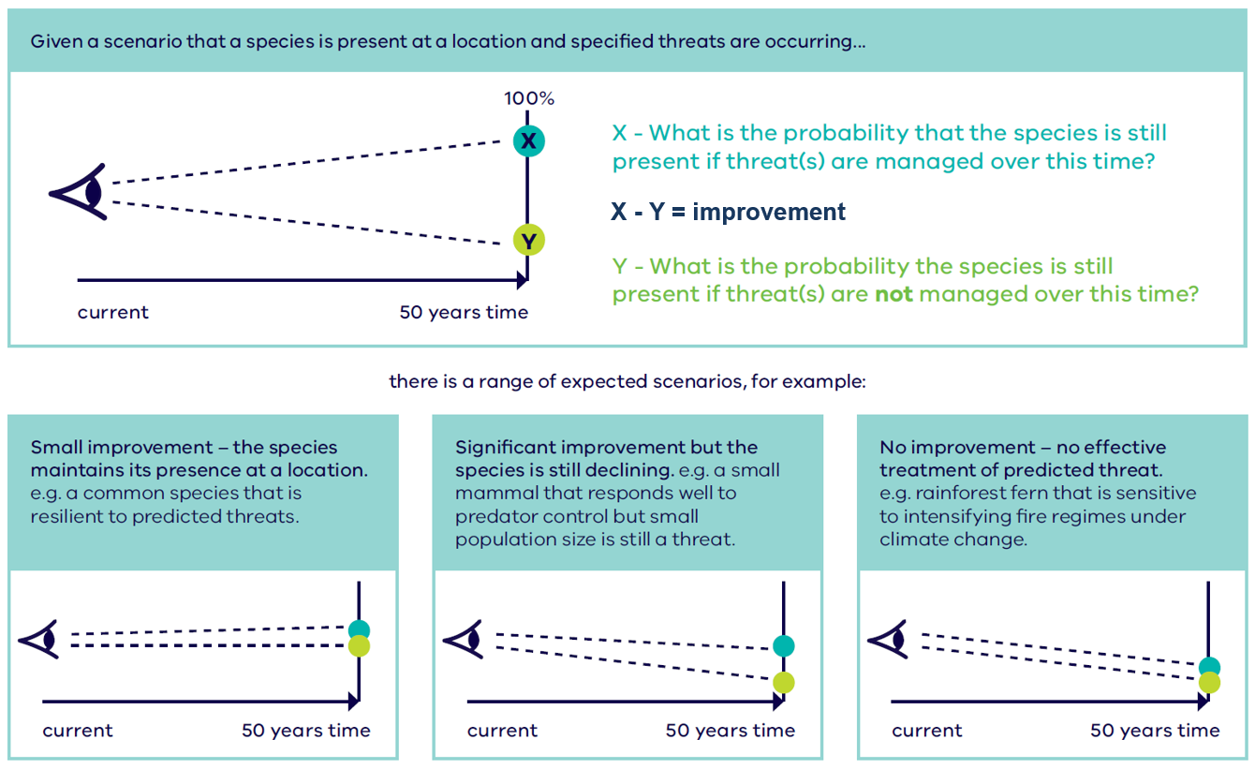

Figure 2: This figure outlines our approach to eliciting information on the effect management actions have on species persistence. The probability that a species will still be present if sustained investment and management is supplied is X. The probability that the species will be present in the long term if threats are not managed is Y. The difference between X and Y indicates the likely increase in the persistence of that species, because of that management action.

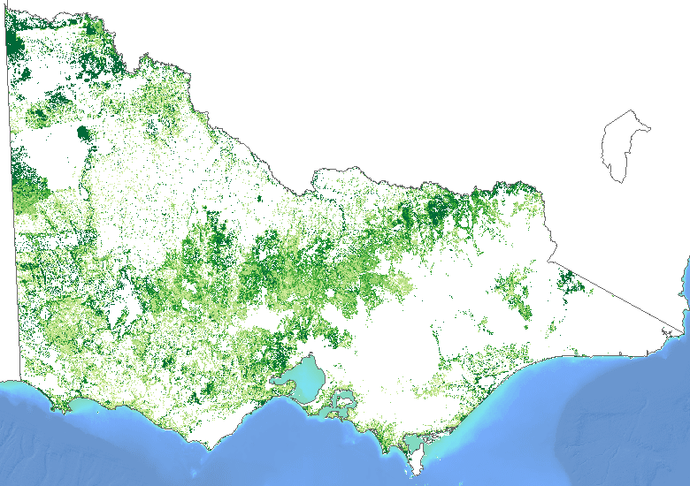

Figure 3: Expected benefit of rabbit control to all biodiversity. Darker green areas indicate a higher potential Change in Suitable Habitat and lighter green areas indicate lower.

## How we estimated management effectiveness

To estimate Change in Suitable Habitat for Victoria’s plants and animals for a range of threats, the NaturePrint team used an expert elicitation approach. Expert elicitation involves asking experts on species’ biology and ecology a series of structured questions about the effectiveness of a management action in certain situations. The process used here followed a formal, structured elicitation method which allowed us to scrutinise the data, account for uncertainty, and minimise biases (which can sometimes lead to poor decisions).

To obtain information on the benefit of various management actions, we held four face-to-face expert workshops – each one focusing on a different species group (mammals, birds, plants and reptiles). Experts were asked a series of questions on different scenarios for different species. Each scenario included the species name, a map identifying the location of the species, and some contextual information about the habitat for that location. Information about the threats occurring at the location and the alternative management actions that could be undertaken are also given.

Experts were then asked to imagine the consequences of not acting at a location – how likely is the species to persist at the location for 50 years with no management? Responses were obtained by asking experts how many out of 10 identical patches the species were likely to still be present at after 50 years, giving high and low estimates to capture uncertainty. Experts were then asked the same question, but this time considering 50 years of managing the threat at that location.

Through this process, thousands of scenarios for mammals, birds, reptiles, plants and amphibians were developed. Most groups had at least one scenario posed for each species. However, because of their diversity, only a subset of vascular plant and species were initially selected for expert elicitation (Table 2).

Given the large number of species (more than 2000) and scenarios covered, expert judgments were collected only for a subset of locations. We then extrapolated responses gained for species and scenarios to other species with similar traits. Using this trait-based modelling approach allowed us to make inferences about the benefits of management actions across all species in different locations. The types of traits used to do this varied between the taxonomic groups and are outlined below (Table 3). The ‘Proportion of Species Answered Directly’ column in Table 2 provides an idea of which groups used the trait-based modelling approach more than others (e.g. plants and birds).

After extrapolating the expert elicitation data to many Victorian scenarios and species, the dataset offered a comprehensive view of the prognosis of Victoria’s biodiversity under different management regimes. This approach was used to develop the Change in Suitable Habitat (see Figure 2) measure of management effectiveness. This measure can be used to assess the relative benefits of individual actions and combinations of actions in different places across Victoria.

Table 2: The number of species for each taxonomic group used in the expert elicitation process, and the total number of species included in the Strategic Management Prospects analysis.

|  |  |  |  |
| --- | --- | --- | --- |
| Taxonomic group | Number of species with answers | Total number of species in SMP | Proportion of species answered directly |
| Birds | 75 | 348 | 0.22 |
| Mammals | 65 | 66 | 0.98 |
| Frogs | 25 | 32 | 0.78 |
| Reptiles | 43 | 53 | 0.81 |
| Plants | 425 | 1819 | 0.23 |
| All Groups | 633 | 2318 | 0.27 |

Table 3: Examples of the types of traits used for each taxonomic group to extrapolate information on the benefit of management actions to other species with similar traits.

|  |  |
| --- | --- |
| Taxonomic group | Traits used to infer management effectiveness across species |
| Birds | Life form, body mass, egg mass, egg clutch size, nesting habit, foraging habit, diet, migration habit |
| Mammals | Body mass, home range, litter size, longevity, diet, social behaviour |
| Frogs | Body size, body length, colour, egg clutch size, egg size, oviposition, time to hatch, oral disc, days to metamorphosis, feeding habit, life cycle periodisation |
| Reptiles | Home range, dispersal distance, critical habitat elements, body size, longevity, sexual maturity, growth rate, diet |
| Plants | Fire sensitivity, snow tolerance, seed size, seed storage, palatability, pollination method, dispersal method, bark type, flowering month, life form, family, nutrient needs |

# Indicative costs

Cost is an important consideration if we want to spend our conservation resources and effort wisely. Estimating what will result in the most cost-effective outcomes for biodiversity will help us decide which actions to do where.

Strategic Management Prospects integrates the indicative cost of specific biodiversity management actions with their expected benefit (measured by Change in Suitable Habitat). This allows for direct comparison of the cost-effectiveness of the suite of actions through a benefit-cost ratio. SMP shows how investment in separate or combined management actions can improve the extent and condition of biodiversity, and where strategic actions could provide the greatest Change in Suitable Habitat per unit cost.

## Which actions are costed in SMP?

The landscape-scale actions costed in the SMP v1.2 analysis are: revegetation, weed control, domestic stock exclusion, fox control, feral cat control, feral goat control, feral deer control, rabbit control, feral pig control and permanent protection of private land. Some actions are modelled as a set of actions where combinations have been deemed to be more beneficial and cost-effective than undertaking a single action only. These include: fox and cat control, domestic stock and weed control, and control of all three large invasive herbivores (deer, goats and pigs).

Some actions are difficult to cost or have social and legal ramifications that are beyond the scope of SMP (such as not doing control burning or timber harvesting; preventing the spread of *Phytophthora*; or controlling horses). For example, the cost of not doing the action could be considered from an operational perspective as a cost saving, but the hidden and unknowable cost of not doing the action could be significant to the community (for example, loss of earnings from development, or the cost of a wildfire that was not avoided). These actions are currently not used in the analysis, but we are able to run scenarios to illustrate how, at a certain price point, considering such threats and actions will produce additional biodiversity benefit across the state.

## Estimating and incorporating costs

Cost in the context of NaturePrint can only be estimated – real costs can only be discovered within a market context such as through competitive tendering. In SMP the costs of on-ground operations were calculated as dollars per hectare using data collected from scientific and grey literature, as well as interviews with DELWP land managers and partners. In SMP v1.2, cost models are informed by considering temporal (time-related), spatial (place-related), and cost components (site costs; opportunity costs to private landholders; transaction costs; and travel costs) using a consistent and structured approach.

### Temporal considerations

All costs associated with the successful implementation of a management action over 50 years have been considered in the modelling. These include costs associated with sub-tasks that may need to be performed over time including start-up, maintenance, follow-up or other tasks undertaken at regular intervals. Costs associated with each sub-task have been discounted back to the present (at a discount rate of 5%) so that all costs can be compared in the context of ‘Present Value’. Interest costs (or other opportunity costs) are real costs and therefore - as in any financial analysis - we need to discount. Ideally, we would discount the conservation benefits as well, but as all benefits are specifically estimated at 50 years there is no useful discrimination.

### Spatial considerations

Costs for all actions have been modelled in a spatially explicit manner, so that the local or site-specific benefits and their associated costs can be mapped and calculated. Costs have been estimated on a unit area basis (i.e. $/hectare). Therefore, we need to account for the effect of ‘economies of scale’. There are always cost advantages when any action is undertaken over a large area compared with a smaller area. The efficiencies gained at different scales will depend on the action. In practice, many actions are undertaken at different spatial scales. Fox baiting is typically implemented over many thousands of hectares whereas revegetation projects are often less than 10 hectares in size. To compare the cost benefit of these disparate actions equitably, cost must be estimated for all actions at a standard scale to prevent cost distortions related to scale. We have chosen to estimate the cost of undertaking all actions over 1000 hectares.

### Cost components

Estimating all costs can be a complex problem. We conceive costs to include four components: site costs; opportunity costs to private landholders; transaction costs; and travel costs (see Figure 4).

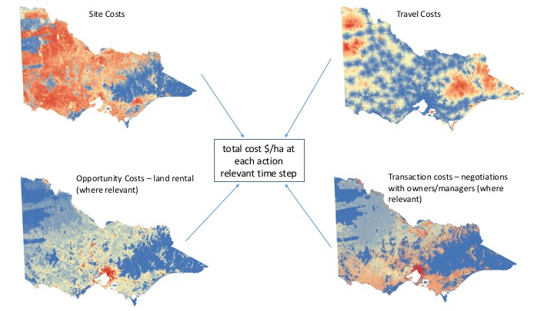

Figure 4. Components of cost models

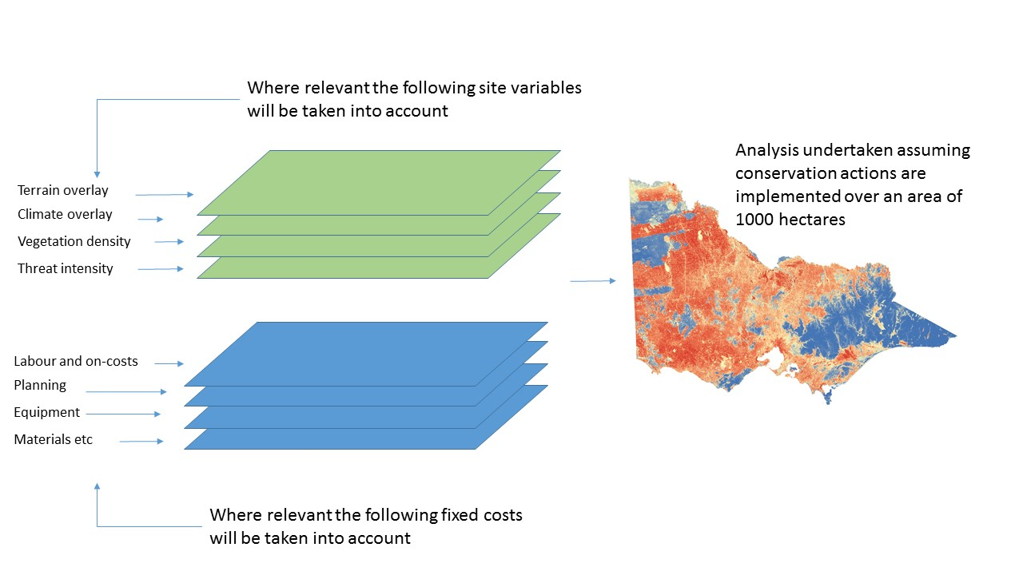

Figure 5. Site Costs for an action at each time step (relative to action)

#### Site costs

Site costs are those costs incurred (at a given spatial scale) to undertake the action in ideal conditions. Sub-costs to be itemised should include: planning costs, plant costs (machinery hire, etc.), labour costs (including all labour on-costs such as training, insurance and rent) and the cost of materials used/consumed. These costs have been estimated in the same way a quantity surveyor might undertake the task – checking suppliers, asking practitioners, etc. These costs will be modified (particularly labour and plant costs) by the nature of the site. Concerns about cost variations between sites have been incorporated into cost estimation through the use and development of spatially explicit overlays relating to climate, terrain, the density of vegetation and where relevant, the intensity of the threat (i.e. degree of weed infestation). See also Figure 5.

#### Opportunity costs

These are the forgone revenues lost to landholders – that we assume may need to be at least matched by project outlays – as a consequence of undertaking those conservation actions that require productive uses (such as cropping or grazing) to cease. We estimate opportunity cost to be roughly equivalent to an annual rent per unit area relevant to the permitted and current land uses and the inherent productivity (in relation to those permitted uses) of the land. These ‘land rent’ cost have been estimated using land-cover models, planning schemes and land valuations by local government area.

#### Transaction costs

These are the necessary costs associated with stakeholder interaction and consultation throughout the course of implementing the action. Stakeholders might be neighbours, landholders, land managers, traditional owners and government agencies, etc. For some actions, such as shooting and baiting, these costs may be considerable.

#### Travel costs

Travel costs are those costs (labour, vehicular, etc) associated with travelling from a notional depot to the site where the action will be undertaken. These costs have been mediated by the arrangement of potential suppliers of services (towns, depots, offices), the speed at which the network of roads and tracks can facilitate travel, and finally the nature of the terrain and vegetation if the final movements must be undertaken by other means (such as on foot or by boat).

## Bringing local knowledge to SMP

SMP is a decision-support tool, but it can’t make the decisions for you. If you are a project manager developing a project informed by the cost-effective actions that SMP has identified for the location and species you are managing, you will need to check your own costs and make your decisions using SMP information as well as your own context.

For example, the current SMP analysis assumes that contractors or staff are conducting the actions. Projects which involve volunteers may be able to deliver similar outcomes at a reduced cost.

Before you can decide on the feasibility of your proposed project based on actual costs, you will need to check:

* if the action/project is actually feasible in your location (for example you may not be able to shoot deer or bait foxes near houses)
* if the action needs to be modified compared to the defined action used in SMP
* if the costs for that action will be relatively high or low for your situation
* if you have the people with the appropriate skills available in the area to carry out the project.

See the NaturePrint and NatureKit websites for more information about using SMP, interpreting the SMP outputs and using SMP to plan projects.

## Continuous improvement

We are committed to a continuous improvement approach, which enables the NaturePrint products and tools to be updated and refined as further data, computational power, research and modelling methods become available. NaturePrint products have a version number to help identify the currency of each product.

Everyone can contribute to the improvement of the NaturePrint tools. For example, by submitting species records to the Victorian Biodiversity Atlas which is a key source of information for NaturePrint. Visit the [Victorian Biodiversity Atlas](https://www.environment.vic.gov.au/biodiversity/victorian-biodiversity-atlas) web page for more information.

Opportunities for feedback on other data layers will be developed.

|  |  |
| --- | --- |
| © The State of Victoria Department of Environment, Land, Water and Planning 2018  LogoThis work is licensed under a Creative Commons Attribution 4.0 International licence. You are free to re-use the work under that licence, on the condition that you credit the State of Victoria as author. The licence does not apply to any images, photographs or branding, including the Victorian Coat of Arms, the Victorian Government logo and the Department of Environment, Land, Water and Planning (DELWP) logo. To view a copy of this licence, visit http://creativecommons.org/licenses/by/4.0/  ISBN 978-1-76047-951-0 (pdf/online)  Disclaimer  This publication may be of assistance to you but the State of Victoria and its employees do not guarantee that the publication is without flaw of any kind or is wholly appropriate for your particular purposes and therefore disclaims all liability for any error, loss or other consequence which may arise from you relying on any information in this publication. | Accessibility  If you would like to receive this publication in an alternative format, please telephone the DELWP Customer Service Centre on 136186, email [customer.service@delwp.vic.gov.au](mailto:customer.service@delwp.vic.gov.au), or via the National Relay Service on 133 677 [www.relayservice.com.au](http://www.relayservice.com.au). This document is also available on the internet at [www.delwp.vic.gov.au](http://www.delwp.vic.gov.au). |