Introduction
Biodiversity Response Planning (BRP) is a long-term area-based planning approach to biodiversity conservation in Victoria. It is designed to strengthen alignment, engagement and participation between government, Traditional Owners, non-government agencies and the community.
DELWP Regional staff have been working with stakeholders on actions to conserve biodiversity in specific landscapes, informed by the best available science and local knowledge.
These Fact Sheets capture a point in time, reflecting data and knowledge available in 2020. They provide information for many (but not all) landscapes across Victoria, containing general information on the key values and threats in each area, as well as the priority cost-effective actions that provide the best protection of biodiversity. Fact Sheets are intended to provide useful biodiversity information for the community, non-government and government organisations during project planning and development.
Further information and the full list of Fact Sheets is available on the Department’s Environment website.

Landscape description
The Chiltern - Mt Pilot and Baranduda focus landscape is 90,282ha in size. Native vegetation covers only 57% of the landscape. Public land makes up 39% of the area and includes the entirety of Chiltern - Mt Pilot National Park which is managed by Parks Victoria. For area context, refer to the map at the end of this Fact Sheet.

Cultural importance
We recognise that the entire landscape has high cultural value for Traditional Owners. Landscapes identified as having “notable” cultural importance is based on the density of recorded cultural heritage sites and knowledge shared by Traditional Owners. We also recognise that there are locations important to Traditional Owners not within these focus landscapes of interest.

Stakeholder interest
As part of the BRP process, in October 2020 stakeholders were asked to nominate focus landscapes and actions of interest. Representatives of DELWP, Parks Victoria, Trust for Nature, Goulburn Broken Catchment Management Authority, North East Catchment Management Authority (NECMA), Taungurung Land and Waters Council, Yorta Yorta Nation Aboriginal Corporation and the Alpine Resorts agreed on the nominated areas.

Habitat Distribution Models identified 59 species with more than 5% of their Victorian range in this landscape area |  | Traditional Owners and stakeholders identified the following species/ communities of interest
 | 49 Plant species, including:  - Beechworth Silver Stringybark (Eucalyptus aff. cinerea), Vulnerable, 79% Victorian range in area  - Granite Rusyhood (Pterostylis sp. aff. boormanii), Endangered, 71% Victorian range in area  - Mount Pilot Spider-orchid (Caladenia pilotensis), Endangered, 71% Victorian range in area | - River Red Gum woodlands  - Large older trees and paddock trees
 | 1 Mammal species:  - Squirrel Glider (Petaurus norfolcensis) Endangered, 6% Victorian range in area | - Brush-tailed Phascogale  - Spot-tailed Quoll
 | 4 Reptile species:  - Dwyer's Snake (Parasuta dwyeri),11% Victorian range in area  - Gray's Blind Snake (Ramphotyphlops nigrescens), 8% Victorian range in area  - Southern Rainbow Skink (Carlia tetradactyla), 7% Victorian range in area  - Copper-tailed Skink (Ctenotus taeniolatus), 5% Victorian range in area | - Lace Monitor
 | 4 Bird species:  - Turquoise Parrot (Neophema pulchella), Near Threatened, 12% Victorian range in area  - Double – barred Finch (Taeniopygia bichenovii), 8% Victorian range in area  - Speckled Warbler (Chthonicola sagittatus), Vulnerable, 5% Victorian range in area  - Regent Honeyeater (Anthochaera phrygia), Critically Endangered, 5% of Victorian range in area | - Barking Owl  - Egrets  - Herons  - Cormorants  - Bitterns  - Spoonbills and ducks
 | 1 Amphibian species:  - Rugose Toadlet (Uperoleia rugosa), Endangered with 7% Victorian range in area | - Giant Bullfrog  - Growling Grass Frog

Strategic Management Prospects
Strategic Management Prospects (SMP) models biodiversity values such as species habitat distribution, landscape-scale threats and highlights the most cost-effective actions for specific locations. More information about SMP is available in NatureKit.

Additional threats
In addition to threats modelled in SMP, stakeholders identified the following:
- Habitat loss and fragmentation
- Reduction of habitat through loss of paddock trees
- Thinning of vegetation through understorey and timber removal (firewood)
- Degradation of linear reserves including roadsides and introduction/infestation of weeds
- Noisy miners are a problem in this landscape – they are aggressive and territorial, allowing them to dominate woodland areas impacting on small woodland bird species
- Climate change, with associated warming and drying climate will lead to generalised ecosystem stress, with impacts to species geographic range and changes to species flowering seasons. This will also result in more extreme weather and increased bush-fire risk including frequency and intensity of bushfires.

Which landscape-scale actions are most cost-effective in this landscape?
Some areas of this focus landscape (coloured areas on the map) have highly cost-effective actions which provide significant benefit for biodiversity conservation.

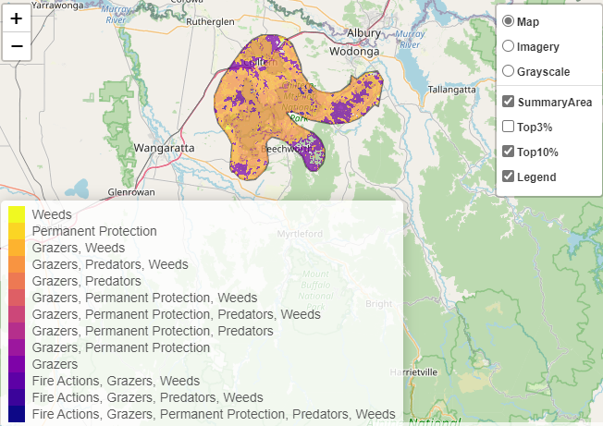

The SMP priority action which ranks among the top 3% for cost-effectiveness of that action across the state for much of the area (>1,000ha) is to control horses. The top 10% of actions are in order:
Control rabbits 78,332ha
Control pigs 70,800ha

Of the top 10% of cost-effective actions, controlling rabbits and pigs provide the most cost-effective biodiversity benefits when considering all flora and fauna.

Biodiversity activities identified (in addition to those modelled in SMP) through the consultation process were:
- Noisy Miner control and woodland habitat enhancement, notably for Regent Honeyeater and Swift Parrot benefit as well as other woodland bird species (this is occurring through the Bush for Birds Program (NECMA)).
- Revegetation of key areas in the landscape to improve linkages, reduce fragmentation and protect existing habitat (paddock trees) is a priority action.

The most cost-effective action for flora and fauna
Plants – Control weeds
Birds, Mammals, Reptiles – Combined cat and fox control
Amphibians – Control rabbits

For a further in depth look into SMP for this landscape, please refer to NatureKit.

