## Introduction

Biodiversity Response Planning (BRP) is a long-term area-based planning approach to biodiversity conservation in Victoria. It is designed to strengthen alignment, engagement and participation between government, Traditional Owners, non-government agencies and the community.

DELWP Regional staff have been working with stakeholders on actions to conserve biodiversity in specific landscapes, informed by the best available science and local knowledge.

These Fact Sheets capture a point in time, reflecting data and knowledge available in 2020. They provide information for many (but not all) landscapes across Victoria, containing general information on the key values and threats in each area, as well as the priority cost-effective actions that provide the best protection of biodiversity. Fact Sheets are intended to provide useful biodiversity information for the community, non-government and government organisations during project planning and development.

Further information and the [full list of Fact Sheets](http://www.environment.vic.gov.au/biodiversity/working-together-for-biodiversity) is available on the Department’s Environment website.

## Landscape description

This 84,687ha area is a mixed landscape of cleared and native vegetation areas (47% native vegetation cover) and is mostly private land (67%). The landscape is characterised by the Dergholm State Park, Dorodong State Forest and the Glenelg River.

|  |
| --- |
| Habitat Distribution Models identify 43 species with more than 5% of their Victorian range in this landscape |
| Plant38 Plants   * Notably the Dergholm Guinea-flower (63% of Victorian range in the landscape, EPBC*-listed Vulnerable), Heathy Guinea-flower (38% of Victorian range in landscape, Victorian Advisory List vulnerable) and Slender Stylewort (21% of Victorian range in landscape, Victorian Advisory List rare) |
| Rat1 Mammal   * Heath Mouse (11% of Victorian range in landscape, near threatened) |
| Snake1 Reptile   * Striped Worm-Lizard (11% of Victorian range in landscape, near threatened) |
| Sparrow1 Bird   * Red-tailed Black Cockatoo (14% of Victorian range, endangered) |
| 2 amphibians   * Southern Toadlet (2% of Victorian range in the landscape, vulnerable) and the Growling Grass Frog (0.67% of Victorian range in the landscape, endangered) Frog |

\**Environment Protection and Biodiversity Conservation Act 1999* (Federal)

## Strategic Management Prospects

Strategic Management Prospects (SMP) models biodiversity values such as species habitat distribution, landscape-scale threats and highlights the most cost-effective actions for specific locations. More information about SMP is available in [NatureKit](https://www.environment.vic.gov.au/biodiversity/naturekit).

## Which landscape-scale actions are most cost-effective in this landscape?

Some areas of this landscape of interest (coloured areas on the map) have highly cost-effective actions which provide significant benefit for biodiversity conservation.

The SMP priority actions which rank among the **top 3%** for cost-effectiveness of that action across the state are in order:

|  |  |
| --- | --- |
| Goat | Control goats 11,151ha |
| Deer | Control deer 1,465ha |
| Rabbit | Control rabbits 1,321ha |
| Grain | Control weeds 944ha |
|  | Permanent protection 725ha |
|  | Revegetation 73ha |

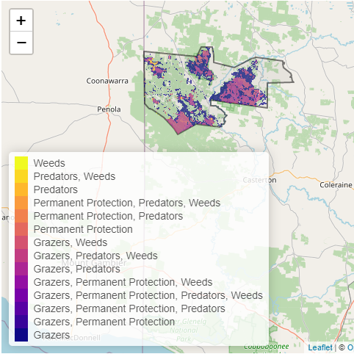

Of the **top 10%** of cost-effective actions, control deer, control rabbits, control goats and combined fox and cat control ranked highest.

|  |  |
| --- | --- |
| The most cost-effective actions for flora & fauna | |
| *Plant* | **Plants** -Control deer, control rabbits, control goats, control weeds |
| *Sparrow* | **Birds** - Combined fox and cat control, control deer, control total grazing pressure |
| *RatSnake* | **Mammals, Reptiles** - Combined fox and cat control, control deer, control goats |
| *Frog* | **Amphibians** - Combined fox and cat control, control deer, control domestic stock grazing |

For a further in depth look into SMP for this landscape please refer to [NatureKit](https://www.environment.vic.gov.au/biodiversity/naturekit).

