Introduction
Biodiversity Response Planning (BRP) is a long-term area-based planning approach to biodiversity conservation in Victoria. It is designed to strengthen alignment, engagement and participation between government, Traditional Owners, non-government agencies and the community.
DELWP Regional staff have been working with stakeholders on actions to conserve biodiversity in specific landscapes, informed by the best available science and local knowledge.
These Fact Sheets capture a point in time, reflecting data and knowledge available in 2020. They provide information for many (but not all) landscapes across Victoria, containing general information on the key values and threats in each area, as well as the priority cost-effective actions that provide the best protection of biodiversity. Fact Sheets are intended to provide useful biodiversity information for the community, non-government and government organisations during project planning and development.
Further information and the full list of Fact Sheets is available on the Department’s Environment website.

Landscape description
This 154,327ha area is a mixed cleared and vegetated landscape (47% native vegetation cover) and is also a mix of public and private land (48% public land). The landscape incorporates the entire Wimmera River and a 200m buffer area.
This focus landscape has a partial overlap with the Wyperfeld - Big Desert focus landscape. For more information, please refer to the Wyperfeld - Big Desert Fact Sheet in the full list of Fact Sheets.

Habitat Distribution Models identify 35 species with more than 5% of their Victorian range in this landscape
24 Plants
- Notably: Three Nerve Wattle (6% of Victorian range in landscape, vulnerable), Umbrella Wattle (5% of Victorian range in landscape, vulnerable)
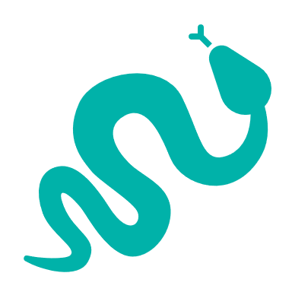
1 Reptile
- Samphire Skink (4% of Victorian range in landscape, endangered)
10 Birds
- Ruddy Turnstone (7% of Victorian range in landscape, vulnerable)
- Freckled Duck (5% of Victorian range in landscape, endangered)
- Red Knot (6% of Victorian range in landscape, endangered)
- Regent Parrot (5% of Victorian range in landscape, vulnerable)
- Redthroat (4% of Victorian range in landscape, endangered)
- Blue-billed Duck (4% of Victorian range in landscape, endangered)
- Curlew Sandpiper (4% of Victorian range in landscape, endangered)
- Marsh Sandpiper (4% of Victorian range in landscape, vulnerable)

Strategic Management Prospects
Strategic Management Prospects (SMP) models biodiversity values such as species habitat distribution, landscape-scale threats and highlights the most cost-effective actions for specific locations. More information about SMP is available in NatureKit.

Which landscape-scale actions are most cost-effective in this landscape?
Some areas of this landscape of interest (coloured areas on the map) have highly cost-effective actions which provide significant benefit for biodiversity conservation.
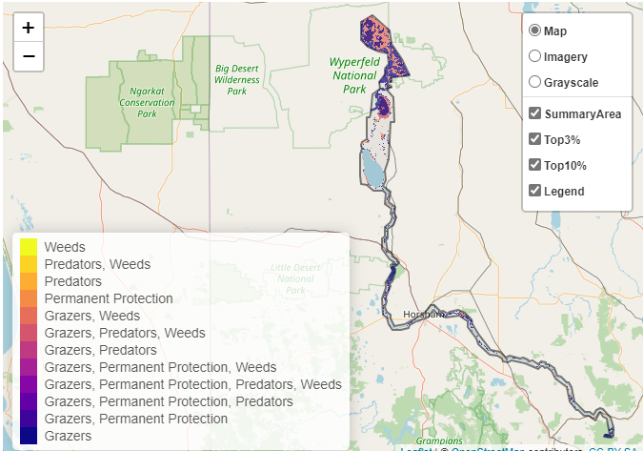
The SMP priority actions which rank among the top 3% for cost-effectiveness of that action across the state are in order:
Control overabundant kangaroos 15,993ha
Control goats 10,241ha
Control weeds 1,551ha
Revegetation 1,125ha
Permanent protection 402ha

In the top 10% of actions, kangaroo control, goat control, rabbit control, weed control and combined fox and cat control rank highly.

The most cost-effective actions for flora & fauna
Plants - Control weeds, control kangaroos, control rabbits
Birds - Control goats, control kangaroos, control rabbits, control weeds
Mammals, Reptiles - Control goats, control kangaroos, control rabbits, control weeds, control foxes and cats
Amphibians - Control rabbits, control kangaroos
For a further in depth look into SMP for this landscape please refer to NatureKit.
