Introduction
Biodiversity Response Planning (BRP) is a long-term area-based planning approach to biodiversity conservation in Victoria. It is designed to strengthen alignment, engagement and participation between government, Traditional Owners, non-government agencies and the community.
DELWP Regional staff have been working with stakeholders on actions to conserve biodiversity in specific landscapes, informed by the best available science and local knowledge.
These Fact Sheets capture a point in time, reflecting data and knowledge available in 2020. They provide information for many (but not all) landscapes across Victoria, containing general information on the key values and threats in each area, as well as the priority cost-effective actions that provide the best protection of biodiversity. Fact Sheets are intended to provide useful biodiversity information for the community, non-government and government organisations during project planning and development.
Further information and the full list of Fact Sheets is available on the Department’s Environment website.

Landscape description
This 122,000ha area is mostly native vegetation (69% cover) and has significant public land (49%). It includes Murray Sunset National Park and the Trust for Nature property Neds Corner as well as the Wargan Basins and Bushland Reserve west of Mildura. The landscape is bordered by the Murray River in the north and the southern boundary follows the Murray Scroll Belt bioregion, terminating west of Lake Hawthorn.
This landscape has a major overlap with the Murray River and Floodplain landscape in areas of Riverine Grassy Woodland or Forests Ecological Vegetation Classes and minor overlaps with the Murray Sunset landscape in the north west. You can find further information on these Focus Landscapes in the full list of Fact Sheets.

Cultural importance
We recognise that the entire landscape has high cultural value for Traditional Owners. Landscapes identified as having “notable” cultural importance is based on the density of recorded cultural heritage sites and knowledge shared by Traditional Owners. We also recognise that there are locations important to Traditional Owners not within these landscapes.
Notable cultural importance for the First People of the Millewa Mallee Aboriginal Corporation includes a possible location of the Fish Environment Program and the Resting Places Program.

Stakeholder interest
As part of the Biodiversity Response Planning process, in October 2020 stakeholders were asked to nominate focus landscapes and actions of interest. First People of the Millewa Mallee, Trust for Nature, Lower Murray Water and Parks Victoria nominated Murray Scroll Belt.
Possible future investment/project development in this landscape will be available to any interested stakeholders in addition to those who nominated this landscape.
Specific stakeholder interests identified through the engagement process within this landscape include:
- Trust for Nature focal landscape and Neds Corner flagship property.
- Parks Victoria Conservation Action Plan assets – Ephemeral freshwater wetland, Chenopod shrubland, Riverine Forest and Woodland, Saline wetlands, Semi-arid Woodlands and Total Grazing Management.
- Mallee Catchment Management Authority, Regional Catchment Strategy priority landscape – 1. Murray River and Floodplain: Merbein to South Australian border.
- Department of Environment, Land, Water and Planning – significant area of public land.

Community interest
There was no specific community interest in biodiversity conservation identified for this area through the consultation process.

 | Habitat Distribution Models identify 207 species with more than 5% of their Victorian range in this landscape area | Traditional Owners, stakeholders and community groups identified the following species of interest
 | 172 Plants, 28 species with more than 50% of Victorian range in area. Notably:  - Soda Bush (endangered, 86% of Victorian range in area)  - Slender Sunray (endangered, 84% of Victorian range in area) | - Darling and Garland Lilies  - Emu Bushes, Round Templetonia  - Slender Sunray  - Desert Groundsel  - Purple Swainson-pea and Kneed Swainson-pea
 | 6 Mammals, 5 species with more than 10% of Victorian range in area. Notably:  - Giles Planigale (near threatened, 81% of Victorian range in area)  - Eastern Wallaroo (endangered, 27% of Victorian range in area) | - Giles Planigale  - Fat-tailed Dunnart  - Red Kangaroo
 | 17 Reptiles, 10 species with more than 10% of Victorian range in area. Notably:  - Red naped Snake (vulnerable, 85% of Victorian range in area)  - Saltbush Striped Skink (critically endangered, 57% of Victorian range in area)  - Samphire Skink (endangered, 30% of Victorian range in area)  - Hooded Scaly-foot (critically endangered, 27% of Victorian range in area) | - Hooded Scaly-foot  - Mud Adder  - Carpet Python
 | 12 Birds, 4 species more than 10% of Victorian range in area. Notably:  - Redthroat (endangered 46% of Victorian range in area)  - Ground Cuckoo Shrike (vulnerable, 32% of Victorian range in area) | - Regent Parrot  - Australian Bustard
 |  | - Growling Grass Frog
Other:
- Native fish
- Insects
- A new species of truffle-like fungi was discovered in 2011, named Agaricus colpeteii
- 13 species of spider, new to science, were discovered in 2011

Strategic Management Prospects
Strategic Management Prospects (SMP) models biodiversity values such as species habitat distribution, landscape-scale threats and highlights the most cost-effective actions for specific locations. More information about SMP is available in NatureKit.

Additional threats
Threats identified (in addition to those modelled in SMP) through the consultation process were:
- alterations to hydrology
- land salinisation
- soil erosion
- habitat degradation due to extremes of climate and weather
- lack of regeneration in some vegetation communities
- recreational activities causing fragmentation
- loss of vegetation, and erosion
- legacy use of public land
- private land use impacting biodiversity
- inappropriate land use planning
- inappropriate fire regimes (planned burning and bushfires)

Which landscape-scale actions are most cost-effective in this landscape?
Some areas of this focus landscape (coloured areas on the map) have highly cost-effective actions which provide significant benefit for biodiversity conservation.
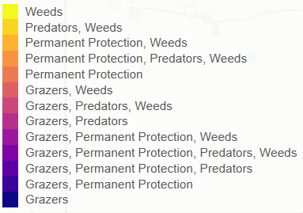
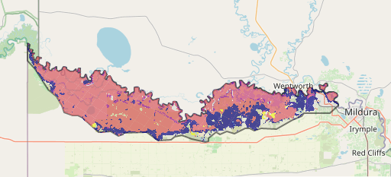
The SMP priority actions which rank among the top 3% for cost-effectiveness of that action across Victoria for much of the area (>25,000ha) are in order:
Control goats 91,808ha
Control pigs 90,740ha
Control weeds 112,489ha
Control overabundant kangaroos 56,275ha
Control rabbits 52,346ha

Of the top 10% of cost-effective actions, control all grazers provides the most cost-effective biodiversity benefits when considering all flora and fauna.

Actions suggested for this landscape through the nomination process are:
- control weed, rabbit, pig and over abundant kangaroos
The most cost-effective actions for flora and fauna
Plants – Control weeds
Mammals, birds and reptiles – Combined cat and fox control
- permanent protection

For a further in depth look into SMP for this landscape please refer to NatureKit.

