Background / preamble
The Upper Snowy landscape was recognised during the 2019/20 Gippsland Biodiversity Response Planning (BRP) process as a focus area for future collaborative biodiversity action and investment.
Under the Victorian Government’s Biodiversity 2037: Protecting Victoria’s Biodiversity plan, the BRP process is a long-term area-based planning approach to biodiversity conservation in Victoria. It is designed to strengthen alignment, engagement and participation between government, Traditional Owners, non-government agencies and the community to benefit biodiversity by working together to identify, promote and tackle local biodiversity needs as part of an ongoing collective process.
In 2019/20, significant impacts from the bushfires in East Gippsland and coronavirus (COVID-19) on community, biodiversity stakeholders and agencies, and the environment, resulted in planned engagement with many local stakeholders in Gippsland about BRP being postponed to a future process. In the interim, a multi-agency working group of local staff in Gippsland came together to identify a series of potential strategic priority actions across the region, as well as 13 focus landscapes. Membership of this working group for Gippsland included staff from the Department of Environment, Land, Water and Planning (DELWP) coasts & marine policy and local forest, fire and biodiversity teams, East Gippsland and West Gippsland Catchment Management Authorities (EGCMA & WGCMA), Parks Victoria, Trust for Nature (TfN), the Bunurong Land Council Aboriginal Corporation (BLCAC) and the Gunaikurnai Land and Waters Aboriginal Corporation (GLaWAC).
As part of this process, the Gippsland BRP working group drew upon information available from the DELWP Strategic Management Prospects (SMP) tool as well as their own local knowledge to identify key biodiversity assets, threats and potential management actions across Gippsland. A subset of this information is presented in this Fact Sheet, reflecting a point in time assessment of some of the important biodiversity needs and landscapes for focus across the region.
These BRP Fact Sheets provide useful biodiversity information for the community, non-government and government organisations during project planning and development, including guidance for stakeholders interested to contribute towards some of the strategic priorities identified in these areas to date. Further information and the full list of Fact Sheets is available on the Department’s Environment website.

Landscape description
Landscape context: 140,953ha, 68% public land, 74% native vegetation cover
The Upper Snowy landscape incorporates the upper reaches of the Snowy River Valley north of Butchers Ridge to the NSW border at Willis, and the Deddick River Valley west from Cabanandra to the NSW border. This area is dominated by extensive areas of steep rocky gorges and mountains and is predominantly rain-shadow country, continuous with similar landscapes in NSW (particularly Kosciuszko National Park).
Major vegetation types here include Shrubby Dry Forest and Rain-shadow woodland (including Cypress-White Box woodland). Freehold land in this landscape is used mainly for cattle and sheep grazing in the Deddick Valley and around Gelantipy and Wulgulmerang. Key features of this area include the upper reaches of Snowy River Gorge, Little River Gorge, and towns of Suggan Buggan, Deddick and Tubbut.

Biodiversity highlights and important places:
This area is characterised by large areas of remote, rugged and inaccessible country along the Snowy River and north of the Deddick Valley. Key biodiversity features include tracts of rain-shadow woodland dominated by White Box and White Cypress Pine, and populations of characteristic flora and fauna including many species not found elsewhere in the state.

Important vegetation communities in this landscape include:
*FFG listed | Nil
**EPBC listed | White Box-Yellow Box-Blakely’s Red Gum Grassy Woodland and derived Native Grassland
*Flora and Fauna Guarantee Act 1988 (Victorian)
**Environment Protection and Biodiversity Conservation Act 1999 (Federal)

Cultural importance
We would like to acknowledge the Traditional Owners and custodians of the land across this landscape. We pay our respects to Country, and to Elders past and present whose knowledge and wisdom has ensured the continuation of culture and traditional practices. We are committed to genuinely partner, and meaningfully engage, with Victoria’s Traditional Owners and Aboriginal communities to support the protection of Country, the maintenance of spiritual and cultural practices and their broader aspirations into the 21st century and beyond in the spirit of self-determination. The Gippsland BRP project team are seeking interest from traditional owners in this area to contribute towards biodiversity planning and conservation processes, including Biodiversity Response Planning.

Stakeholder and community interest
Local engagement for BRP in Gippsland in 2019/20 was postponed due to impacts from fire and coronavirus (COVID-19). If you would like to contribute local knowledge about this landscape in the future, find out more about BRP or add your name to the state-wide or Gippsland BRP stakeholder lists, you can find further information on the Department’s Environment website.

Species summary
An analysis of available Habitat Distribution Models* identified 189 species with more than 5% of their Victorian range falling within the Upper Snowy BRP landscape, including 48 threatened species and 8 EPBC listed species.
*Note: While version 2.0 of the SMP model utilises HDMs for ~3,200 terrestrial species in its analysis, these models currently exclude aquatic, invertebrate, marine and non-vascular plant species. These HDMs and SMP will continue to be improved upon with ongoing input from species experts and natural resource management practitioners.
Species class | Species with a high proportion of their Victorian distribution in this landscape | Other notable species identified during the BRP process
185 plants, incl. 47 threatened species (7 EPBC) | 19 species with more than 50% of their Victorian range falling within this landscape, notably:  - Mountain Cryptandra Cryptandra speciose subsp. speciosa (FFG listed, vulnerable, 90% of Victorian range)  - Deddick Blue-box Eucalyptus baueriana subsp. deddickensis (FFG listed, endangered, 89% of Victorian range, restricted to the area around Deddick)  - Suggan Buggan Wax-flower Philotheca myoporoides subsp. brevipedunculata (FFG listed, vulnerable, 84% of Victorian range)  - Slender Burgan Kunzea phylicoides (82% of Victorian range)  - Narrow-leaf Bent-grass Deyeuxia pungens (EPBC listed, Vulnerable, 82% of Victorian range, restricted to area around Suggan Buggan)  - Snowy River Phebalium Phebalium glandulosum subsp. riparium (79% of Victorian range)  - Rock Mallee Eucalyptus saxatilis (FFG listed, vulnerable, 77% of Victorian range)  - Snowy River Westringia Westringia cremnophila (EPBC listed, Vulnerable, 59% of Victorian range) | - Wombargo Wattle acacia tabula (FFG listed, vulnerable, restricted to this landscape)  - Pinnate Goodenia Goodenia macmillanii (FFG listed, vulnerable, 48% of Victorian range, restricted to Gippsland)  - Mountain Germander Teucrium thieleanum (FFG listed, vulnerable, 35% of Victorian range)
1 mammal, incl. 1 threatened species (1 EPBC) | Includes:  - Brush-tailed Rock-wallaby (EPBC listed, Vulnerable, 95% of Victorian range) | - Spot-tailed Quoll (EPBC listed, Endangered, 5% of Victorian range)  - Eastern Wallaroo (FFG listed, endangered)
2 reptile, incl. 0 threatened species (0 EPBC) | Includes:  - Red-throated Skink (21% of Victorian range)  - Gippsland Water Dragon (6% of Victorian range) | - None raised
0 birds | No species with more than 5% of their Victorian range within this landscape. | (Landscape supports many common bird species)
1 frog, incl. 0 threatened species (0 EPBC) | Includes:  - Smooth Toadlet (5% of Victorian range) | - None raised
Other species raised by the working group (e.g. fish, invertebrates etc):
None raised

Strategic Management Prospects
Strategic Management Prospects (SMP) models species distributions, habitat importance, landscape-scale threats, and management costs. It then compares and highlights those places with the greatest opportunities for cost-effective action state-wide. Learn more about this tool on the SMP webpage.

Which landscape-scale actions are most cost-effective in this landscape?
The maps and information below show those places and actions modelled by SMP to provide the best opportunities for cost-effective action to benefit biodiversity across the state. Coloured areas in the maps below indicate opportunities for highly cost-effective actions that provide significant benefits to biodiversity in those places. If undertaken across Victoria, these collective actions should provide the greatest potential benefit to biodiversity by focusing on undertaking landscape-scale actions in places where they will provide the greatest benefit for cost across all species.
Map a) shows actions in the top 3% cost-effectiveness areas, and Map b) shows actions in the top 10% cost-effective areas.
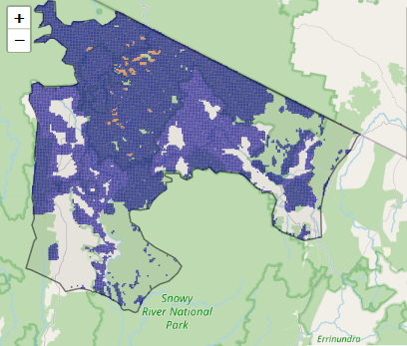
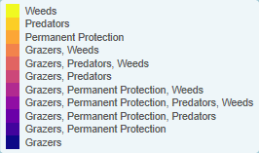
The following landscape-scale actions were ranked among the top 3% cost-effective opportunities for biodiversity action across the state by SMP:
Map a) – SMP top 3% cost-effective actions

Control horses 85,252ha
Control pigs 11,350ha
Control goats* 9,492ha

*The Gippsland BRP working group advised feral goats are generally not a critical issue for the region, however inclusion of goats in integrated herbivore control programs would be beneficial.

The following landscape-scale actions were ranked among the top 10% cost-effective opportunities for biodiversity action across the state by SMP:
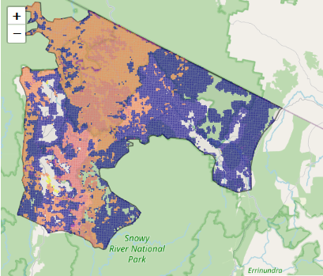
Map b) – SMP top 10% cost-effective actions

Control horses 85,394ha
Control deer 61,661ha
Control weeds 56,872ha
Control pigs 40,313ha
Combined deer and horse control 40,060ha
Control rabbits 31,251ha

The most cost-effective actions for flora & fauna according to SMP
 | Plants – Control horses, Control weeds and Control deer |  | Birds – Control horses and Control deer
 | Mammals – Control horses, Control deer, Combined fox and cat control and Control weeds |  | Amphibians – Control deer and Control horses
 | Reptiles – Control horses, Control deer, Control weeds, Control pigs and Combined fox and cat control
For a further in depth look into SMP for this landscape please refer to NatureKit.

Additional threats raised by the working group
- Changes to natural flow regimes impacting upon wetlands

Highest priority strategic actions
With consideration of the information available in SMP and local knowledge of this landscape, the Gippsland BRP working group identified the following priority actions for future collaboration and investment in this landscape:
The highest priority actions for the Upper Snowy landscape include:
- Integrated large herbivore control (particularly pigs, horses and deer)
- Controlling transformer weeds
- Controlling foxes (including the continuation & expansion of the Southern Ark fox-baiting program)
Other key actions highlighted by the working group include:
- Permanent protection (particularly of White-Box woodland)
- Protection and restoration of riparian corridors (including the restoration of natural flow regimes and aquatic habitats)
- Targeted cat control

