Background / preamble
The Baw Baw landscape was recognised during the 2019/20 Gippsland and Hume Biodiversity Response Planning (BRP) processes as a focus area for future collaborative biodiversity action and investment.
Under the Victorian Government’s Biodiversity 2037: Protecting Victoria’s Biodiversity plan, the BRP process is a long-term area-based planning approach to biodiversity conservation in Victoria. It is designed to strengthen alignment, engagement and participation between government, Traditional Owners, non-government agencies and the community to benefit biodiversity by working together to identify, promote and tackle local biodiversity needs as part of an ongoing collective process.
In 2019/20, significant impacts from the bushfires in East Gippsland and coronavirus (COVID-19) on community, biodiversity stakeholders and agencies, and the environment, resulted in planned engagement with many local stakeholders in Gippsland about BRP being postponed to a future process. In the interim, a multi-agency working group of local staff in Gippsland came together to identify a series of potential strategic priority actions across the region, as well as 13 focus landscapes. Membership of this working group for Gippsland included staff from the Department of Environment, Land, Water and Planning (DELWP) coasts & marine policy and local forest, fire and biodiversity teams, East Gippsland and West Gippsland Catchment Management Authorities (EGCMA & WGCMA), Parks Victoria, Trust for Nature (TfN), the Bunurong Land Council Aboriginal Corporation (BLCAC) and the Gunaikurnai Land and Waters Aboriginal Corporation (GLaWAC).
As part of this process, the Gippsland BRP working group drew upon information available from the DELWP Strategic Management Prospects (SMP) tool as well as their own local knowledge to identify key biodiversity assets, threats and potential management actions across Gippsland. A subset of this information is presented in this Fact Sheet, reflecting a point in time assessment of some of the important biodiversity needs and landscapes for focus across the region.
In a parallel process, in October 2020 the local Hume BRP working group (consisting of DELWP, Parks Victoria, Trust for Nature, Goulburn Broken Catchment Management Authority, North East Catchment Management Authority, Taungurung Land and Waters Council, Yorta Yorta Nation Aboriginal Corporation and the Victorian Alpine Resorts) also nominated Baw Baw as a focal landscape for its intrinsic alpine values and endemic flora & fauna.
These BRP Fact Sheets provide useful biodiversity information for the community, non-government and government organisations during project planning and development, including guidance for stakeholders interested to contribute towards some of the strategic priorities identified in these areas to date. Further information and the full list of Fact Sheets is available on the Department’s Environment website.

Landscape description
Landscape context: 21,473ha, 100% public land, 81% native vegetation cover
The Baw Baw landscape area features a distinctive alpine ridge known as the Baw Baw plateau. This plateau is isolated from other alpine environments in the Great Dividing Range. Reaching to 1,561m, the plateau is the most southerly alpine and sub-alpine environment of mainland Australia, with annual rainfall exceeding 1,000mm. The plateau is dominated by alpine and sub-alpine vegetation, grading to Montane Wet Forest and Damp Forest on the slopes.
This landscape includes part of Baw Baw National Park, the Baw Baw Alpine Ski Resort and surrounding state forest and overlaps slightly with the Eastern Yarra Ranges BRP landscape in Port Phillip region.

Biodiversity highlights and important places:
The Baw Baw plateau features distinctive alpine flora with many isolated species. It is also home to one of Victoria’s most critically endangered amphibians, the Baw Baw Frog. The plateau environment consists of Snow Gum woodlands, wet alpine heathlands and open grassland flats, with cold air drainage areas supporting alpine sphagnum bogs. Tall Mountain Ash forests are present on the southern aspects, while Alpine Ash occur on the northern aspects and upper slopes. This landscape (along with the neighbouring Upper Latrobe Foothills landscape) supports one of the few large areas of forest in the eastern central highlands to have escaped the impact of large bushfires over the last 20 years (most of this area last burnt in 1939), making this area a significant fire refuge for forest species. Montane Riparian Thicket in this landscape is important habitat for Victoria’s faunal emblem, the Leadbeater’s Possum.
Most threat management needs in this landscape tend to be preventative in nature, with a strong focus on surveillance and rapid response following detection. The majority of this landscape is in relatively good condition. Further information relating to values and threats to this area are captured in the Greater Alpine National Parks Management Plan 2016.
Important vegetation communities in this landscape include:
*FFG listed | Alpine Bog / Fen Community  Cool Temperate Rainforest
**EPBC listed | Alpine Bog / Fen Community
Other important communities | Montane Riparian Thicket (Leadbeater’s Possum habitat)
*Flora and Fauna Guarantee Act 1988 (Victorian)
**Environment Protection and Biodiversity Conservation Act 1999 (Federal)

Cultural importance
We would like to acknowledge the Traditional Owners and custodians of the land across this landscape, including the Gunaikurnai particularly the Brayakaulung people. We pay our respects to Country, and to Elders past and present whose knowledge and wisdom has ensured the continuation of culture and traditional practices. We are committed to genuinely partner, and meaningfully engage, with Victoria’s Traditional Owners and Aboriginal communities to support the protection of Country, the maintenance of spiritual and cultural practices and their broader aspirations into the 21st century and beyond in the spirit of self-determination. The Gippsland BRP project team are seeking interest from traditional owners in this area to contribute towards biodiversity planning and conservation processes, including Biodiversity Response Planning.
The Gunaikurnai Land and Waters Aboriginal Corporation (GLaWAC) are the appointed Registered Aboriginal Party (RAP) and hold a Native Title determination and Traditional Owner Recognition Settlement Agreement over part of this landscape, including across the Baw Baw plateau. GLaWAC are an ongoing member of the Gippsland BRP working group.

Stakeholder and community interest
Local engagement for BRP in Gippsland in 2019/20 was postponed due to impacts from fire and coronavirus (COVID-19), however the Mount Baw Baw Alpine Board provided input via the local Hume BRP working group process.
If you would like to contribute local knowledge about this landscape in the future, find out more about BRP or add your name to the state-wide or Gippsland BRP stakeholder lists, you can find further information on the Department’s Environment website.

Species summary
An analysis of available Habitat Distribution Models* identify 53 species with more than 5% of their Victorian range falling within the Baw Baw BRP landscape, including 4 threatened species and 2 EPBC listed species.
*Note: While version 2.0 of the SMP model utilises HDMs for ~3,200 terrestrial species in its analysis, these models currently exclude aquatic, invertebrate, marine and non-vascular plant species. These HDMs and SMP will continue to be improved upon with ongoing input from species experts and natural resource management practitioners.
Species class | Species with a high proportion of their Victorian distribution in this landscape | Other notable species identified during the BRP process
51 plants, incl. 2 threatened species (0 EPBC) | 5 species with greater than 90% of their Victorian range within this landscape, including:  - Broad Eyebright Euphrasia gibbsiae subsp. subglabrifolia (restricted to Baw Baw plateau)  - Tasmanian Fleabane Pappochroma tasmanicum (FFG listed, vulnerable, restricted to Baw Baw plateau and Tasmania)  - Baw Baw Snow-gentian Gentianella bawbawensis (restricted to Baw Baw plateau)  - Baw Baw Pepper Tasmannia vickeriana (98% of Victorian range, restricted to Baw Baw plateau and surrounds)  - Baw Baw Sally Eucalyptus pauciflora subsp. acerina (93% of Victorian range, restricted to Baw Baw plateau and nearby Mount Useful)  Other notable species include:  - Water Blinks Montia fontana subsp. fontana (80% of Victorian range, Victorian population restricted to the area around Mount Baw Baw)  - Subalpine Baeckea Backea latifolia (67% of Victorian range, Victorian populations restricted to areas around Lake Mountain, Baw Baw plateau and Mount Buller)  - Serpent Heath Richea victoriana (32% of Victorian range, restricted to areas around Mount Baw Baw and Lake Mountain/Blue Range)  - Creeping Coprosma Coprosma perpusilla subsp. perpusilla (30% of Victorian range, Victorian populations restricted to aw Baw plateau and Snowy Range)  - Silver Astelia Astelia alpine var. novae-hollandiae (22% of Victorian range, restricted to Australian Alps)  - Mountain Mitrewort Schizacme montana (21% of Victorian range, Victorian populations restricted predominantly to Baw Baw plateau but also Snowy Range)  - Spreading Clubmoss Lycopodium scariosum (17% of Victorian range, Victorian populations restricted to Baw Baw plateau and Mount Hotham)  - Alpine Tuft-rush Oreobolus pumilio subsp. pumilio (14% of Victorian range, Victorian population restricted to Baw Baw plateau and Bogong High Plains)  - Mountain Broom-heath Monotoca oreophila (13% of Victorian range, restricted to Victorian Alps)  - Mountain Coral Heath Epacris microphylla var. rhombifolia (11% of Victorian range, Victorian populations restricted to Lake Mountain, Mount Baw Baw and surrounds and Snowy Range)  - Turquoise Coprosma Coprosma moorei (11% of Victorian range, restricted to Victorian Alps and Tasmania) | - Tree Geebung Persoonia arborea (FFG listed, vulnerable, restricted to wet montane forests of the Yarra, Thompson, Latrobe, and Bunyip River catchments)  - Treubia tasmanica (FFG listed, endangered, restricted to Baw Baw plateau and Tasmania)
1 mammal, incl. 1 threatened species (1 EPBC) | Including:  - Leadbeater’s Possum (EPBC listed, Critically Endangered, 7% of Victorian range) | - Broad-toothed Rat (EPBC listed, Vulnerable, 2% of Victorian range)  - Greater Glider (EPBC listed, Vulnerable, 1% of Victorian range)
0 reptiles | No species with more than 5% of their Victorian range within this landscape. | - Alpine Bog Skink (FFG listed, endangered, 3% of Victorian range)
0 birds | No species with more than 5% of their Victorian range within this landscape. | (Landscape supports many bird species, including Sooty Owl (FFG listed, vulnerable, 1% of Victorian range))
1 frog, incl. 1 threatened species (1 EPBC) | Including:  - Baw Baw Frog (EPBC listed, Endangered, 99% of Victorian range, restricted to Mount Baw Baw plateau and immediate surrounds) | - Alpine Tree Frog (EPBC listed, Vulnerable)
Other species raised by the working group (e.g. fish, invertebrates etc):
Gippsland Burrowing Crayfish (FFG listed, endangered, restricted to west Gippsland), Canthopampus dedeckkeri (FFG listed, vulnerable, records in Victoria restricted to Baw Baw village), Colubotelson searli (FFG listed, vulnerable), Thaumatoperla robusta (FFG listed, data deficient)

Strategic Management Prospects
Strategic Management Prospects (SMP) models species distributions, habitat importance, landscape-scale threats, and management costs. It then compares and highlights those places with the greatest opportunities for cost-effective action state-wide. Learn more about this tool on the SMP webpage.

Which landscape-scale actions are most cost-effective in this landscape?
The maps and information below show those places and actions modelled by SMP to provide the best opportunities for cost-effective action to benefit biodiversity across the state. Coloured areas in the maps below indicate opportunities for highly cost-effective actions that provide significant benefits to biodiversity in those places. If undertaken across Victoria, these collective actions should provide the greatest potential benefit to biodiversity by focusing on undertaking landscape-scale actions in places where they will provide the greatest benefit for cost across all species.
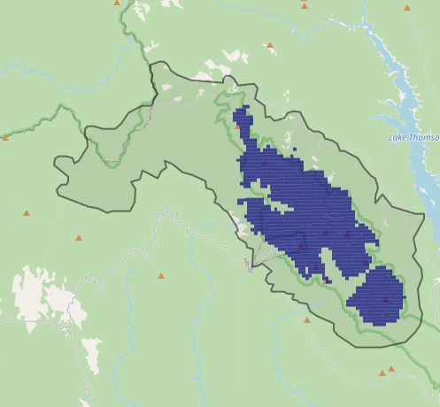
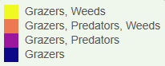
Map a) shows actions in the top 3% cost-effectiveness areas, and Map b) shows actions in the top 10% cost-effective areas
Map a) – SMP top 3% cost-effective actions
The following landscape-scale actions were ranked among the top 3% cost-effective opportunities for biodiversity action across the state by SMP:

Control deer 6,131ha
Control domestic stock grazing* 329ha

*The Gippsland BRP working group advised that controlling domestic stock is currently not a critical issue for this landscape (historic threat only).

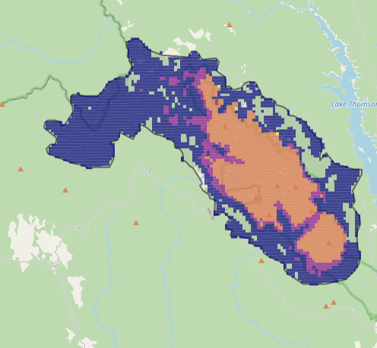
Map b) – SMP top 10% cost-effective actions
The following landscape-scale actions were ranked among the top 10% cost-effective opportunities for biodiversity action across the state by SMP:

Control deer 19,258ha
Combined cat and fox control 7,822ha
Control cats 6,774ha
Control weeds 6,040ha
Control foxes 4,349ha

The most cost-effective actions for flora & fauna according to SMP
 | Plants – Control deer |  | Birds – Control deer and Combined cat and fox control
 | Mammals – Combined cat and fox control (particularly cats) |  | Amphibians – Control deer and Combined cat and fox control (particularly cats)
 | Reptiles – Control deer and Combined cat and fox control (particularly cats)
For a further in depth look into SMP for this landscape please refer to NatureKit.

Additional threats raised by the working group
- Habitat loss (general threat, e.g. due to climate change)

Highest priority strategic actions
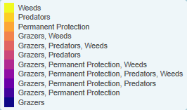
With consideration of the information available in SMP and local knowledge of this landscape, the Gippsland BRP working group identified the following priority actions for future collaboration and investment in this landscape:
The highest priority actions for the Baw Baw landscape include:
- Surveillance and control of large herbivores (particularly deer and potentially horses)
- Surveillance and control of transformer weeds
Other key actions highlighted by the working group include:
- Targeted predator control
- Other targeted actions aimed towards particular threatened species (ideas raised through the Hume working group included: monitoring of Greater Glider and Leadbeater’s Possum, protection of Sphagnum bogs, and creation of a nursery for alpine specific species)

