Introduction
Biodiversity Response Planning (BRP) is a long-term area-based planning approach to biodiversity conservation in Victoria. It is designed to strengthen alignment, engagement and participation between government, Traditional Owners, non-government agencies and the community.
DELWP Regional staff have been working with stakeholders on actions to conserve biodiversity in specific landscapes, informed by the best available science and local knowledge.
These Fact Sheets capture a point in time, reflecting data and knowledge available in 2020. They provide information for many (but not all) landscapes across Victoria, containing general information on the key values and threats in each area, as well as the priority cost-effective actions that provide the best protection of biodiversity. Fact Sheets are intended to provide useful biodiversity information for the community, non-government and government organisations during project planning and development.
Further information and the full list of Fact Sheets is available on the Department’s Environment website.

Landscape description
This 65,677ha area covers most of the Mornington Peninsula. The landscape has 27% native vegetation, and 7% public land.
This landscape has a minor overlap with the Westernport Bay Ramsar landscape along part of the coast. For more information, please refer to the Westernport Bay Ramsar Fact Sheet in the full list of Fact Sheets.
Note that Devilbend Reservoir, Point Nepean and Mornington Peninsula National Parks, and Peninsula Wetlands and Bay Coast landscapes of interest have been excised from this area, and are considered separately. See the full list of Fact Sheets for information about these areas.

Cultural importance
We recognise that the entire landscape has high cultural value for the Bunurong People both past and present. Most areas of this landscape have notable cultural importance based on knowledge shared by Traditional Owners, the Bunurong People.
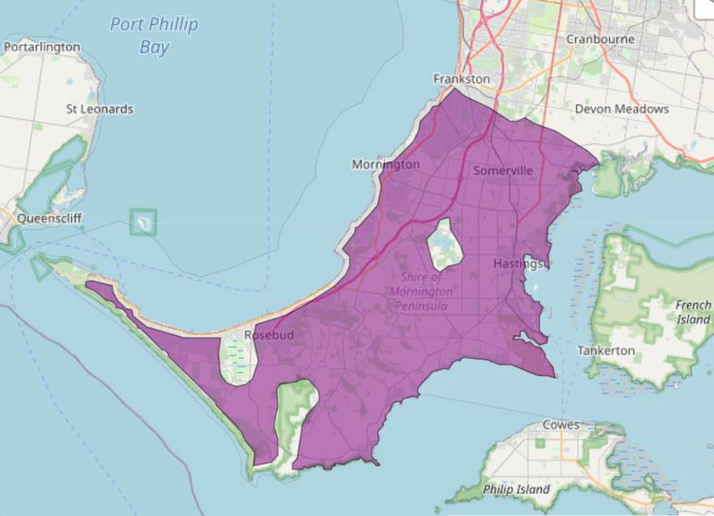

Figure 1: Map showing location of Mornington Peninsula landscape (purple).

Habitat Distribution Models identify 25 species with more than 5% of their Victorian range in this landscape | Traditional Owners, stakeholders and community groups identified the following species of interest
- 25 Plant species  - 12 species with more than 10% of statewide range in area  - Notable species: Frankston Spider-orchid (endangered, 82% statewide range in area), Mount Martha Bundy (endangered, 80% statewide range in area), Venus-hair Fern (endangered, 65% statewide range in area), Coast Helmet-orchid (vulnerable, 34% statewide range in area), Beaded Glasswort (poorly known, 32% statewide range in arera) | - Rare and endangered orchids: Caladenia robinsonii, Corybas sp. aff. diemenicus, Corybas despectans, Cobra Greenhood, Leafy Greenhood  - Other flora species: Clover Glycine, Wood Sorrel, Dainty Maidenhair Fern, Poa poiformis var. ramifer, Adraina quadripartia, Nicotiana maritima, Stackhousia spathulata, Colobanthus apetalus var. apetalus, Lotus australis, Zygophyllum billardierei, Olearia sp. 2, Berula erecta, Pultanaea canaliculata, Euphrasia collina
- 0 Mammal species with more than 5% of statewide range in area  - Notable species: Southern Brown Bandicoot (near threatened, 1.5% statewide range in area), Grey-headed Flying-fox (vulnerable, 1.1% statewide range in area) | - White-footed Dunnart  - Long-nosed Bandicoot
- 0 Reptile species with more than 5% of statewide range in area  - Notable species: Four-toed Skink (near threatened, 4.4% statewide range in area), Metallic Skink (3.4% statewide range in area), Swamp Skink (vulnerable, 3.0% statewide range in area), Glossy Grass Skink (vulnerable, 2.4% statewide range in area) | - Swamp Skink
- 0 Bird species with more than 5% of statewide range in area  - Notable species: Little Wattlebird (2.3% statewide range in area), Hooded Plover (vulnerable, 2.2% statewide range in area) | - Lewin’s Rail  - Australasian Bittern  - Powerful Owl  - Hooded Plover  - White-bellied Sea Eagle  - Black Falcon  - Chestnut-rumped Heathwren  - Ruddy Turnstone  - Sooty Oystercatcher  - Spotted Harrier
- 0 species of amphibians with more than 5% of statewide range in area  - Notable species: Pobblebonk Frog (Limnodynastes dumerilii insularis, 2.1% statewide range in area), Southern Toadlet (vulnerable, 2.0% statewide range in area) | - Southern Toadlet

Strategic Management Prospects
Strategic Management Prospects (SMP) models biodiversity values such as species habitat distribution, landscape-scale threats and highlights the most cost-effective actions for specific locations. More information about SMP is available in NatureKit.
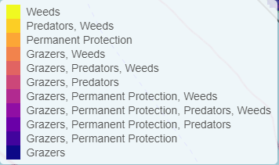
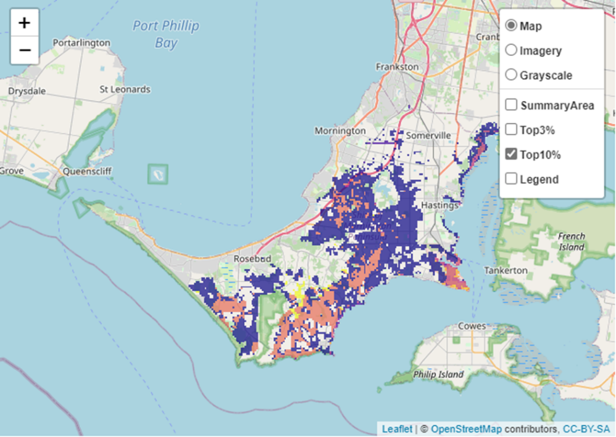
Areas of Mornington Peninsula shown in Figure 2 have highly cost-effective actions (within the top 10% of cost-effectiveness for that action across the state) that provide significant benefit for biodiversity conservation.
Figure 2: The SMP priority actions which rank among the top 10% for cost-effectiveness of that action across the state. “Grazers” includes deer, domestic grazing, goats, horses, over-abundant kangaroos, pigs, rabbits and total grazing pressure

Actions with area in the top 3% and top 10%
Specific Action | Area in top 3% (ha) | Area in top 10% (ha)
Control Rabbits | 10 | 26,743
Control Weeds | 0 | 5,273
Revegetation | 0 | 4,159
Control Total Grazing Pressure | 280 | 1,346
Control Cats | 0 | 1,077
Control Foxes | 0 | 1,038
Control Pigs | 196 | 765
Control Overabundant Kangaroos | 21 | 629
Control Domestic Grazing | 0 | 514
Permanent Protection | 153 | 350

The most cost-effective action for flora & fauna
Plants, Birds, Mammals, Amphibians and Reptiles - Control rabbits

For a further in depth look into SMP for this landscape, please refer to NatureKit.

Current actions in the Mornington Peninsula landscape
Specific Actions | Current actions – top 10% (ha) | Current actions – outside top 10% (ha)
Rabbit Control | 244 | 118
Pig Control | 17 | 123
Weed Control | 13 | 419
Cat Control | 13 | 78
Fox Control | 13 | 357
Domestic Grazing Control | 2 | 139
Permanent Protection | 0 | 140
Revegetation | 0 | 11

Current actions – top 10% = The area (ha) of the specific action currently occurring in locations identified by SMP as being in the top 10% for cost-effectiveness for that action across the state
Current actions – outside top 10% = The area (ha) of the specific action currently occurring in locations within this landscape that are not identified by SMP as being in the top 10% for cost-effectiveness for that action across the state

What you told us
SMP is just one tool to use in the process of understanding biodiversity values. Feedback from our stakeholders is also vitally important and forms the basis of our understanding of knowledge gaps.

Mornington Peninsula was identified by stakeholders as a focus landscape in the ‘medium’ category in Port Phillip region.

Stakeholder interest

Important landscapes
- Significant number of parks
- Coolart Wetlands
- Hopetoun and Norfolk reserves
- Biolink between Greens Bush and Arthurs Seat
- Central ridgeland core of the Peninsula
- Frankston Nature Conservation Reserve
- Trust for Nature properties
- Arthurs Seat State Park
- Warringine Park
- Woods Bushland Reserve
- Creeklines, including Main Creek and Balcombe Creek

Important vegetation communities
- Vegetation communities: Coastal Moonah Woodlands, Heathland, Cool Temperate Rainforest, Sand Heathland communities, Tall Marsh

Current activities/programs/partnerships
- Works on Council reserves and roadsides (Mornington Peninsula Shire)
- Mornington Peninsula Biolink Focus area
- Landcare Biolinks
- Port Phillip and Westernport CMA Regional Catchment Strategy – Naturelinks (project at concept phase)
- Trust for Nature properties (including as part of Biodiversity Response Planning project 093 – Iconic Estates: Port Phillip/Westernport)
- Various Friends of groups, Landcare groups and other community groups focusing on biodiversity conservation
- Metropolitan Open Space Strategy
- Parks Victoria Peri-urban Weed program at Arthurs Seat
- City of Casey Linkage Biozone

Additional threats
Threats identified through the consultation process (in addition to those modelled in SMP):
- Sea level rise/climate change
- Storm surge
- Coastal trampling
- European rats
- Coastal Moonah Woodland Ecological Vegetation Class threatened by residential development
- Creation of illegal tracks, firewood collection, dog walking, illegal fishing, rubbish dumping
- Environmental weeds

